

***Faculty of Engineering and Technology***

***Electrical and Computer Engineering Department***

***Electronic lab (ENEE3102)***

**Pre lab of EX #6**

**Multistage Amplifiers and Frequency Response " "**

**Instructor :-**

**Dr. Mohammad Jehad Ju'Beh**

**ENG . Amjad Shaalan**

**Prebared by :- Hussam Ali**

**ID:- 1172476**

**Sec:-1**

***I. Multistage Amplifier Design:***

We want to design a two-stage amplifier with a voltage gain 200 to give a peak-to-peak output of 2.5 v.

Av1 = 100, Av2 = 2, Vi = 12.5 m Vp-p .

To design the first stage of the amplifier for the h-parameters of a transistor are

hie = 4 ${10}^{3}$*Ω

hoe = ${10}^{-4}$ 1\Ω

hfe = 300

hre = 10-3

Vcc = 10v

The capacitor = 100uF in parallel with $R_{E}$.

* design the first stage:(before not found values of resistors)

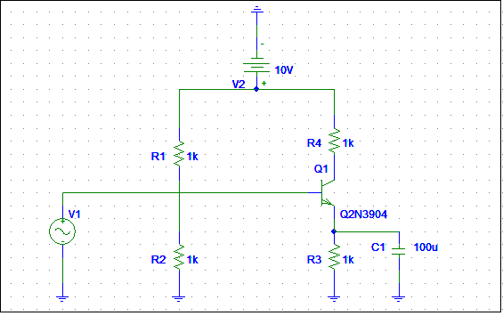

Dc analysis

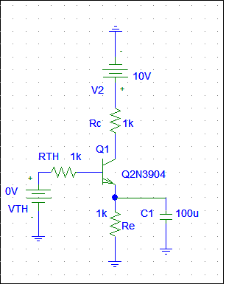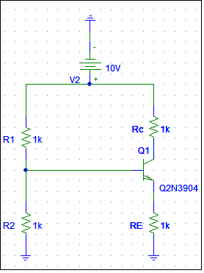

$h_{fe=β=300}$ =

$$hie=\frac{vT}{IB}=\frac{25.6mv}{IB}=4*{10}^{3} →IB=6.4*{10}^{-6} A$$

IE=(hfe+1)IB =(300+1)6.4 ${10}^{-6}=1.92*{10}^{-3}A$

*

Ic= $β ib=300*6.4*{10}^{-6}=1.92*{10}^{-3}A$

IC=IE

Let VE=0.1 vcc VE=0.1*10=1V

$V_{\begin{aligned}E → RE=519Ω \\ \end{aligned}}$ $I_{E}$ $R_{E}$ =

To Find $R_{1}$& $R_{2}$ we need to $R_{TH}$& $V_{TH}$

$$RTH=\frac{R2}{R2 R1}VCC=\frac{β RE}{10}=\frac{300*519}{10}=15570Ω=15..6KΩ$$

VTH+VBE+RE*IE+(RTH $(β+1)$\ *IE)=0-

$V_{TH}$ = $I_{E}[$ $\frac{R_{TH}}{β+1}$ + $R_{E}$] + $V_{BE}=$

$V_{TH}$ = 1.926 [ $\frac{15.57 }{301}$ + 0.519 ] + 0.7

$V_{TH}$ = 1.8 volt.

$V_{TH}$ = $\frac{R_{2}}{R_{1+ R_{2}}}$ $V_{CC}$ $→$ $\frac{V_{TH}}{V_{CC}}$ = $\frac{R_{2}}{R_{1+ R_{2}}}$

$\frac{R_{2}}{R_{1}+ R_{2} }$ = 0.18 $↔(1)$

$R_{TH}$ = $\frac{{R_{1}R}_{2}}{R_{1}+ R_{2}}$ = 15.57 $↔(2)$

We make up (1) in (2) and we get:

$R_{1}$ = 86.5 K $Ω$

$R_{2}$ = 18.98 K $Ω$

Ac analysis (small signal equivalent circuit):

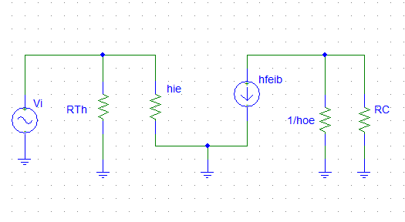

Find RC ??

$V_{O }$ = - $h_{fe}$ $i_{b}$** ($R_{C}$// $\frac{1}{h_{oe}}$).

$i_{b}$ = $\frac{V_{i }}{h_{ie}}$

$V_{O }$ = = - $h_{fe}$ $\frac{ V_{i }}{h_{ie}}$** ($R_{C}$// $\frac{1}{h_{oe}}$).

$\frac{V_{O }}{V_{i }}$ = - $h_{fe}$ $\frac{ 1}{h_{ie}}$* * ($R_{C}$// $\frac{1}{h_{oe}}$) = 100

-300 $\frac{1}{4000}$ ${ R}_{C}$* *// $\frac{1}{{10}^{4}}$ = - 100

${ R}_{C}$// $\frac{1}{{10}^{4}}$ = 1333.33

(${ R}_{C}$ ${10}^{4}$*)/( $R_{C}$ + ${10}^{4})$ = 1333.33

${ R}_{C}$ = 1.538 k $Ω$

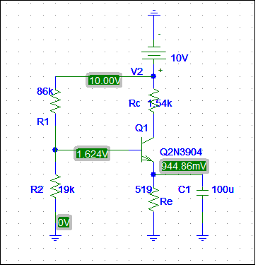

Then the same procedure for stage 2:

The values of R1,R3,RE are the same of stage 1 but Rc is different because the gain is 2:

$V_{O }$ = - $h_{fe}$ $i_{b}$** ($R_{C}$// $\frac{1}{h_{oe}}$).

$i_{b}$ = $\frac{V_{i }}{h_{ie}}$

$V_{O }$ = = - $h_{fe}$ $\frac{ V_{i }}{h_{ie}}$** ($R_{C}$// $\frac{1}{h_{oe}}$).

$\frac{V_{O }}{V_{i }}$ = - $h_{fe}$ $\frac{ 1}{h_{ie}}$* * ($R_{C}$// $\frac{1}{h_{oe}}$) = 2

-300 $\frac{1}{4000}$ ${ R}_{C}$* *// $\frac{1}{{10}^{4}}$ = - 2

${ R}_{C}$// $\frac{1}{{10}^{4}}$ = 26.67

(${ R}_{C}$ ${10}^{4}$*)/( $R_{C}$ + ${10}^{4})$ = 26.67

${ R}_{C}$ = 26.74 k $Ω$

When we setup the designed for stage 2 circuit, the voltages are :

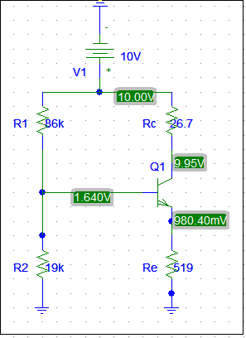

**The two stages together ::**

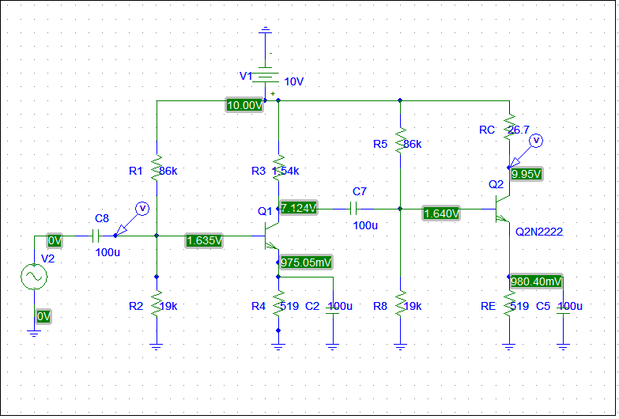

**Vin show in figure below :**



**Vout show in figure below :**

$Voltage gain$****

**show in figure below :**



**III. DIFFERENTIAL AMPLIFIER**.

1)a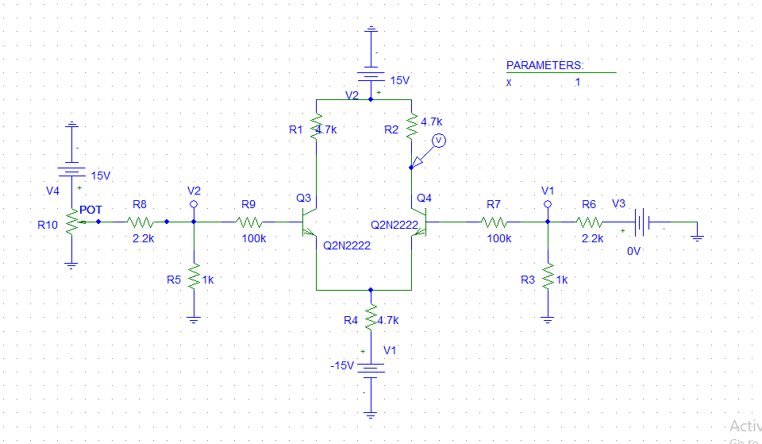

***II. FREQUENCY RESPONSE.***

In lab taken and fill the table data in different frequency