

Faculty of Engineering and Technology

Electrical Engineering Department

ــــــــــــــــــــــــــــــــــــــــــــــــــــــــــــــــــــــــــــــــــــــــــــــــــــــــــــــــــــــــــــــــــــــــــــــ

ELECTRONIC LAB

Pre Lab

Experiment#6

Multistage Amplifier and Frequency Response

**Student’s Name: jana al-zeer**

**Student’s No : 1161228**

**Instructors :Dr.** mohammad ju’beh

Eng.Qassam Barghouthi

**Section : 2**

***Multistage amplifier***

1. ***Multistage amplifier design :***

**First stage design :**

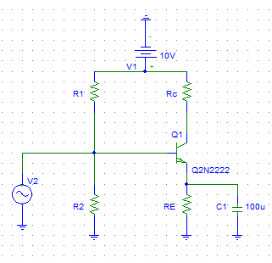

**Dc analysis:**

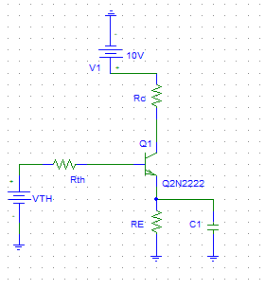

hie=Vt/IB IC=B IB

4000=BVt/Ic =300*25.69*10^-3/Ic

Ic=1.926*10^-3 A

Then to find RE we assume that VE=0.1 Vcc

VE=10/10=1 v

VE=IR*RE

RE = 1/1.926*10^-3 = 0.159 K.

IB= 6.42 UA.

IE=1.932*10^-3 A.

To find R1 and R3 we need Rth and Vth :

Let Rth=B*RE/10

=300*519/10= 15570 Ohm

IE=(Vth-0.7)/(RE+Rth/B+1).

Vth=1.79 volts .

Vth=(R3/R3+R1)*Vcc……1

Rth=(R1*R3)/(R1+R3)……2

SOLVING THE TWO EQUATIONS :

R1=86 KΩ

R3=19 KΩ

***Ac analysis (small signal equivelant circuit ):***

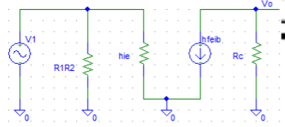

Design for the first stage :

Vo=-hfe*ib*(Rc//1/hoe).

ib =Vi/hie

Vo = -hfe*(Vi/hie)*(Rc//1/hoe).

Vo/Vi=-hfe*(1/hie)*(Rc//1/hoe)=100

300*(1/4000)*(Rc//10^4)=100

(Rc//10^4)=1333.3

(Rc*10^4)/(Rc+10^4)=1333.3

Rc=1.54 kΩ

The two stages together :

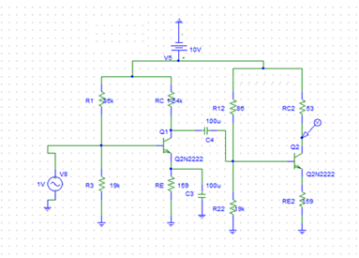

1. ***Frequency response***

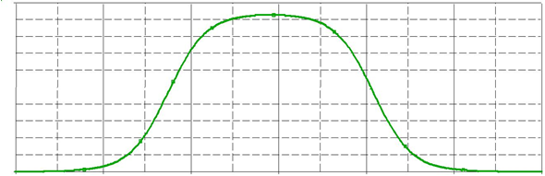

1. ***Differential amplifiers***

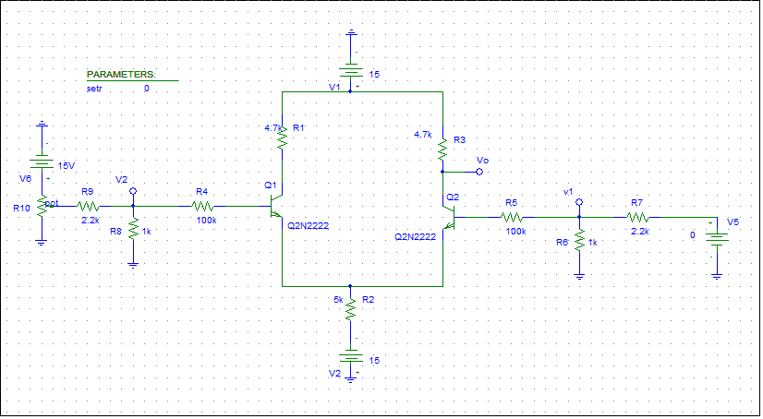

|  |  |
| --- | --- |
| **V1=V2(V)** | **Vout(V)** |
| **0** | **8.669** |
| **1** | **8.230** |
| **2** | **7.794** |
| **3** | **7.363** |
| **4** | **6.922** |
| **5** | **5.434** |

The second part :

|  |  |  |
| --- | --- | --- |
| ***V1(V)*** | ***V2(V)*** | ***Vout(V)*** |
| ***0*** | ***0*** | ***8.669*** |
| ***0.05*** | ***-0.05*** | ***8.272*** |
| ***0.1*** | ***-0.1*** | ***7.88*** |
| ***0.15*** | ***-0.15*** | ***7.491*** |
| ***0.2*** | ***-0.2*** | ***7.078*** |