

**Faculty of Engineering & Technology**

**Electrical & Computer Engineering Department**

**ENEE 3102 – Electronics Lab**

Experiment#7

Power Amplifiers

**Prepared by:**

**Name: Abdallah Fialah Number: 1162193**

**Instructor:**

**Mr: Mohammad Al-jubeh TA: Eng.Amjad**

**Date:**

**9/10/2020**

**Section: #1**

***I. THE CLASSES OF POWER AMPLIFIER***

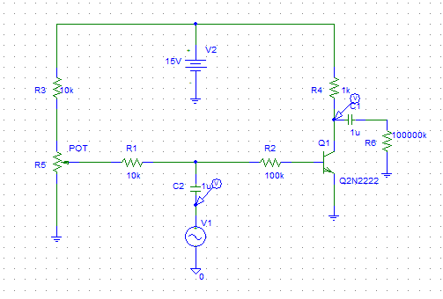

* The input voltage with Vp=4voltand Fin=1 kHz , the output shown below:

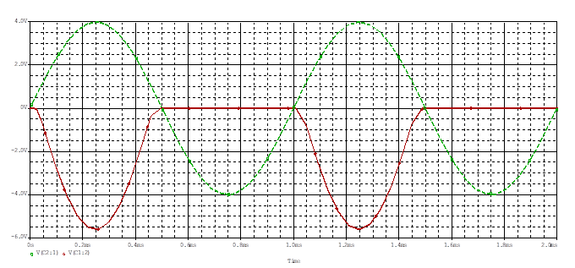

the class of the amplifier in this case is class B.

* The set = 0.24 , and the out put shown as

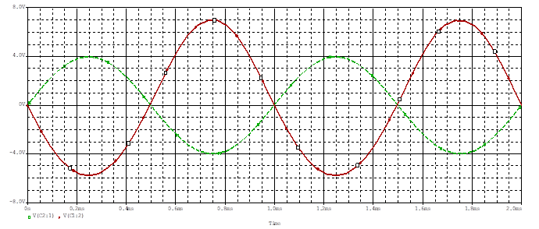

Class A power amplifier, because the input and the output are out of phase by 180 degree

* the set=0 and the out put shown as:

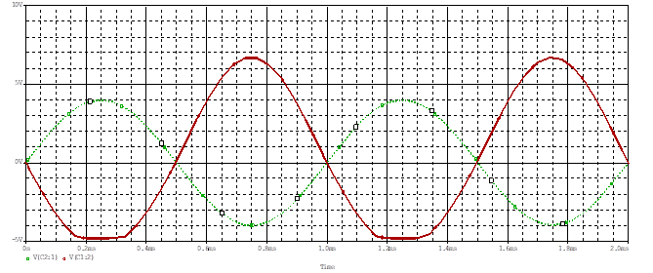

this is a class AB power amplifier

* bias voltage =0.71

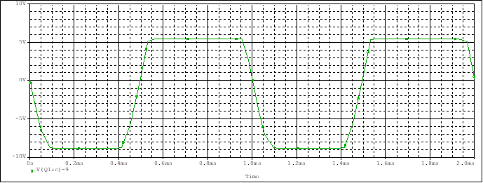

***II. PUSH-PULL AMPLIFIER:***

We connect the circuit shown in figure

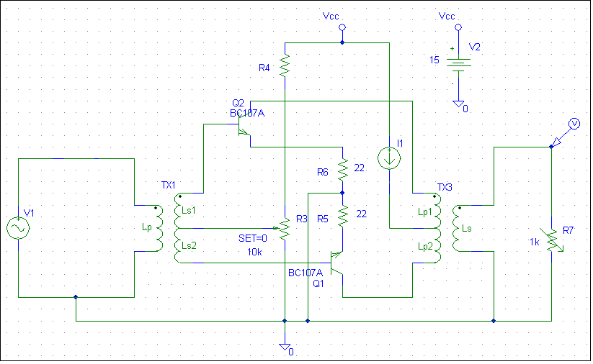

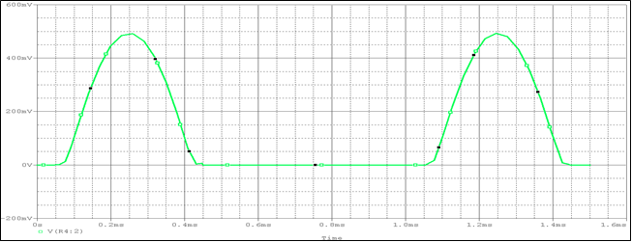

The circuits diagram:

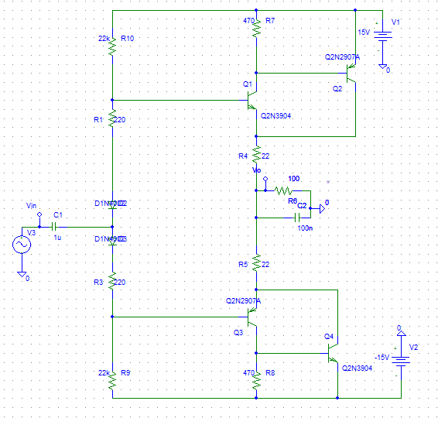

The input:

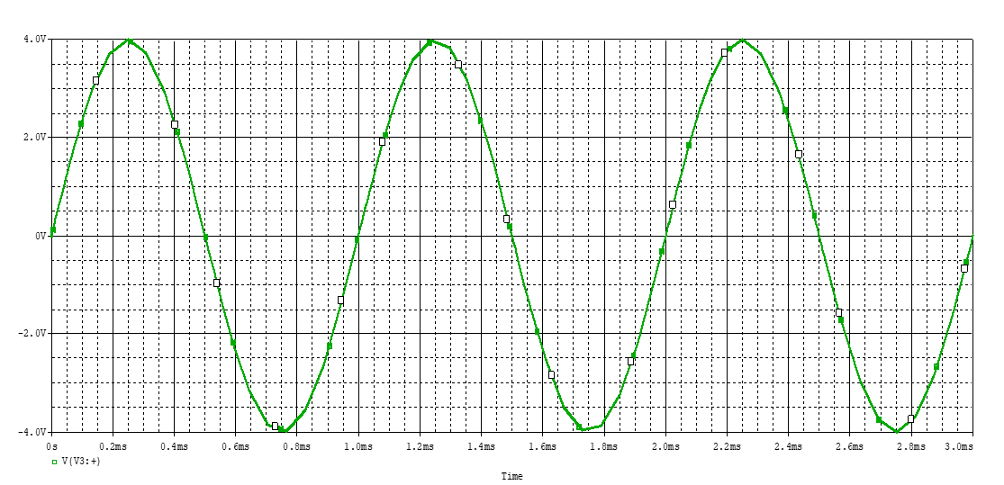

The input and the output of the circuits:

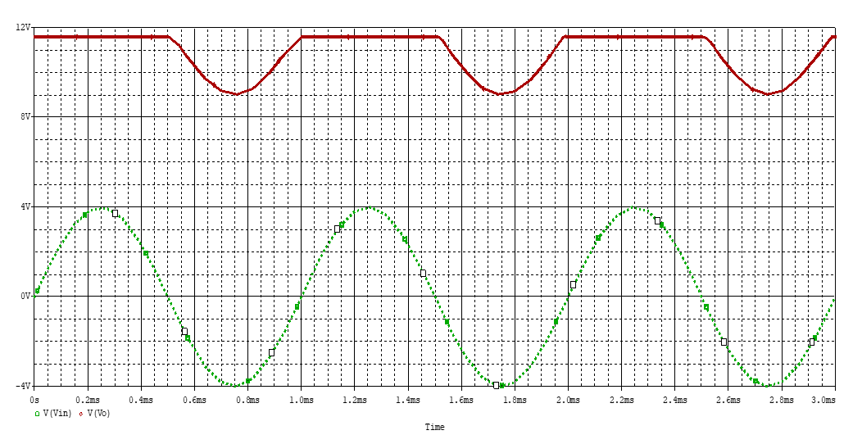

The output power =VL*IL :

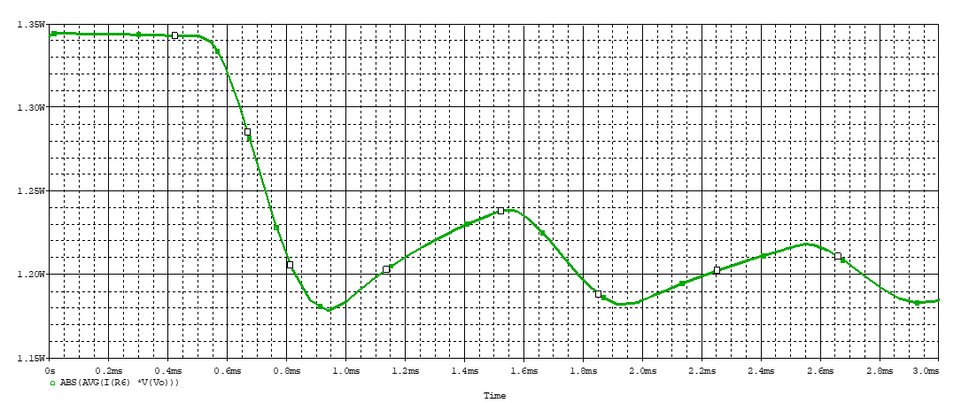

The average power is equal to 1.25 W, and the max power = 1.38 W.