

Faculty of Engineering and Technology

Electrical and Computer Engineering Department

ENEE3102

Electronics Lab

Experiment # 7

Pre lab

*Student’s name : Anas Joudeh*

*Student’s number : 1142570*

*Instructor : Dr.Mohammad AL-Jubeh*

1. ***THE CLASSES OF POWER AMPLIFIER :***

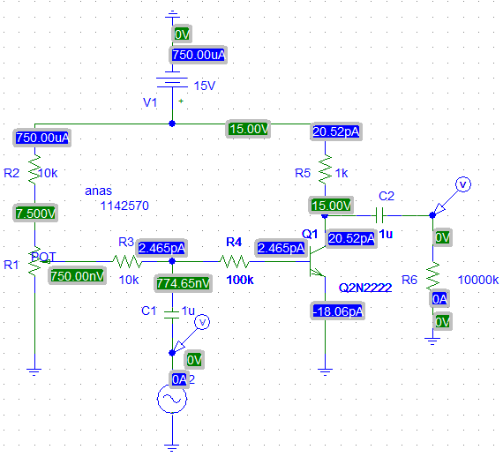

Vsin in= 8 Vp-p

1. When the set = 1 , The output is :



This class of power is class B , The output voltage in the active region for a half wave .

1. When set = 0.25 , The output is :



This class of power is class A , The output is wave is complete and shifted by 180 degree .

1. When set = 0 , The output is :



This class of power is class A-B amplifier, The transistor is in active region between 180 – 360 degree.

4.

1. ***PUSH-PULL AMPLIFIER:***

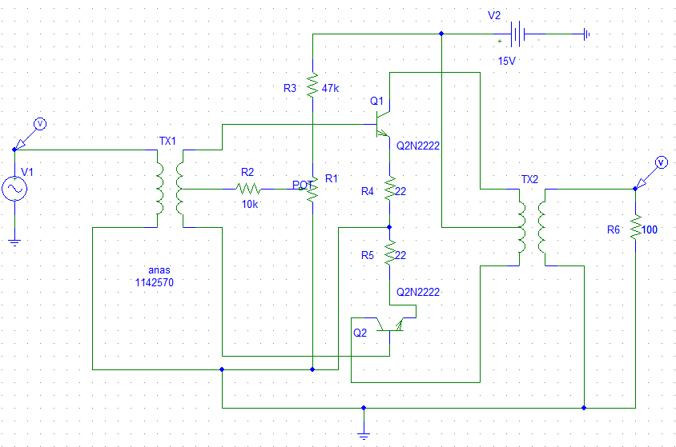

1. ***COMPLEMENTARY PUSH-PULL AMPLIFIER :***

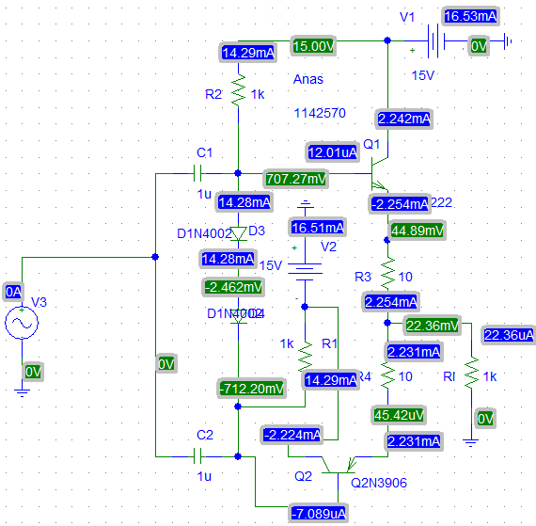

When Rl = 100 ohm :

