

Prelap #8

Danan Abu Hussein

1131657

***. Adding Application***

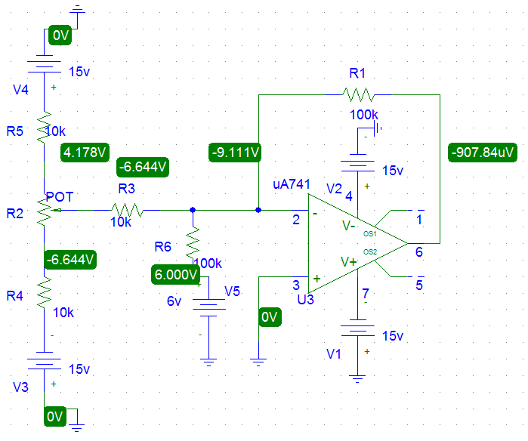

***II. Voltage Follower Application***

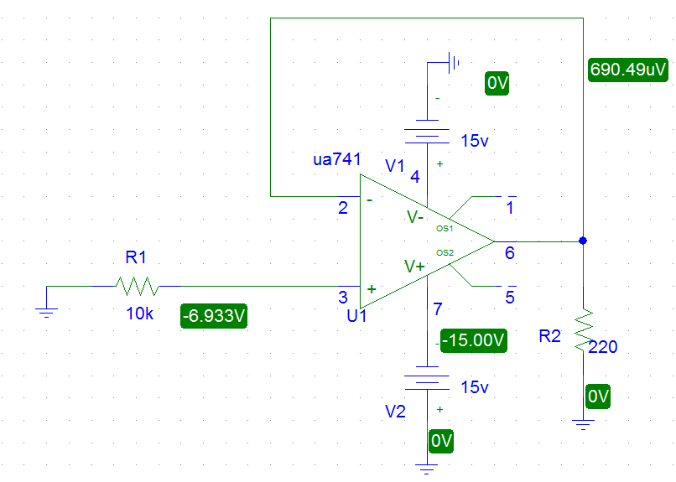

***III. Comparator Application***

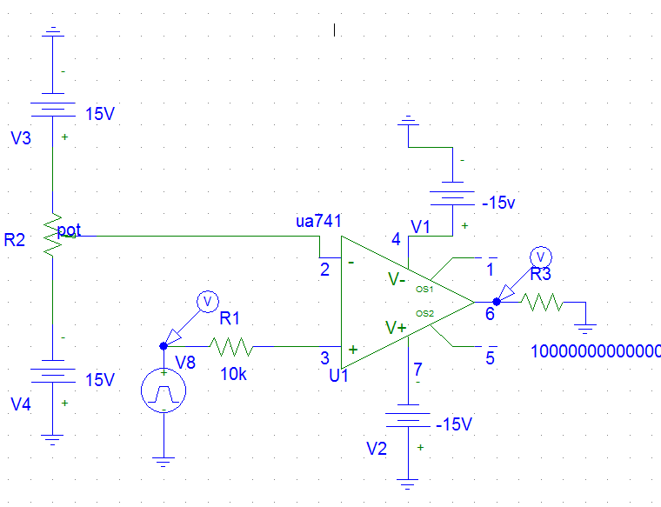



***IV. Integrator and Differentiator***

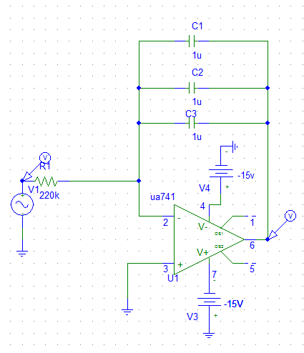



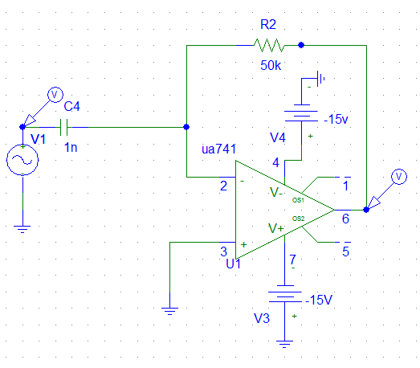



***V. To investigate the effect of adding hysteresis:***

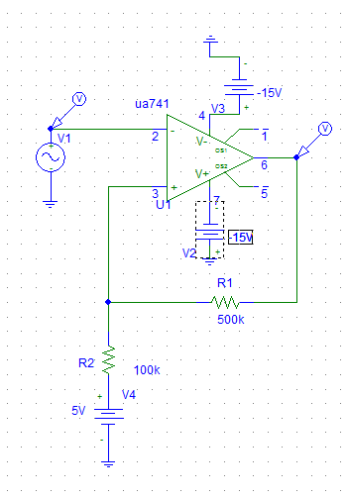



***VI. Active Clipping Circuit:***



