Birzeit University logo

Electronics lab

ــــــــــــــــــــــــــــــــــــــــــــــــــــــــــــــــــــــــــــــــــــــــــــــــــــــــــــــــــــــــــــــــــــــــــــــــــــــــــــــــــــــــــــــــــــــ

***Zener diode and the voltage regulated power supply.***

Dana Abu Hussein 1131657

Prelab exp #9

***I.ZENER DIODE.***

***1)***

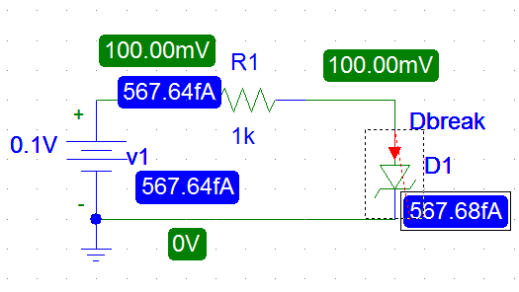

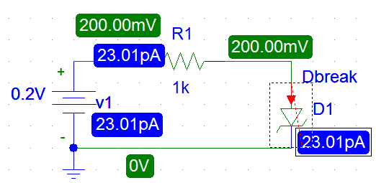

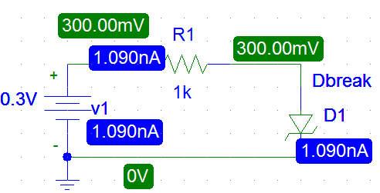

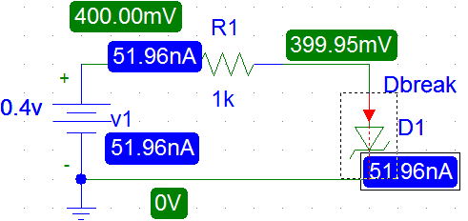

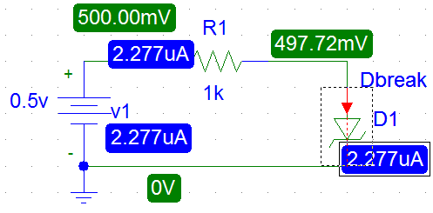

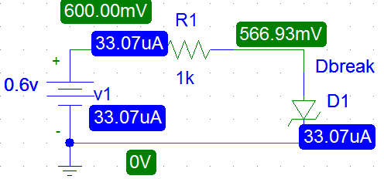

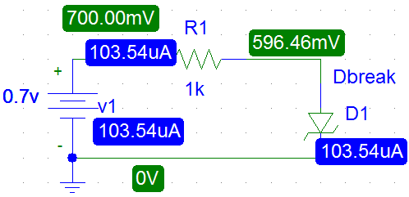

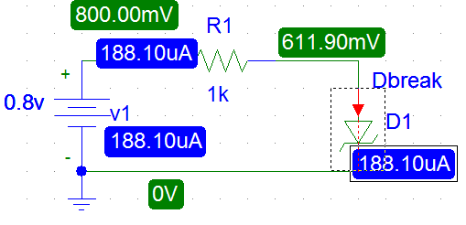

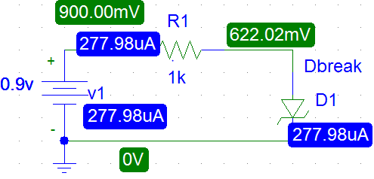

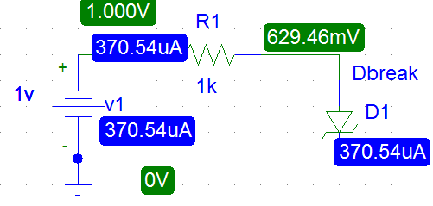

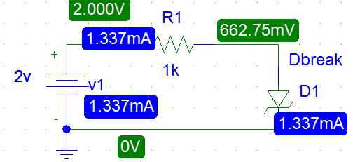

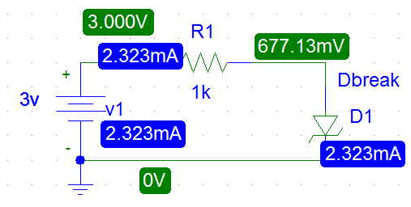

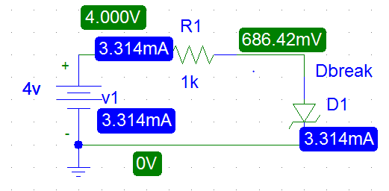

**2)**

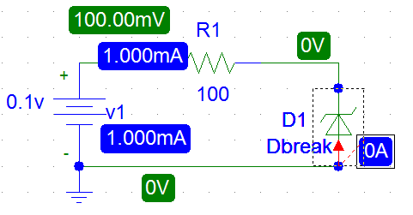

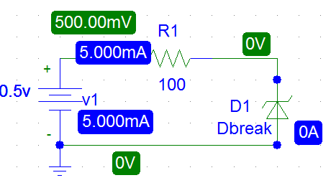

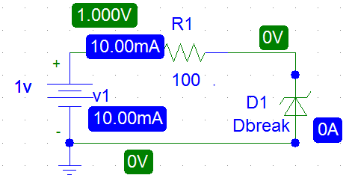

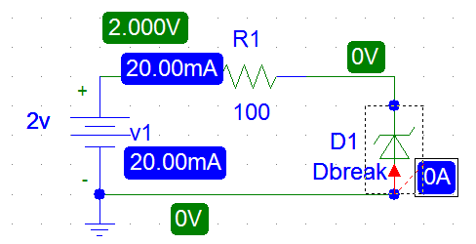

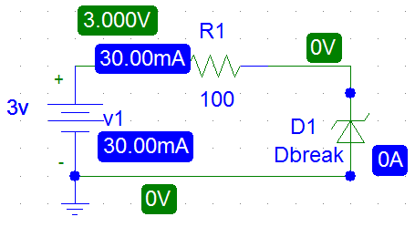

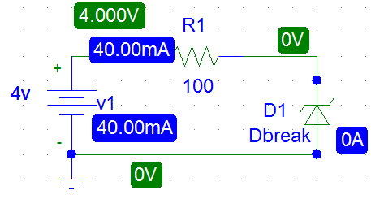

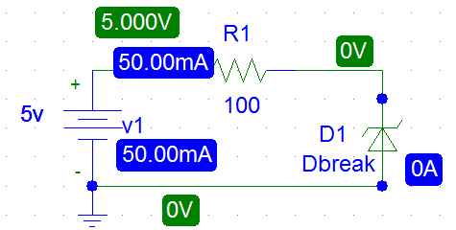

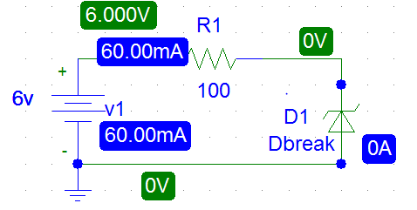

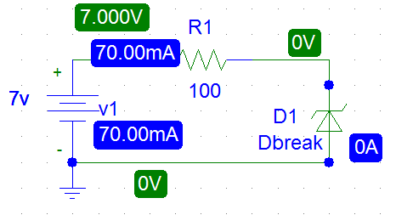

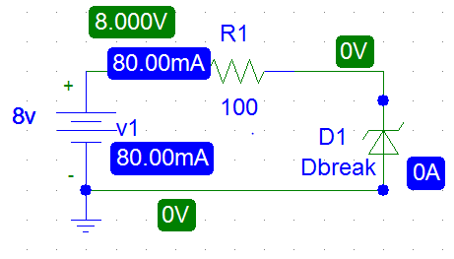

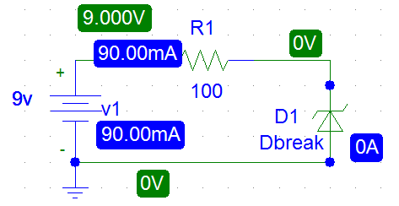

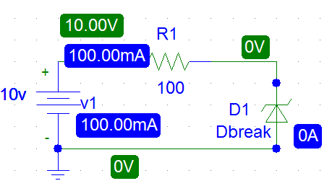

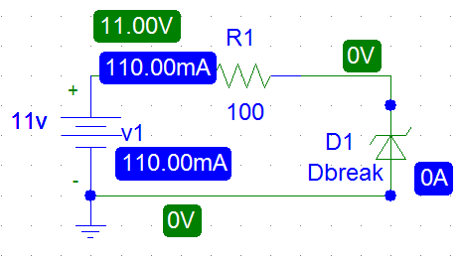

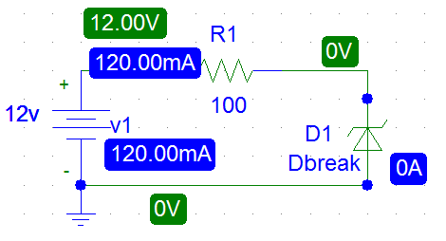

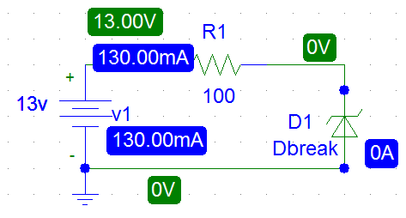

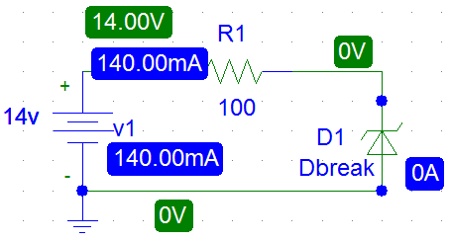

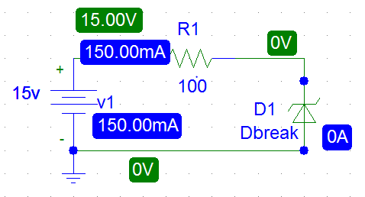

**3)**

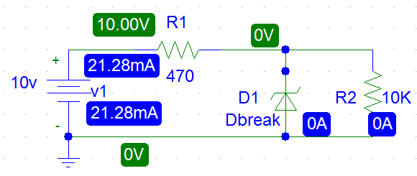

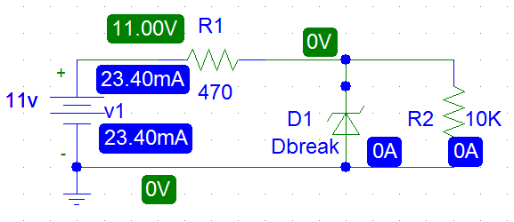

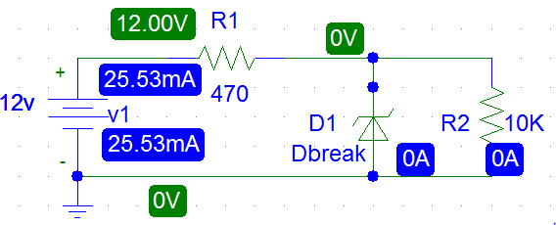

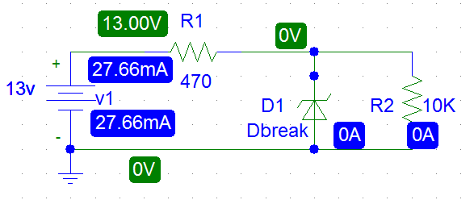

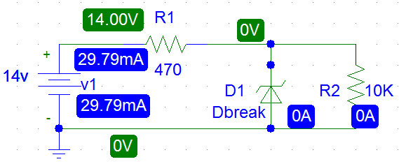

With E set to 10V measure the load voltage VL for RL=(8.2K,6.8K,4.7K,2.2K).

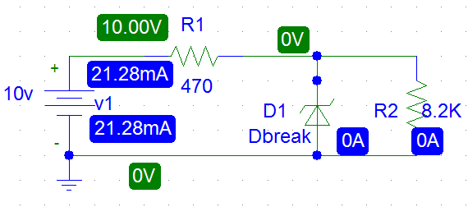

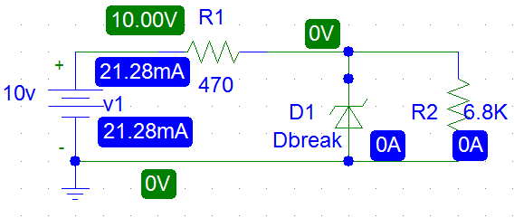

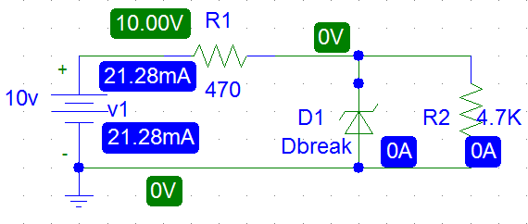

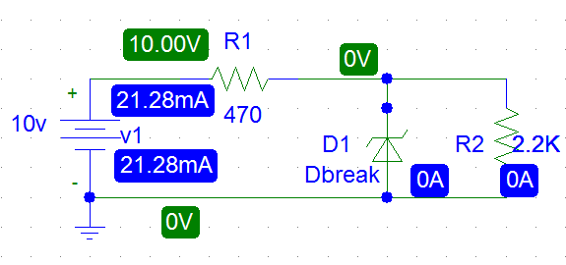

***II. THE VOLTAGE REGULATED POWER SUPPLY.***

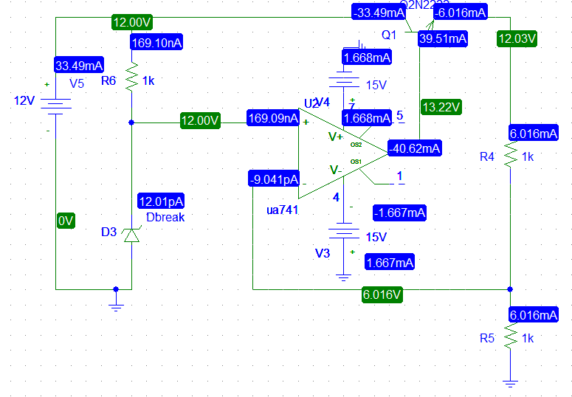

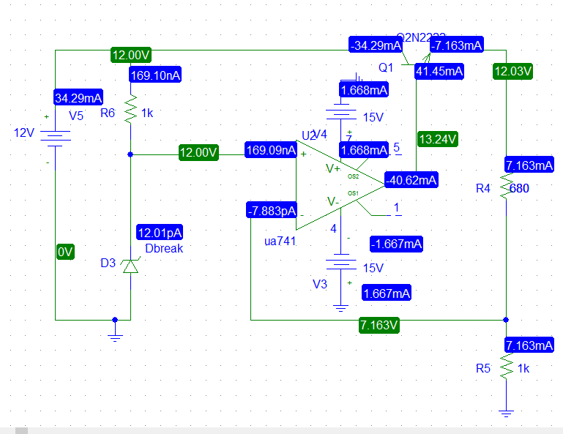

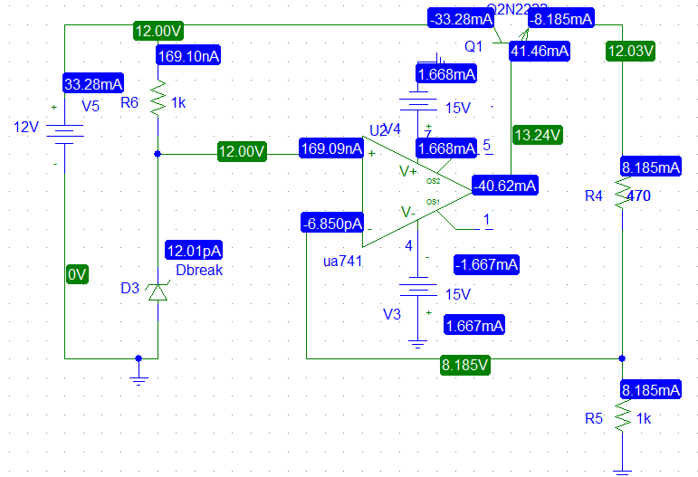

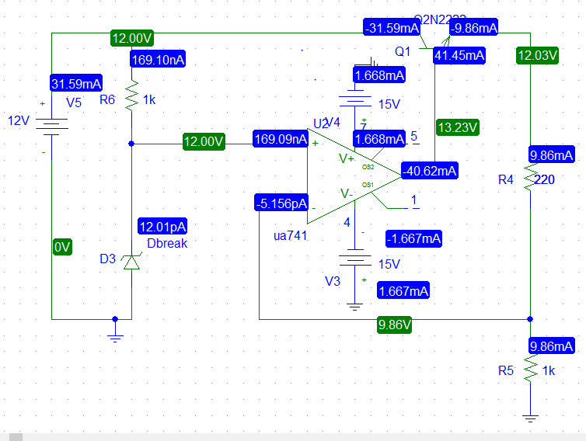

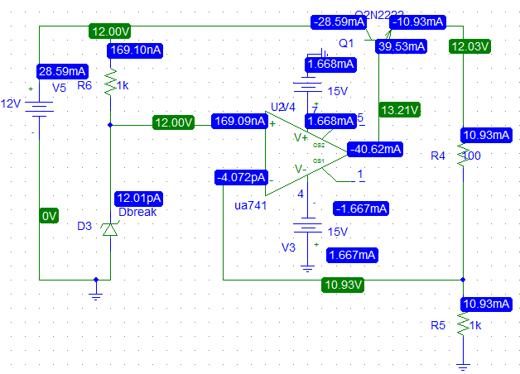

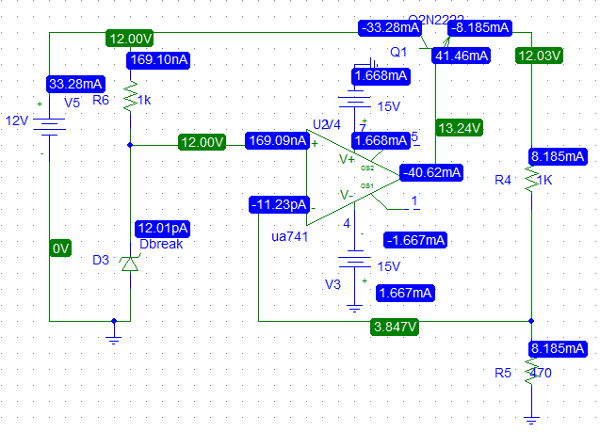

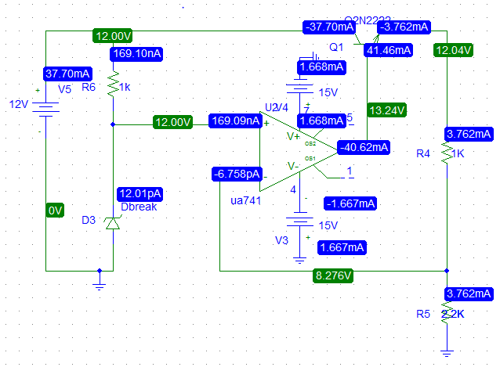

**ــــــــــــــــــــــــــــــــــــــــــــــــــــــــــــــــــــــــــــــــــــــــــــــــــــــــــــــــــــــــــــــــــــــــــــــــــــــــــــــــــــــــــــــــــــــــــــــ**

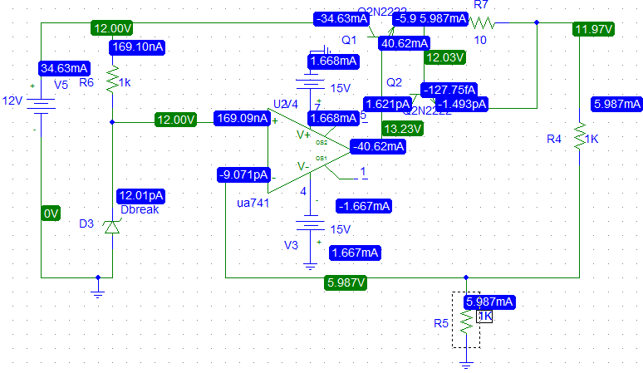

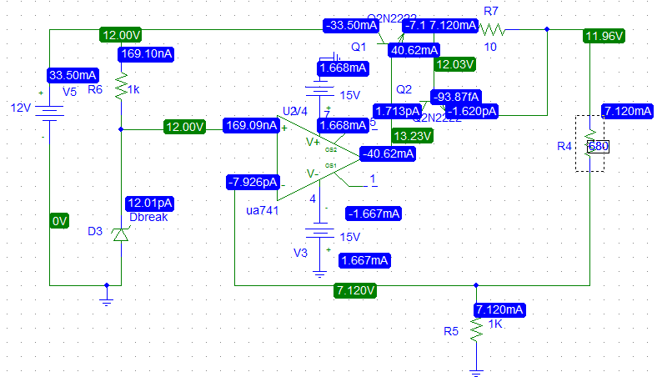 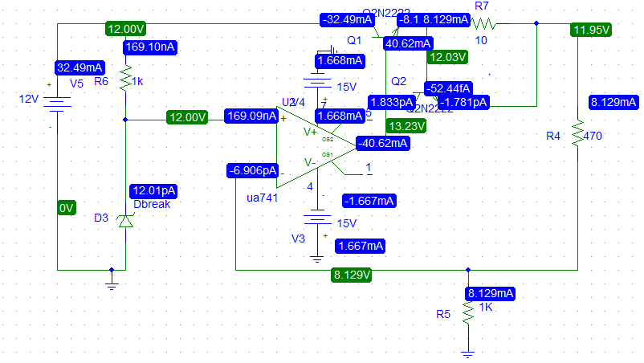 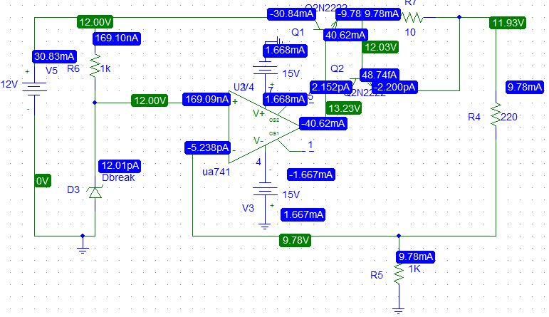

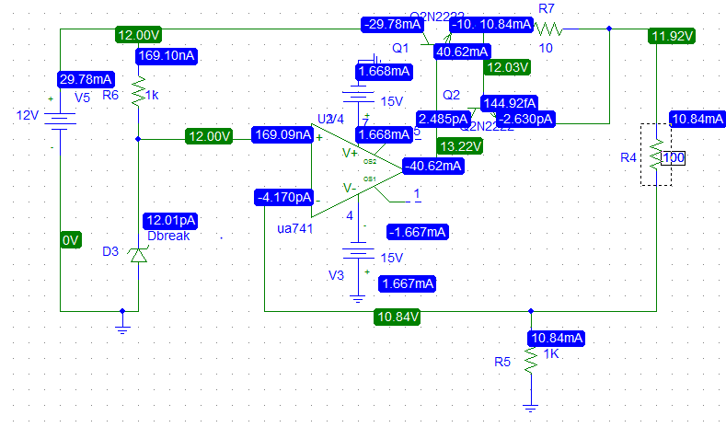 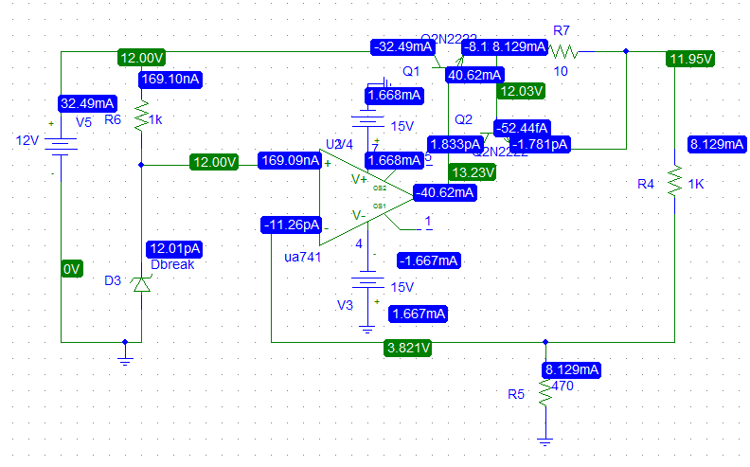

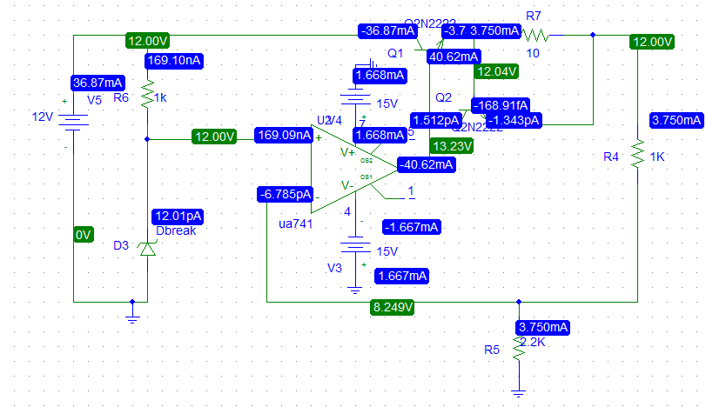

***III. THREE TERMINAL FIXED VOLTAGE REGULATOR 7805.***

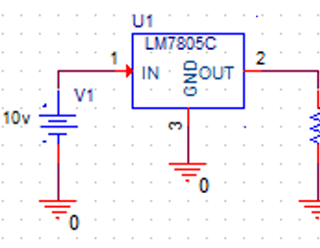

|  |  |  |
| --- | --- | --- |
| RL(Ω) | VL(V) | IL(m A) |
| 25 | 4.995 | 199.8 |
| 50 | 4.996 | 99.92 |
| 100 | 4.997 | 49.97 |
| 200 | 4.997 | 24.985 |
| 400 | 4.997 | 12.4925 |
| 600 | 4.997 | 8.3833 |
| 800 | 4.997 | 6.246 |
| 1000 | 4.997 | 4.997 |

From these results load regulation:

∆VL /∆ IL=.001/99.2m=0.01

after that Rl was set to be 100Ω, then the output voltage and current were measured for different values of input voltage then filled in the table below.

|  |  |  |
| --- | --- | --- |
| Vi(V) | VL(V) | IL(m A) |
| 8 | 4.9949 | 199.797 |
| 9 | 4.995 | 199.799 |
| 10 | 4.9951 | 199.803 |
| 11 | 4.9952 | 199.807 |
| 12 | 4.9953 | 199.81 |
| 13 | 4.9954 | 199.814 |
| 14 | 4.9955 | 199.818 |
| 15 | 4.9956 | 199.822 |

Form these values we got that line regulation is

∆VL/∆Vi=0.0001/1=0.0001

***III. THE LM317 ADJUSTABLE VOLTAGE REGULATOR.***

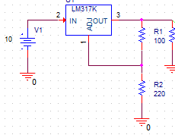

|  |  |  |
| --- | --- | --- |
| R2(Ω) | VL(V) | IL(m A) |
| 0 | 1.261 | 1.261 |
| 100 | 2.502 | 2.502 |
| 200 | 3.755 | 3.755 |
| 300 | 5.008 | 5.008 |
| 500 | 7.514 | 7.514 |
| 700 | 8.273 | 8.237 |

Then when Rl=1k, R1=100 and Vin=10 ,

The load voltage and currents were filled in the table below for different values of R2.

After that the output voltage and current were filled for different values of Vin, where R2=220Ω, R1=100Ω, Rl=1kΩ.

|  |  |  |
| --- | --- | --- |
| Vi(V) | VL(V) | IL(m A) |
| 10 | 4.0058 | 4.0058 |
| 12 | 4.0058 | 4.0058 |
| 14 | 4.0059 | 4.0059 |
| 15 | 4.0059 | 4.0059 |
| 16 | 4.0059 | 4.0059 |
| 17 | 4.0059 | 4.0059 |

Voltage regulation: line regulation= ∆VL/∆Vi=.0001/1=.0001 (approximately Zero)

Load regulation=∆VL/∆IL=0

Then load voltage and current were measured and filled in the table below as Rl varying and (R1=100Ω, R2=220Ω, Vin=10 volt).

|  |  |  |
| --- | --- | --- |
| RL(Ω) | VL(V) | IL(m A) |
| 100 | 4.006 | 40.05 |
| 200 | 4.006 | 20.03 |
| 400 | 4.006 | 10.01 |
| 500 | 4.006 | 8.04 |
| 600 | 4.006 | 6.676 |
| 700 | 4.006 | 5.722 |
| 1000 | 4.006 | 4.006 |