

Faculty of Engineering and Technology

Electrical and Computer Engineering Department

ENEE3102

Electronics Lab

Experiment # 9

Pre lab

*Student’s name: Juomah Bader*

*Student’s number: 1142570*

*Instructor : Dr.Mohammad AL-Jubeh*

1. ***Adding Application :***

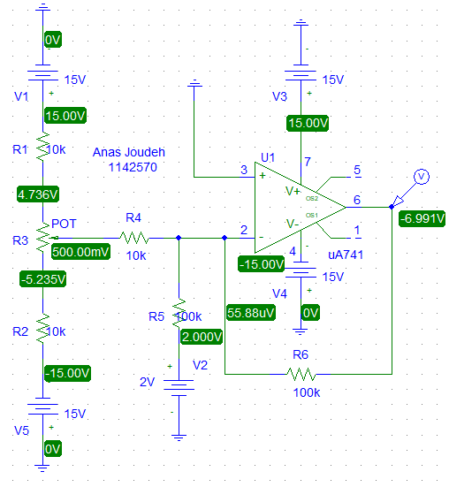

1162462

|  |  |  |
| --- | --- | --- |
| **Input voltage(v)** | | **Output voltage(v)** |
| **V1** | **V2** | **VO** |
| 0.5 | 2 | -6.991 |
| 0.1 | 6 | -6.991 |
| 0.3 | 4 | -6.991 |
| -0.9 | 2 | -7.010 |
| -1.1 | 4 | 7.232 |
| -1.5 | 6 | 9.029 |

***II. Voltage Follower Application :***

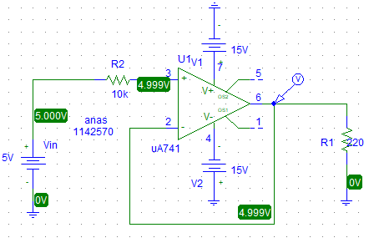

1162462



|  |  |
| --- | --- |
| **Vin (V)** | **Vout (V)** |
| 6 | 5.9990 |
| 8 | 7.9989 |
| 10 | 8.9352 |
| 12 | 8.9352 |
| 15 | 8.9352 |

***III. Comparator Application :***

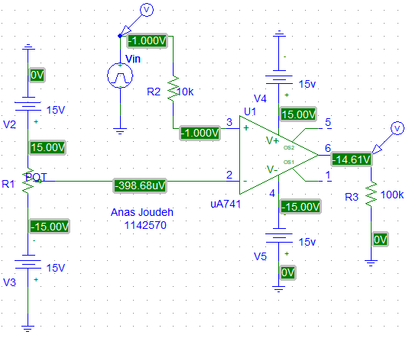

1162462



***IV. Integrator and Differentiator :***

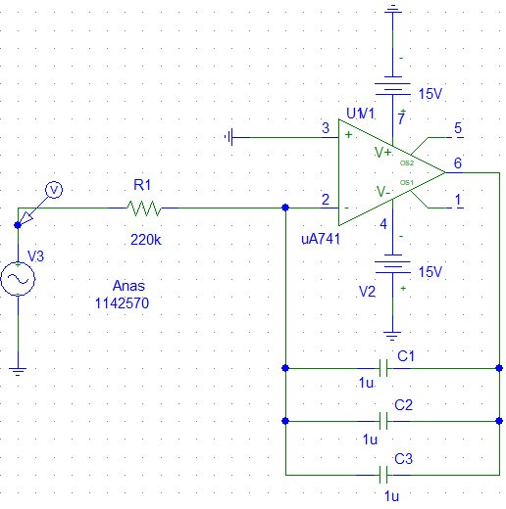

1162462

The Input :



The Output :



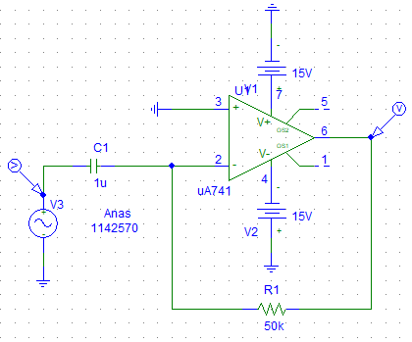

1162462

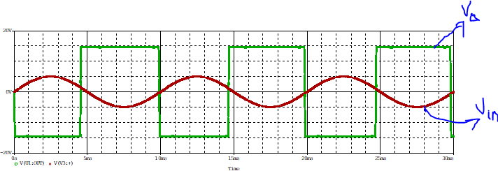

***V. To investigate the effect of adding hysteresis:***

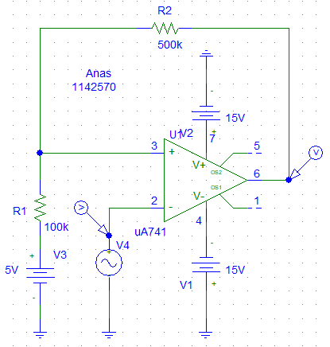

1162462

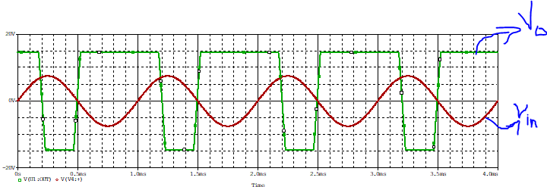

***VI. Active Clipping Circuit:***

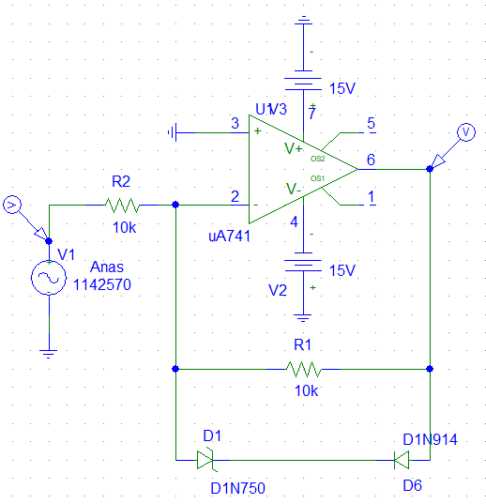

1162462



1. By Reveres both diode :

