

Faculty of Engineering and Technology

Electrical and Computer Engineering Department

**ENEE 3102 – Electronics Lab**

Pre-lab for Experiment No.9

**The Operational Amplifier**

Prepared By:

Name: Suhaeb Qadan Number: 1160297

Instructor: Dr. Mohammad Al Jubeh

TA: Eng. Almo`tassem Billah

Date: 6/11/2019

Sec#: 1

**Part 1: Adding Applecation**

The circuit below was built using PSpice simulation as shown:

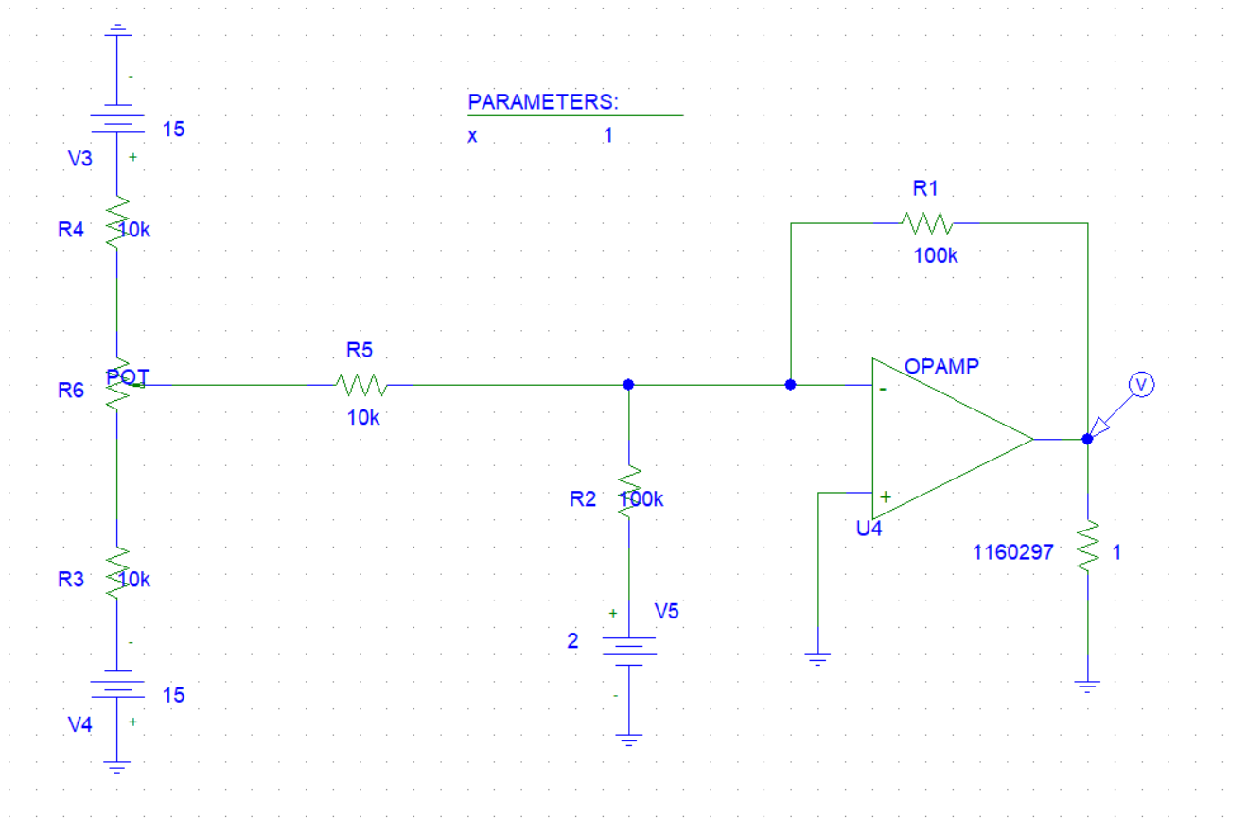

The output voltage was observed by setting the values of V1 and V2, the values of V1 was determined by using Parameters and the setting value was changed and recorded from the output waveform, it`s found by knowing the value of the V1 using a cursor as follows in Figure:



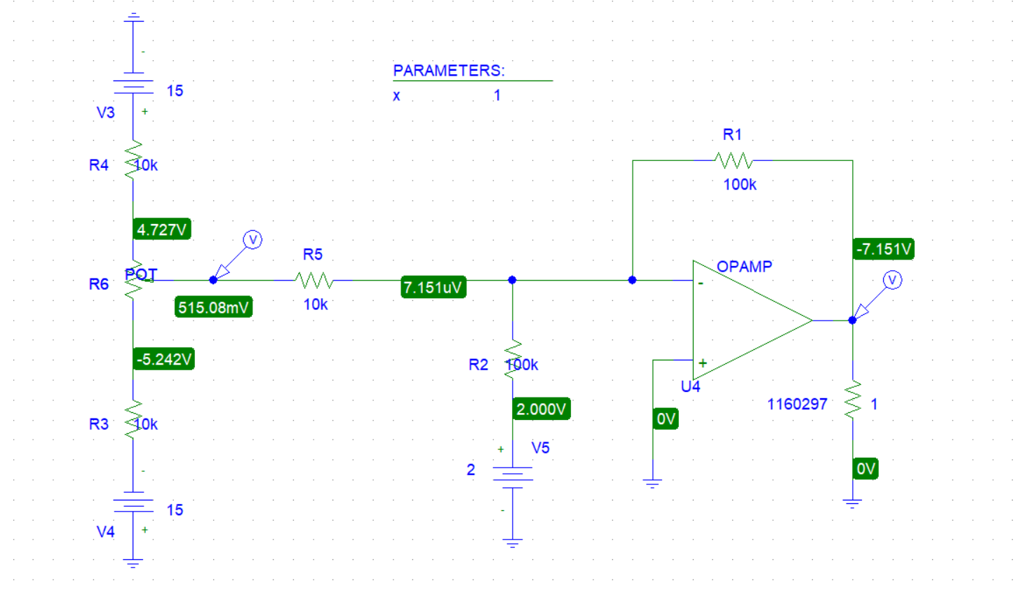

|  |  |  |  |
| --- | --- | --- | --- |
| **Input voltage** | | **Out** | **put voltage** |
| **V1** | **V2** | **VO** | **Calculated voltage** |
| **0.5** | **2** | -7.151 | -7 |
| **0.1** | **6** | -7.086 | -7 |
| **0.3** | **4** | -7.2 | -7 |
| **-0.9** | **2** | 7.09 | 7 |
| **-1.1** | **4** | 7.164 | 7 |
| **-1.5** | **6** | 9.021 | 9 |

**Part 2: Voltage Follower Application**

