* **DIODE CHARACTERISTICS:**

1. By building the first circuit that are shown below we get the required value :

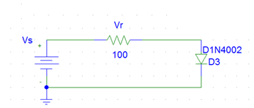

* The value of Vs was changed as what is requiring . The value of Vr and ID was recorded for each value f Vs:

|  |  |  |  |
| --- | --- | --- | --- |
| **VS** | **VR** | **VD** | **ID** |
| 0 | 24.68e-24V | 99.99mV | 0 |
| 0.1 | 8.5uV | 99.99mV | 85.47nA |
| 0.2 | 68.4uV | 199.93mV | 684.15nA |
| 0.3 | 484.3uV | 299.52mV | 4.84uA |
| 0.4 | 3.2mV | 396.77mV | 32.27uA |
| 0.5 | 17.2mV | 482.74mV | 172.58uA |
| 0.6 | 56.3mV | 531.85mV | 564.59uA |
| 0.7 | 118.4mV | 598.32mV | 1.384mA |
| 0.8 | 193.23mV | 606.72mV | 1.933mA |
| 0.9 | 275.1mV | 606.72mV | 2.751mA |
| 1 | 361.158mV | 638.48mV | 3.612mA |
| 1.5 | 819mV | 681mV | 8.190mA |
| 2 | 1.30V | 704.68mV | 12.95mA |
| 2.5 | 1.780V | 721.12mV | 17.79mA |
| 3 | 2.267V | 733.71mV | 22.66mA |

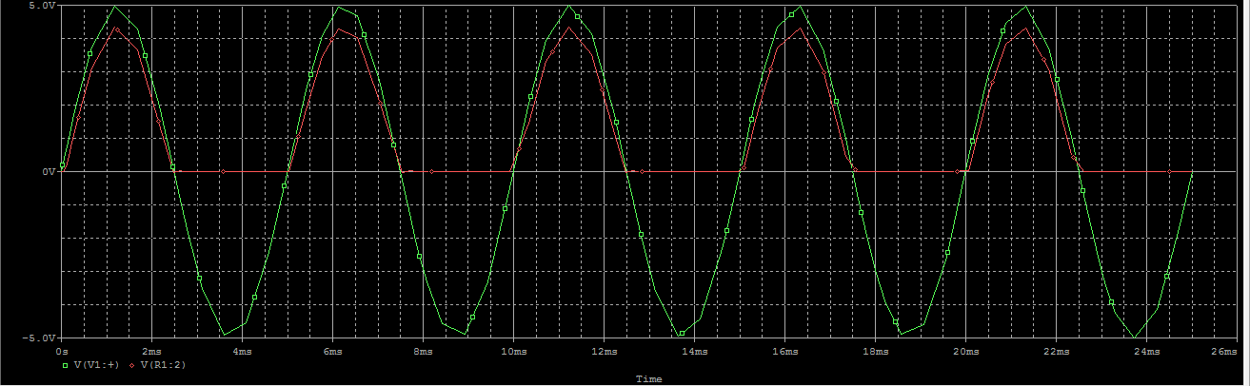

- The graph of ID versus VD :

* **RECTIFICATION :**

Building the shown circuit :

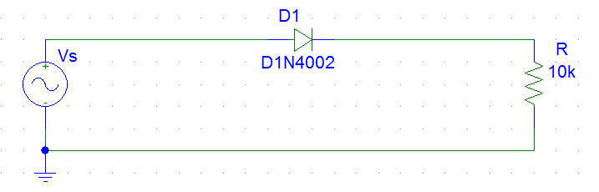

* The output voltage as shown in the figure :



.*We notice when the Vinp is Positive then Diode is ON (forward)

But when Vinp is Negative then Diode is OFF ( Reverse Bias ,Vout =0 ) .

The next graph shows this case with Vin and Vout togather:



* Is Vpk nearly equal to the peak voltage of the supply?

Yes they are nearly equalled since the supply voltage is 5 V and Vpk is 4.3 ( clear from the graph)

* Why will Vpk not be exactly equal to the source peak voltage ?

Because of the Voltage of the Resistor And there is a voltage drop of 0.7V caused by the

PN junction in the diode.

* How much will it differ?

Difference is equal to the value of Circuit Current Multiply By R .(by 0.7 volts for Silicon Diode).

* How could you obtain a negative voltage relative to zero?

Change the direction of the diode .The Positive side on Sin wave gives a Reverse Bais then we only get negative voltage .

Fullwave rectification :

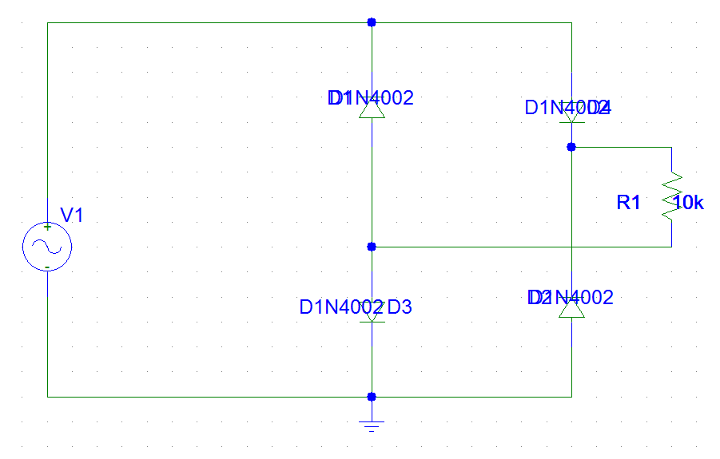

The output waveform is:

* **Rectification with filter Capacitor :**

Building the shown circuit to get the input and output voltages graphs:

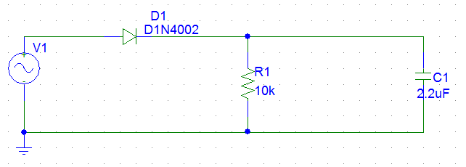

* Graphs of the input and output voltages:



*We note that the output voltage as long as Vin > Vc the diode is on and the capacitor is charging ,then as the Vin become less than Vc the diode will turn off and the capacitor will start discharging and so on .

**The Ripple factor:**

r = $\frac{RMSvalueofRippleVoltage}{AvgValueofOutputSignal}$

$$RMSValue= \frac{PeaktoPeakvalue}{2 \sqrt{3}}=\frac{V_{lrPk-Pk}}{2 \sqrt{3}}$$

$AvgValueofOutputSignal =$ VLDC = Vm – 0.5 $V_{lrPk-Pk}$

$V_{lrPk-Pk}= \frac{Vm}{f_{0}RC}= \frac{5}{200*2.2*{10}^{-6}*10000}$ = 1.136 V

$r= \frac{\frac{V_{lrPk-Pk}}{2 \sqrt{3}}}{Vm-0.5V_{lrPk-Pk}}= \frac{1}{\sqrt{3}\left(2f_{0}Rc-1 \right)}$ = 0.0740 = 74 * 10 -3

* By changing the value of the capacitor to 47uF we redraw the graphs of the output and input voltages :



Substitute C with 47uF to find the ripple factor :

$r= \frac{1}{\sqrt{3}\left(2f_{0}Rc-1 \right)}$ =3.07* 10-3

* Is the ripple now less than or more than it was with the larger value of the capacitor?

The Ripple Decreased , the value of the Ripple factor also decreased .

* Is the mean rectified voltage now greater or less?.

Less than the previous one .

* Does the ripple voltage change with frequency?

Then Ripple Factor Depends on $V_{lrPk-Pk}$ which depends on frequency so yes.

* If the input frequency is low, do you need a larger or a smaller capacitor to achieve the same smoothing as when the frequency is higher?

We need a larger C .

* **Other Applications:**

1. **Clipping Circuits:**

Building the following circuit: 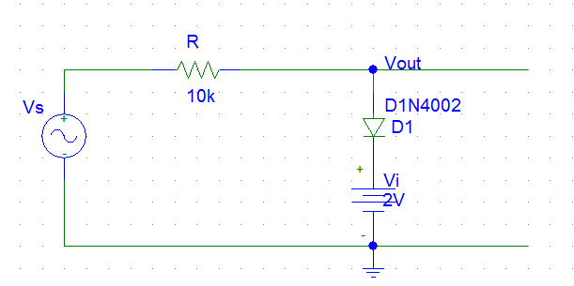

The output graph (shows input and output voltages:



**Theoretically to find how the diode acts using KVL :**

- Vin +2 + 0.7 – IR =0

IR = Vin -2.7

I = Vin -2.7 /R > 0

Vin -2.7 > 0

Vin > 2.7

When Vin > 2.7 Diode is ON And Vout = 2.7

When Vin <2.7 Diode is OFF And Vout = Vin

**Theoretically to find how the diode acts (reversed) using KVL :**

-Vin +2 -.7 –IR =0

IR = - Vin + 1.3

I = - Vin + 1.3 / R > 0

- Vin + 1.3 > 0

Vin < 1.3

When Vin < 1.3 Diode is ON And Vout = 1.3

When Vin > 1.3 Diode is OFF And Vout = Vin

* What difference is there between the input and output wave?

The output voltage clamped at different value .

* At what voltage is the output wave form chopped off?

At 2.7 and 1.3 Volts

* If the dc is 2V, at what voltage are the positive peaks chopped off?

They will be chopped of at 2.7 and 1.3 Volts as shown up .

* If the ac is 10V p-p, does the clipping voltage change? No.
* What is the relationship between the clipped level and the dc voltage?

The chopping level equal to the dc voltage applied to the circuit minus 0.7 which is

The voltage of the diode

1. **Clamping Circuits:**

**A . Building the following circuit:**

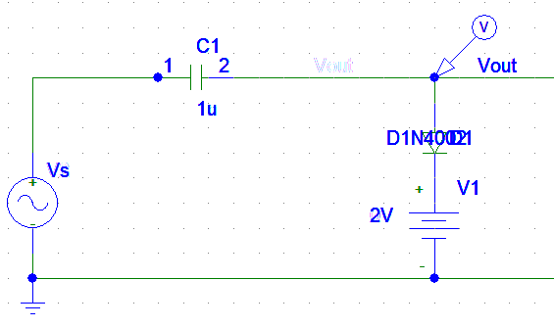



*We notice when Vin > 0 then diode and capacitor charges to the value of Vin – Vdc = 3 -2 =3 volt and Vout = Vdc =2 Volt but when Vin < 0 Diode is OFF and Vout = Vin + Vc = 3+1=4 Volt.

- **Note** : the Vp-p value shown in the graph has a different value from the calculated and assumed ones only for the purpose of obviousness in the graph.

* Does the output wave form alternate about the same dc level as the input waveform?

No , there may be DC source such that the output depends on it beside the biasing of the Diode.

* To what value is the positive peak of the output waveform clamped, if the ac input signal is 5VPK?

when Vin > 0 then diode and capacitor charges to the value of Vin – Vdc = 5 -2 =3 volt and Vout = Vdc =2 Volt but when Vin < 0 Diode is OFF and Vout = Vin + Vc = 5+3=8 Volt

* Does the positive peak still stay clamped to the same level?

No it is clamped upwards or downwards

* Can you see any relation between the reference voltage setting and the clamping level?

Yes , the Clamping Level = Vdc + Vc

1. **Voltage Multiplier:**

Constructing the following circuit:

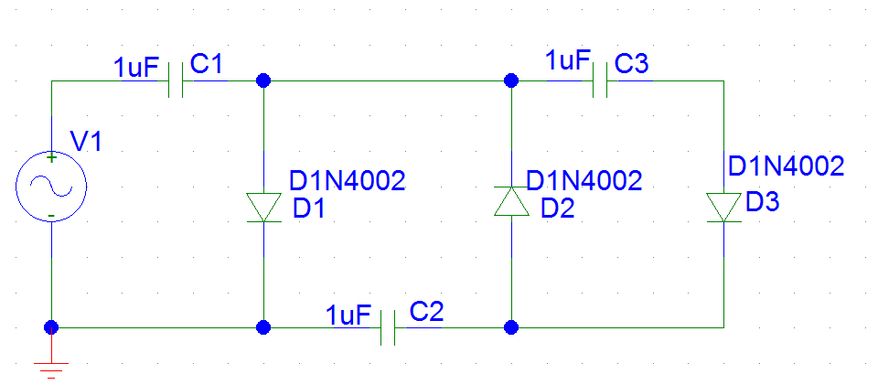

We got the following graphs for at the different capacitors :

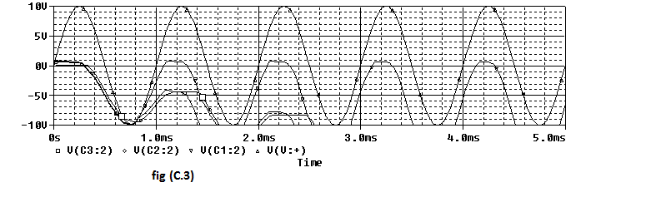

* Is the output voltage between a,b twice the input voltage?

**Yes**

* Is the output voltage between c,d three times the input voltage

**Yes**

* What is the peak inverse voltage across each diode?

**6 volt**