* **THE CLASSES OF POWER AMPLIFIER.**

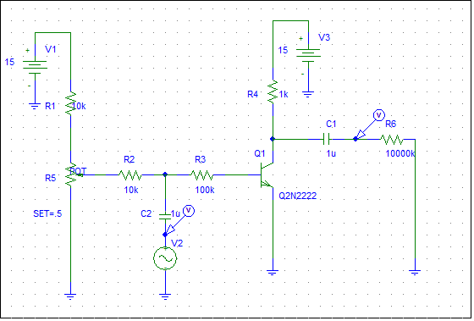

Fig (1)

At first, we set the input to 10V peak when the set point was 1 , the output shown in Figure-2-:

Fig (2)

By applying 2 v peak on the input and the set to 0.5 (CLASS B 180 out of phase) as shown in fig (3):



Fig (3)

By applying 6 v peak on the input and the set to 0.005we can show fig (4):



Fig (4)

By applying 14 v peak on the input and the set to 0.3 we get the fig (5) :



Fig (5)

* **PUSH-PULL AMPLIFIER.**

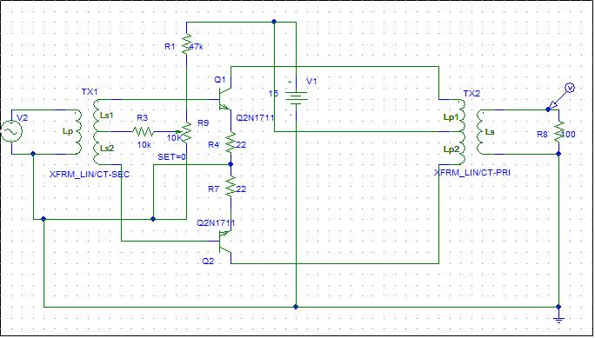

Fig (6)

the potentiometer was short circuit, when the input was 4Vp-p and 1KHz the output appeared with distortion as shown in fig (7) :

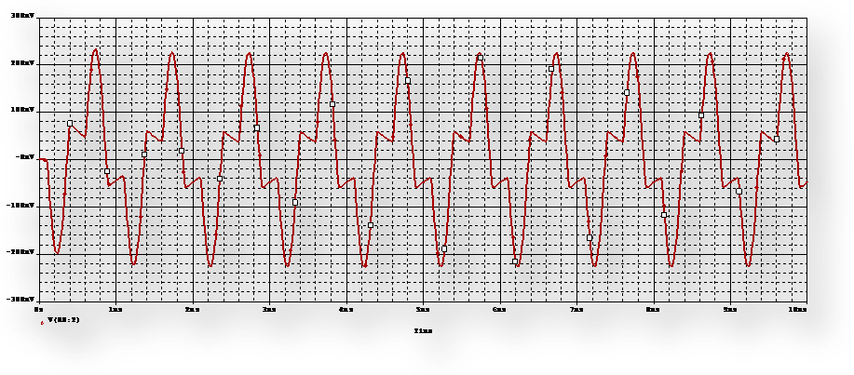

Fig (7)

When the input was 0.5 Vp-p and 1KHz the output disappears as shown in fig (8) :

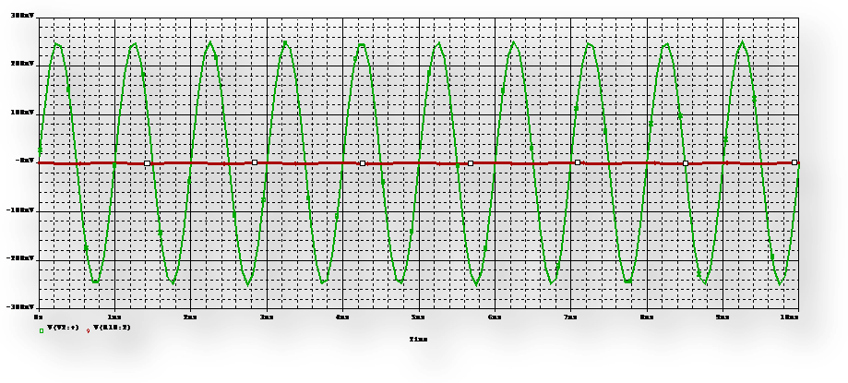

Fig (8)

We change the set point of the potentiometer until the distortion disappears; the set point at that time was 0.6:

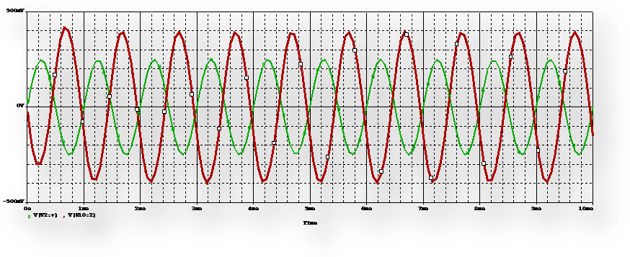

Fig (9)

To having an output of 4Vp-p, the input was set to be 29Vp-p:

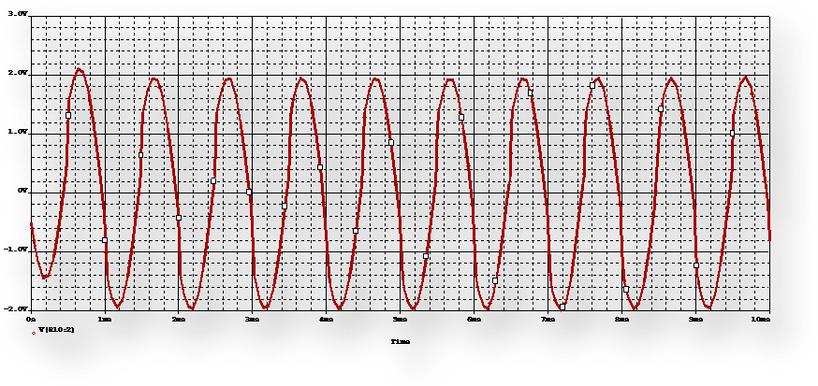

Fig (10)

The output peak-to-peak voltage for different values of RL recorded in table (1)

|  |  |  |  |
| --- | --- | --- | --- |
| **Load**  **Resistor**  **(Ω)** | **Output Voltage**  **(volts)** | | **Output**  **Power**  **(mW)** |
| **Peak-to-peak** | **RMS** |
| **320** | 6.67 | 2.36 | 17.41 |
| **220** | 5.31 | 1.88 | 16.07 |
| **150** | 4.27 | 1.51 | 15.20 |
| **100** | 2.21 | 0.78 | 6.08 |
| **69** | 2.00 | 0.71 | 7.31 |
| **50** | 1.28 | 0.46 | 4.23 |
| **41** | 1.12 | 0.39 | 3.71 |

Table (1)



**Faculty of Engineering and Technology**

ELECTRONICS LAB ENEE3102

Dr . Nasser Ismai

ــــــــــــــــــــــــــــــــــــــــــــــــــــــــــــــــــــــــــــــــــــــــــــــــــــــــــــــــــــــــــــــــــــــــــــــــــــــــــــــــــــــــــــــــــ

***Prelab #6***

***Dana Abu Hussein 1131657***