

Faculty of Engineering and Technology

Electrical and Computer Engineering Department

Electronics LAB (ENEE3102)

Pre-LAB of the Project

**________________________________________________________**

Prepared by:

Name: Sara Totah Number: 1181779

Instructor:

Mohammad Jehad Al Ju'Beh

Date:

12/12/2020

Section: #1

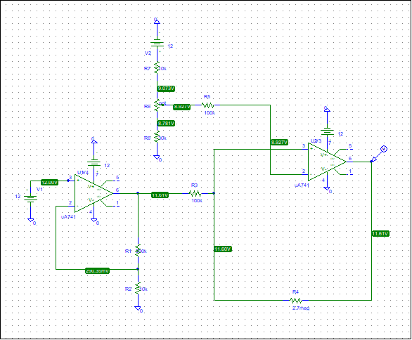

Figure 1: Circuit design

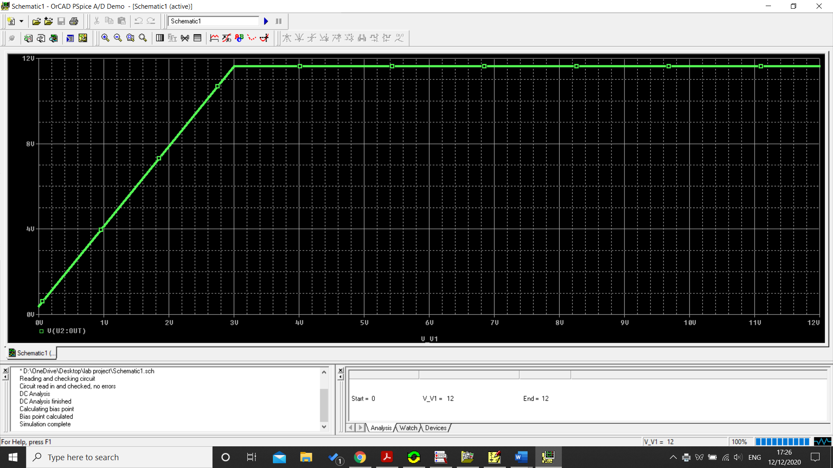

Figure 2: Simulation