

**Faculty of Engineering and Technology Electrical and Computer Engineering Department**

ENEE3102

ELECTRONICS LAB

**Experement {12}**

**Project**

**{ Pre lab }**

**Student Name:** Juomah Bader.

**Student ID : #1162462.**

**Instructor:** Dr.Mohammad Jehad Al Ju’Beh.

**Section : {1}**

**Date : 27/11/2019.**

The Project : Room Thermostat

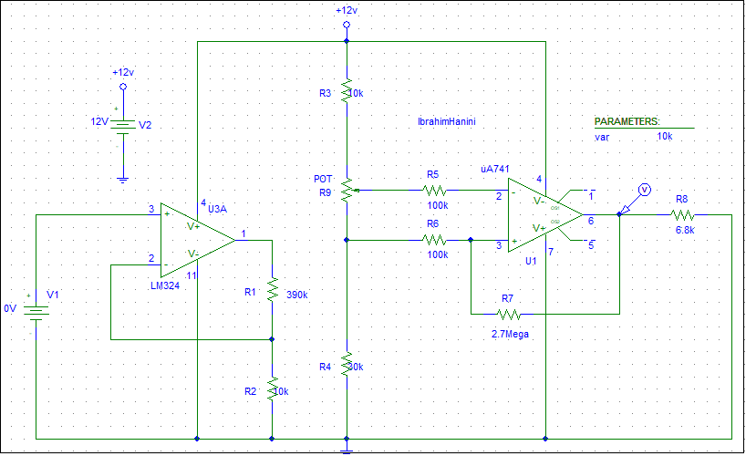

Juomah

1162462

**Figure {1} the simulation circuit for the project**

**The temperature sensor is replaced by a DC battery and changed it from DC sweep from {0 to 1V} with 0.1step.**



**Figure {2} the output from the non inverting {LM324} amp in the circuit in figure {1}**



**Figure {3} the output from the Schmitt trigger {uA741} amp in the circuit in figure {1}**



**Figure {3} the output from the Schmitt trigger {uA741} amp in the circuit in figure {1} after change the potentialmeter**