

Faculty of Engineering and Technology

Electrical Engineering Department

ــــــــــــــــــــــــــــــــــــــــــــــــــــــــــــــــــــــــــــــــــــــــــــــــــــــــــــــــــــــــــــــــــــــــــــــ

ELECTRONIC LAB

Pre Lab

Experiment#12

project

**Student’s Name: Jana Al-Zeer**

**Student’s No : 1161228**

**Instructors :Dr.** Mohammad Ju’beh

Eng.Qassam Barghouthi

**Section : 2**

*Circuit:*

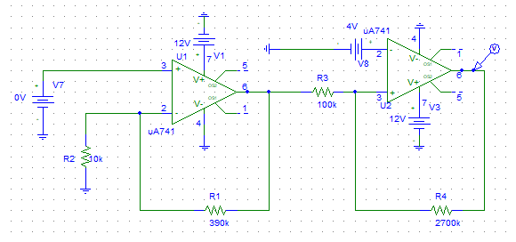

*output from Schmitt trigger :*

