

Faculty of Engineering and Technology

Electrical and Computer Engineering Department

**ENEE 3102 – Electronics Lab**

Pre-lab for Experiment No.11

**PROJECT**

Prepared By:

Name: Suhaeb Qadan Number: 1160297

Instructor: Dr. Mohammad Al Jubeh

TA: Eng. Almo`tassem Billah

Date: 27/11/2019

Sec#: 1

The following circuit shown below was connected using PSPICE simulation

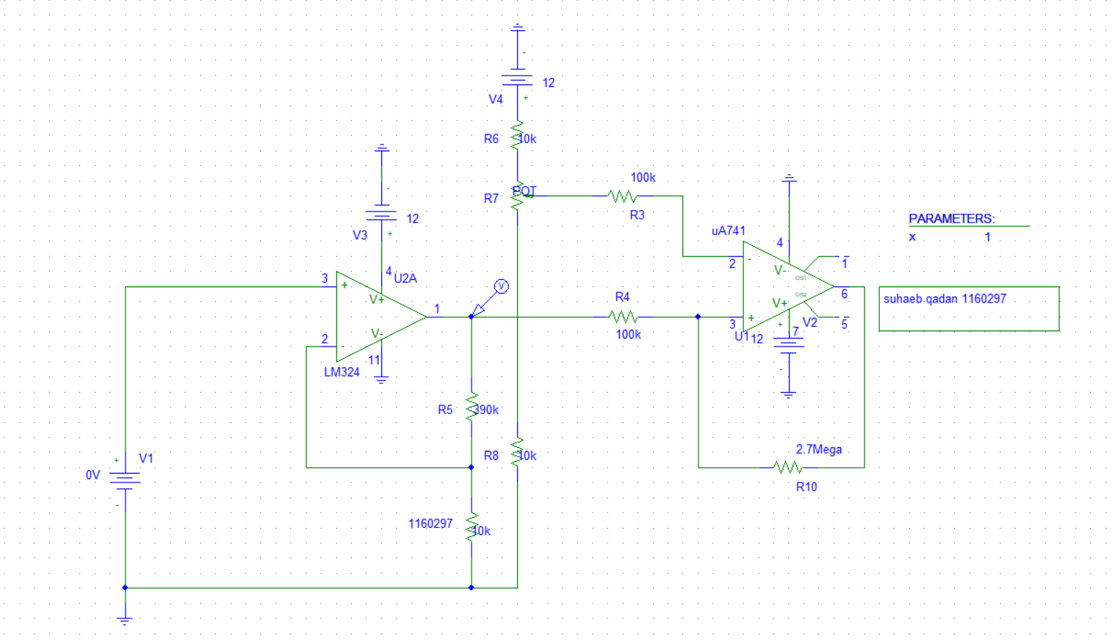

Figure : Circuit of project experiment

The output from the non-inverting amplifier is shown below



Figure : The output simulation from the non-inverting amplifier

The output from the Schmitt trigger is shown below



Figure : The output from the second stage