

**Faculty of Engineering and Technology Electrical and Computer Engineering Department Circuit’s**

**lab (ENEE3102)**

**Experiment no.10**

**Zener Diodes and Voltage Regulators**

**Student Name:** **Anas Manasrah**

**Student Number:**  **1152701**

**Section:** **(1)(** **Tuesday)**

**Date: 15/ 12/ 2017**

**Instructor: Dr .** [Mohammad Jehad Al Ju'Beh](https://ritaj.birzeit.edu/bzu-msgs/type?mttid=104&classid=119986)

***Abstract:***

The aim of the experiment :

We learn about the I-V characteristic of a zener diode .Also , We notice the operation of the voltage-regulated power supply. In addition , We learn the use of zener diode as voltage-regulator.

Equipment we used :

1.Zener diodes.

2.Wires.

3.Risesters .

4.DC voltage.

5.Transistors.

6.OP _Amp.

7.Voltage Regulater .

***Theory :***

The forward characteristic of the curve we have previously described above in the DIODE section. It is the reverse characteristics we will discuss here.

Notice that as the reverse voltage is increased the leakage current remains essentially constant until the breakdown voltage is reached where the current increases dramatically. This breakdown voltage is the zener voltage for zener diodes. While for the conventional rectifier or diode it is imperative to operate below this voltage; the zener diode is intended to operate at that voltage, and so finds its greatest application as a voltage regulator.

The basic parameters of a zener diode are:

a. Obviously, the zener voltage must be specified. The most common range of zener voltage is a 3.3 volts to 75 volts, however voltages out of this range are available.

b. A tolerance of the specified voltage must be stated. While the most popular tolerances are 5% and 10%, more precision tolerances as low as 0.05 % are available. A test current (Iz) must be specified with the voltage and tolerance.

c. The power handling capability must be specified for the zener diode. Popular power ranges are 1/4, 1/2, 1, 5, 10, and 50 Watts.

**Regulated Power Supply:**

A regulated power supply is where by some means the output voltage is maintained or regulated within certain pre-defined limits.

To regulate small amounts of current the cheapest approach is to use a zener diode (as in steps 9 to 11). Higher currents can be obtained from higher power zeners but we prefer to use dedicated I.C.'s in these cases. In one instance you can use a zener diode in conjunction with a pass transistor to extend the range of the zener regulator.

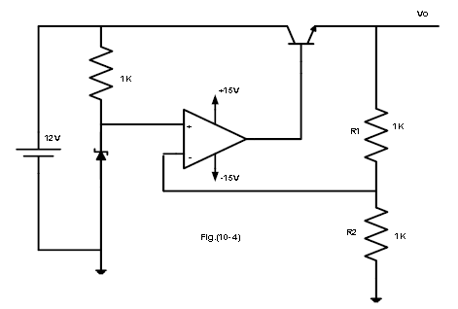

The voltage-regulator shown above, works as follows:

VL = ( 1 + R1/R2 ) * Vz ; this is in the condition that VL < Vi ;

When the load is changed to lower resistance,

* VL ↓ ⇒ V(-) ↓ ⇒ Vd = V(+) - V(-) ↑ ⇒ Vop = Ad*Vd ↑ ⇒ VB ↑ ⇒ IC ≈ IL ↑ ⇒ VL↑.

And so the output voltage stays approximately constant.

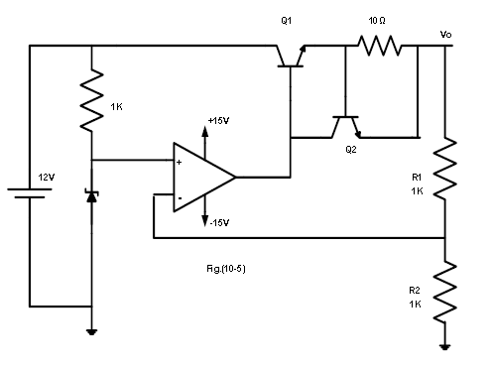

The other type of voltage-regulator shown works as the first one, but it has a protection for the load, i.e., it supplies the load with maximum current that doesn’t exceed. In the normal range it is designed to work with the second transistor in the cut off and it works as the above voltage regulator. But when more current it taken to the load the voltage across the base-emitter junction is increased, until it get ≈ 0.7V, then the second transistor works and no more increase in the current.

Imax = 0.7/ Rsc.

Procedures & Calculations :

***I.ZENER DIODE.***

*1. WE connect the circuit shown in Fig (10-1).*

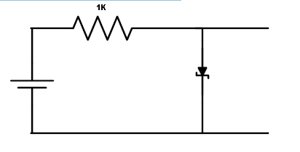

2. We Set the applied voltage E to (0.1, 0.2, 0.3, 0.4, 0.5, 0.6, 0.7, 0.8, 0.9, 1,2,3,4)V.

3. For each value of E

We measure the voltage a cross the resistor, the forward current through the zener diode, and the voltage a cross the zener diode and fill as in table 10.1

|  |  |  |  |
| --- | --- | --- | --- |
| **E(V)** | **VR(V)** | **VZ(V)** | **I (m A)** |
| **0.1** | 2.80m | 0.100 | 2.00u |
| **0.2** | 7.43m | 0.200 | 6.50u |
| **0.3** | 35.26m | 0.300 | 36.40u |
| **0.4** | 102.02m | 0.400 | 100.50u |
| **0.5** | 0.19 | 0.495 | 0.18 |
| **0.6** | 0.26 | 0.579 | 0.25 |
| **0.7** | 0.35 | 0.641 | 0.36 |
| **0.8** | 0.43 | 0.665 | 0.42 |
| **0.9** | 0.54 | 0.680 | 0.54 |
| **1** | 0.62 | 0.690 | 0.63 |
| **2** | 1.61 | 0.740 | 1.59 |
| **3** | 2.52 | 0.765 | 2.60 |
| **4** | 3.41 | 0.784 | 3.50 |

Table 10.1

4. We Connect the circuit shown in Fig(10-2).

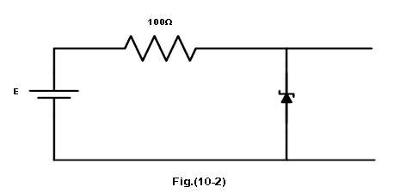

5.We Set the applied voltage E to values shown in table 10.2.

6. For each value of E,We measure the voltage across the zener diode and the current through the zener diode.

|  |  |  |
| --- | --- | --- |
| **E(V)** | **VZ(V)** | **I (m A)** |
| **0.1** | 0.10 | 0u |
| **0.5** | 0.50 | 0.01u |
| **1** | 1.00 | 0.60u |
| **2** | 1.90 | 1.10 |
| **3** | 2.40 | 6.30 |
| **4** | 2.70 | 13.70 |
| **5** | 2.90 | 21.20 |
| **6** | 3.00 | 30.20 |
| **7** | 3.10 | 39.80 |
| **8** | 3.20 | 48.80 |
| **9** | 3.30 | 57.40 |
| **10** | 3.39 | 67.30 |
| **11** | 3.44 | 76.40 |
| **12** | 3.54 | 85.20 |
| **13** | 3.56 | 94.50 |
| **14** | 3.59 | 104.70 |
| **15** | 3.62 | 113.90 |

Table 10.2

7. Using the results obtained in steps 3 and 6 constitute a graph of the characteristic of the zener diode.

8. We Connect the circuit shown in Fig (10-3).

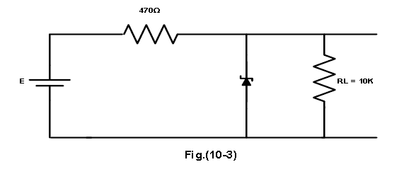

9. We Set E to (10,11,12,13,14)V.

10. We Measure the load voltage VL and Fill table 10.3

|  |  |  |  |  |  |
| --- | --- | --- | --- | --- | --- |
| E | 10 | 11 | 12 | 13 | 14 |
| VL | 2.70 | 2.75 | 2.79 | 2.83 | 2.87 |

Table 10.3

11. With E set to 10V . We measure the load voltage VL for RL=(8.2K,6.8K,4.7K,2.2K).

|  |  |  |  |  |
| --- | --- | --- | --- | --- |
| RL | 8.2k | 6.8k | 4.7 k | 2.2k |
| VL | 2.73 | 2.73 | 2.72 | 2.71 |

Table 10.4

***II. THE VOLTAGE REGULATED POWER SUPPLY.***

1. connect the circuit of Fig.(10-4).

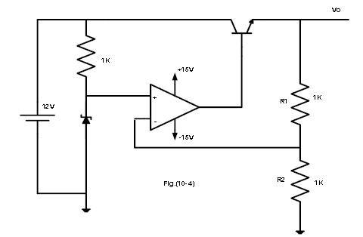

2. We measure Vo.

3. Attach a 1k load resistor to the output. We measure Io and Vo.

4. Repeat step 3 for load resistance RL = (680 , 470 , 220 , 100) ohm and fill Table

|  |  |  |  |  |  |  |
| --- | --- | --- | --- | --- | --- | --- |
| RL | open | 1k** | 680 ** | 470 ** | 220 ** | 100 ** |
| Vo | 5.0 | 5.03 | 5.04 | 5.04 | 5.04 | 5.01 |
| Io | 0.0 | 4.97m | 7.29m | 10.48m | 22.60m | 49.30m |

5. We Set RL back to 1K .Change the value of R2 to 470 ohm. The output voltage is 5.04 V.

6. Change R2 to 2.2k. The output voltage is 3.64V.

7. Connect the circuit shown in Fig.(10-5).

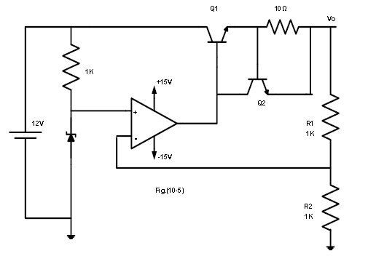

8. We measure Vo.

9. We Repeat steps 3 and 4 . and record your results .

|  |  |  |  |  |  |  |  |
| --- | --- | --- | --- | --- | --- | --- | --- |
| RL | open | 1k** | 680 ** | 470 ** | 220 ** | 100 ** | 50 ** |
| Vo | 5.01 | 5.02 | 5.03 | 5.02 | 5.00 | 5.00 | 5.00 |
| Io | 0.0 | 4.9m | 7.3m | 10.6m | 22.4m | 48.5m | 96.0m |

***II. THREE TERMINAL FIXED VOLTAGE REGULATOR 7805.***

1. We Connect the circuit of Fig (10.6).

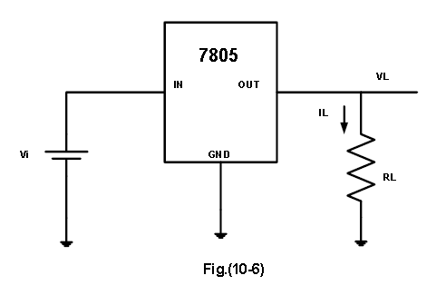

1. With Vi=10V . We measure IL and VL for the load resistances listed in the table 10.2.

|  |  |  |
| --- | --- | --- |
| **RL(Ω)** | **VL(V)** | **I L(m A)** |
| **25** | 0.78 | 19.56 |
| **50** | 0.70 | 11.50 |
| **100** | 0.72 | 6.68 |
| **200** | 1.43 | 6.89 |
| **400** | 2.57 | 6.24 |
| **600** | 3.25 | 5.30 |
| **800** | 3.74 | 4.61 |
| **1000** | 4.18 | 4.13 |

1. Table 10.2.
2. 3. Using the results of table 10.2 , We determine the load regulation of the 7805.knowing that

load regulation = ΔVL /Δ IL =2.171/8.948=242.6

1. 4. Set RL=100 ohm , adjust the input voltage Vi as listed in table 10.3. We measure VL and IL for each input voltage in the table.

|  |  |  |
| --- | --- | --- |
| **Vi(V)** | **VL(V)** | **I L(m A)** |
| **8** | 0.78 | 8.18 |
| **9** | 0.70 | 6.71 |
| **10** | 0.72 | 6.49 |
| **11** | 0.72 | 6.50 |
| **12** | 0.72 | 6.54 |
| **13** | 0.73 | 6.59 |
| **14** | 0.73 | 6.66 |
| **15** | 0.74 | 6.72 |

Table 10.3

Using the results of table 11.3 , determine the line regulation of the 7805 .knowing that

line regulation = ΔVL/ΔVi=0.75/11.5=0.0652

***III. THE LM317 ADJUSTABLE VOLTAGE REGULATOR.***

1. Connect the circuit of Fig.(10.7).

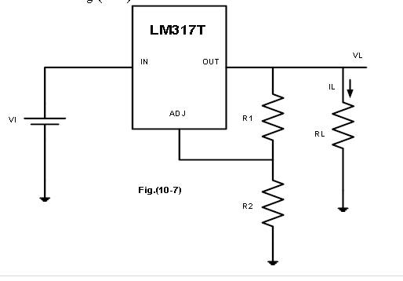

2. With Vi=10V, R1=100Ω, RL=1k , adjust R2 as shown in table 10.4.

|  |  |  |
| --- | --- | --- |
| **R2(Ω)** | **VL(V)** | **I L(m A)** |
| **0** | 1.26 | 1.0 |
| **100** | 2.52 | 2.4 |
| **200** | 3.79 | 3.6 |
| **300** | 5.06 | 4.0 |
| **500** | 7.99 | 7.3 |
| **700** | 8.57 | 8.3 |

Table 10.4

3. We measure and record VL,IL for each R value.

4. With RL =1k , R1=100 ohm , R2=220 , adjust Vi as listed in table 10.5.

|  |  |  |
| --- | --- | --- |
| **Vi(V)** | **VL(V)** | **I L(m A)** |
| **10** | 4.01 | 3.91 |
| **12** | 4.01 | 3.91 |
| **14** | 4.01 | 3.91 |
| **15** | 4.01 | 3.91 |
| **16** | 4.01 | 3.91 |
| **17** | 4.01 | 3.91 |

Table 10.5

5. We measure and record the load voltage and current for each input voltage value.

6. Using your results, calculate the line regulation for the LM317T voltage regulator.

line regulation = ΔVL/ΔVi=4.01/14=0.2864 .

1. With Vi=10V, R1=100 0hm , R2=220 , adjust RL as shown in table 10.6.
2. We measure and record VL,IL for each RL value.

|  |  |  |
| --- | --- | --- |
| **RL(Ω)** | **VL(V)** | **I L(m A)** |
| **100** | 4.02 | 40.00 |
| **200** | 4.02 | 19.90 |
| **400** | 4.01 | 9.90 |
| **500** | 4.01 | 8.00 |
| **600** | 4.01 | 6.61 |
| **700** | 4.01 | 5.70 |
| **1000** | 4.01 | 3.90 |

Table 10.6

**Conclusion:**

The zener diode works as a normal diode in the forward bias and the reverse-bias, as long as the voltage across it doesn’t reach the breakdown voltage in the reverse-bias. When it is reached the voltage stays approximately the same while the current increases so fast.Also ,The zener diode can be used as a simple voltage regulator, as seen in steps 8 to 11. The voltage remains approximately constant in spit of the load is changed.

The first voltage-regulator has approximately constant output voltage, although the output current is changed, i.e., the load is changed.

In the second voltage-regulator the voltage in the first was constant, then the output voltage began to drop as the load has lower resistance, i.e., more current is supplied (has a max current the can’t be exceeded).

**GOOD LOOK**

