

Faculty of Engineering and Technology

Electrical and Computer Engineering Department

Electronics Laboratory (ENEE3102)

**Report of Experiment 10**

**“ Zenor diode, Voltage Regulator”**

Prepared by:

Name: Jana Al-Zeer Number:1161228

Partners:

Name: Tuqa Remawi Number: 1160899

Name: Hanen Zahran Number:1162549

Instructor: Mohammad Ju’beh TA: Eng.Qassam

Section: 2

Date: 22 / 7 / 2019

***Abstract:***

The goal of this experiment is to deal with the Zener diode, To demonstrate the use of zener diode as voltage regulator and to construct the I.V characteristic of a zener diode. Also, to notice the operation of the voltage-regulated power supply, fixed and adjustable IC regulators.

***Table of Contents***

1. Theory..................................................................................................................... 1

2. Procedure ,data and calculation ............................................................................... 5

3. Conclusion............................................................................................................... 14

4. References: ............................................................................................................. 15

***Table of figures:***

1. Figure (1.1) ..................................................................................................................1

2. Figure (1.2)...................................................................................................................1

3. Figure (1.3).................................................................................................................. 2

4. Figure (1.4):................................................................................................................. 2

5. Figure (1.5): .................................................................................................................3

6. Figure (1.6): ................................................................................................................ 3

7. Figure (1.7): ................................................................................................................ 4

8. Figure (2.1): .................................................................................................................5

9. Figure (2.2): .................................................................................................................6 10.Figure (2.3): ................................................................................................................ 7

11.Figure (2.4): .................................................................................................................7

12.Figure (2.5): ................................................................................................................ 8

13.Figure (2.6): ................................................................................................................ 9

14.Figure (2.7): ................................................................................................................ 10

15.Figure (2.8): ................................................................................................................ 11

***Table of tables:***

1. Table(1) ...................................................................................................................... 5

2. Table(2)....................................................................................................................... 6

3. Table(3):...................................................................................................................... 7

4. Table(4):...................................................................................................................... 8

5. Table(5):...................................................................................................................... 8

6. Table(6):...................................................................................................................... 9

7. Table(7):...................................................................................................................... 10

8. Table(8):...................................................................................................................... 11

9. Table(9):...................................................................................................................... 12

10. Table(10):...................................................................................................................12

11. Table(11):.................................................................................................................. 13

***Theory:***

***I.ZENER DIODE:***

A Zener diode is a type of [diode](https://en.wikipedia.org/wiki/Diode) that allows current to flow not only from its anode to its cathode, but also in the reverse direction, when the Zener voltage is reached.

[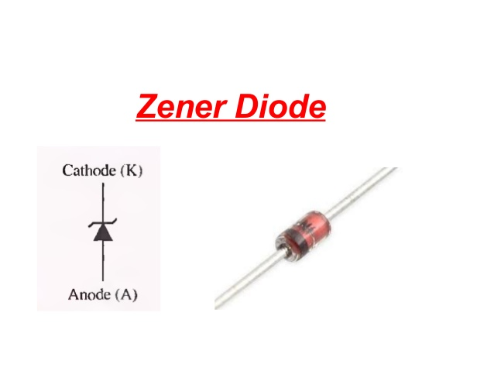](https://www.slideshare.net/touqeerjumani/zener-diodes)

**Fig.(1.1)” Zener diode and the symbol of it”**

 Zener Breakdown is observed in the Zener diodes having Vz less than 5V or between 5 to 8 volts. When  a reverse voltage is applied  to a Zener diode, it causes a very intense electric field to appear across a narrow depletion region. Such an intense electric field is strong enough to pull some of the valence electrons into the conduction band by breaking their covalent bonds .these electrons then become free electrons which are available for conduction.  A large number of such free electrons will constitute a large reverse current through the Zener diode and breakdown is said to have occurred due to the Zener effect.

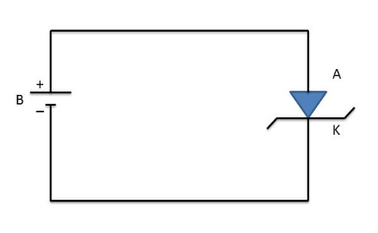

**Fig.(1.2)”forward bias of Zener diode”**

1

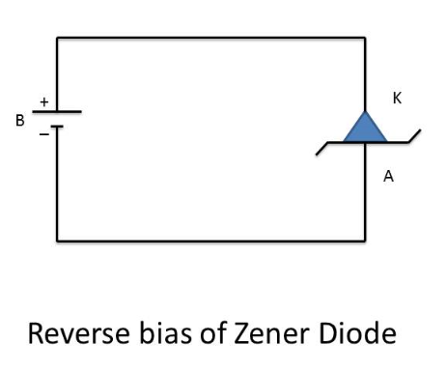

**Fig.(1.3)”reverse bias of zener diode”**

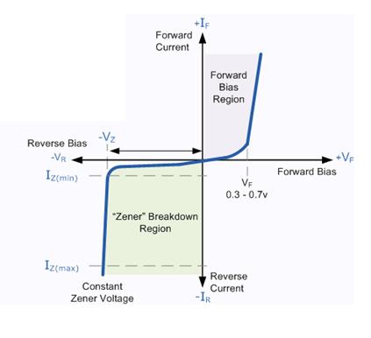

**Fig.(1.4)”Characteristics of Zener diode”**

***II. THE VOLTAGE REGULATED POWER SUPPLY.***

a linear regulator is a system used to maintain a steady voltage. The resistance of the regulator varies in accordance with the load resulting in a constant voltage output. The regulating device is made to act like a variable [resistor](https://en.wikipedia.org/wiki/Resistor), continuously adjusting a [voltage divider](https://en.wikipedia.org/wiki/Voltage_divider) network to maintain a constant output voltage and continually dissipating the difference between the input and regulated voltages as [waste heat](https://en.wikipedia.org/wiki/Waste_heat). By contrast, a [switching regulator](https://en.wikipedia.org/wiki/Switching_regulator) uses an active device that switches on and off to maintain an average value of output. Because the regulated voltage of a linear regulator must always be lower than input voltage, efficiency is limited and the input voltage must be high enough to always allow the active device to drop some voltage.

2

Linear regulators may place the regulating device in parallel with the load ([shunt](https://en.wikipedia.org/wiki/Shunt_(electrical)) regulator) or may place the regulating device between the source and the regulated load (a series regulator). Simple linear regulators may only contain a [Zener diode](https://en.wikipedia.org/wiki/Zener_diode) and a series resistor

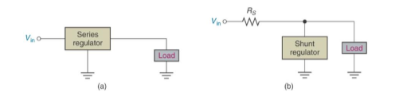

**Fig.(1.5)”(a) series regulator, (b) shunt regulator”**

***III. THREE TERMINAL FIXED VOLTAGE REGULATOR 7805***

A LM7805 Voltage Regulator is a voltage regulator that outputs +5 volts.

An easy way to remember the voltage output by a LM78XX series of voltage regulators is the last two digits of the number. A LM7805 ends with "05"; thus, it outputs 5 volts. The "78" part is just the convention that the chip makers use to denote the series of regulators that output positive voltage. The other series of regulators, the LM79XX, is the series that outputs negative voltage. So:

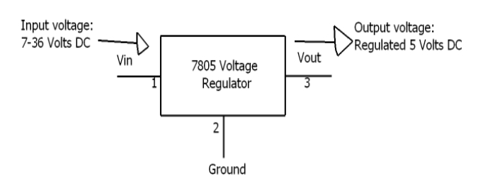

**Fig.(1.6):” Fixed voltage regulator 7805”**

**3**

***IV. THE LM317 ADJUSTABLE VOLTAGE REGULATOR.***

The LM317 is an example of an adjustable-voltage regulator, is a three terminal voltage regulator IC from National Semiconductors. The IC is capable of delivering up to 1A of output current. Input voltage can be up to 40V and output voltage can be adjusted from 1.2V to 37V.

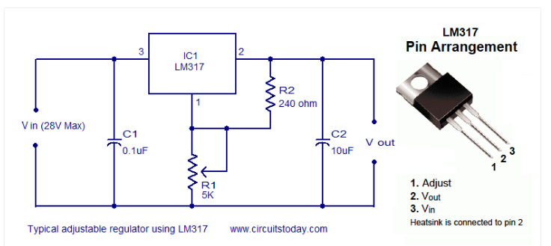

**Fig.(1.7):” Adjustable voltage regulator”**

**4**

***Procedure, data and calculation:***

***I.ZENER DIODE:***

* The circuit shown in Fig (2.1) was connected
* the applied voltage E was Set to (0.1, 0.2, 0.3, 0.4, 0.5, 0.6, 0.7, 0.8, 0.9, 1,2,3,4) V.
* For each value of E, the voltage a cross the resistor, the forward current through the Zener diode, and the voltage a cross the Zener diode were measured and filled in table (1).

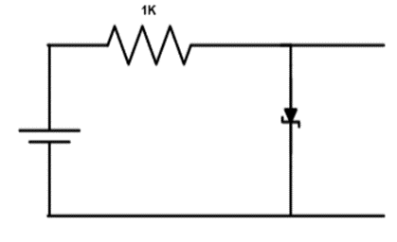

**Fig.(2.1)**

|  |  |  |  |
| --- | --- | --- | --- |
| **E(V)** | **VR(V)** | **VZ(V)** | **I(m A)** |
| **0.1** | **0** | **0.1** | **0** |
| **0.2** | **0** | **0.2** | **0** |
| **0.3** | **0** | **0.3** | **0** |
| **0.4** | **0** | **0.4** | **0** |
| **0.5** | **0.002** | **0.498** | **0.002** |
| **0.6** | **0.016** | **0.584** | **0.016** |
| **0.7** | **0.0643** | **0.6357** | **0.0643** |
| **0.8** | **0.1524** | **0.6476** | **0.1524** |
| **0.9** | **0.23** | **0.67** | **0.23** |
| **1** | **0.3276** | **0.6724** | **0.3276** |
| **2** | **1.29** | **0.71** | **1.29** |
| **3** | **2.247** | **0.753** | **2.247** |
| **4** | **3.244** | **0.756** | **3.244** |

**Table (1)**

**5**

* the circuit in figure (2.2) was connected.
* the applied voltage E was set to values shown in table (2) For each value of E.
* the voltage across the Zener diode and the current through the Zener diode were measured and filled in table (2).

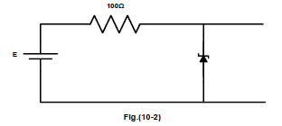

**Fig.(2.2)**

Note: In this part, we connected an incorrect resister which value 1KΩ and the result shown in table below.

|  |  |  |
| --- | --- | --- |
| **E(V)** | **VZ(V)** | **I(m A)** |
| **0.1** | 0.098 | 0 |
| **0.5** | 0.520 | 0 |
| **1** | 0.957 | 0.043 |
| **2** | 1.604 | 0.396 |
| **3** | 1.883 | 1.117 |
| **4** | 2.025 | 1.975 |
| **5** | 2.144 | 2.856 |
| **6** | 2.218 | 3.856 |
| **7** | 2.292 | 4.708 |
| **8** | 2.344 | 5.656 |
| **9** | 2.396 | 6.604 |
| **10** | 2.442 | 7.558 |
| **11** | 2.481 | 8.519 |
| **12** | 2.517 | 9.483 |
| **13** | 2.550 | 10.45 |
| **14** | 2.581 | 11.419 |
| **15** | 2.609 | 12.391 |

**Table(2)**

* Now using results in table 2 and 3 the graph of the characteristic of the Zener diode

**6**

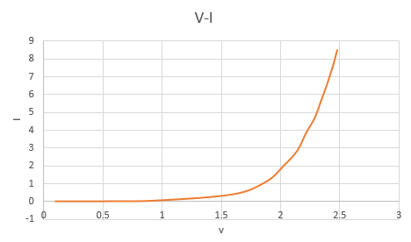

**Fig.(2.3**):” **Characteristics of Zener diode**”

* Now the circuit in figure (2.4) was connected E was set as in table 3 the load voltage measured and filled in table 3.

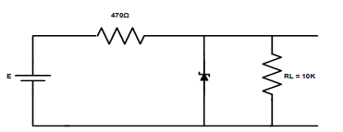

**Fig. (2.4)**

|  |  |  |  |  |  |
| --- | --- | --- | --- | --- | --- |
| 14 | 13 | 12 | 11 | 10 | E(V) |
| 2.840 | 2.805 | 2.764 | 2.725 | 2.682 | VL(V) |

**Table (3)**

**7**

* Then E set to 10v the load voltage for Rl changed as in Table 4

|  |  |  |  |  |
| --- | --- | --- | --- | --- |
| 2.2k | 4.7k | 6.8k | 8.2k | Rl |
| 2.661 | 2.676 | 2.680 | 2.685 | Vl(v) |

**Table (4)**

***II. THE VOLTAGE REGULATED POWER SUPPLY***

* The circuit in the figure (2.5) was connected. And vo was measured for different load as in table (5) and filled in the same table.

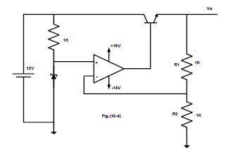

**Fig.(2.5)**

|  |  |  |  |  |  |  |
| --- | --- | --- | --- | --- | --- | --- |
| Rl | open | 1k | 680 | 470 | 220 | 100 |
| Vo | 5.056 | 5.06 | 5.061 | 5.06 | 5.058 | 5.058 |
| Io | 0 | 5m | 7.29 m | 10.45m | 22.2m | 47.1m |

**Table (5)**

8

* With Rl =1k and R2 changed to 470 ohms. the new output voltage is Vo=7.901V
* With R2 changed to 2.2k ohm Vo=3.63V
* After that the circuit in figure (2.6) Vo was measured according to table (6).

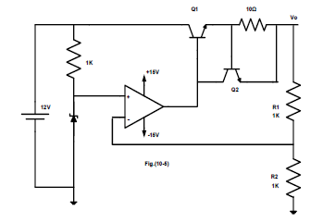

**Fig. (2.6)**

|  |  |  |  |  |  |  |  |
| --- | --- | --- | --- | --- | --- | --- | --- |
| Rl | open | 1k | 680 | 470 | 220 | 100 | 50 |
| Vo | 4.969 | 4.97 | 4.97 | 4.97 | 4.97 | 4.97 | 4.759 |
| Io | 0 | 4.9m | 7.17m | 10.3m | 22.2m | 48.4m | 93.9m |

**Table (6)**

***III. THREE TERMINAL FIXED VOLTAGE REGULATOR 7805***

* The circuit in the figure (2.7) was connected

9

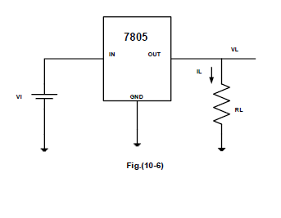

**Fig. (2.7)**

* with vi = 10v ,IL and VL was measured for RL listed in table (7)

|  |  |  |
| --- | --- | --- |
| RL(Ohm) | VL(V) | IL(m A) |
| 25 | 4.95 | 198 |
| 50 | 5.06 | 101.2 |
| 100 | 5.07 | 50.7 |
| 200 | 5.07 | 25.35 |
| 400 | 5.07 | 14.25 |
| 600 | 5.07 | 8.45 |
| 800 | 5.07 | 6.34 |
| 1000 | 5.07 | 5.07 |

**Table (7)**

* The load regulation = ∆VL /∆ IL = (5.07-5.07)/(25.35-50.7)=0

**10**

* Rl set to 100Ω and vi as listed in table (8)

|  |  |  |
| --- | --- | --- |
| **Vi(V)** | **VL(V)** | **IL(m A)** |
| **8** | **5.08** | **50.8** |
| **9** | **5.08** | **50.8** |
| **10** | **5.08** | **50.8** |
| **11** | **5.08** | **50.8** |
| **12** | **5.08** | **50.8** |
| **13** | **5.08** | **50.8** |
| **14** | **5.08** | **50.8** |
| **15** | **5.08** | **50.8** |

**Table (8)**

* line regulation = ∆VL/∆Vi = 0

***IV. THE LM317 ADJUSTABLE VOLTAGE REGULATOR.***

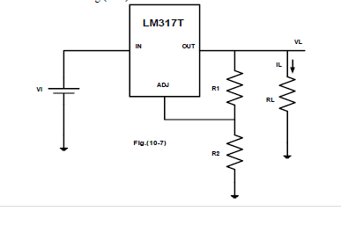

**Fig.(2.8)**

11

* the circuit in figure (2.8) was connected
* With Vi=10V, R1=100Ω, RL=1k, R2 adjusted as shown in table (9)

|  |  |  |
| --- | --- | --- |
| **R2(Ω)** | **VL(V)** | **IL(m A)** |
| **0** | 1.2 | 1.2 |
| **100** | 2.56 | 2.56 |
| **200** | 3.85 | 3.85 |
| **300** | 5.13 | 5.13 |
| **500** | 7.69 | 7.69 |
| **700** | 8.46 | 8.46 |

**Table (9)**

* With RL =1k, R1=100 ohm, R2=220, Vi adjusted as listed in table (10)

|  |  |  |
| --- | --- | --- |
| **Vi(V)** | **VL(V)** | **IL(m A)** |
| **10** | 4.072 | 4.07 |
| **12** | 4.073 | 4.07 |
| **14** | 4.07 | 4.07 |
| **15** | 4.07 | 4.07 |
| **16** | 4.07 | 4.07 |
| **17** | 4.07 | 4.07 |

**Table(10)**

* line regulation = ∆VL/∆Vi =0

The line regulation is zero meaning that this voltage regulator is very effective.

12

* With Vi=10V, R1=100 0hm, R2=220, RL adjusted as shown in table (11)

|  |  |  |
| --- | --- | --- |
| **RL(Ω)** | **VL(V)** | **IL(m A)** |
| **100** | 4.06 | 40.6 |
| **200** | 4.06 | 20.3 |
| **400** | 4.07 | 10.175 |
| **500** | 4.07 | 8.14 |
| **600** | 4.07 | 6.78 |
| **700** | 4.07 | 5.81 |
| **1000** | 4.07 | 4.07 |

**Table (11)**

13

***Conclusion***

In this experiment many electrical circuits were built, simulated and many parameters were measured and calculated in order to achieve the objectives that were set. The theoretical and practical results were close to each other and there were some systematic errors due to measuring, reading and rounding some numbers.

We have used Zener diode, understood how it works as a regulator and constructed the I.V characteristic of it. Also, to notice the operation of the voltage-regulated power supply, fixed and adjustable IC regulators.

14

***References***

* https://en.wikipedia.org/wiki/Zener_diode
* https://instrumentationforum.com/t/zener-diode-construction-symbol-principle-vi-characteristics-zener-break-down/3422
* https://blog.oureducation.in/zener-breakdown-and-avalanche-breakdown-mechanism/
* https://en.wikipedia.org/wiki/Linear_regulator
* http://www.learningaboutelectronics.com/Articles/What-is-a-LM7805-voltage-regulator
* http://www.circuitstoday.com/few-lm317-voltage-regulator-circuits

15