

**Faculty of Engineering and Technology**

**Electrical and Computer Systems Engineering**

ENEE3102

Instructor: Dr. Nasser Ismail

ـــــــــــــــــــــــــــــــــــــــــــــــــــــــــــــــــــــــــــــــــــــــــــــــــــــــــــــــــــــــــــــــــــــــــــــــــــــــــــــــــــــــ

***Course Name***

ELECTRONICS LAB (section 2)

***Experiment No. 1***

### Oscillators

Prepared by:

Dana Abu Hussein 1131657

***Group Members***

Hajar karajeh

Hiam arar

***Date of Experiment***

May 7, 2016

***Date Submitted***

May 14, 2016

**-** **Abstract:**

The purpose of this experiment is to learn about oscillator and some application, we use oscilloscope to obtain the output for each circuit.

Finally the experiment achieve the purpose.

**- Objective:**

The aim of this experiment is to demonstrate the wien bridge oscillator , RC phase-shift oscillator, the colpitts oscillator and the RC a stable multivibrator.

**- Theory:**

**Oscillators are used to generate signals, for circuit to operate as an Oscillators it must satisfy the Barkhausen criterial for sustained oscillation**

1. **The feedback must be positive, this means that the feedback signal must be phased so that it adds to the amplifier’s signal.**
2. **The loop gain (AB) must be greater than unity to allow oscillator to build up and equal to unity to sustain the oscillation.**
3. ***THE WEIN BRIDGE OSCILLATOR.***

* The wien bridge oscillator employs a lead – lag network
* At one particular frequency, the phase shift a cross the network is 0 , therefore the feedback network is connected to the opamp’s noninverting input terminal .

Analysis

as shown in fig (1) :

Z1 = R1 // (1/JWC1) =

Z2= R2+ (1/jwc2)

B(jw) = =

At w0 B(jw)must be real and positive

**W0 =**

**When R1 = R2 =R & C1 = C2=C**

**W0 =1/RC**

**B= 1/3**

**AV=3 in phase with B**

# *THE RC PHASE SHIFT OSCILLATOR.*

As shown in fig(2) :

**W0 =**

# **B = -1/29**

# **A=29 in phase with B**

# *THE COLPITTS OSCILLATOR.*

A Colpitts oscillator is the electrical dual of a [Hartley oscillator](http://en.wikipedia.org/wiki/Hartley_oscillator). Fig. 3 shows the basic Colpitts circuit, where two [capacitors](http://en.wikipedia.org/wiki/Capacitor) and one [inductor](http://en.wikipedia.org/wiki/Inductor) determine the [frequency](http://en.wikipedia.org/wiki/Frequency) of oscillation. The [feedback](http://en.wikipedia.org/wiki/Feedback) needed for oscillation is taken from a [voltage divider](http://en.wikipedia.org/wiki/Voltage_divider) made of two capacitors, whereas in the Hartley oscillator the feedback is taken from a voltage divider made of two inductors (or a single, tapped inductor).

Multivibrator:

A multivibrator is an [electronic circuit](http://en.wikipedia.org/wiki/Electronic_circuit) used to implement a variety of simple two-state systems such as [oscillators](http://en.wikipedia.org/wiki/Oscillators), [timers](http://en.wikipedia.org/wiki/Timer) and [flip-flops](http://en.wikipedia.org/wiki/Flip-flop_%28electronics%29). It is characterized by two amplifying devices (transistors, electron tubes or other devices) cross-coupled by resistors or capacitors. The name "multivibrator" was initially applied to the free-running oscillator version of the circuit because its output waveform was rich in harmonics. There are three types of multivibrator circuits depending on the circuit operation:

astable, in which the circuit is not stable in either state —it continually switches from one state to the other. It does not require an input such as a clock pulse.

monostable, in which one of the states is stable, but the other state is unstable (transient). A trigger causes the circuit to enter the unstable state. After entering the unstable state, the circuit will return to the stable state after a set time. Such a circuit is useful for creating a timing period of fixed duration in response to some external event. This circuit is also known as a one shot.

bistable, in which the circuit is stable in either state. The circuit can be flipped from one state to the other by an external event or trigger.

Multivibrators find applications in a variety of systems where square waves or timed intervals are required. For example, before the advent of low-cost integrated circuits, chains of multivibrators found use as [frequency dividers](http://en.wikipedia.org/wiki/Frequency_divider). A free-running multivibrator with a frequency of one-half to one-tenth of the reference frequency would accurately lock to the reference frequency. This technique was used in early electronic organs, to keep notes of different octaves accurately in tune. Other applications included early [television](http://en.wikipedia.org/wiki/Television) systems, where the various line and frame frequencies were kept synchronized by pulses included in the video signal.

**- Experimental / Procedure:**

*I. THE WEIN BRIDGE OSCILLATOR.*

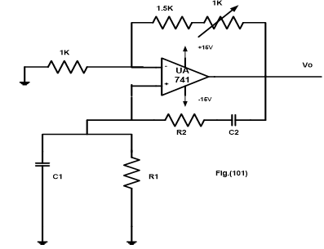

Fig (1): *THE WEIN BRIDGE OSCILLATOR*

Circuit shown in fig(1) was connected , and the output was noted until it with least amount of distortion at difference value of resister and capacitor.

# *II. THE RC PHASE SHIFT OSCILLATOR.*

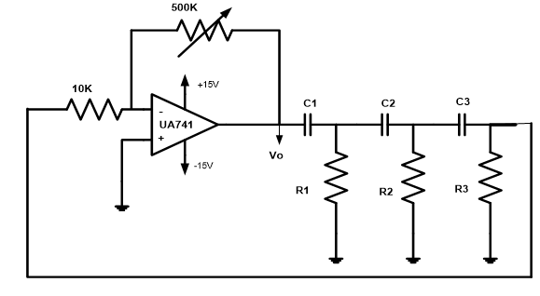

# Fig (2) : *THE RC PHASE SHIFT OSCILLATOR.*

Circuit in fig(2) was connected , and the output was noted at difference value of resistor and capacitor .

# *III. THE COLPITTS OSCILLATOR.*

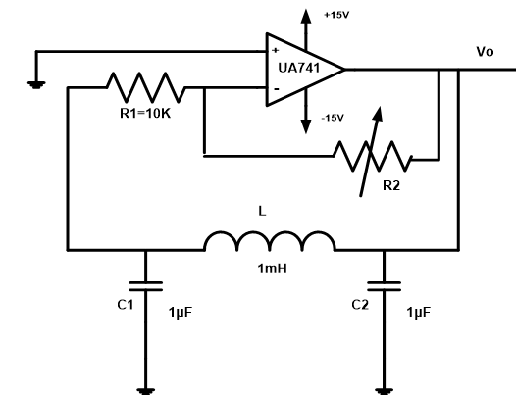

Fig (3) : *THE COLPITTS OSCILLATOR*

Circuit in fig (3) was connected , and the output was measured when R2 = 500K , then the pot adjusted until the output signal disappeared and the corresponding value of pot was record . and then L was replaced with 10mh and repeat step 2,3 .

# *IV. THE RC ASTABLE OSCILLATOR.*

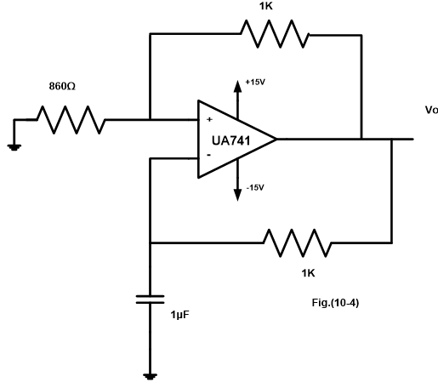

# Fig (4) : *THE RC ASTABLE OSCILLATOR.*

Circuit in fig (4) was connected, amplitude and frequency of output was record, then c was replaced with 0.1 m and step 2 was repeated.

# *V. THE 555 TIMER CHIP AS AN ASTABLE MULTIVIBRATOR.*

# 

Fig (5): *THE 555 TIMER CHIP AS AN ASTABLE MULTIVIBRATOR.*

Circuit in fig (5) was connected , frequency and duty cycle of output was measured at difference value of R2 (10,20,30,40,50 K) and VC(t) was sketched for difference value of R2 .

**- Data and calculation:**

***I. THE WEIN BRIDGE OSCILLATOR.***

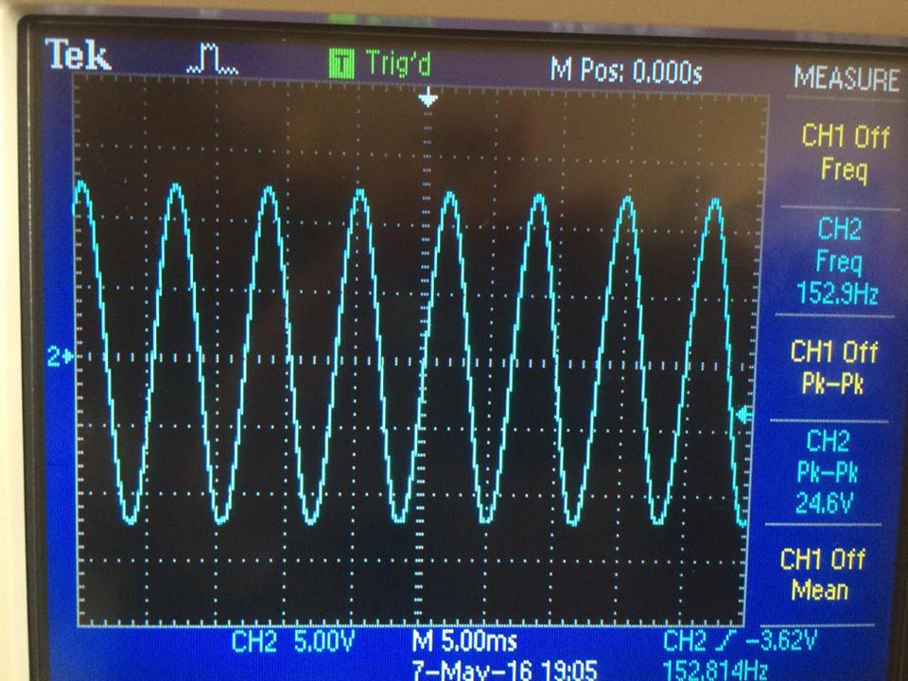

Fig (6): output With R1 = R2 = 10k and C1 = C2 = 0.1μF

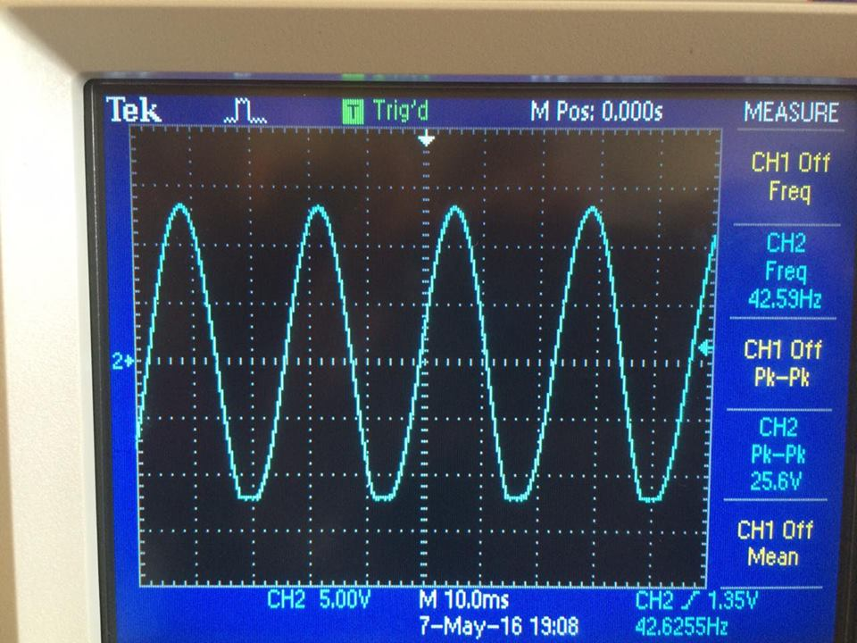

Fig (7): output with R1 = R2 = 10k and C1 = C2 =0.33 μF

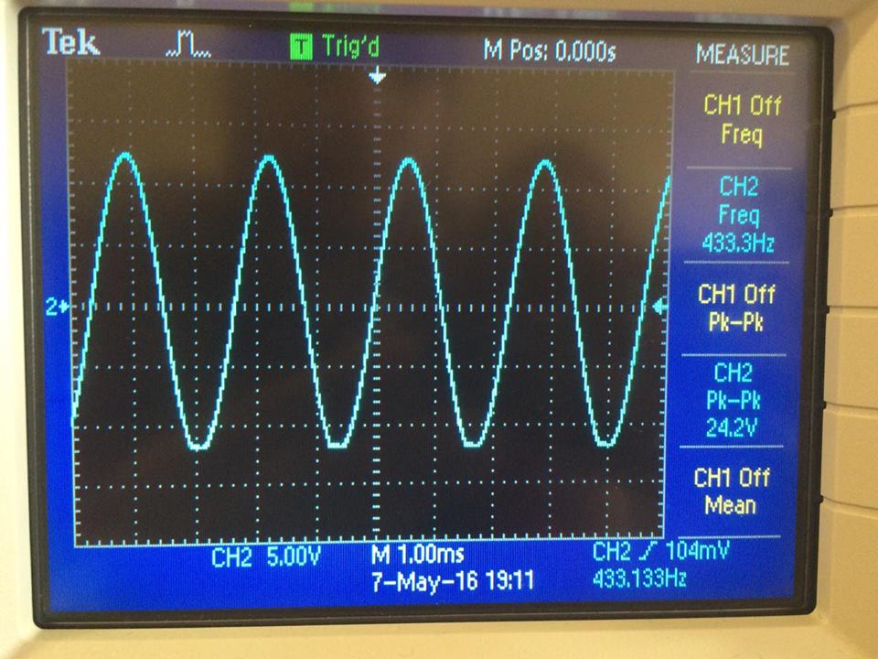

Fig (8) : output with C1 = C2 =0.33 μF and R1 = R2 = 1k

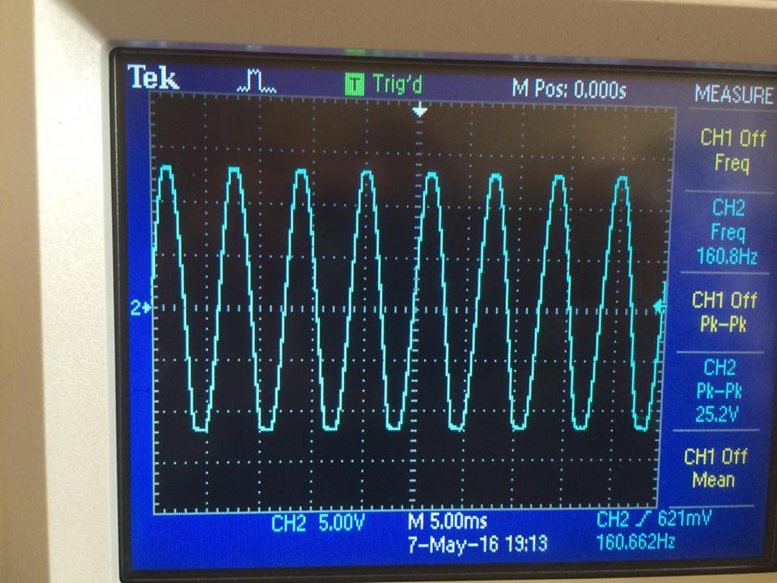

Fig (9) : output with C1 = C2 =1 μF and R1 = R2 = 10k

# *II. THE RC PHASE SHIFT OSCILLATOR.*

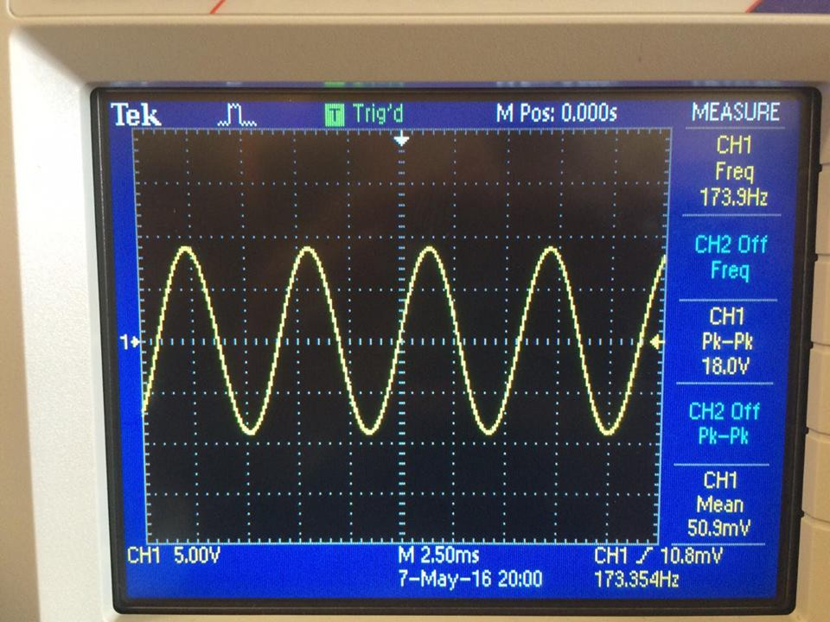

Fig (10) : output with R1 = R2 = R3 = 1k and C1 = C2 = C3 = 0.33uF

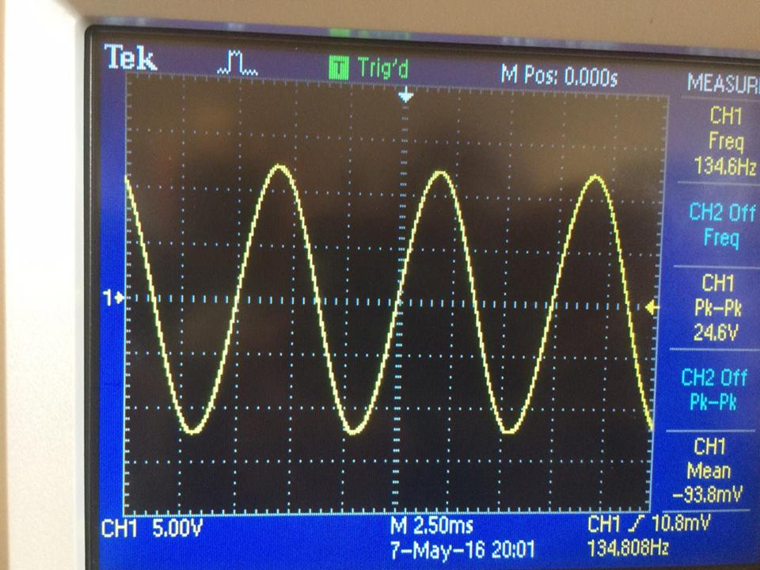

Fig (11) : output with R1 = R2 = R3 = 1k and C1 = C2 = C3 = 0.47uF

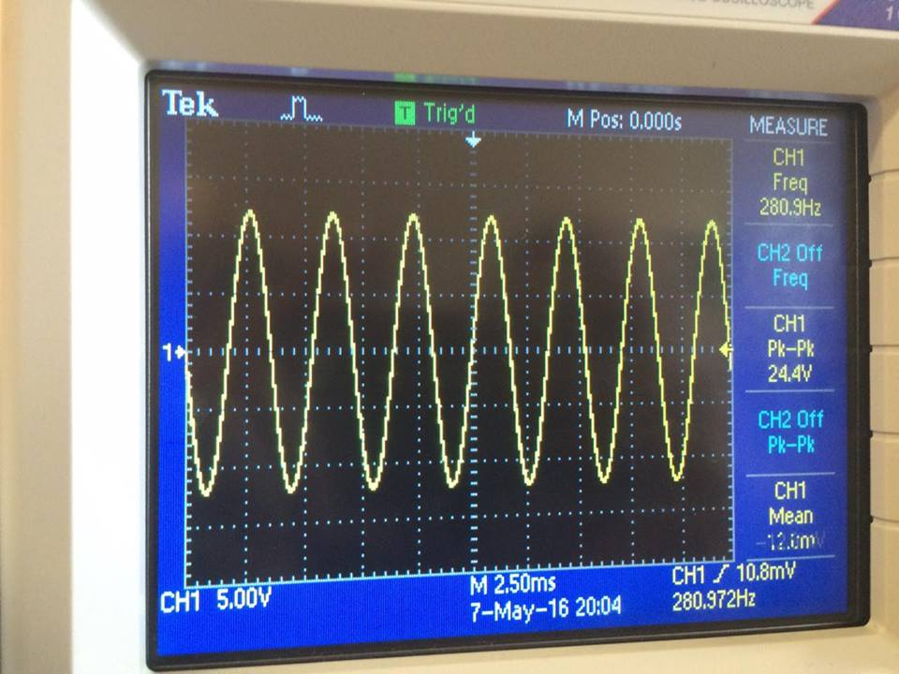

Fig (12): output with R1 = R2 = R3 = 470 ohm and C1 = C2 = C3 = 0.47uF

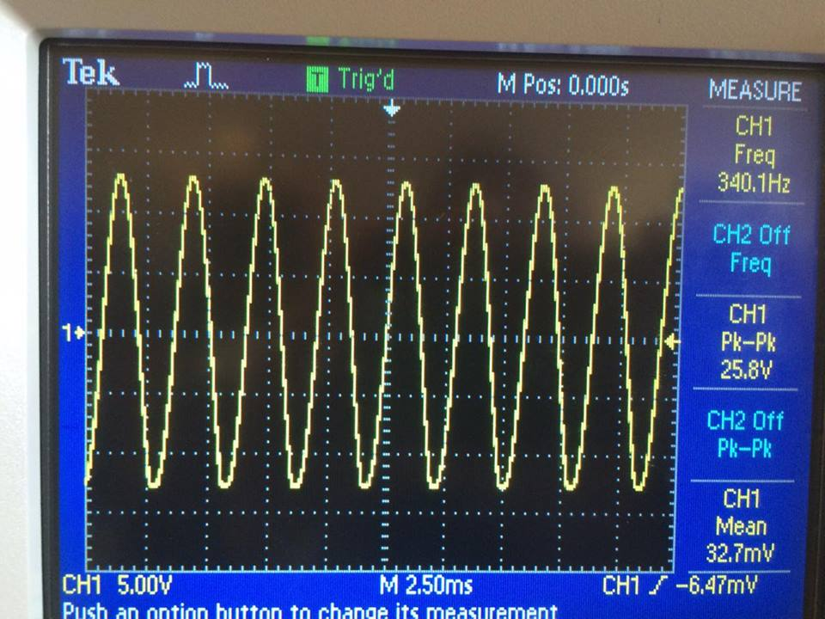

Fig (13): output with R1 = R2 = R3 = 470 ohm and C1 = C2 = C3 = 0.33uF

# *III. THE COLPITTS OSCILLATOR.*

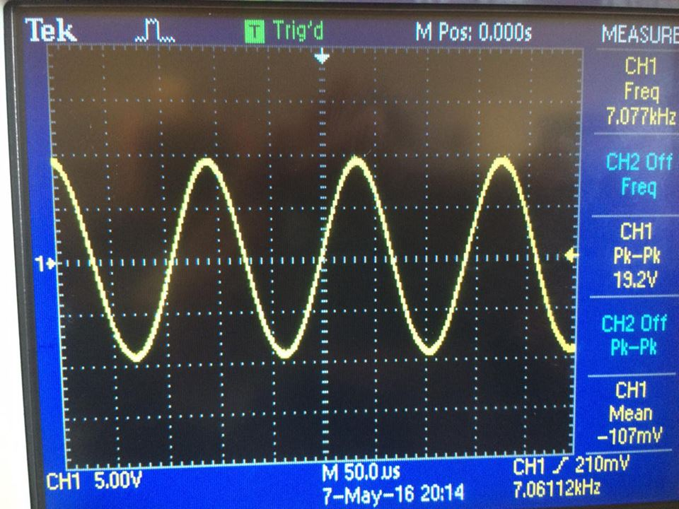

Fig (14): output with L = 1mH

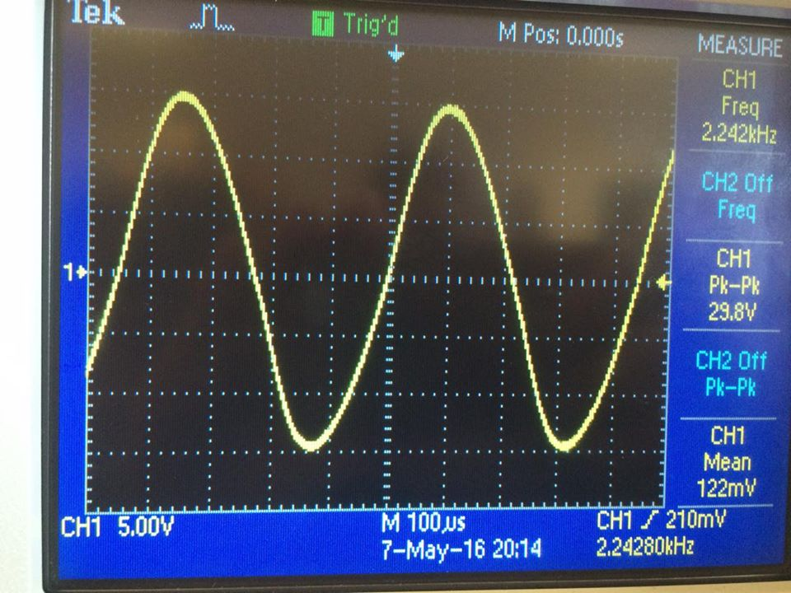

Fig (15): output with L = 10Mh

# *IV. THE RC ASTABLE OSCILLATOR.*

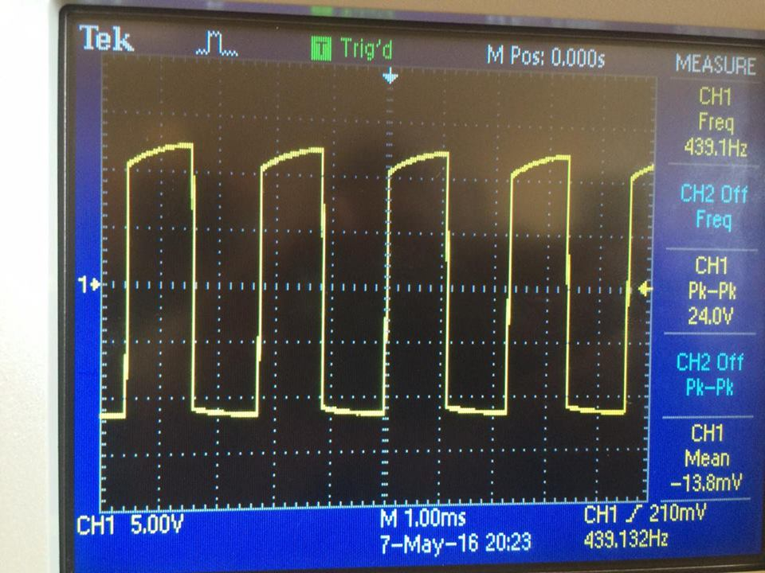

Fig (16) : output with C=1μF

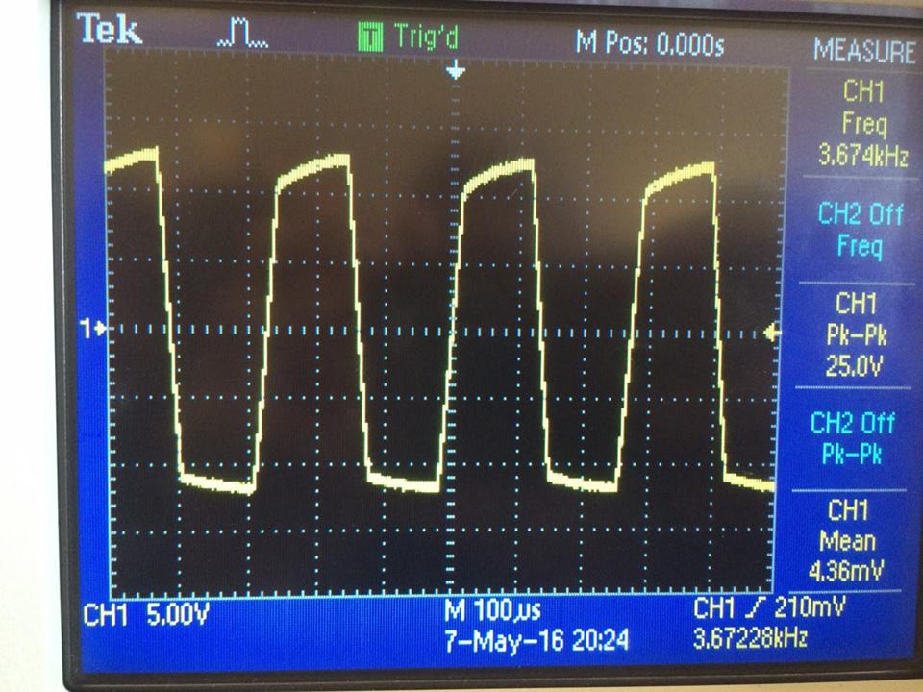

Fig (17) : output with C =0.1μF

# *V. THE 555 TIMER CHIP AS AN ASTABLE MULTIVIBRATOR.*

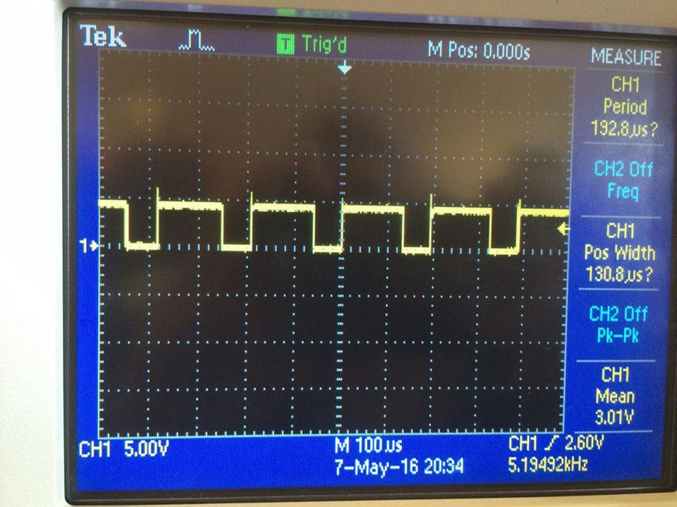

Fig (18) : R2 = 10K

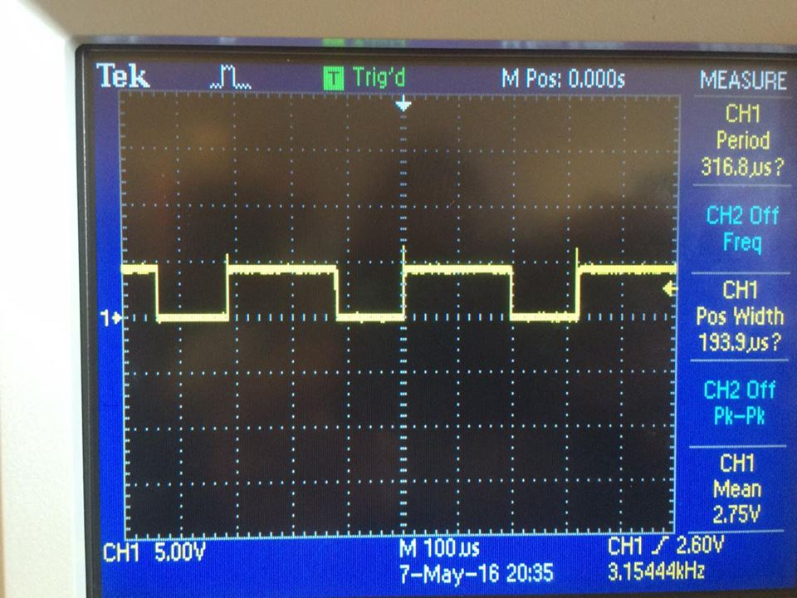

Fig (19): R2 =20K

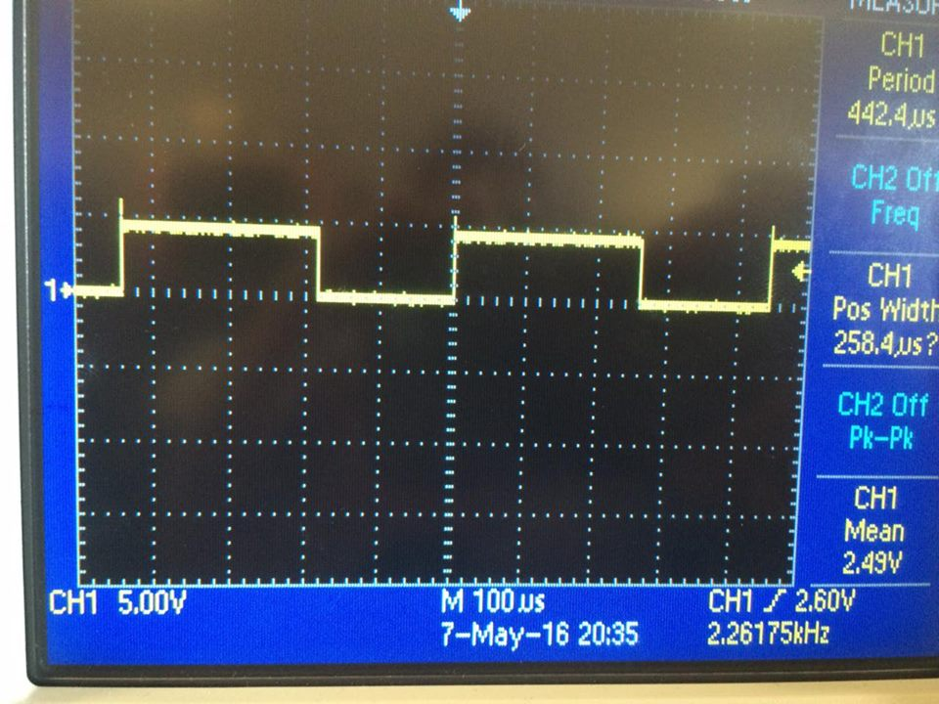

Fig (20) : R2= 30K

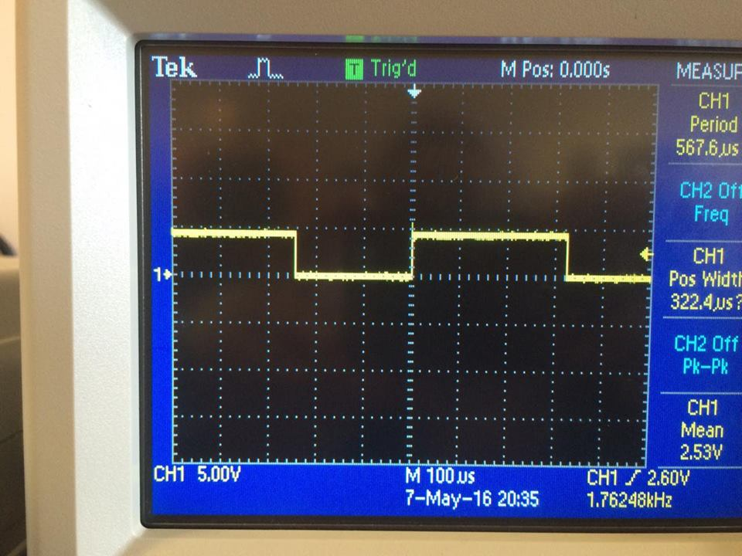

Fig (21) : R2 = 40k

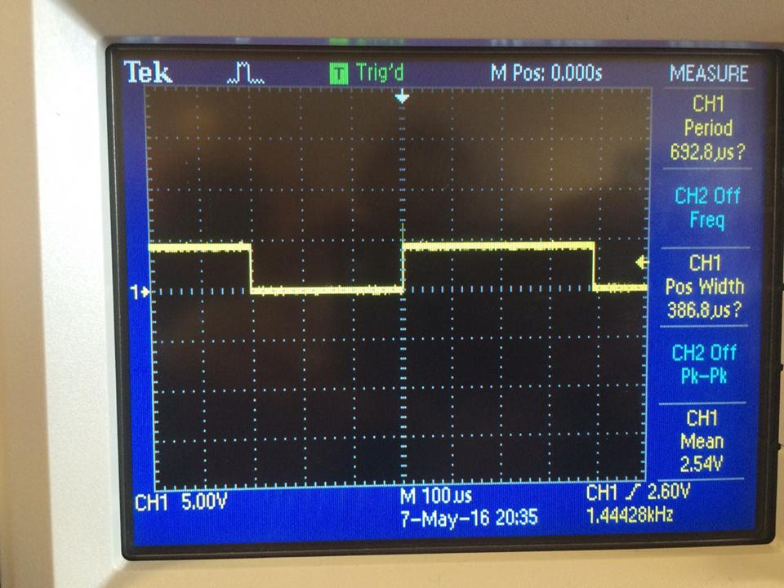

Fig (22) : R2=50k

**- Discussion of Results:**

In first part we recognize that when we change resistor the amplitude change, in second part we show the effect of changing the resistor and capacitor to the output signal, also, in third part of colpitts oscillator circuit we note the effect of change inductor to the amplitude and frequency output , in fourth part changing the value of capacitor well change the amplitude and frequency , Finally , in the last part we show how the 555 timer can work as an oscillator .

**- Conclusion:**

In this lab we learn important part of electronic circuit which called oscillator, and we learn how to deal with it in different circuit that use in many application in daily life .

**- References:**

Electronics lab manual