

Faculty of Engineering and Technology

Electrical and Computer Engineering

Department

ENEE3102

Electronics Laboratory

Experiment #10

Zenor diode, Voltage Regulator

Name : Naheda Issa

ID # : 1151492

Partners name :

Tasneem Mofreh :1152414

Khitam Anwar : 1152244

Table of Contents:

Abstract …………………………………3

Theory …………………………………3-6

Procedure ……………………………….7-13

Conclusion ………….…………………….13

Abstract :

The aims of doing this experiment :

1. To understand I.V characteristic of a zener diode.

2. To know the use of zener diode as voltage regulator.

3. To notice the operation of the voltage regulator.

4. To demonstrate the circuit and operation of astable multivibrator

method used :

by connecting the circuits as shown in procedure part and saw the behavior of all parts.

Theory :

A Zener diode is a particular type of [diode](https://en.wikipedia.org/wiki/Diode) that, unlike a normal one, allows current to flow not only from its anode to its cathode, but also in the reverse direction, when the *Zener voltage* is reached.

Zener diodes have a highly doped [p-n junction](https://en.wikipedia.org/wiki/P-n_junction). Normal diodes will also [break down](https://en.wikipedia.org/wiki/Breakdown_voltage) with a reverse voltage but the voltage and sharpness of the knee are not as well defined as for a Zener diode. Also normal diodes are not designed to operate in the breakdown region, but Zener diodes can reliably operate in this region

[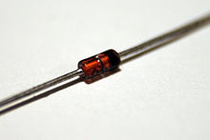](https://en.wikipedia.org/wiki/File:Zener_Diode.JPG)

[**Electronic symbol**](https://en.wikipedia.org/wiki/Electronic_symbol)

[Zener diode symbol-2.svg](https://en.wikipedia.org/wiki/File:Zener_diode_symbol-2.svg)

A conventional solid-state diode allows significant current if it is [reverse-biased](https://en.wikipedia.org/wiki/Reverse-biased) above its reverse [breakdown voltage](https://en.wikipedia.org/wiki/Breakdown_voltage). When the reverse bias breakdown voltage is exceeded, a conventional diode is subject to high current due to [avalanche breakdown](https://en.wikipedia.org/wiki/Avalanche_breakdown). Unless this current is limited by circuitry, the diode may be permanently damaged due to overheating. A Zener diode exhibits almost the same properties, except the device is specially designed so as to have a reduced breakdown voltage, the so-called Zener voltage.

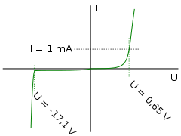

Current-voltage characteristic of a Zener diode with a breakdown voltage of 17 volts. Notice the change of voltage scale between the forward biased (positive) direction and the reverse biased (negative) direction.

[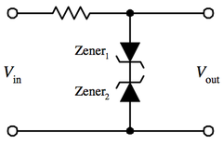](https://en.wikipedia.org/wiki/File:WaveClipper1.png)

[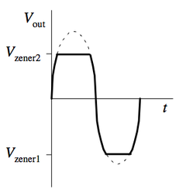](https://en.wikipedia.org/wiki/File:WaveClipper2.png)

Examples of a Waveform Clipper

Two Zener diodes facing each other in series will act to clip both halves of an input signal. [Waveform clippers](https://en.wikipedia.org/wiki/Clipper_(electronics)) can be used not only to reshape a signal, but also to prevent voltage spikes from affecting circuits that are connected to the power supply.



Examples of a Waveform Clipper

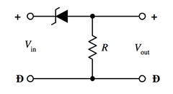

A Zener diode can be applied to a circuit with a resistor to act as a voltage shifter. This circuit lowers the output voltage by a quantity that is equal to the Zener diode's breakdown voltage.

Examples of a Voltage Shifter

A Zener diode can be applied in a [voltage regulator](https://en.wikipedia.org/wiki/Voltage_regulator) circuit to regulate the voltage applied to a load, such as in a [linear regulator](https://en.wikipedia.org/wiki/Linear_regulator)

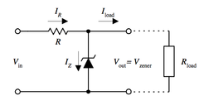

Examples of a Voltage Regulator

A regulated power supply :

is where by some means the output voltage is maintained or regulated within certain pre-defined limits.

To regulate small amounts of current the cheapest approach is to use a zener diode (as in steps 9 to 11). Higher currents can be obtained from higher power zeners but we prefer to use dedicated I.C.'s in these cases. In one instance you can use a zener diode in conjunction with a pass transistor to extend the range of the zener regulator.

Procedure :

I. ZENER DIODE:

1. the circuit shown in Fig (10-1)was connected: 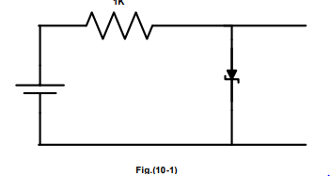

2. the applied voltage E was Setted to (0.1, 0.2, 0.3, 0.4, 0.5, 0.6, 0.7, 0.8, 0.9, 1,2,3,4)V

|  |  |  |  |
| --- | --- | --- | --- |
| E(v) | VR(v) | Vz(v) | I(A) |
| 0.1 | 0 | 0.1 | 0 |
| 0.2 | 0 | 0.2 | 0 |
| 0.3 | 0.09m | 0.09 | 0.09u |
| 0.415 | 0.0m | 0.464 | 1.55u |
| 0.534 | 0.45m | 0.498 | 2.74u |
| 0.6139 | 0.84m | 0.610 | 35u |
| 0.7086 | 1.72m | 0.634 | 73u |
| 0.8172 | 3.63m | 0.639 | 85u |
| 0.9315 | 7.95m | 0.658 | 159u |
| 1 | 11.37m | 0.660 | 173u |
| 2 | 0.37m | 0.715 | 1.19m |
| 3 | 1.099m | 0.734 | 2.35m |
| 4 | 1.853m | 0.743 | 3.34m |

3. the voltage a cross the resistor, the forward current through the zener diode, and the voltage a cross the zener diode were measured and filled in table 10.1.

4. the circuit shown in Fig(10-2) w as connected

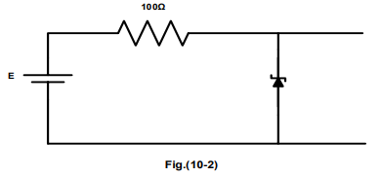

5. the applied voltage E was setted to values shown in table 10.2.

6. For each value of E, the voltage across the zener diode and the current through the zener diode was measured.

|  |  |  |
| --- | --- | --- |
| E(V) | Vz(V) | I(A) |
| 0.1 | 0.103 | 0 |
| 0.5 | 0.486 | 0.34u |
| 1 | 1.04 | 17.36u |
| 2 | 1.9 | 1.37m |
| 3 | 2.38 | 6.74m |
| 4 | 2.61 | 13m |
| 5 | 2.8 | 22m |
| 6 | 2.92 | 31.1m |
| 7 | 3.02 | 40m |
| 8 | 3.1 | 49.92m |
| 9 | 3.17 | 58.74m |
| 10 | 3.225 | 68.23m |
| 10.9 | 3.26 | 77m |
| 12 | 3.313 | 87.96m |
| 13 | 3.345 | 96.58m |
| 14 | 3.38 | 106.65 |
| 15 | 3.41 | 116.7m |

8. the circuit shown in Fig (10-3)was connected:

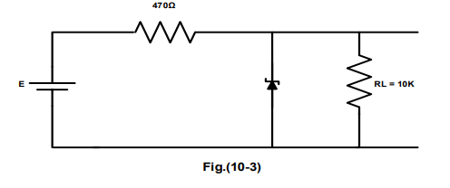

9. E was Setted to (10,11,12,13,14)V.

10. the load voltage VL was Measured and Filled in table 10.3

|  |  |  |  |  |  |
| --- | --- | --- | --- | --- | --- |
| E | 10 | 11 | 12 | 13 | 14 |
| V(RL) | 2.672 | 2.712 | 2.75 | 2.785 | 2.814 |

11. With E setted to 10V the load voltage VL was measured for RL=(8.2K,6.8K,4.7K,2.2K).

|  |  |  |  |  |
| --- | --- | --- | --- | --- |
| RL | 8.2k | 6.8k | 4.7k | 2.2k |
| V(RL) | 2.67 | 2.67 | 2.67 | 2.652 |

II. THE VOLTAGE REGULATED POWER SUPPLY.

1. the circuit of Fig.(10-4)was connected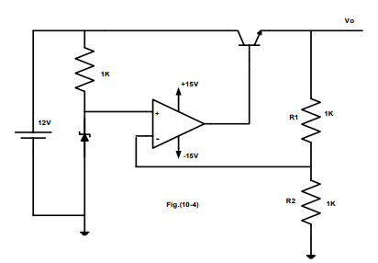
2. Vo was Measured.
3. a 1k load resistor was attached to the output. Io and Vo was measured
4. step 3 was repeated for load resistance RL = (680 , 470 , 220 , 100) ohm and fill Table

|  |  |  |  |  |  |  |
| --- | --- | --- | --- | --- | --- | --- |
| RL | Open | 1k | 680 | 470 | 220 | 100 |
| Vo | 4.988 | 4.987 | 4.989 | 4.991 | 4.993 | 5 |
| Io | 0 | 4.94 | 7.242 | 10.409 | 22.58 | 49.14 |

1. Set RL back to 1K .Change the value of R2 to 470 ohm . What is the new output voltage.
2. R2 was changed to 2.2k.
3. the circuit was connected shown in Fig.(10-5). 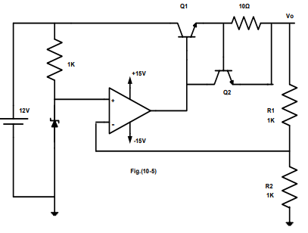
4. Measure Vo.
5. steps 3 and 4 was repeated. and our results were recorded .

|  |  |  |  |  |  |  |  |
| --- | --- | --- | --- | --- | --- | --- | --- |
| RL | open | 1k | 680 | 470 | 220 | 100 | 50 |
| Vo | 4.991 | 4.994 | 4.994 | 4.994 | 4.995 | 4.994 | 4.66 |
| Io m | 0 | 5.02 | 7.36 | 10.63 | 19.13 | 49.15 | 96.87 |

II. THREE TERMINAL FIXED VOLTAGE REGULATOR 7805.

1. the circuit of Fig (10.6 )was connected.

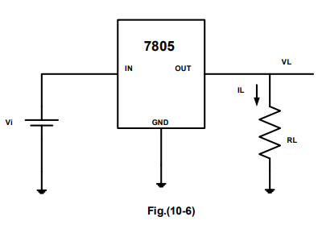

1. With Vi=10V measure IL and VL for the load resistances listed in the table 10.2.

|  |  |  |
| --- | --- | --- |
| **RL** | **VL(v)** | **IL (mA)** |
| **30** | **4.8** | **160** |
| **50** | **4.93** | **98.5** |
| **100** | **5** | **50.02** |
| **200** | **5.04** | **25.26** |
| **400** | **5.05** | **12.7** |
| **600** | **5.06** | **8.49** |
| **800** | **5.06** | **6.38** |
| **1000** | **5.01** | **5.11** |

3. Using the results of table 10.2 , determine the load regulation of the 7805.knowing that load regulation = ∆VL /∆ IL

4. RL=100 ohm was setted , the input voltage Vi was adjusted as listed in table 10.3. VL and IL was measured for each input voltage in the table

|  |  |  |
| --- | --- | --- |
| **Vi(V)** | **VL(v)** | **IL (mA)** |
| **8** | **5** | **50.06** |
| **9** | **5** | **50.06** |
| **10** | **5** | **50.06** |
| **11** | **5** | **50.06** |
| **12** | **5.04** | **50.06** |
| **13** | **5** | **50.06** |
| **14** | **5** | **50.06** |
| **15** | **5** | **50.06** |

III. THE LM317 ADJUSTABLE VOLTAGE REGULATOR.

1. the circuit of Fig.(10.7 )was connected.

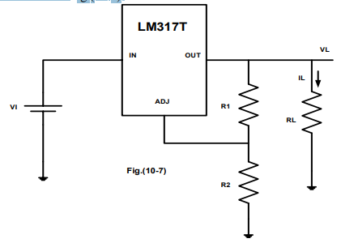

1. With Vi=10V, R1=100Ω, RL=1k , adjust R2 as shown in table 10.4.

|  |  |  |
| --- | --- | --- |
| **R2** | **VL(v)** | **IL (mA)** |
| **0** | **1.178** | **1.18** |
| **100** | **2.5** | **2.55** |
| **200** | **3.81** | **3.84** |
| **300** | **5.09** | **5.13** |
| **500** | **7.64** | **7.7** |
| **700** | **5.82** | **8.6** |

3. VL,IL for each R value was measured and recorded

4. With RL =1k , R1=100 ohm , R2=220 , Vi was adjusted as listed in table 10.5.

|  |  |  |
| --- | --- | --- |
| **Vi(V)** | **VL(v)** | **IL (mA)** |
| **10** | **4.028** | **4.08** |
| **11** | **4.028** | **4.08** |
| **12** | **4.028** | **4.08** |
| **14** | **4.028** | **4.08** |
| **15** | **4.028** | **4.08** |
| **16** | **4.028** | **4.08** |
| **17** | **4.028** | **4.08** |

5. the load voltage and current were measured and recorded for each input voltage value.

6. Used our results, the line regulation was calculated for the LM317T voltage regulator.

7. With Vi=10V, R1=100 0hm , R2=220 , RL was adjusted as shown in table 10.6.

|  |  |  |
| --- | --- | --- |
| **R2** | **VL(v)** | **IL (mA)** |
| **100** | **3.97** | **39.65** |
| **200** | **4** | **20.01** |
| **400** | **4.01** | **10.04** |
| **500** | **4.02** | **8.04** |
| **600** | **4.02** | **6.7** |
| **700** | **4.02** | **5.74** |
| **1000** | **4.03** | **4.01** |

8. VL,IL was measured and recorded for each RL value.

#### Conclusion: -

We had seen the following conclusions:

1. The zener diode works as a normal diode in the forward bias and the reverse-bias, as long as the voltage across it doesn’t reach the breakdown voltage in the reverse-bias. When it is reached the voltage stays approximately the same while the current increases so fast.
2. The zener diode can be used as a simple voltage regulator, as seen in steps 8 to 11. The voltage remains approximately constant of the load is changed.
3. The first voltage-regulator has approximately constant output voltage, although the output current is changed, i.e., the load is changed.
4. In the second voltage-regulator the voltage in the first was constant, then the output voltage began to drop as the load has lower resistance, i.e., more current is supplied (has a max current the can’t be exceeded)