

Faculty of Engineering and Technology

Electrical and Computer Engineering Department

Electronics LAB (ENEE3102)

Report on Experiment #3

The Transistor Biasing and the DC Parameters

Prepared by:

Name: Sara Totah Student ID: 1181779

Instructor:

Mohammad Jehad Al Jubeh

Date:

20/9/2020

Section: #1

Table of Contents

**Abstract:** 2

**Theory:** 2

**Procedure, Data and results:** 4

I. The Transistor Biasing: 4

II. The Transistor DC Parameters: 6

A. Input Characteristic: 6

B. Forward Voltage Characteristic: 7

C. Reverse Voltage Characteristics: 8

D. The output Characteristic: 9

**Conclusion:** 11

**References:** 11

# **Abstract:**

In this experiment the supplies connections to the transistor, the characteristics of the BJT transistor for varying DC supply and the three modes the transistor could get in (active, saturation and cut-off regions) were examined.

# **Theory:**

The Bipolar Junction Transistor (BJT) is a semiconductor, three terminal device that can amplify the signal, consists of:

1. Base.
2. Emitter.
3. Collector.

There are two types of BJTs:

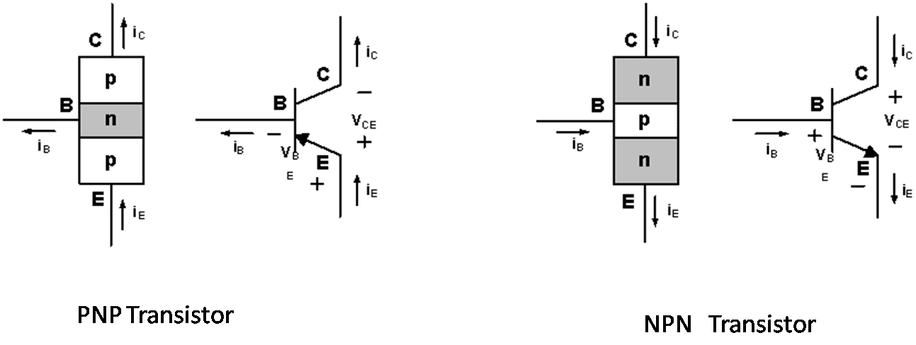

Figure 1

BJT transistor types:

1. **Active region:** The Emitter-Base junction should be forward biased, and the Collector-Base should be Reverse biased.

IC = αIE

IC = βIB

IE = (1+β) IB

Β = $\frac{α}{1-α}$

1. **Saturation region:** The Emitter-Base junction should be forward biased, and the Collector-Base should be forward biased.

VCE = VCE,sat

VBE = 0.8V, Si, npn

VBE = -0.8V, Si, pnp

1. **Cut-off region:** The Emitter-Base junction should be reverse biased, and the Collector-Base should be Reverse biased.

IB = IC = IE = 0

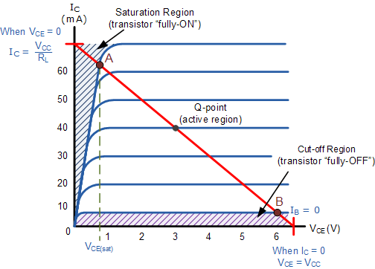

Figure 2

Usually BJT transistor works as an amplifier in the active region and as a switch in the cut-off region.

# **Procedure, Data and results:**

## The Transistor Biasing:



Figure (3-1)

PNP transistor:

First, the circuit above was connected, and the variable DC supply was set to 4volts, the supply makes both junctions reversed so the BJT transistor is in the cut-off region.

IC = 0.01mA

IB = 0.01mA

IE = 0.01mA

then the connection of the supply was reversed so both junctions were forward biased, and the transistor was in the saturation region.

IC = - 0.334A

IB = 0.66A

IE = 0.334A

NPN transistor:

The PNP transistor was replaced with NPN transistor and the variable DC supply was set to 4volts, so the transistor was in the saturation region the currents were measured:

IC = 0.34A

IB = - 0.68A

IE = 0.333A

then the connection of the supply was reversed so both junctions were forward biased, and the transistor was in the reverse region, and the currents were measured:

IC = 0mA

IB = 0mA

IE = 0mA



Figure (3-2)

PNP transistor:

First, the circuit above was connected, and the variable DC supplies were set to 15volts, the supplies make BE junction forward biased, and BC junction reverse biased, so the transistor is in Active region.

IC = 1.42mA

IB = 0.12mA

IE = 1.43mA

then the connection of the supplies was reversed so BE junction reversed biased, and BC junction forward biased, so the transistor is in Reverse region.

IC = - 1.42mA

IB = 0.031mA

IE = - 1.11mA

NPN transistor:

First, the circuit above was connected, and the variable DC supplies were set to 15volts, the supplies make BE junction reverse biased, and BC junction forward biased, so the transistor is in Reverse region.

IC = 1.43mA

IB = 0.02mA

IE = -1.23mA

then the connection of the supplies was reversed so BE junction forward biased, and BC junction reversed biased, so the transistor is in Active region.

IC = -1.42mA

IB = 0.012mA

IE = -1.44mA

## The Transistor DC Parameters:

### Input Characteristic:



Figure (3-3)

The circuit above was connected, then the VCE and IB were set to equal 0, then the Base-Emitter voltage was measured, the potentiometer was used to adjust the value of the base current according to the table down below:

|  |  |  |
| --- | --- | --- |
| VCE | IB[uA] | VBE [V] |
|  |  |  |
|  | 0 | 0 |
| 0 | 5 | 0.483 |
|  | 10 | 0.492 |
|  | 15 | 0.510 |
|  | 0 | 0 |
| 0.2 | 5 | 0.489 |
|  | 10 | 0.496 |
|  | 15 | 0.513 |
|  | 0 | 0.01 |
| 0.4 | 5 | 0.510 |
|  | 10 | 0.523 |
|  | 15 | 0.544 |

Table 1

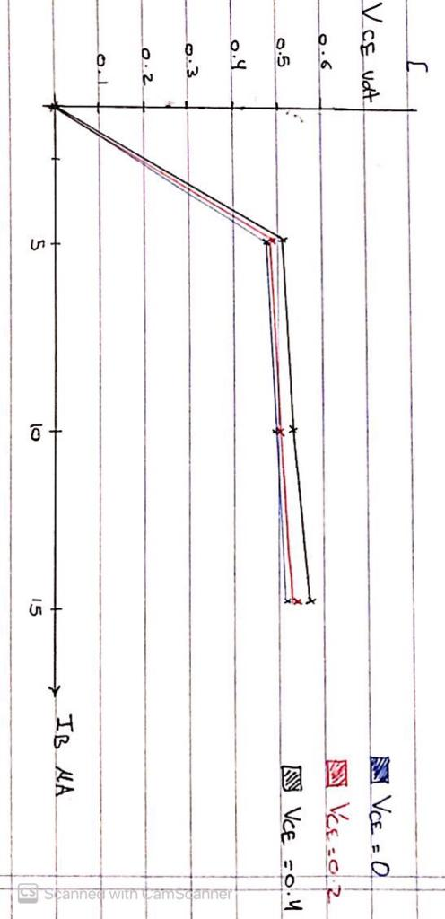

VBE vs IB

### Forward Voltage Characteristic:

For the same circuit in figure (3-3) VCE was set to 2.5volts, and the potentiometer was used to adjust the value of the base current according to the table down below:

|  |  |  |
| --- | --- | --- |
| VCE | IB[uA] | IC [mA] |
|  |  |  |
|  | 0 | 0 |
| 2.5 | 5 | 0.203 |
|  | 10 | 0.411 |
|  | 15 | 0.645 |
|  | 0 | 0 |
| 5 | 5 | 0.207 |
|  | 10 | 0.415 |
|  | 15 | 0.652 |
|  | 0 | 0 |
| 15 | 5 | 0.214 |
|  | 10 | 0.421 |
|  | 15 | 0.665 |

Table 2

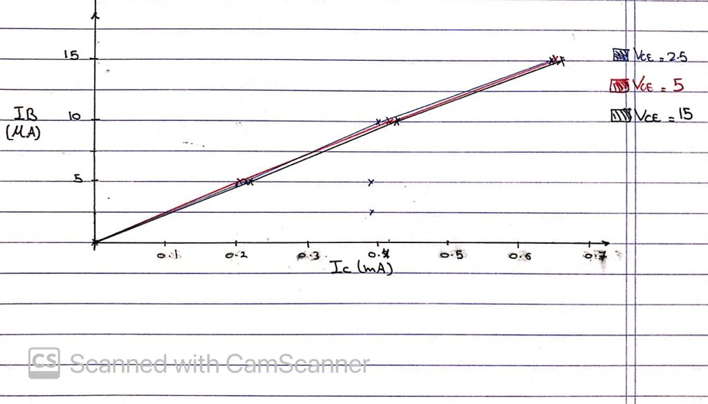

IB vs IC

### Reverse Voltage Characteristics:

For the same circuit in figure (3-3) VBE was measured according to the table down below:

|  |  |  |
| --- | --- | --- |
| IB [uA] | VCE[V] | VBE[V] |
|  |  |  |
|  | 0 | 0 |
| 2.5 | 0.5 | 0.22 |
|  | 2 | 0.223 |
|  | 5 | 0.223 |
|  | 15 | 0.23 |
|  | 0 | 0.42 |
| 5 | 0.5 | 0.45 |
|  | 2 | 0.45 |
|  | 5 | 0.453 |
| 15 | 0.46 |
|  | 0 | 0.50 |
| 15 | 0.5 | 0.502 |
|  | 2 | 0.509 |
|  | 5 | 0.51 |
|  | 15 | 0.51 |

Table 3

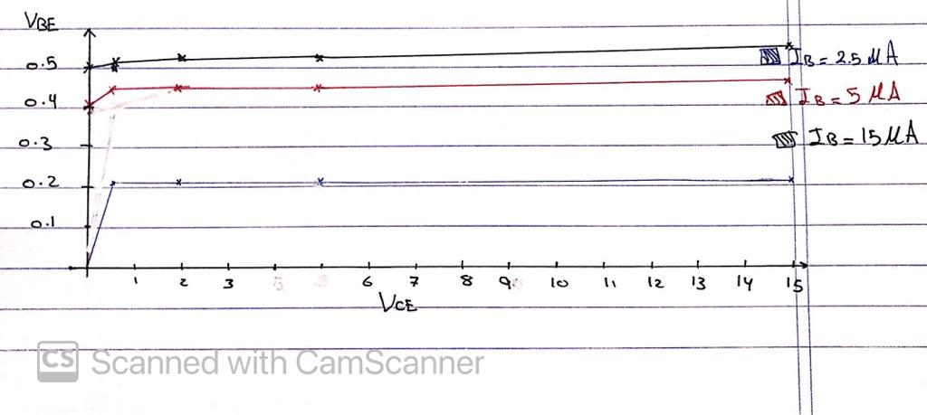

VBE vs VCE

### The output Characteristic:

For the same circuit in figure (3-3) VBE was measured according to the table down below:

|  |  |  |
| --- | --- | --- |
| IB [uA] | VCE[V] | IC [mA] |
|  |  |  |
|  | 0 | 0 |
| 2.5 | 0.5 | 0.003 |
|  | 2 | 0.003 |
|  | 5 | 0.003 |
|  | 15 | 0.004 |
|  | 0 | 0.020 |
| 5 | 0.5 | 0.023 |
|  | 2 | 0.024 |
|  | 5 | 0.024 |
| 15 | 0.025 |
|  | 0 | 0.00 |
| 15 | 0.5 | 0.33 |
|  | 2 | 0.35 |
|  | 5 | 0.35 |
|  | 15 | 0.36 |

Table 4

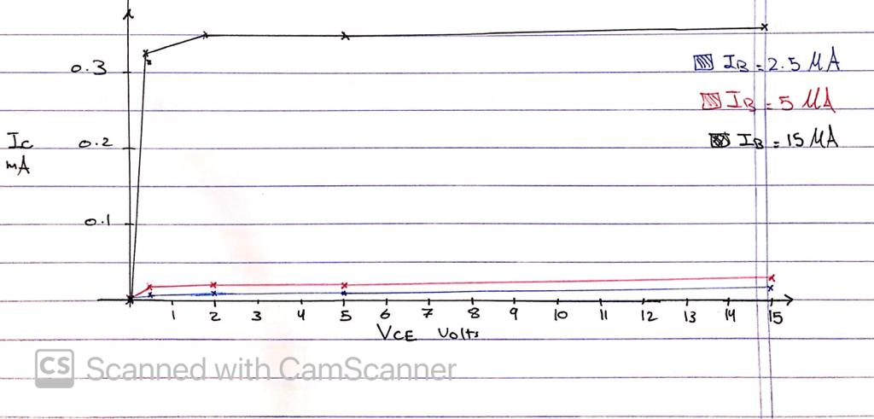

**Questions:**

* HIE = (∆VBE/∆IB) |vce=0.----------------------> input characteristic

HIE =

* HRE =(∆VBE/∆VCE) | ib=0. --------------------> reverse characteristic

HRE =

* HOE =(∆IC/∆VCE) | ib=0. ----------------------> output characteristic

HOE =

* HFE=(∆IB/IC) | vce=0. ------------------------> forward current transfer characteristic.

HFE = = 0.0226

# **Conclusion:**

Finally, after comparing our measured values with the theoretical values taken from pspice simulation, they were very close to each other, and the small difference was due to some systematic errors.

This experiment was very helpful in getting to know BJT transistor and it’s operating principle, types and structure.

# **References:**

1. <https://www.electrical4u.com/bipolar-junction-transistor-or-bjt-n-p-n-or-p-n-p-transistor/>
2. Electronics Lab ENEE3102 Lab Manual
3. Microelectronic_Circuits_6th_Edition