

Faculty of Engineering and Technology

Electrical and Computer Engineering Department

Electronics Laboratory (ENEE3102)

**Report of Experiment 3**

**“The transistor biasing and DC Parameters”**

Prepared by:

Name: Jana Al-Zeer Number:1161228

Partners:

Name: Tuqa Remawi Number: 1160899

Name: Hanen Zahran Number:1162549

Instructor: Mohammad Ju’beh TA: Eng.Qassam Barghouthi

Section: 2

Date: 4 / 7 / 2019

Abstract:

In this experiment we will learn how to identify the type of transistor PNP , NPN and what is the appropriate type of biasing consist with it (how to connect voltage source to it ). We will learn what is the meaning of transistor DC parameters such as (input characteristic…..) , and we will plot graphs to explain these characteristics.

***Table of Contents***

1. Theory:..................................................................................................................... (1-3)

2. Procedure, data and calculation.............................................................................. (4-11)

3. Conclusion:................................................................................................................ 12

4. References: ................................................................................................................ 13

**Theory:**

The Bipolar Junction Transistor (BJT) is a semiconductor device which can be used for switching or amplification, A bipolar transistor consists of a three-layer “sandwich” of doped semiconductor materials, either P-N-P in the Figure [below](https://www.allaboutcircuits.com/textbook/semiconductors/chpt-4/bipolar-junction-transistors-bjt/#03071.png) (b) or N-P-N at (d). Each layer forming the transistor has a specific name. The schematic symbols are shown in the Figure [below](https://www.allaboutcircuits.com/textbook/semiconductors/chpt-4/bipolar-junction-transistors-bjt/#03071.png)(a) and (d).

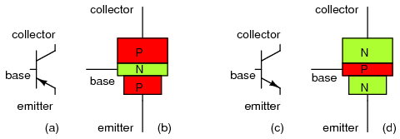

*Fig.(1): BJT transistor: (a) PNP schematic symbol, (b) physical layout (c) NPN symbol, (d) layout.*

The transistor has four operation regions as shown in the figure below:

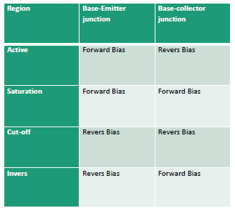

Fig.(2)

1. In active Region   –   the transistor operates as an amplifier and Ic = β*Ib
2. Saturation   –   the transistor is “Fully-ON” operating as a switch and Ic = I(saturation)
3. Cut-off   –   the transistor is “Fully-OFF” operating as a switch and Ic = 0

1

The modes of operation can be described in terms of the applied voltages (this description applies to NPN transistors; polarities are reversed for PNP transistors):

* Forward-active: base higher than emitter, collector higher than base (in this mode the collector current is proportional to base current by β).
* Saturation: base higher than emitter, but collector is not higher than base.
* Cut-Off: base lower than emitter, but collector is higher than base. It means the transistor is not letting conventional current go through from collector to emitter.
* Reverse-active: base lower than emitter, collector lower than base: reverse conventional current goes through transistor.

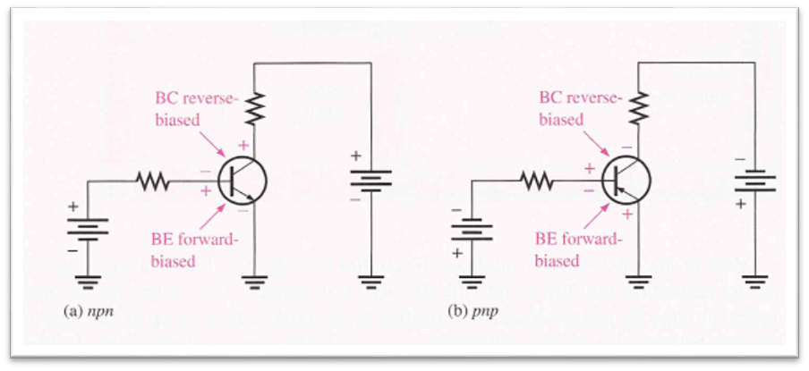

Fig.(3): This figure shows the bias of BJT Transistor

Current-Voltage relationship of BJT:

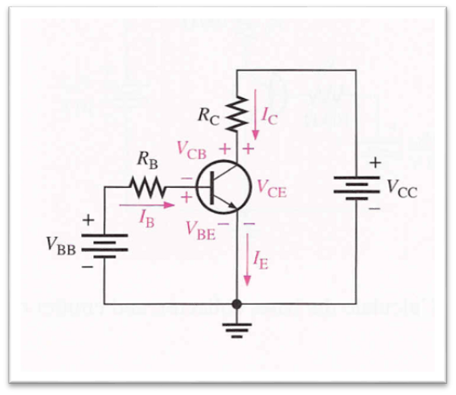

Fig.(4)

VBE: voltage at base with respect to emitter

VCE: voltage at collector with respect to emitter

2

VCB: voltage at collector with respect to base

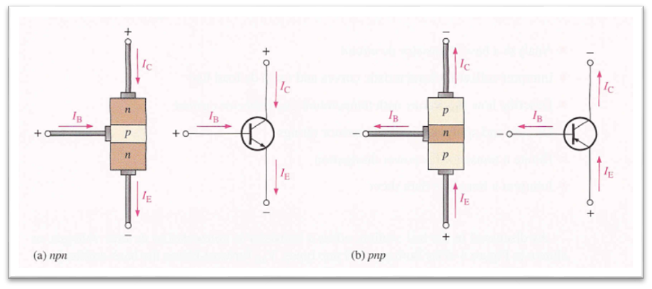

Fig.(5)

There are three current types flowing in bipolar junction transistor. There are collector current IC, emitter current IE, and base current IB.

By Kirchhoff's Current Law KCL,

IE = IB + IC …….(1)

And in the active region we can use these equations:

Ic=α*Ie……(2)

Ic=β*Ib……..(3)

Ie=(β+1)*Ib……..(4)

Where $\left(β=\frac{α}{1-α}\right) which is the dc current gain (β=\frac{IC}{IB})$**……(5)**

Where α is the common-base current gain. The common-base current gain is approximately the gain of current from emitter to collector in the forward-active region. This ratio usually has a value close to unity; between 0.98 and 0.998

And β is The common-emitter current gain is represented; it is approximately the ratio of the DC collector current to the DC base current in forward-active region. It is typically greater than 100 for small-signal transistors but can be smaller in transistors designed for high-power applications.

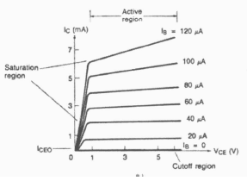

Fig.(6)

3

***Procedure, data and calculation:***

*I. The Transistor Biasing:*

1. The circuit shown in Fig.(7) was connected using the PnP transistor .

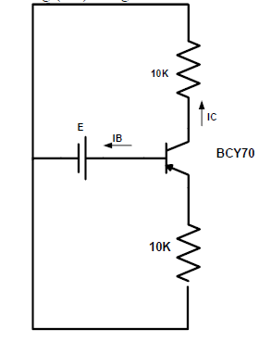

Fig.(7)

2. The voltage source was set to 4V and the currents were measured:

IC=IB=IE=0A

* That mean the transistor is in the cut-off region.

Then the voltage source was reversed and the currents were measured:

IC= 0.331mA , IB=0.002mA ,IE=0.33mA

* notice that IC=IE-IB in this case and The transistor in the saturation region.

3. The same last two steps were repeated for npn transistor.

First when the voltage source is connected with the base the currents were:

Ic=0.027mA ,Ib=0.mA Ie=0.026mA

* The transistor is in the saturation region

After the source reversed the currents are:

Ic=Ib=Ie=0A

4

* The transistor is in the cut-off region

4.The circuit in figure (8) was connected .

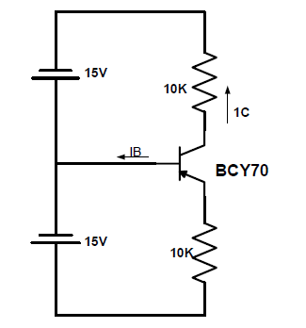

Fig. (8)

In the pnp case the BE junction is forward biased and the BC junction is reverse biased.

The currents are: Ib=0A Ic=1.434mA Ie=1.42mA

In the pnp case the BC junction is forward biased and the BE junction is reverse biased.

The currents are: Ib=0A Ic=1.418mA Ie=1.435mA

* The currents in the two cases are very close

***II. The Transistor DC Parameters:***

*A : Input Characteristic:*

* The circuit in fig.(9) was connected

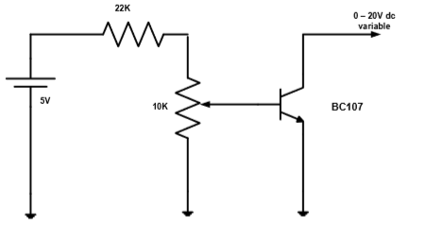

Fig.(9).

5

* the power supply was Switched on. measured VBE when VCE = 0V and IB = 0 µA. 
* the 10K potentiometer was rotated slowly clock wise till base current is 5 µA . VBE was measured until VCE is still 0 V. Repeat for IB as shown in Table 1 , and continued for other values of VCE.

Table (1)

|  |  |  |
| --- | --- | --- |
| **VCE** | **IB(µA)** | **VBE[V]**  **Measure** |
|  | 0 | 0.123 |
| 0 | 5 | 0.5175 |
|  | 10 | 0.5413 |
|  | 15 | 0.553 |
|  | 0 | 0.1562 |
| 2 | 5 | 0.5472 |
|  | 10 | 0.575 |
|  | 15 | 0.5906 |
|  | 0 | 0.002 |
| 3 | 5 | 0.5609 |
|  | 10 | 0.5859 |
|  | 15 | 0.6023 |

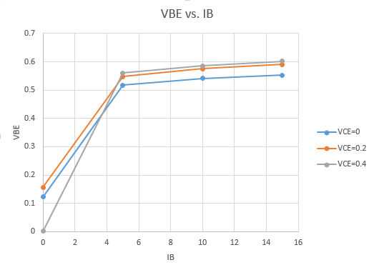

Fig.(10)

7

***B: Reverse Voltage Characteristic:***

1. For the same circuit of Fig.(9), the supply was switched off. the 10K pot. was set to zero and variable knob is at minimum .

2. the supply was Switched on and IB= 2.5µA .Recorded VBE for VCE settings as in Table 2

Table(2)

|  |  |  |
| --- | --- | --- |
| **IB(µA)** | **VCE** | **VBE[V]**  **Measure** |
|  | 0 | 0.521 |
|  | 0.5 | 0.528 |
| 2.5 | 2 | 0.528 |
|  | 5 | 0.528 |
|  | 15 | 0.525 |
|  | 0 | 0.537 |
|  | 0.5 | 0.537 |
| 5 | 2 | 0.537 |
|  | 5 | 0.537 |
|  | 15 | 0.537 |
|  | 0 | 0.56 |
|  | 0.5 | 0.59 |
| 15 | 2 | 0.59 |
|  | 5 | 0.59 |
|  | 15 | 0.59 |

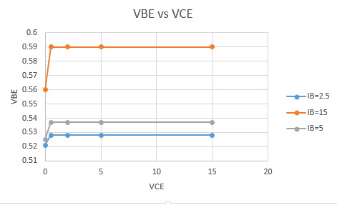

Fig.(11)

8

***C: The output Characteristics:***

1. For the same circuit of Fig.(9), the supply was switched off. the 10K pot. was set to zero and variable knob is at minimum .

2Recorded IC where the settings as in Table 3

Table(3)

|  |  |  |
| --- | --- | --- |
| **IB(µA)** | **VCE** | **IC[Ma]Measure** |
|  | 0 | 12.6u |
|  | 0.5 | 18.4u |
| 2.5 | 2 | 18.6u |
|  | 5 | 19u |
|  | 15 | 20.3u |
|  | 0 | 32.6u |
|  | 0.5 | 74.4 |
| 5 | 2 | 74.6 |
|  | 5 | 75.5 |
|  | 15 | 76.5 |
|  | 0 | 0.130 |
|  | 0.5 | 0.985 |
| 15 | 2 | 0.992 |
|  | 5 | 1.005 |
|  | 15 | 1.039 |

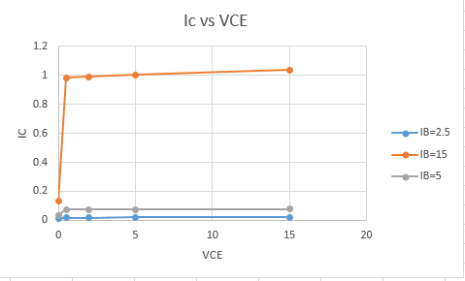

Fig.(12)

9

***D:Forward Current Transfer Characteristic:***

1.For the same circuit of Fig.(9), the pot. Was returned to zero and VCE reset to 2.5V. Measured IC for IB as in table 4

Table(4)

|  |  |  |
| --- | --- | --- |
| **VCE** | **IB(µA)** | **VBE[V]**  **Measure** |
|  | 0 | 0 |
| 2.5 | 5 | 0.09 |
|  | 10 | 0.54 |
|  | 15 | 1 |
|  | 0 | 0 |
| 5 | 5 | 0.19 |
|  | 10 | 0.56 |
|  | 15 | 0.98 |
|  | 0 | 0 |
| 15 | 5 | 0.23 |
|  | 10 | 0.5 |
|  | 15 | 1.01 |

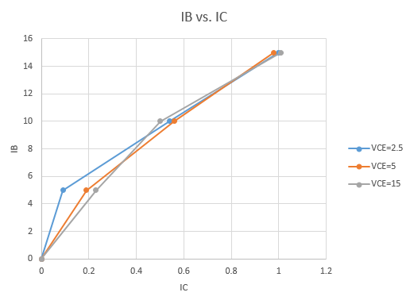

Fig.(13)

10

***Questions:***

HIE =(∆VBE/∆IB )|vce=0. “ input characteristic”

=(0.66-0)/(15)=44kΩ

HRE =(∆VBE/∆VCE) | ib=0.” reverse characteristic”

=(0.65-0.56)/15=6*10^-3

HOE =(∆IC/∆VCE) | ib=0.” output characteristic”

=(6.020-0.56)/(15)=3.64*10^-4Ω

HF E=(∆IB/IC) | vce=0.” forward current transfer characteristic”

*=(15u-0)/(4.096m-0)=3.662*10^-3*

11

**Conclusion:**

In conclusion the transistor junctions work just like two diodes that share a terminal, the way to bias the bjt in one of the three important biasing regions: the cut-off , active and saturation regions is clear. One now understand the meaning of each parameter of the two-port equivalent circuit of the bjt from the graphs and why the hoe and hre are dropped from the circuit due to their low values. The data collected in this experiment coincides with expected theoretical data with minor errors. Such errors can be expected from uncalibrated instruments or from unprecise supply and/or component values. The errors in this experiment are negligible and thus one can say that this experiment was successful.

12

***References :***

* Electronics lab manual
* https://www.allaboutcircuits.com/textbook/semiconductors/chpt-4/bipolar-junction-transistors-bjt/
* https://www.electronics-tutorials.ws/transistor/tran_1.html

13