

Faculty of Engineering and Technology

Electrical and Computer Engineering Department

**ENEE 3102 – Electronics Lab**

Experiment No. 3

**The transistor biasing and DC Parameters**

Prepared By:

Name: Suhaeb Qadan Number: 1160297

Instructor: Dr. Mohammad Al Jubeh

TA: Eng. Almo`tassem Bilhah

Date: 25/9/2019

Sec#: 1

# **Abstract**

In this experiment, some concept was studied about bipolar junction transistor, the aim of this experiment is to become familiar and understand how the operating principle of bipolar junction transistor in DC mode, to investigate the supplies connections to the transistor. Also, to investigate the characteristics of the transistor for varying dc supply voltage to its three connection models. the characteristic of the transistor was also studied in many cases, and the relations between currents and voltages were also observed.

Equipment's List:

* DC power supply.
* BJT (PnP, nPn).
* Resistors and Potentiometer.
* Electrical Kit.
* Wires.

**Table of Contents**

**Abstract** 2

**Theory** 4

**Procedure** 6

**Part A: The Transistor Biasing** 6

**Part B: The Transistor DC Parameters** 7

**Data, Calculation and Discussion** 9

**Part A: The Transistor Biasing** 9

**Part B: The Transistor DC Parameters** 10

**Conclusion** 15

**References** 16

**Appendix** 17

**List of Figures**

Figure 1: Types of bipolar junction transistor… [3] 5

Figure 2: Circuit for transistor biasing using the PnP transistor 7

Figure 3: Circuit for transistor biasing using the PnP transistor when the two variable DC sources were set to 15V 7

Figure 4: Circuit to show the input characteristic of the DC parameters for transistor using the nPn transistor, potentiometer, power supply. 8

Figure 5: The plot of VBE against IB, VBE is on the y-axis. 11

Figure 6: The plot of IC against IB, where`s IB on the Y-axis. 12

Figure 7: The plot of VBE against VCE, where`s VBE on the Y-axis 13

Figure 8: The plot of IC against VCE, where`s IC on the Y-axis. 14

**List of Tables**

Table 1: Input Characteristic 11

Table 2: Forward Current Transfer Characteristic 12

Table 3: Reverse Voltage Characteristic 13

Table 4: The Output Characteristic 14

# **Theory**

**Definition of Bipolar Junction Transistor**

A bipolar junction transistor (BJT) is a type of semiconductor that uses both electron and hole charge carriers. They are used to amplify electric current. BJT is formed by joining two types of semiconductors, P-type and N-type, with a third base. This base can modulate the amount of electricity flowing through it. These devices allow for the amplification of electric current in a very small space.

A bipolar junction transistor is also known as a bipolar transistor… [1]

**Types of Bipolar Junction Transistor**

**There are two types of**[Bipolar Junction Transistor (BJT)](http://www.polytechnichub.com/what-is-bjt-bipolar-junction-transistor/)**are given below:**

1. NPN bipolar junction transistor.
2. PNP bipolar junction transistor… [2]

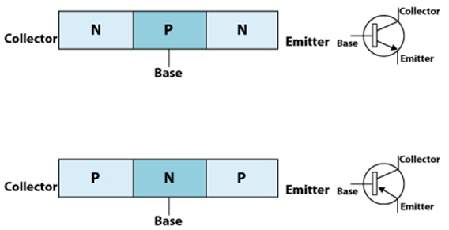

Figure 1: Types of bipolar junction transistor… [3]

**Working Principle of BJT**

The BE junction is a forward bias and the CB is a reverse bias junction. The width of the depletion region of the CB junction is higher than the BE junction. The forward bias at the BE junction decreases the barrier potential and produces electrons to flow from the emitter to the base and the base is a thin and lightly doped it has very few holes and less amount of electrons from the emitter about 2% it recombine in the base region with holes and from the base terminal it will flow out. This initiates the base current flow due to combination of electrons and holes. The left-over large number of electrons will pass the reverse bias collector junction to initiate the collector current… [3]

**Transistor Biasing**

Transistor Biasing is the process of setting a transistors DC operating voltage or current conditions to the correct level so that any AC input signal can be amplified correctly by the transistor. The steady state operation of a transistor depends a great deal on its base current, collector voltage, and collector current values and therefore, if the transistor is to operate correctly as a linear amplifier, it must be properly biased around its operating point… [4]

**Transistor Characteristics**

**Transistor Characteristics** are the plots which represent the relationships between the [current](https://www.electrical4u.com/electric-current-and-theory-of-electricity/) and the [voltages](https://www.electrical4u.com/voltage-or-electric-potential-difference/) of a [transistor](https://www.electrical4u.com/bipolar-junction-transistor-or-bjt-n-p-n-or-p-n-p-transistor/) in a particular configuration. By considering the transistor configuration circuits to be analogous to two-port networks, they can be analyzed using the characteristic-curves which can be of the following types:

1. **Input Characteristics:** These describe the changes in input current with the variation in the values of input voltage keeping the output voltage constant.
2. **Output Characteristics:** This is a plot of output current versus output voltage with constant input current.
3. **Forward Current Transfer Characteristics:** This characteristic curve shows the variation of output current in accordance with the input current, keeping output voltage constant.
4. **Reverse Voltage Characteristics:** This is a plot of output voltage verses input voltage, by considering to keep the input current constant.

**Advantages of BJT**

* High driving capability.
* High frequency operation.
* Digital logic family has an emitter coupled logic used in BJTs as a digital switch.

**Applications of BJT**

* Switching.
* Amplification.

# **Procedure**

## **Part A: The Transistor Biasing**

The circuit was connected in Figure 2 as shown below:

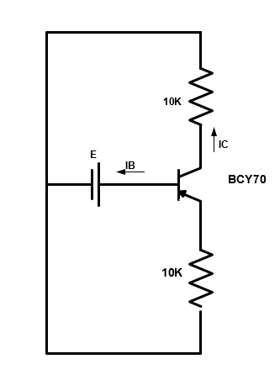

Figure 2: Circuit for transistor biasing using the PnP transistor

PnP transistor was used, the supply was turned on and the variable DC voltage was set to 4V, the values of IE, IC and IB were measured using DMM and the results were recorded in calculations part.

When the connections of the supply were reversed such that both junctions are forward biased. The values of IE, IC and IB were measured using DMM and the results were recorded in calculations part.

The circuit was connected in Figure 3 as shown below:

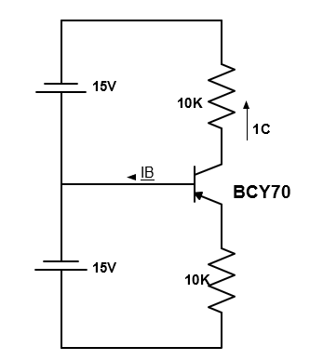

Figure 3: Circuit for transistor biasing using the PnP transistor when the two variable DC sources were set to 15V

PnP transistor was used, the two supply was turned on and the two variable DC voltage were set to 15V, the values of IE, IC and IB were measured using DMM and the results were recorded in calculations part.

When the connections of the two supplies were reversed and nPn transistor was used, the values of IE, IC and IB were measured using DMM and the results were recorded in calculations part.

## **Part B: The Transistor DC Parameters**

**B.1: Input Characteristic:**

The circuit was connected in Figure 4 as shown below:

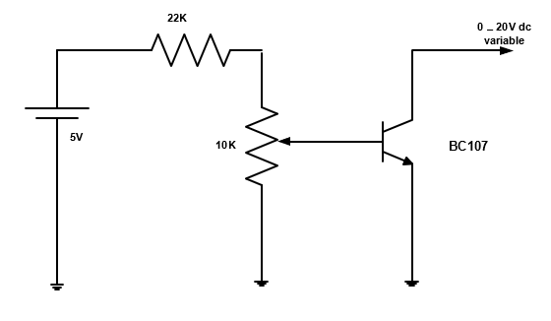

Figure 4: Circuit to show the input characteristic of the DC parameters for transistor using the nPn transistor, potentiometer, power supply.

Initially, the variable DC supply knop to min, and the 10k potentiometer to zero, switch on the power DC supply. VBE was measured for a constant value of VCE, and by rotating the potentiometer slowly to get a constant value of IB. The results of VBE were recorded in table 1.

**B.2: Forward Current Transfer Characteristic:**

For the same circuit of Figure 4, IC was measured for a constant value of VCE, and by rotating the potentiometer slowly to get a constant value of IB. The results of IC were recorded in table 2.

**B.3: Reverse Voltage Characteristic:**

For the same circuit of Figure 4, VBE was measured for a constant value of IB, and by rotating the potentiometer slowly to get a constant value of VCE. The results of VBE were recorded in table 3.

**B.4: The Output Characteristic:**

For the same circuit of Figure 4, IC was measured for a constant value of IB, and by rotating the potentiometer slowly to get a constant value of VCE. The results of IC were recorded in table 4.

# **Data, Calculation and Discussion**

## **Part A: The Transistor Biasing**

From the circuit connected in Figure 2, PnP transistor was used. The values of IE, IC and IB are equals **zero**.

For the same circuit, when the connections of the supply were reversed such that both junctions are forward biased. The values of IE, IC and IB:

IB = 0.661 µA IC = 0.335 µA IE = 0.335 µA

When both junctions are forward biased, that means the transistor is in the saturation region, and when both are reversed, the transistor is in cut-off region.

From the circuit connected in Figure 3, PnP transistor was used. The values of IE, IC and IB:

IB = 13 µA IC = 1.432 mA IE = 1.432 mA

For the same circuit, When the connections of the two supplies were reversed and nPn transistor was used, the values of IE, IC and IB:

IB = 49 µA IC = 1.406 mA IE = 1.42 mA

From the results, noticed that when one junction is forward biased and one is reverse biased. The transistor is in active region.

When the supplies terminals were reversed, and nPn transistor was used. The currents are almost the same with the currents that are found when PnP was used.

If the emitter junction is reverse biased and collector junction is forward biased in a transistor, then it is said to be in reverse active region which is exactly analogous with the forward active region and with the roles of collector and emitter reversed.

## **Part B: The Transistor DC Parameters**

**B.1: Input Characteristic:**

Table 1: Input Characteristic

|  |  |  |  |
| --- | --- | --- | --- |
| VCE [V] | IB[µA] |  | VBE [V] |
| 0 |  | 0 | 0 |
|  | 5 | 0.464 |
|  | 10 | 0.496 |
|  | 15 | 0.51 |
| 0.2 |  | 0 | 0.012 |
|  | 5 | 0.517 |
|  | 10 | 0.547 |
|  | 15 | 0.565 |
| 0.4 |  | 0 | 0.012 |
|  | 5 | 0.518 |
|  | 10 | 0.550 |
|  | 15 | 0.568 |

The plot of VBE against IB, where`s VBE on the Y-axis.

Figure 5: The plot of VBE against IB, VBE is on the y-axis.

**B.2: Forward Current Transfer Characteristic:**

Table 2: Forward Current Transfer Characteristic

|  |  |  |  |
| --- | --- | --- | --- |
| VCE [V] | IB [µA] |  | IC [mA] |
| 2.5 |  | 0 | 0.16 |
|  | 5 | 0.168 |
|  | 10 | 0.1615 |
|  | 15 | 0.1622 |
| 5 |  | 0 | 0.162 |
|  | 5 | 0.1629 |
|  | 10 | 0.1636 |
|  | 15 | 0.1642 |
| 15 |  | 0 | 0.1603 |
|  | 5 | 0.1607 |
|  | 10 | 0.1614 |
|  | 15 | 0.1622 |

The plot of IC against IB, where`s IB on the Y-axis.

Figure 6: The plot of IC against IB, where`s IB on the Y-axis.

**B.3: Reverse Voltage Characteristic:**

Table 3: Reverse Voltage Characteristic

|  |  |  |
| --- | --- | --- |
| IB [µA] | VCE [V] | VBE [V] |
| 2.5 | 0 | 0.441 |
| 0.5 | 0.445 |
| 2 | 0.445 |
| 5 | 0.445 |
| 15 | 0.445 |
| 5 | 0 | 0.47 |
| 0.5 | 0.48 |
| 2 | 0.48 |
| 5 | 0.48 |
| 15 | 0.48 |
| 15 | 0 | 0.54 |
| 0.5 | 0.573 |
| 2 | 0.573 |
| 5 | 0.573 |
| 15 | 0.573 |

The plot of VBE against VCE, where`s VBE on the Y-axis.

Figure 7: The plot of VBE against VCE, where`s VBE on the Y-axis

**B.4: The Output Characteristic:**

Table 4: The Output Characteristic

|  |  |  |
| --- | --- | --- |
| IB [µA] | VCE [V] | IC |
| 2.5 | 0 | 0 µA |
| 0.5 | 2 µA |
| 2 | 2.02 µA |
| 5 | 2.1 µA |
| 15 | 2.1 µA |
| 5 | 0 | 1.5 µA |
| 0.5 | 8.5 µA |
| 2 | 8.5 µA |
| 5 | 8.5 µA |
| 15 | 8.6 µA |
| 15 | 0 | 17.3 µA |
| 0.5 | 0.3 mA |
| 2 | 0.301 mA |
| 5 | 0.305 mA |
| 15 | 0.312 mA |

The plot of IC against VCE, where`s IC on the Y-axis.

Figure 8: The plot of IC against VCE, where`s IC on the Y-axis.

**Question:**

* HIE = (∆VBE/∆IB) |VCE=0 … [1]
* HIE = = 3.6 kΩ
* HRE = (∆VBE/∆VCE) | IB=0 … [2]
* HRE = 0
* HOE = (∆IC/∆VCE) | IB=0 … [3]
* HOE = = 1.33 µ℧
* HFE = (∆IB/IC) | VCE=0 … [4]
* HFE = = 7.14

# **Conclusion**

In this excitement, it`s clearly that BJT has three terminals which is the three layers of semiconductors. These are an emitter, base and collector. The main use of the bipolar transistor is in the application of an amplifier due to the fact that a small base current control the current at the collector and emitter, all objectives in experiment were conserved and every goal was achieved.

At the end of this experiment, after comparing our measured values with the calculated ones, a small error was encountered which is due to systematic errors, thus having these values very close to the calculated ones theoretically from PSpice simulation. Also, the potentiometer effected to the results, especially in the part of the output characteristic. Finally, this experiment is very important for each electrical engineering student, because knowing the operating principle of transistor and how it works in all regions is very important.

# **References**

[1] <https://www.techopedia.com/definition/7900/bipolar-junction-transistor-bjt>

4:15 AM, September 23 ,2019

[2] <https://www.polytechnichub.com/types-bipolar-junction-transistor/>

4:40 AM, September 23 ,2019

[3] <https://www.elprocus.com/bipolar-junction-transistors-working-principle-and-applications/>

4:44 AM, September 23 ,2019

[4] <https://www.electronics-tutorials.ws/amplifier/transistor-biasing.html>

5:16 AM, September 23 ,2019

# **Appendix**

* HIE = (∆VBE/∆IB) | VCE=0 **Equation… (1)**
* HRE = (∆VBE/∆VCE) | IB=0 **Equation… (2)**
* HOE = (∆IC /∆VCE) | IB= 0 **Equation… (3)**
* HFE = (∆IB / IC) | VCE =0 **Equation… (4)**