

**Faculty of Engineering and Technology**

**ENEE3102, Electronics Lab.**

**Experiment #3 Report**

**The Transistor Biasing and the DC Parameters**

**Name : Fadi Abughazaleh**

**ID# : 1141961**

**Abstract:**

In this experiment the DC parameters of NPN and PNP bipolar junction transistors were investigated. The different biasing of the transistors were done; the transistors were seen in the cut-off, active and saturation regions. The necessary measurements were made to be able to approximate the two-port equivalent circuit for the BJT.

**Theory:**

The Bipolar Junction Transistor (BJT) is an electronic device made of doped semiconductor layers, it has two types: PNP and NPN; the name suggests the doped layers configuration shown below in figure 1.

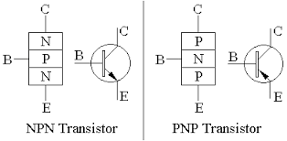

Figure 1

The NPN transistor is much faster than the PNP since the mobility of the electrons is larger than that of holes.

The transistor has four operation regions three of which are important: the cut-off region, the active region and the saturation region. See figure 2 and 3.

When both junction are reverse biased this region is called the cut-off region, in this region no current flows from any of the transistor terminals.

When the base-emitter junction is forward biased and the base-collector junction is reverse biased this region is called the active region, in this region the transistor can work as an amplifier. In the active region the base current and collector current have a linear relation with a slope of beta (the current gain of the transistor).

When both junction are forward biased this region is called the saturation region.

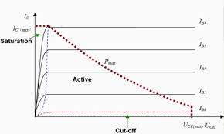

Figure 2

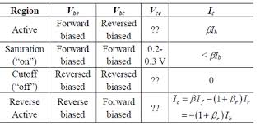

Figure 3

Usually the Transistor either works as an amplifier in the active region or as a switch in the cut-off and saturation regions.

**Procedure and results:**

The circuit in figure (3-1) was connected and then the voltage source was reversed.



In the first case the diode conducts, but when the supply is reversed the diode does not conduct.

Then the base-collector junction was investigated and the same results were found the diode conducts when the supply is connected to the base and it doesn’t conduct when the supply is reversed.

The circuit in Figure (3-2) was connected next.



The voltage source was set to 4V and the currents were measured:

Ic=Ib=Ie=0.1uA

Approximately zero meaning that the transistor is in the cut-off region.

Then the voltage source was reversed and the currents were measured:

Ic=330mA , Ib=656mA ,Ie=330mA

The transistor here is in the saturation region.

Next the same last two steps were repeated for an npn transistor.

First when the voltage source is connected with the base the currents were:

Ic=0.33mA ,Ib=0.63mA Ie=0.31mA

The transistor is in the saturation region

After reversing the source the currents are:

Ic=Ib=Ie=0.1uA

The transistor is in the cut-off region

The circuit in figure (3-3) was connected next.



In the pnp case the BE junction is forward biased and the BC junction is reverse biased.

The currents are: Ib=0.012mA Ic=1.42mA Ie=1.43mA

In the pnp case the BC junction is forward biased and the BE junction is reverse biased.

The currents are: Ib=0.03mA Ic=1.37mA Ie=1.41mA

The currents in the two cases are very close!!!!

Next the circuit in figure (3-4) was connected and the following tables were filled:



|  |  |  |
| --- | --- | --- |
| VCE | IB [A] | VBE [V]  Measure |
| 0 | 0 | 0 |
| 5 | 0.512 |
| 10 | 0.538 |
| 15 | 0.5503 |
| 0.2 | 0 | 0 |
| 5 | 0.537 |
| 10 | 0.567 |
| 15 | 0.58 |
| 0.4 | 0 | 0 |
| 5 | 0.541 |
| 10 | 0.583 |
| 15 | 0.584 |

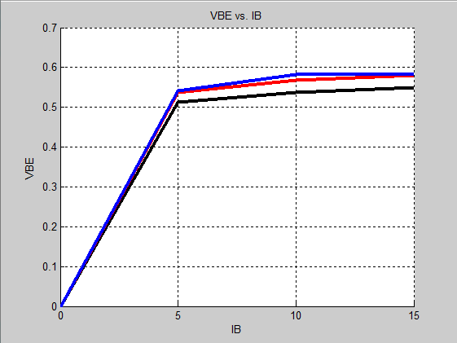

Figure 4

This graph shows the input characteristic of the bjt meaning how VBE changes to different input (Ibase).

|  |  |  |
| --- | --- | --- |
| IB [A] | VCE [V] | VBE [V]  Measure |
| 2.5 | 0 | 0 |
| 0.5 | 0.48 |
| 2 | 0.48 |
| 5 | 0.48 |
| 15 | 0.48 |
| 5 | 0 | 0.54 |
| 0.5 | 0.55 |
| 2 | 0.55 |
| 5 | 0.55 |
| 15 | 0.55 |
| 15 | 0 | 0.56 |
| 0.5 | 0.59 |
| 2 | 0.59 |
| 5 | 0.59 |
| 15 | 0.59 |

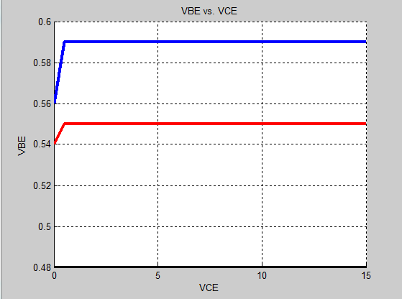

Figure 5

This graph shows the reverse voltage characteristic; it shows how the input voltage changes when the output voltage changes.

|  |  |  |
| --- | --- | --- |
| IB [A] | VCE [V] | IC [mA] <= Measure |
| 2.5 | 0 | 0.0014 |
| 0.5 | 0.004 |
| 2 | 0.004 |
| 5 | 0.004 |
| 15 | 0.005 |
| 5 | 0 | 0.025 |
| 0.5 | 0.013 |
| 2 | 0.014 |
| 5 | 0.014 |
| 15 | 0.015 |
| 15 | 0 | 0.001754 |
| 0.5 | 0.335 |
| 2 | 0.35 |
| 5 | 0.355 |
| 15 | 0.369 |

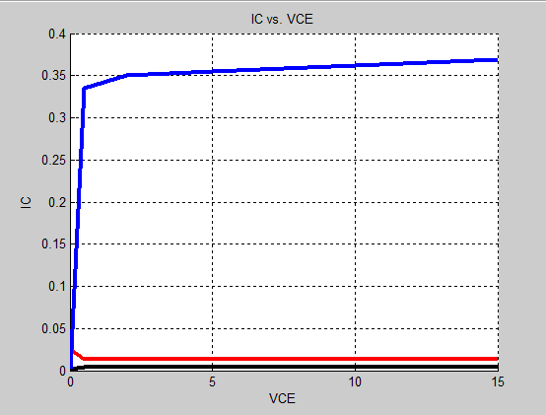

Figure 6

This graph shows the output characteristic of the bjt; it shows how the output current changes when the output voltage changes.

|  |  |  |
| --- | --- | --- |
| VCE | IB [A] | IC [mA]🡸 |
| 2.5 | 0 | 0 |
| 5 | 0.0687 |
| 10 | 0.16715 |
| 15 | 0.303 |
| 5 | 0 | 0 |
| 5 | 0.07584 |
| 10 | 0.17773 |
| 15 | 0.303 |
| 15 | 0 | 0 |
| 5 | 0.072 |
| 10 | 0.177 |
| 15 | 0.307 |

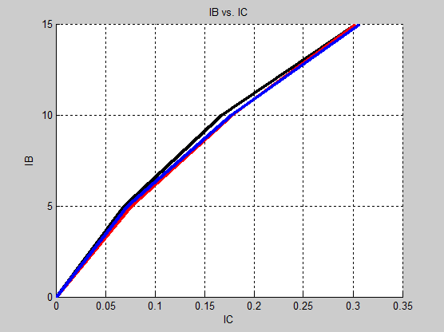

Figure 7

This graph shows the current transfer characteristic; it shows the current gain of the transistor beta which is the inverse slope.

From all the previous graphs one can calculate the parameters of the two-port network that represents the bjt. See figure 8.

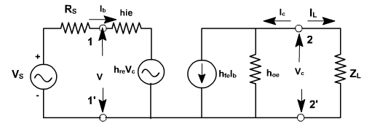

Figure 8

The equations for these parameters are shown in figure 9.

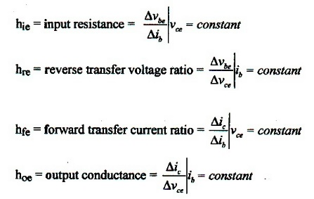

Figure 9

Hie=2.4k ohm

Hre=0

Hoe=1x10^-7 siemens

Hfe=beta=19.69

**Conclusion:**

In conclusion the transistor junctions work just like two diodes that share a terminal, the way to bias the bjt in one of the three important biasing regions: the cut-off , active and saturation regions is clear. One now understand the meaning of each parameter of the two-port equivalent circuit of the bjt from the graphs and why the hoe and hre are dropped from the circuit due to their low values. The data collected in this experiment coincides with expected theoretical data with minor errors. Such errors can be expected from uncalibrated instruments or from unprecise supply and/or component values. The errors in this experiment are negligible and thus one can say that this experiment was successful.