

Faculty of Engineering and Technology

Electrical and Computer Engineering Department

Electronics LAB (ENEE3102)

Report of Experiment #4

Transistor as an Amplifier

Prepared by:

Name: Sara Totah Student ID: 1181779

Instructor:

Mohammad Jehad Al Jubeh

Date:

20/9/2020

Section: #1

Table of Contents

**Abstract:** 2

**Theory:** 2

**Procedure, Data and results:** 5

I. COMMON EMITTER TRANSISTOR AMPLIFIER: 5

II. COMMON COLLECTER TRANSISTOR AMPLIFIER: 6

**III.** **COMMON BASE TRANSISTOR AMPLIFIER:** 8

**Conclusion:** 11

**References:** 11

# **Abstract:**

The aim of this experiment was investigating the properties of the transistor amplifier in its three configuration, common emitter, common collector and common base connection, also in this experiment the effect of applying sinusoidal signal to a transistor connected in common emitter was investigated.

# **Theory:**

There are two types of transistor npn and pnp types, both of them can work in three regions: Active, Saturation and cut-off region.

Transistor amplifier properties:

1. Common emitter:

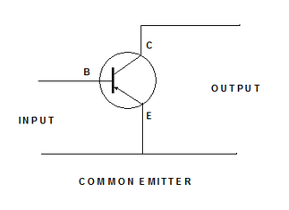

* Volrage gain (Av >1).
* Current gain (Ai >1).
* Input Impedance (Zi) is large.
* Output Impedance (Zo) is large.

1. Common Collector:

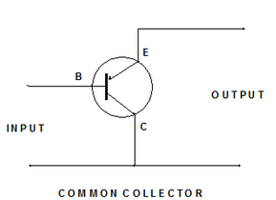

* Volrage gain (Av) < 1.
* Current gain (Ai) >1.
* Input Impedance (Zi) is very large.
* Output Impedance (Zo) is very small.

**Note:** The small signal gain voltage less than 1 is used to improve total voltage gain of multistage amplifier.

1. Common Base:

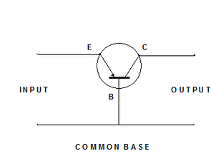

* Volrage gain (Av) > 1.
* Current gain (Ai) < 1.
* Input Impedance (Zi) is very small.
* Output Impedance (Zo) is large.

Approximate BJT models:

1. Common Emitter & Common Collector:

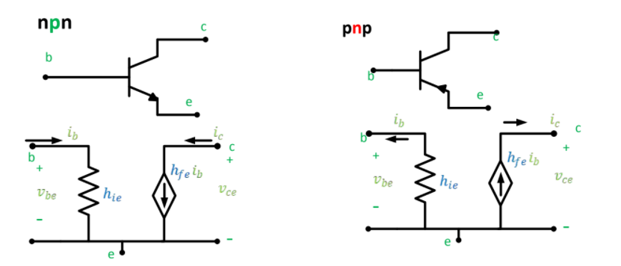

|  |  |  |
| --- | --- | --- |
|  | Ic = hfe * ib = βi­b | (1) |
|  | hfe = β | (2) |
|  | $$hie=\frac{V_{T}}{I_{B}}= \frac{{βV}_{T}}{I_{C}}= \frac{{(β+1)V}_{T}}{I_{E}}$$ | (3) |

1. Common Base:

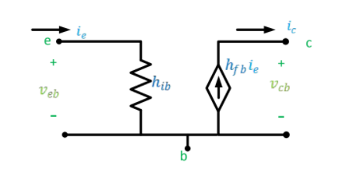

|  |  |  |
| --- | --- | --- |
|  | Ic = hfb * ie = αi­e | (1) |
|  | hfb = α | (2) |
|  | $$hib=\frac{V_{T}}{I_{E}}$$ | (3) |
|  | hie = (hfe + 1)*hib | (4) |

# **Procedure, Data and results:**

## COMMON EMITTER TRANSISTOR AMPLIFIER:

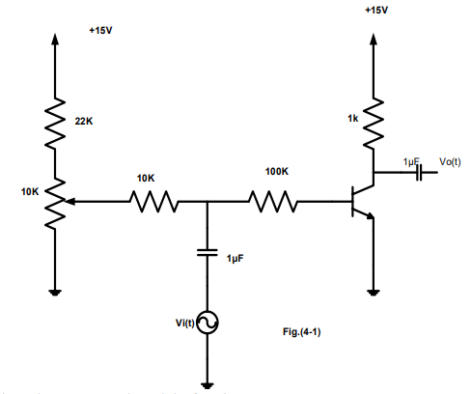

Figure (4 - 1)

First, the circuit in figure (4 – 1) was connected, the power supply and the function generator were connected, then the frequency of the function generator was set to 1KHz, and the amplitude to zero, the DC collector voltage (Vc) was adjusted to 8 volts, then the oscilloscope channels was connected to the base and to the output of the circuit, and the function generator was adjusted till the output voltage of the circuit = 8 volts peak-peak, and the measures were taken.

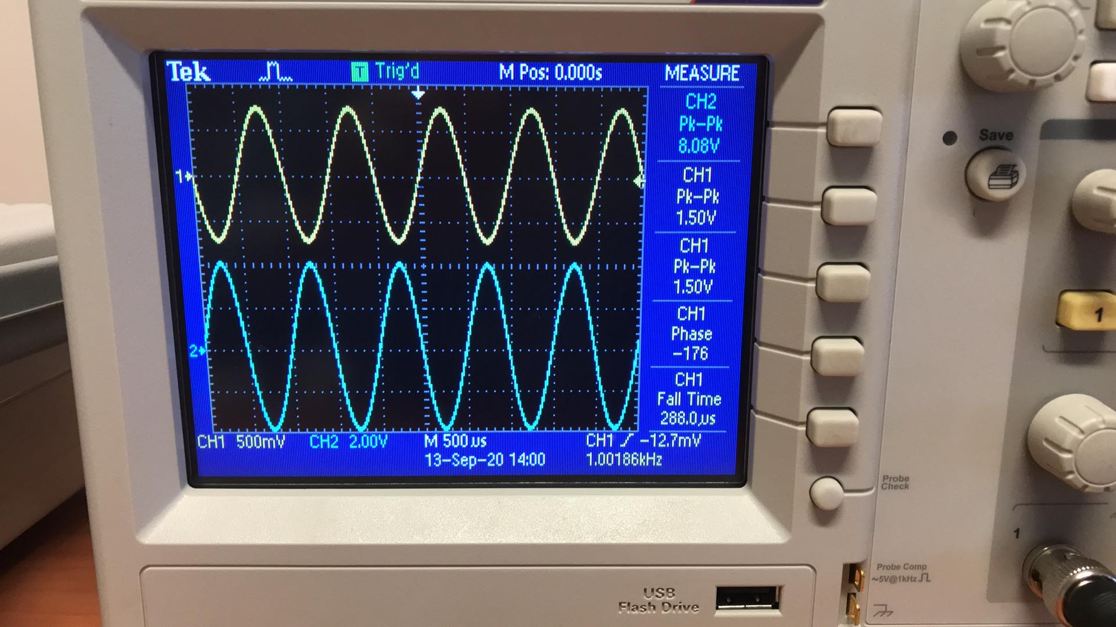

Figure (4 – 1)-wave

Vo = 4volts

Vbe = 0.614volts

Vi = 1.50volts

Ic = 2.4mA

Ib = 34.7uA

Ii = Ib = 34.7uA

Io = 15mA

* Voltage gain of the transistor: Av = Vo/Vbe = 4 / 0.614 = 6.5
* Voltage gain of the amplifier: Av = Vo/Vi = 4 / 1.5 = 2.6
* Current gain of the transistor: Ai = Ic / Ib = 69.1
* Current gain of the amplifier: Ai = 432.2
* Input Impedance: 43.23k

## COMMON COLLECTER TRANSISTOR AMPLIFIER:

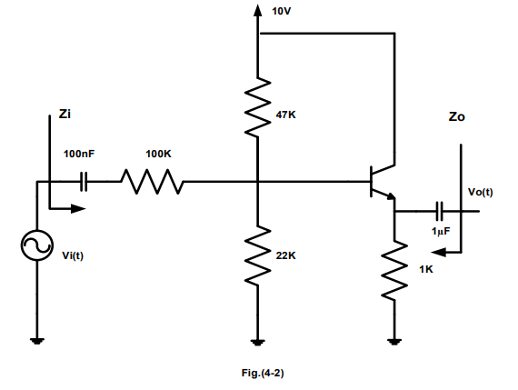

Figure (4 - 2)

First, the circuit in figure (4 – 2) was connected, the variable dc control was set to minimum, then the power supply was switched on and the variable dc voltage was adjusted to give a Vcc of +10v, then the frequency of the sine wave generator of 1kHz, and the output of the generator was set to zero by disconnecting its output, then some measures were taken:

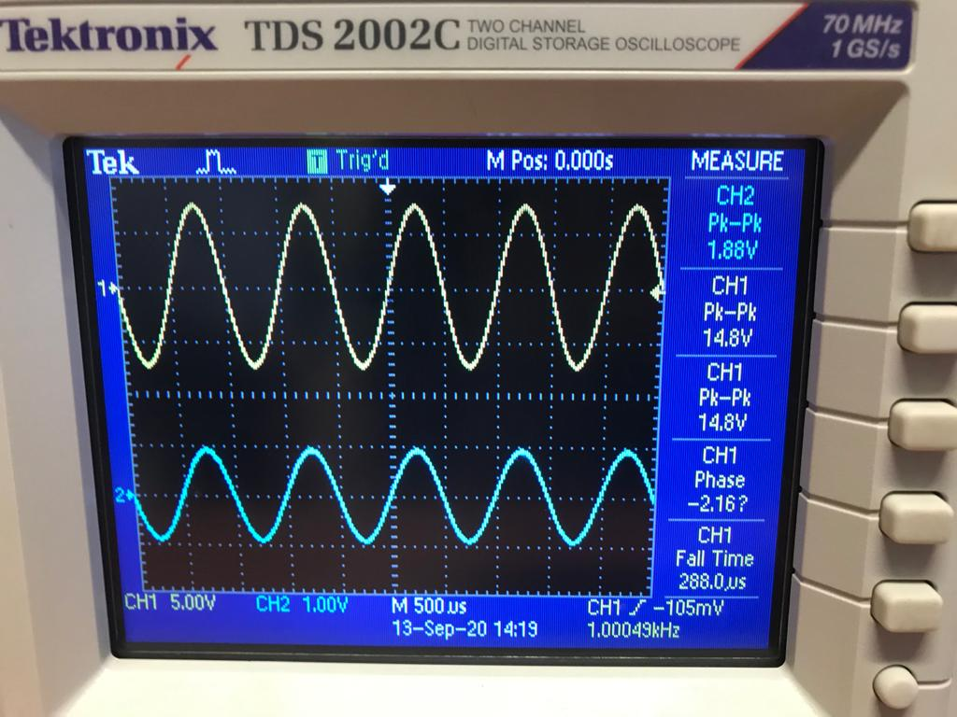

Figure (4 – 2) - wave 1

Output Voltage vs input voltage

VE = 2.3v

VB = 3v

Then the output amplitude was adjusted until the output amplitude is 2 volts peak-peak, and the input voltage needed to achive this output was measured:

Vin = 15/2 = 7.5v

Vout = 2/2 = 1v

* Voltage gain: Av = Vo/Vi = 0.13

Then the voltage around 100k was measured:

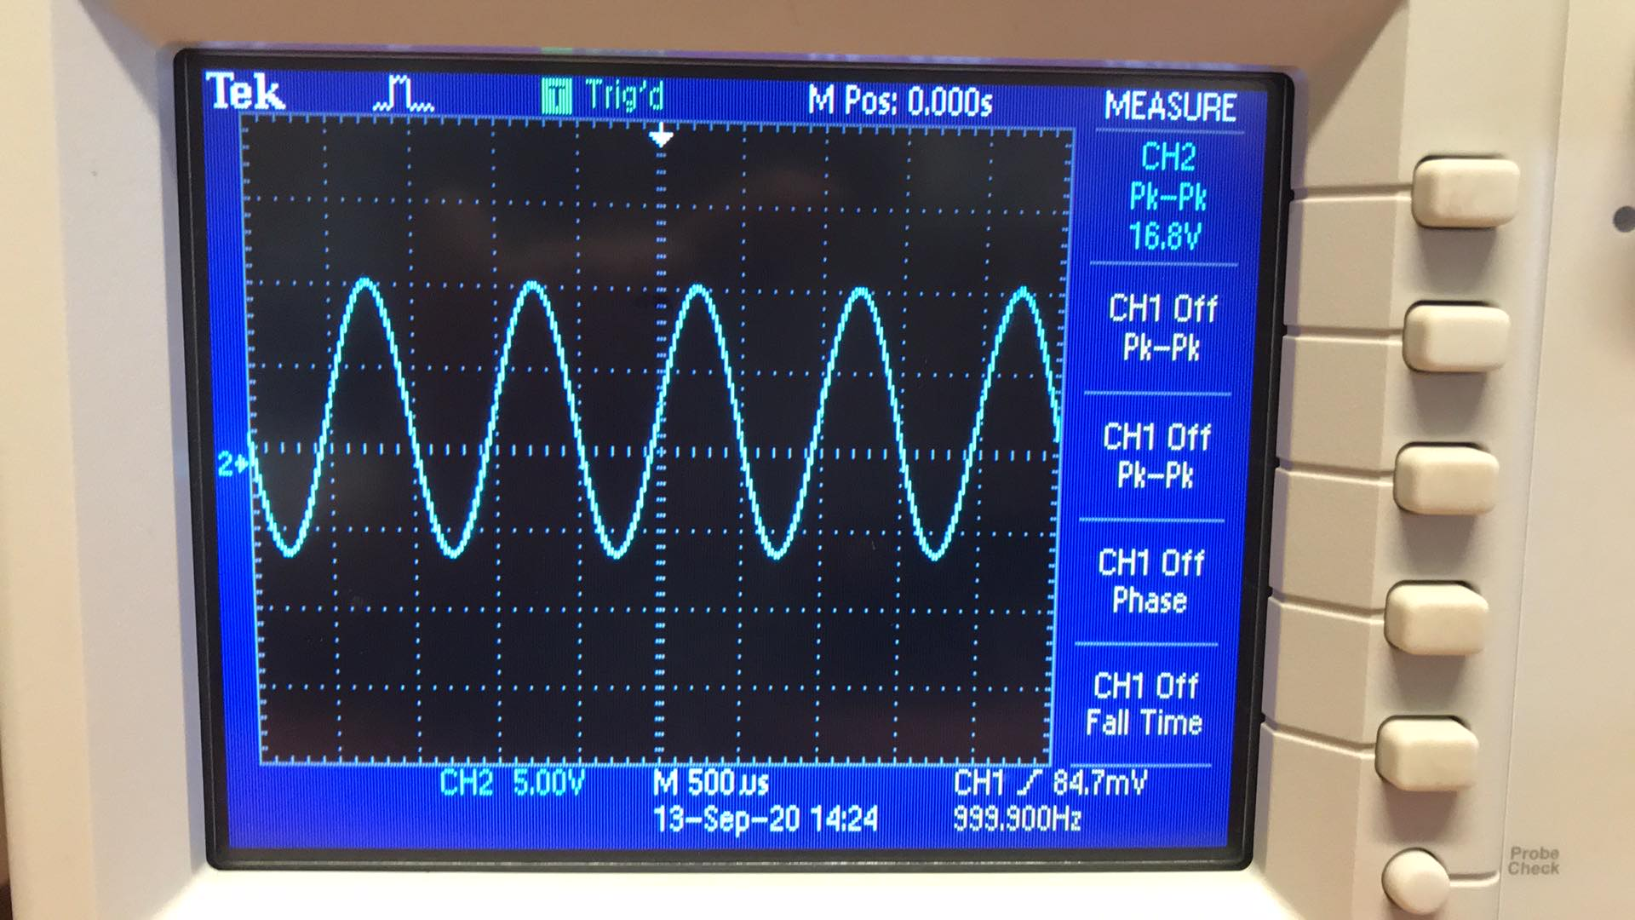

Figure (4 – 2) - wave 2

* Iin = V100kΩ / 100KΩ = 16.8 / 100k = 0.168mA
* Iout = Vout / 1kΩ = 1mA
* Ai = Iout / Iin = 1m / 0.168m = 5.95
* Zi = Vin / Iin = 7.5/0.168m = 44.6k
* Zout = VT / IT = 7mV / 37.77 uA = 185.3

|  |  |
| --- | --- |
| **Quantity** | **Measured Values** |
| Vin | 7.5v |
| Vout | 1v |
| Iin | 0.168mA |
| Iout | 1mA |
|  | Calculated Values |
| Av = Vout/Vin | 0.13 |
| Ai = Iout / Iin | 5.95 |
| Zin = Vin / Iin | 44.6k |
| Zout | 185.3 |

## **COMMON BASE TRANSISTOR AMPLIFIER:**

Note: this part was done theoretically using Pspice.

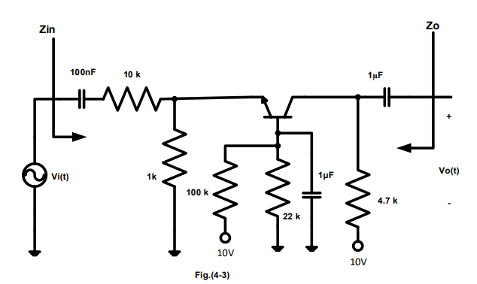

Figure (4 - 3)

First the circuit in Figure (4 – 3) was connected, the variable dc control was set to minimum, then the power supply was switched on and the variable dc voltage was adjusted to give a Vcc of +10v, then the frequency of the sine wave generator of 1kHz, and the output of the generator was set to zero by disconnecting its output, then some measures were taken:

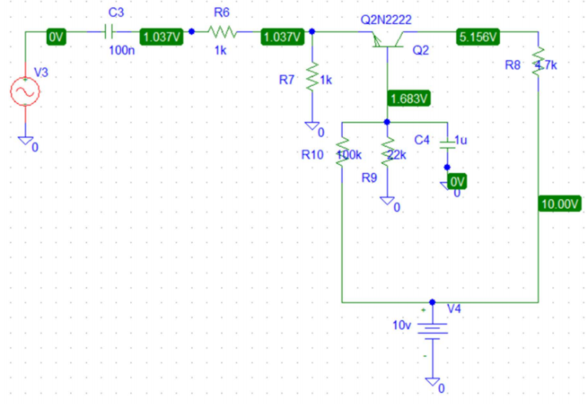

VBE= 0.651v

VCE=4.12v

VBC=-3.45v

IA= 1.03mA

IB=6.7uA

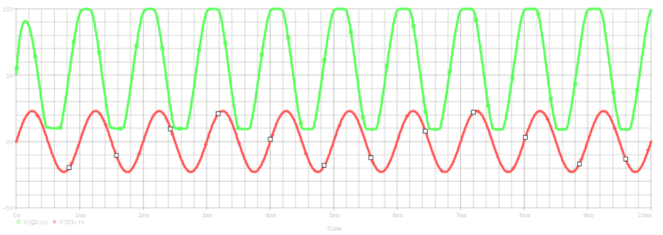

Output voltage vs input voltage

Figure (4-3) – wave 1

* The voltage gain: Av = Vo / Vin = 1 / 2.3 = 0.435

The AC voltage across the 10k resistor was measured:

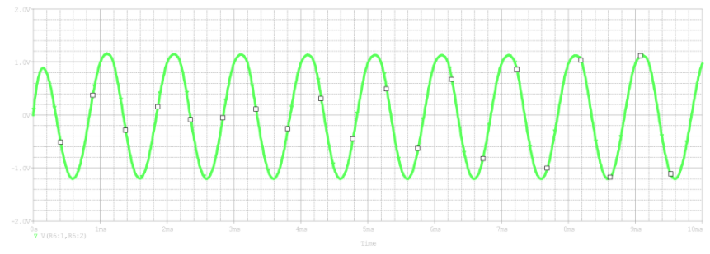

Figure (4 -2)-wave 2

Voltage across 10k

* The input current: In =Vin / R = 2.3/10k = 0.23mA
* The output current: Iout =Vo / R = 1/4.7k = 0.21mA
* Current gain: Ai =Io / Iin =0.91
* The input impedance: Zi =Vi /Iin = 2.3/.23m = 10kΩ
* The output impedance =Vo /Io = 4.8kΩ

|  |  |
| --- | --- |
| **Quantity** | **Measured Values** |
| Vin | 1v |
| Vout | 2.3v |
| Iin | 0.23mA |
| Iout | 0.21mA |
|  | Calculated Values |
| Av = Vout/Vin | 0.435 |
| Ai = Iout / Iin | 0.91 |
| Zin = Vin / Iin | 10k |
| Zout | 4.8k |

# **Conclusion:**

As mentioned before, the common emitter is supposed to make the output signal bigger than the input signal, which was proven by finding the voltage and current gain (both were larger than 1), and the input and output impedances were as supposed large.

In the common collector, the current gain was larger than 1, while the voltage gain was less than 1, and the output impedance was very small compared with the input impedance.

In the common base, we were expecting a voltage gain higher than 1, but the opposite is what happened because of the 10k resistor, while the current gain was very small and the input & output impedances were large.

The Data calculated and measure in this report matches the data in the pre-lab that we handed week ago.

# **References:**

1. <https://www.electrical4u.com/bipolar-junction-transistor-or-bjt-n-p-n-or-p-n-p-transistor/>
2. Electronics Lab ENEE3102 Lab Manual
3. Microelectronic_Circuits_6th_Edition