

**Faculty of Engineering and Technology**

**Electrical and Computer Systems Engineering**

**ENEE3102**

**“Exp#4”**

**BJT Transistor As An Amplifier CE,CC,CB Connection**

**Student’s name:** **Tamara Amro**

**Student’s number: 1172771**

**DR**: **Mohammad Jehad Al Ju'Beh**

**Eng: Amgad**

**29/10/2020**

**Table of Contents**

**ABSTRACT1**

**THEORY1**

**PROCEDURE7**

**Data, calculations, and analysis of results** **10**

**Conclusion** **15**

**References** **15**

**ABSTRACT:**

**The aim of this experiment is to explore the effect of applying an AC sinusoidal signal to the powered BJT when it is connected once as common emitter, and other as common collector, and as common base, and investigate the differences between the three types of connection by calculating some parameters from the measurements.**

* The methods used are by :

**By recording the current, voltage by convenient equipment.**

* The Equipment’s used:

**1. Resistances.**

**2. Capacitances.**

**3. Voltage source.**

**4. Transistors Amplifier BJT.**

**5-oscillcope**

**Other device**

**THEORY:**

**Bipolar Junction Transistor (BJT): it is a semiconductor device that can amplify electrical signals such as radio or television signals.it has two types .the first is npn type the second is pnp type**

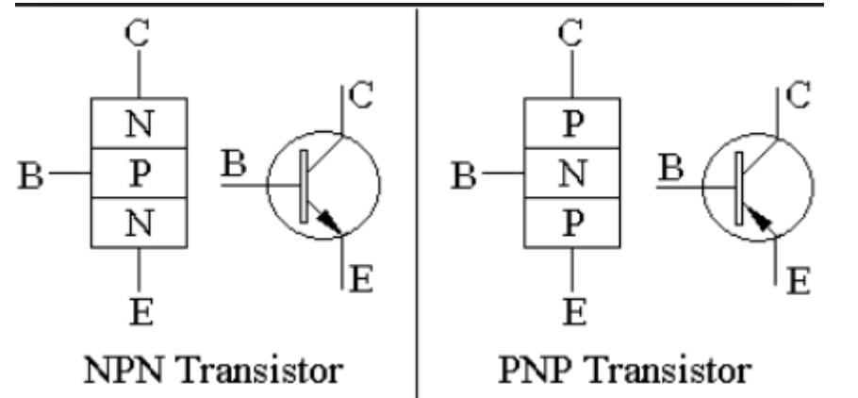

Figure 1(Two Types of BJT Transistor)

**And it has three terminals, then there is basically three possible way to connect it with an electronic circuit, such that one terminal has to be common to both the input and the output every kind of connection has its advantages and disadvantages, which means that the application determines the type of connection which can serve it. The three types are common emitter (CE), common collector (CC), and common base (CB). To differ between the three types of connection, some parameters are used.**

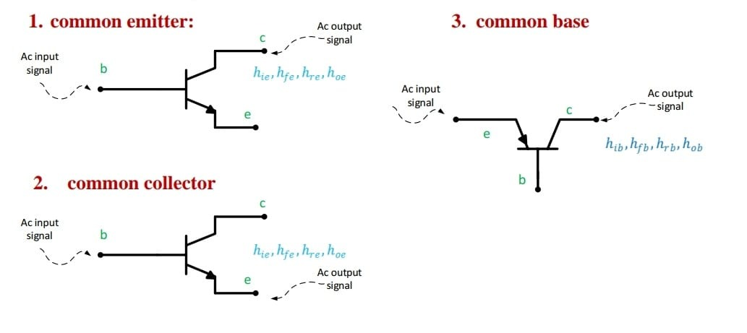

Figure 2(common emitter (CE), common collector (CC), and common base (CB).)

1. **COMMON EMMITER CONNECTION**

**This is the most common connection, such that, when an amplifier called amplifier without saying the type of connection so it is a common emitter, so it is the default amplifier, and that is because, it can amplify the voltage and the current in the same time, so it is a good choice when the type of the signal that would be amplified isn’t known In this circuit the base terminal of the transistor serves as the input, the collector is the output, and the emitter is common to both . The CE has a large input impedance -but less than the CC-, so it is a perfect voltage amplifier, but that is bad for the circuit to be a current amplifier. In contrast, it has a large output impedance and that is bad for the voltage amplifier and good for the current amplifier. Note that the CE is an inverting amplifier, and so, the output signal is 180o out of phase.**

**The main Characteristic:**

1. **Voltage gain is high (Av >> 1)**
2. **There is a current gain (Ai > 1)**
3. **Not very high input impedance (Zi)**
4. **Low output impedance (Zo)**

Its small signal equivalent circuit:

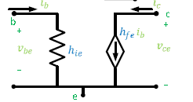

Figure 3(small signal equivalent of CE)

1. **Common Collector Connection CC**

**This type of connection has a large current gain, but it hasn’t a voltage gain (A<1). However, it has a very large input impedance and very small output impedance, and so it is known as a buffer, which can be used to separate two circuits (two stages for example) where the base terminal of the transistor serves as the input, the emitter is the output, and the collector is common to both**

**The main Characteristic:**

1. **No voltage gain (Av = 1) ; so like buffer**
2. **There is a current gain (Ai > 1)**
3. **High input impedance (higher than in common emitter)**
4. **Low input impedance**

**Its small signal equivalent circuit**:



Figure 4(small signal equivalent circuit of cc)

.

## C) Common Base Connection CB

**It has a high voltage gain. In other hand, it hasn’t a current gain. Because of its very low input impedance, its voltage gain is not stable i.e. if the input resistor of the input power source changes, then the voltage gain of the amplifier would affect roughly. Where input signal is applied to the emitter terminal and the output is taken from the collector terminal.**

**The main Characteristic:**

1. **There is a voltage gain (Av > 1)**
2. **Ai < 1**
3. **Low input impedance**
4. **High output impedance**

**Its small signal equivalent circuit:**

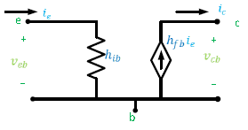

Figure 5(small signal equivalent circuit of CB)

**Procedure**

## Common Emitter Transistor Amplifier:

1. **We connected the circuit as shown below:**

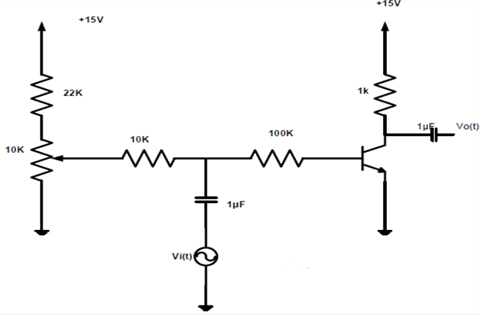

Figure (CE Circuit)

1. **we adjusted Vcc to be +15V ,but we kept AC source off. After that, we increased the AC voltage source amplitude until Vo,p-p=8V and we made frequency=1KHz.We used the oscilloscope and made that CH1 is the input and CH2 the output. The results in Figure(9)**
2. **The base bias point was adjusted using the potentiometer till the DC voltage of the capacitor became 8V.**
3. **By measuring the input and output currents and voltages, the current gain, voltage gain, and the input impedance were calculated and recorded.**

## Common Collector Transistor Amplifier:

**1-We connected the circuit as shown below:**

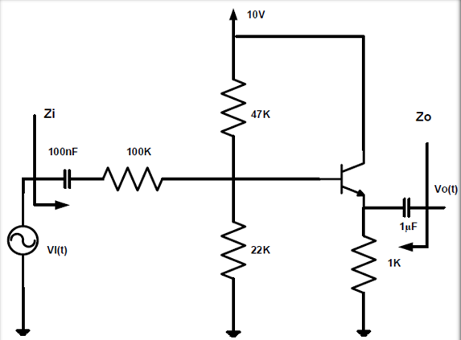

Figure 7(CC Circuit)

**2. Then we adjusted Vcc to be +10V, but we kept AC source off. After that, we increased the AC voltage source amplitude until Vo,p-p=2V and we made frequency=1KHz.We used the oscilloscope and made that CH1 is the input and CH2 the output. The results in Figure (10).**

**3. The input voltage, the voltage across the 100KΩ resistor, and the input current were measured and recorded in Table 1.**

**4. The input voltage was replaced by a short circuit, and a sinusoidal wave was connected in the output terminal in order to calculate the output 1impedance by measuring the output voltage and current, and the results were recorded in Table 1.**

## Common Base Transistor Amplifier:

## We connected the circuit as shown below:

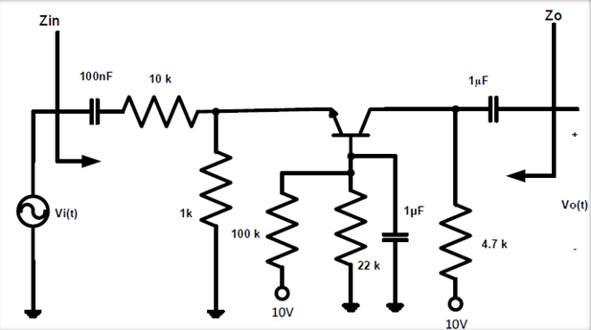

Figure 8(CB circuit)

1. **then we adjusted Vcc to be +10V ,but we kept AC source off. After that, we increased the AC voltage source amplitude until Vo,p-p=2V and we made frequency=1KHz.We used the oscilloscope and made that CH1 is the input and CH2 the output. The results in Figure (11) .**
2. **The input current and the voltage across the 100kΩ resistor were measured.**
3. **the input was replaced by a short circuit and the sine wave generator was connected to the output to calculate the output impedance as done in the common collector .All results were recorded in Table 2.**

**Data, calculations, and analysis of results:**

1. **Common Emitter Transistor Amplifier :**

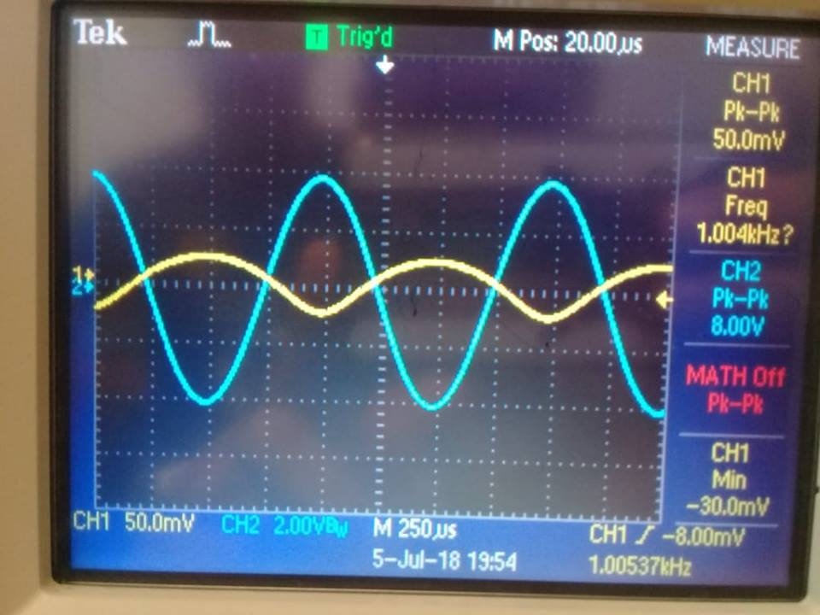

Figure 9(The input and the output voltages for the CE)

**Then we measured and found that:**

**VBE=157mV**

**VCE=2.75V**

**Vin,p-p=50.0mV ,**

**Vo,p-p=8.00V.**

**Now we calculate:**

**Gain= Vo/ Vin =8/50m = 160**

**After that we turned up the function generator output until the output of the circuit is 8 volts peak-to –peak and our result:**

**Iin =12.8 µA**

**Io= 2.77 mA**

**Now we can calculate current gain: Ai= Io/Iin=IC/IB= 2.77m\0.0128m ≅ 216.4**

**In addition, We calculate Zi=Vi/Ii=VBE/IB= 50m \ 0.0128m ≅ 3.9 kΩ**

1. **Common Collector Transistor Amplifier :**

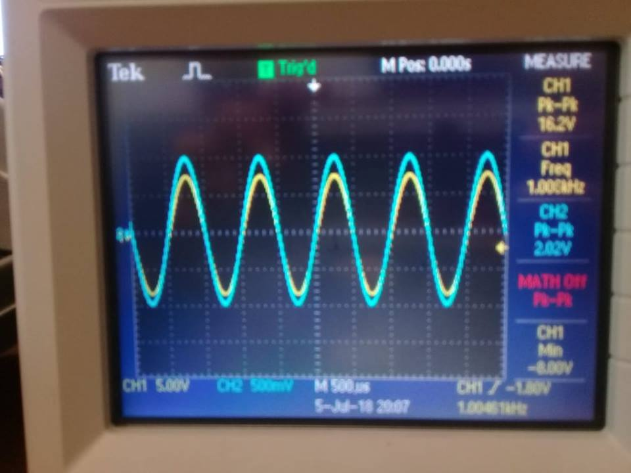

**Figure 10(The input and the output voltages for the CC)**

**Vin,p-p=16.2V , Vo,p-p=2.02V**

**Now we calculate**

**Vin,rms=Vin,p-p/2*(2^0.5)=5.72V.**

**Vo,rms= Vo,p-p/2*(2^0.5)=0.714 V**

**Table 1**

|  |  |
| --- | --- |
| **Quantity** | **Measured Value** |
| **VB** | **2.98 V** |
| **VE** | **2.37 V** |
| **V100kΩ resistor** | **4.9 V** |
| **Vout** | **2.02 Vp-p** |
| **Iin = V100kΩ resistor \ 100k** | **49 µA** |
| **Vin** | **16.2 Vp-p** |
| **Iout** | **Vo,rms/RE=(2.02/2 $√2$*)/1k=0.71mA** |
|  | **Calculated value** |
| **VBE = VB – VE** | **2.98 – 2.37 = 0.61V** |
| **Av = Vout \Vin** | **2.02 \ 16.2 = 0.1246** |
| **Ai = Iout \ Iin** | **0.71m \ 0.049m ≅ 15** |
| **Zin = Vin\ Iin** | **5.727 \ 49µ ≅ 116.8kΩ** |
| **Zout = Vtest \ Itest** | **0.272 \ 1.55m = 175.48 ohm** |

**Questions:**

**How is the output quiescent voltage related to the input?**

**We can see that this circuit is a common collector amplifier. Also, we know that the common collector used as a buffer. That means that the input impedance of this amplifier is very large and out impedance is small.in addition we know that the voltage gain is close to 1 and has a large current gain is we considered in the last circuit.**

**How do the parameters compare with those of the common emitter stage?**

**The common collector circuit we use the same parameters of the common emitter that’s means we have HFE=Beta and HIE=VT/IB.**

1. **Common Base Transistor Amplifier :**

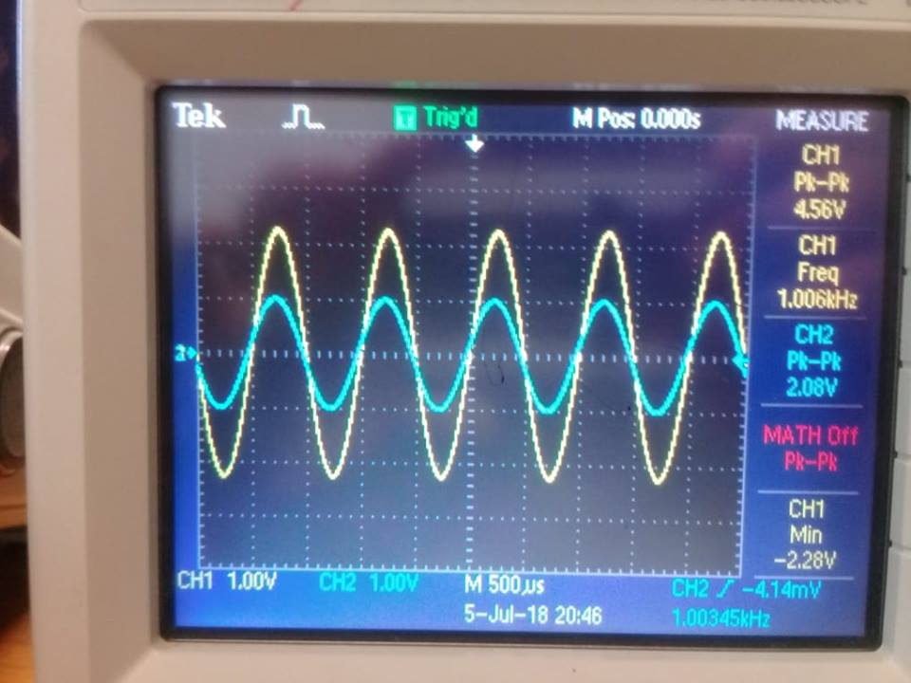

**Figure 11(The input and the output voltages for the CB)**

**Vin,p-p=4.56V , Vo,p-p=2.08V**

**Now we calculate**

**Vin,rms=Vin,p-p/2*(2^0.5)=1.612V.**

**Vo,rms= Vo,p-p/2*(2^0.5)=0.735 V**

**Table 2**

|  |  |
| --- | --- |
| Quantity | Measured Value |
| IB | **8.16 µA** |
| IC | **1.1 mA** |
| VBE | **-4.76V** |
| VCE | **4.894V** |
| VBC | **0.47mV** |
| V10kΩ resistor | **5.32V** |
| Vout | **2.08 Vp-p** |
| Iin = V10kΩ resistor \ 10k | **0.532 mA** |
| Iout | **Vo,rms/Rc=(2.08/2 $√2$*)/4.7k=0.156mA,rms** |
|  | **Calculated value** |
| Av = Vout \Vin | **2.08 \ 4.56 ≅ 0.456** |
| Ai = Iout \ Iin | **0.156m\0.532 ≅ 0.293** |
| Zin = Vin\ Iin | **1.6122\0.532m ≅ 3 Ω** |
| Zout = Vout \ Iout | **5.3\1.15m = 4.6 kΩ** |

**Questions:**

**3. How is the output quiescent voltage related to the input?**

**In the common base amplifier as the last circuit it's amplify the voltage with a high voltage gain but low current gain and it has a small input impedance and high output impedance.**

**4. How do the parameters compare with those of the common emitter stage?**

**In this circuit we have to use different parameters like: HIB=VT/IEQ and HFB=alpha=Beta /(1+Beta) .**

**Conclusion:**

**It was seen how the DC voltage source was used to select the mode of operation of the transistor. In addition , for the three different configurations(parameters), it was observed how the transistor would amplify the input. The four properties (Av, Ai, Zi, Zo) were found for each configuration. Finally, were within the expected range. But ,there were some errors because the components values’ we errors and the measuring devices. Also, when biasing the transistor, it was seen that the minimum Vc value can be little bit more than what is required due to the transistors properties which contributed in the errors also. It was seen how to amplify an AC signal by different ways for different purposes.**

**References**

**[1] Electrical and computer engineering department, circuit lab manual, 2018, pp. 51-59.**

**[3] http://www.rfwireless-world.com/Terminology/CB-vs-CE-vs-CC-transistor-configurations.html**