ش

**Faculty of Engineering and Technology**

**Electrical and Computer Systems Engineering**

ENEE3102

Instructor: Dr. Nasser Ismail

ـــــــــــــــــــــــــــــــــــــــــــــــــــــــــــــــــــــــــــــــــــــــــــــــــــــــــــــــــــــــــــــــــــــــــــــــــــــــــــــــــــــــ

***Course Name***

ELECTRONICS LAB (section 2)

***Experiment No. 4***

The Field-Effect Transisto*r*

Prepared by:

Dana Abu Hussein 1131657

***Group Members***

Hajar karajeh

Hiam arar

***Date of Experiment***

March 12, 2016

***Date Submitted***

March 19, 2016

**-** **Abstract:**

The aim of the experiment is to learn about another type of transistor it is JFET and we must recognize its characteristic, application and how deal theoretical and experiment with it.

We will use main equipment such as oscilloscope, DVM and many devices (resistor, JFET …).

The main result understands the behavior of JFET and how to calculate and analysis its data.

**- Objective:**

The aim of the experiment is to get understand the difference between the bipolar and field effect transistor and gets an ideaabout thecharacteristics of an n-channel JFET and how it is work as amplifier.

**- Theory:**

The Field Effect Transistor (FET) is a three terminal device. Three terminals are Drain (D), Source (S) and Gate (G). FETs have some advantages **like high input impedance (100 $μΩ$), fewer steps in manufacturing and more devices can be package into smaller area for integrated circuit IC , however it have some disadvantages such as low values of voltage gain and poor high frequency performance .**

**Two types of JFET: 1) N-channel JFET as shown in fig (1)**

**2) P- channel JFET**

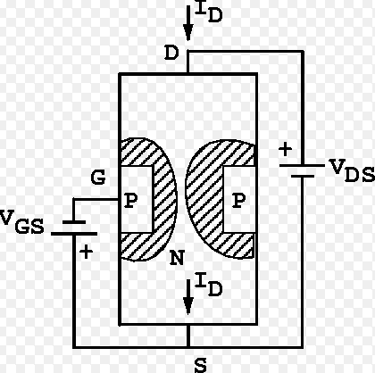

**Fig (1): N-channel JFET**

In this experiment we will obtain output characteristics of N-channel FET as we show in fig (1), reverse biasing the gate to source junction cause the formation of depletion region, the drain has the proper polarity with respect to the source to establish the drain current I DS, the value of I DS depends on the width of the channel, the width of the channel is controlled by reverse biasing the pn junction between gate and source. If the channel width increases IDS increase. And the voltage causes the depletion region to touch close the channel is called pinch off voltage

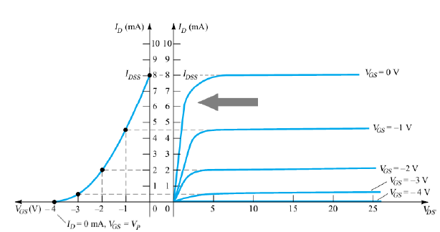

**Fig (2): JFET transfer** characteristics **curve**

**As show in fig (2) different region represented ohmich region, pinch off region and cut off region. And the VGS (t) can show.**

**IDS (t) = IDSS (1- ) 2 ……………………. eq(1)**

**In the pinch off region for n-channel:**

**VP < VGS (t) $≤$ 0**

$$\left|VDS\right|>\left|Vp\right|- \left|VGS \right|$$

**- Experimental / Procedure:**

*I. CHARACTERESTICS OF AN N-CHANNEL JFET.*

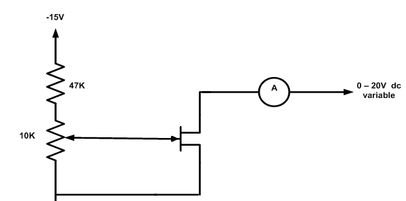

Fig (3)

Circuit shown in fig(3) was connected , power supply was switch on , and VDS was set to the first value in table (1) and then ID was read for each value of VGS, all steps were repeated for all values of VDS and ID was being recorded .

II. A JFET AMPLIFIER.

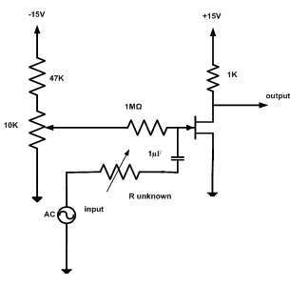

Fig (4)

Circuit in fig (4) was connected and the sine wave generator was set to 1 KHz and its output amplitude turned to zero, the potentiometer was set to give a value of +10 v for VDS and R unknown to zero. Now input was applied to 2 volts peak to peak from the generator and then the output was observed on the oscilloscope and now the output voltage was measured and then the R unknown was increased until the output signal about half its original size.

*III. COMMON DRAIN AMPLIFIER.*

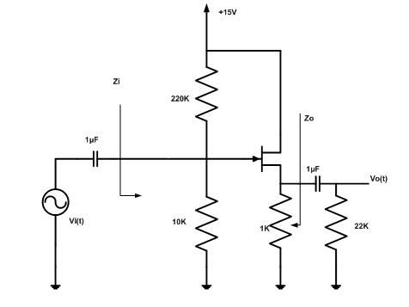

Fig (5)

Circuit in fig (4) was connected and the sine wave generator was set to 1 KHz and its output amplitude turned to zero, the DC voltages of VG and VS was measured, now input was applied to 2 volts peak to peak from the generator and then the output was observed on the oscilloscope, finally the input and output impedances was measured.

IV. CONSTANT CURRENT SOURCE.

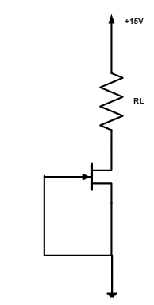

Fig (6)

The circuit shown in fig(6) was connected , the VR was measured and ID was calculated for each value of the resistor , then the result was recorded in table (2) .

***- Calculations:***

*I. CHARACTERESTICS OF AN N-CHANNEL JFET.*

1. When VDS almost 5 volt.

2. Yes change in VGS cause change in ID

3. No its almost zero.

4. gm = change in ID/ change in VGS = (7.80-5.81) / (-1+1.5) =3.98 m

*II. A JFET AMPLIFIER.*

From photo (1):

Vo p-p = 5.6 v

A = Vo /Vin = 5.6/2 = 2.8

*III. COMMON DRAIN AMPLIFIER.*

From photo (3) :

Vo p-p = 392 mv in phase

Vin = 131 mv Vout =113 mv

Iin  = 6.2 $μA$ Iout = 101.3 $μA$

Since Z =V/ I Zin = 21.129 KΩ Zout = 1.1155 KΩ

IV. CONSTANT CURRENT SOURCE.

For Fig (6):

Apply ohm's law:

ID= VL/RL ,

For trial one ID = 1.208/0.1 =12.08 mA

**- Results:**

*I. CHARACTERESTICS OF AN N-CHANNEL JFET.*

Table (1): characteristics of an n-channel JFET

|  |  |  |  |  |  |  |  |
| --- | --- | --- | --- | --- | --- | --- | --- |
|  | **ID (mA) for VDS = (v)** | | | | | | |
| **VGS (v)** | **0** | **0.5** | **1** | **2** | **5** | **10** | **15** |
| **0** | 0.0232 | 3.24 | 5.75 | 9.36 | 12.26 | 12.46 | 12.28 |
| **-0.5** | 0.0241 | 2.91 | 5.33 | 8.03 | 9.86 | 9.98 | 9.98 |
| **-1.0** | 0.0224 | 1.656 | 4.04 | 6.28 | 7.59 | 7.80 | 7.81 |
| **-1.5** | 0.0226 | 1.477 | 3.4 | 4.8 | 5.6 | 5.81 | 5.87 |
| **-2.0** | 0.0218 | 1.51 | 2.46 | 3.3 | 3.7 | 3.88 | 3.94 |
| **-2.5** | 0.0213 | 0.914 | 1.53 | 1.916 | 2.19 | 2.33 | 2.39 |

When VDS =10 volt and VGS =-1 volt IG=0

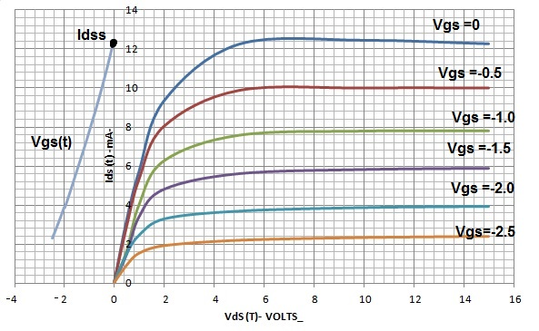

Fig (7): characteristics of an n-channel JFET

*II. A JFET AMPLIFIER.*

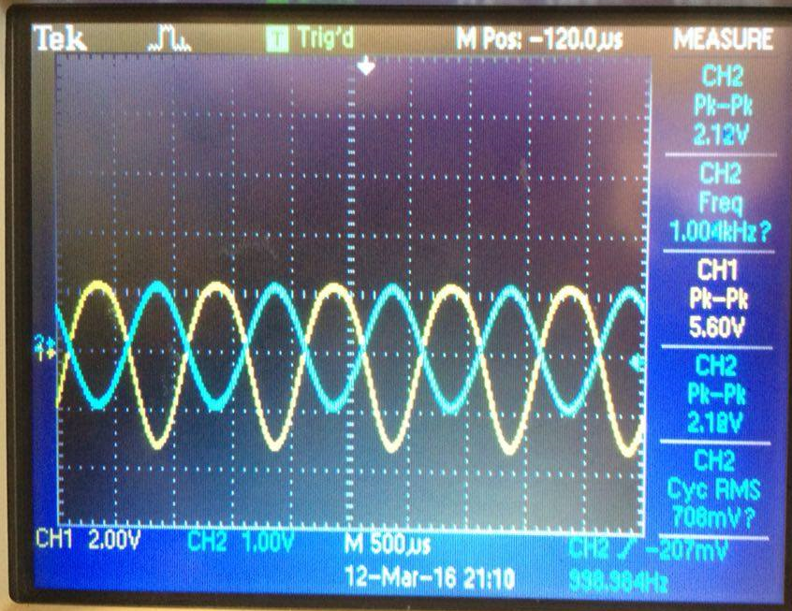

Photo (1): output signal in oscilloscope when R unknown in fig (4) is zero

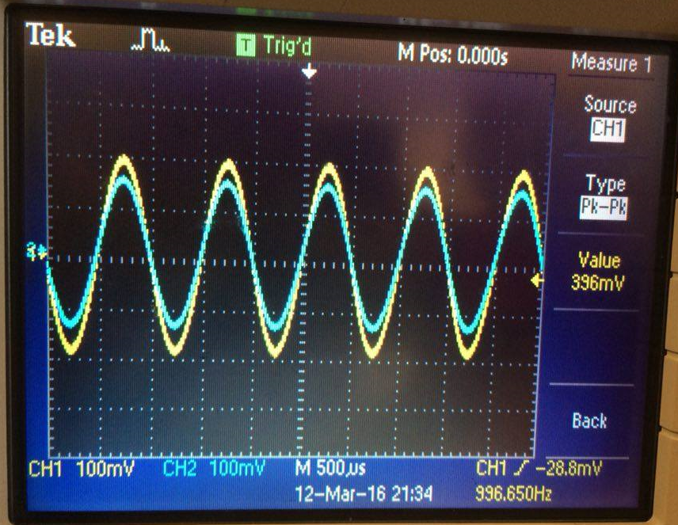

Photo (2): output signal in oscilloscope when R unknown in fig (4) increase to a value that make output about half its original size (R = 2 $μ$ Ω) as a buffer.

*III. COMMON DRAIN AMPLIFIER.*

(VS) DC = 3.452 v (VG) DC = 1.337 v

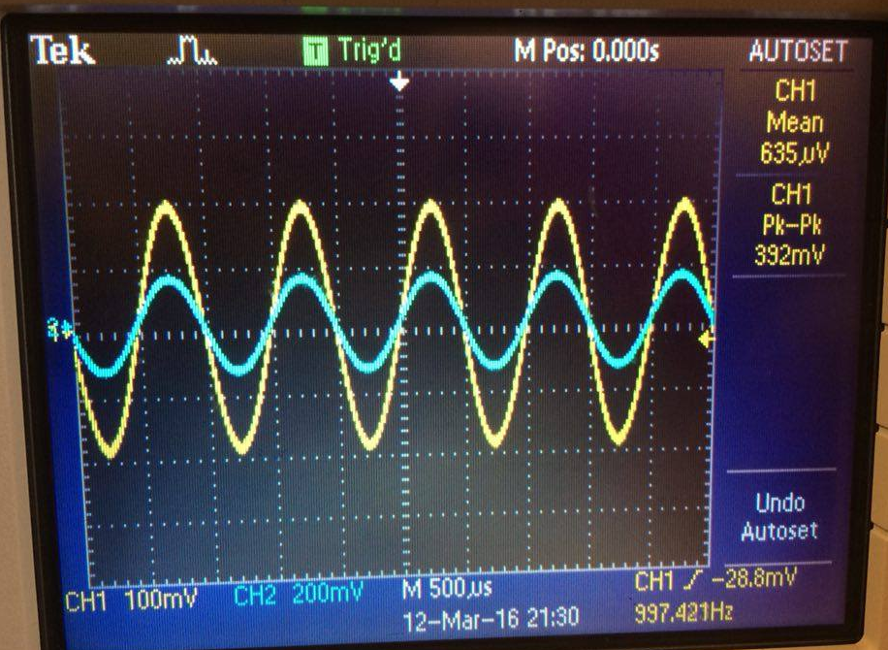

Photo (3): output signal in oscilloscope when input signal in fig (5) is 0.4v peak-peak

IV. CONSTANT CURRENT SOURCE.

Table (2): constant current source

|  |  |  |
| --- | --- | --- |
| **RL (kΩ)** | **VR (v)** | **ID (mA)** |
| **0.1** | 1.208 | **12.08** |
| **0.22** | 3.966 | **18.03** |
| **0.33** | 5.3 | **16.06** |
| **0.47** | 6.971 | **14.83** |
| **0.56** | 8.044 | **14.36** |
| **1** | 12.033 | **12.03** |
| **1.5** | 13.178 | **8.79** |
| **2** | 13.799 | **6.90** |
| **3** | 14.212 | **4.74** |

**- Discussion of Results:**

In part one from table (1) the curve plotted between output drain current ID versus output drain to source voltage VDS for constant values of input Gate to source voltage VGS as shown in fig (7) It can be subdivided into two regions Ohmic region This part of the characteristic is linear indicating that for low values of VDS, current varies directly with voltage following Ohm's Law. It means that JFET behaves like an ordinary resistor; the second region is pinch of region it is also known as saturation region or 'amplifier' region. Here, JFET operates as a constant-current device because ID is relatively independent of VDS. It is due to the fact that as VDS increases channel resistance also increases proportionally thereby keeping ID practically constant at IDSS. Also, It is the curve plotted between output drain current versus input Gate to source voltage for constant values of output drain to source voltage as shown in fig (7) and it can represented as eq (1) .

For part two, we can show that the JFET can use as amplifier ND get specific gain and this what photo (1,2 ) show .

In third part, from calculation and photo (3) we recognize that the JFET can use as common drain amplifier and we show that the input impedance is greater than the output impedance.

For the last part, from table (2) we noticed that as we increase the value of load resistor the current increase to limit value (max load as max current) then it will decrease as we increase resistor.

**- Conclusion:**

In this experiment we learned about the characteristics of the JFET (N-channel), and the amplifier of JFET is three types: common gate, common source and common drain. Also, we learned how to deal with theoretical equation.

Finally, we did see one of the application of the JFET that its the constant current source when VGS = zero.

**- Appendix:**

- Data sheet

**- References:**

* Faculty of Engineering, electronics Laboratory, Birzeit University, Birzeit, 2016
* [**https://www.google.ps/webhp?sourceid=chrome-instant&ion=1&espv=2&ie=UTF-8#q=fet%20experiment%20pdf**](https://www.google.ps/webhp?sourceid=chrome-instant&ion=1&espv=2&ie=UTF-8#q=fet%20experiment%20pdf)