

**Faculty of Engineering and Technology Electrical and Computer Engineering Department Circuit’s**

**lab (ENEE3102)**

**Experiment no.4**

***BJT Transistor As An Amplifier ,CE,CC,CB Connection***

**Student Name:** **Anas Manasrah**

**Student Number:**  **1152701**

**Section:** **(1)(** **Tuesday)**

**Date: 13/ 10/ 2017**

**Instructor: Dr .** [Mohammad Jehad Al Ju'Beh](https://ritaj.birzeit.edu/bzu-msgs/type?mttid=104&classid=119986)

**Abstract:**

**The aims of this experiment are:**

to design a common emitter amplifier stage and examine its performance . Also, Three different circuits were connected and investigated. Voltage gain, current gain, input and output impedances were calculated for each circuit. finally to investigate the properties of the trans. amplifier in common collector connection.

The methods used are by :

Recording the current, voltage by convenient equipment.

The Equipments used:

1. Resistances .
2. Capacitances .
3. Voltage sourse.
4. Transistors Amplifier BJT.
5. Other Divices.

Theory :

There are two kinds of transistors: NPN and PNP. A transistor can be in one of three modes of operations (actually there are four modes but one of them, the inverse mode, is rarely used). Its mode of operation identifies its usage; Active mode to be an amplifier, saturation and cut-off modes to be as a switch. A mode is selected by biasing the transistor using DC voltage source. After biasing, it is needed for the transistor to amplify an AC signal; this is done by using one of three circuits:

1. Common Emitter Transistor Amplifier:

This is the most common configuration , Its small signal equivalent circuit:

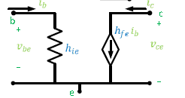

The most important properties of this configuration are:

* Voltage gain is high (Av >> 1)
* There is a current gain (Ai > 1)
* Not very high input impedance (Zi)
* Low output impedance (Zo)

1. Common Collector Transistor Amplifier:

It is a lot similar to the common emitter, but its impedances are better, Its small signal equivalent circuit (same as in common emitter):



Properties of this configuration:

* No voltage gain (Av = 1)
* There is a current gain (Ai > 1)
* High input impedance (higher than in common emitter)
* Low input impedance

1. Common Base Transistor Amplifier:

Its small signal equivalent circuit:

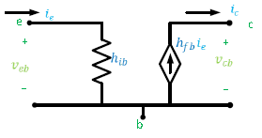

Properties of this configuration:

* There is a voltage gain (Av > 1)
* Ai < 1
* Low input impedance
* High output impedance

Procedure, Data & Calculations :

***I. COMMON EMITTER TRANSISTOR AMPLIFIER***

First of all we connected the circuit of figure (1) .Also, we Set the function

generator frequency to

1KHz sine wave and amplitude to zero.



Figure1

then we adjusted Vcc to be +8V ,but we kept AC source off , then we measured and found that:

VBE=14.5mV

VCE=2.64V

Vin,p-p=46.0mV ,

Vo,p-p=8.00V. Now we calculate:

Vin,rms=Vin,p-p/2*(2^0.5)=0.0163V.

Vo,rms= Vo,p-p/2*(2^0.5)=2.83V.

Gain= VCE/ VBE=182.06

After that we turned up the function generator output until the output of the circuit is 8 volts peak-to –peak and our result :

IB =22.1uA

Ic= 6.67 mA

Now we can calculate current gain: Ai= Io/Iin=IC/IB=6.67mA/22.1uA =301.8

We used the oscilloscope and made that CH1 is the input and CH2 the output. The results in the next image.

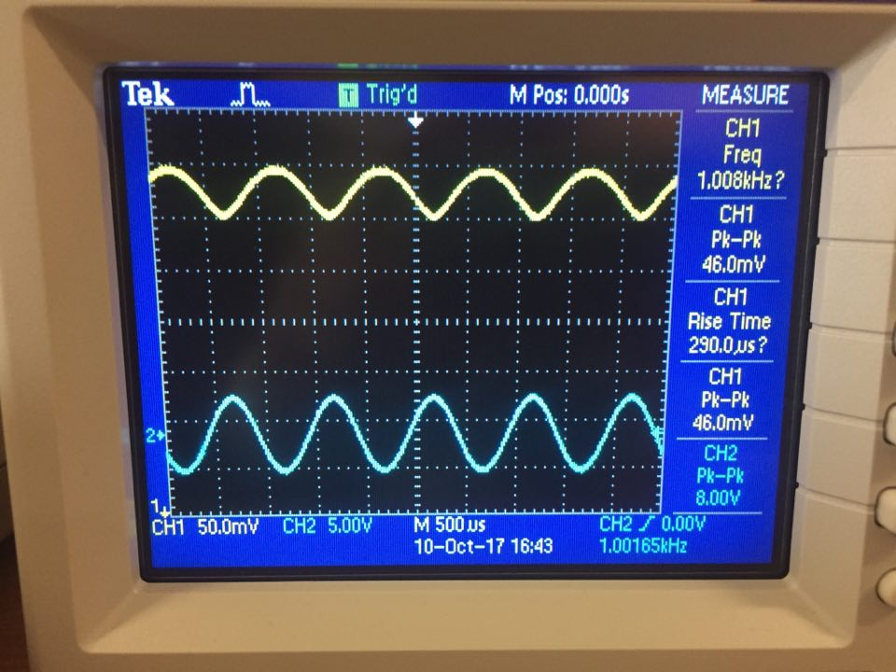

In addition , We calculate Zi=Vi/Ii=VBE/IB=14.5mV/22.1uA=0.656mA

We calculated Zo =Vo/Io=8V/6.67mA=1199.4 ohm .

***II. COMMON COLLECTER TRANSISTOR AMPLIFIER.***

We connected the circuit as shown in Figure(2),then we adjusted Vcc to be +10V ,but we kept AC source off , then we measured that:

VEQ(DC)=2.43V

VBQ(DC)=3.8V .

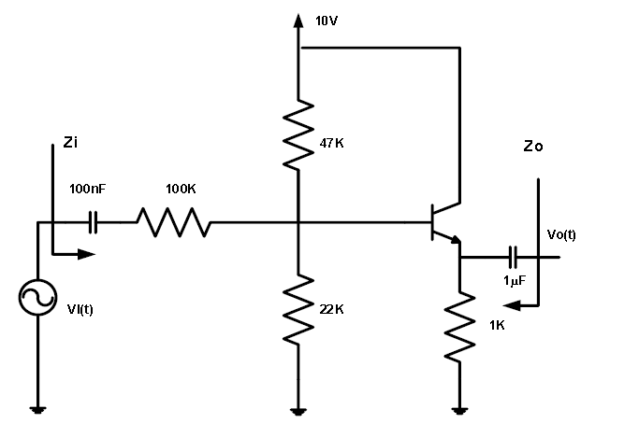

Figure2

In addition ,we increased the AC voltage source amplitude until Vo,p-p=2V and we made frequency=1KHz.We used the oscilloscope and made that CH1 is the input and CH2 the output. The results in the next image.

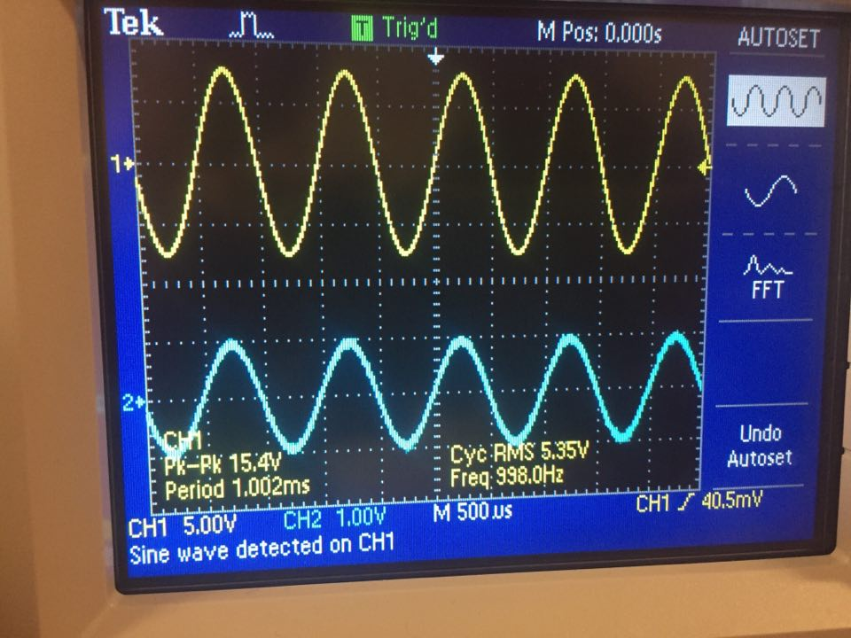

Vin,p-p=15.4V , Vout,p-p=2V.

Vabout 100(ohm)=4.62V rms

Now we calculate

Vin,rms=Vin,p-p/2*(2^0.5)=5.44V.

Vo,rms= Vo,p-p/2*(2^0.5)=0.7071V.

Now we calculate

Iin=Vabout(100k),rms/100k=4.62/100k=0.0462 mA,rms

To calculate voltage gain :

Av= Vo/Vin=2/15.4=0.13 .

Io= Vo,rms/RE=0.707mA

Now we can calculate current gain:

Ai= Io/Iin=0.707mA/0.0462mA=15.3. We also calculate Zi=Vi/Ii=5.44/0.0462 mA=117.74K ohms .

To calculate Zo we have to remove the ac voltage source and replace it with a short circuit, then we connect the AC source to the output to have Vtest and Itest to calculate Zo=Vtest/Itest.

We found that Itest=1.0mA and Vtest=1.015V, then:

Zo=1.015/1.0mA=1015 ohm

We results in table 4.2

|  |  |
| --- | --- |
| **Quantity** | **Measured values** |
| **Vin** | 15.4V,p-p |
| **Vout** | 2V,p-p |
| **iin** | 0.0462 mA,rms |
| **iout** | 0.707mA |
|  | **Calculated values** |
| **AV=Vout/Vin** | 0.13 |
| **Ai=iout/iin** | 15.3 |
| **Zin=Vin/iin** | 117.74K ohm |
| **Zout** | 1015 ohm |

Table 4.1

***Questions:***

~How is the output quiescent voltage related to the input?

We can see that this circuit is a common collector amplifier . Also ,we know that the common collector used as a buffer. That means that the input impedance of this amplifier is very large and out impedance is small.in addition we know that the voltage gain is close to 1 and has a large current gain is we considered in the last circuit.

~How do the parameters compare with those of the common emitter stage?

The common collector circuit we use the same parameters of the common emitter that’s means we have HFE=Beta and HIE=VT/IB.

***III. COMMON BASE TRANSISTOR AMPLIFIER***

We connected the circuit as shown in Figure(3)

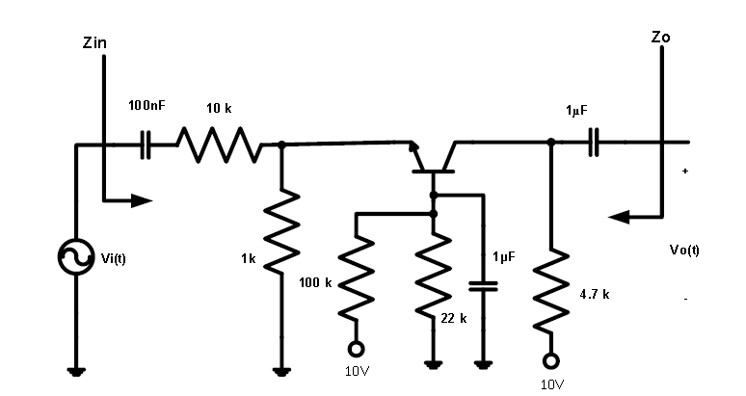

Figure(3)

we adjusted Vcc to be +10V ,but we kept AC source off , then we found that:

VEQ(DC)=1.11V

VBQ(DC)=1.74V

VCQ(DC)=4.71V

After that , we increased the AC voltage source amplitude until Vo,p-p=2V and we made frequency=1KHz.We used the oscilloscope and made that CH2 is the input and CH1 the output. The results in the next image.

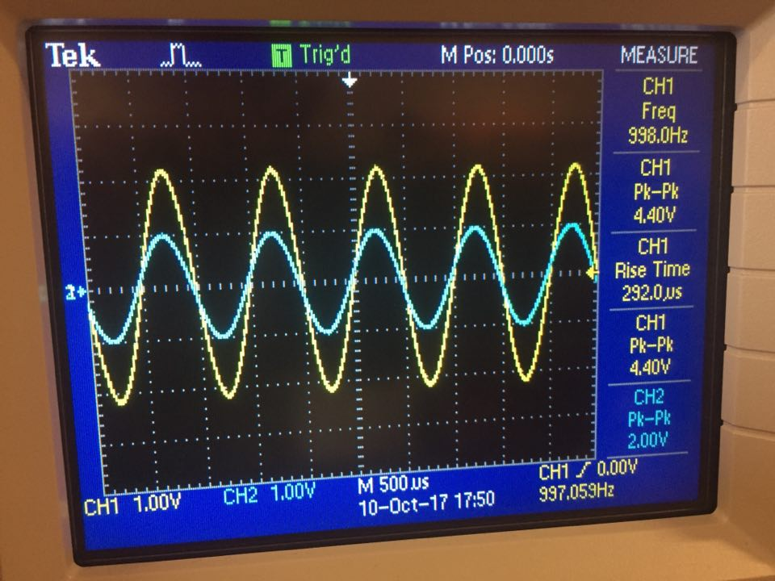

Vin,p-p=4.4V , Vo,p-p=2.00V

Now we calculate

Vin,rms=Vin,p-p/2*(2^0.5)=1.556V.

Vo,rms= Vo,p-p/2*(2^0.5)=0.707V

To calculate voltage gain :

Av= Vo/Vin=2/1.556=1.286

We found the Voltage about 10k resistor =1.36V,rms

Iin=Vabout,rms(10k)/10k=1.36/10k=0.136 mA,rms.

. Io= Vo,rms/RC=0.1504mA,rms

Now we can calculate current gain:

Ai= Io/Iin=0.1504/0.136=1.11 .

We also calculate Zi=Vi/Ii=1.556/0.136mA=11.44ohm .

To found Zo by we have to remove the ac voltage source and replace it with a short circuit, then we connect the AC source to the output to have( V,test )and (I,test) to calculate Zo=Vtest/Itest.

We measured that Vtest,rms=1.49 V , and we found that Itest=0.31 mA ,rms .

Zo=1.49/0.31mA=4.806K ohm.

We results in table 4.2.

|  |  |
| --- | --- |
| **Quantity** | **Measured values** |
| **Vin** | 4.4V ,p-p |
| **Vout** | 2V,p-p |
| **iin** | 0.136 mA,rms |
| **iout** | 0.1504mA,rms |
|  | **Calculated values** |
| **AV=Vout/Vin** | 1.286 |
| **Ai=iout/iin** | 1.11 |
| **Zin=Vin/iin** | 11.44ohm |
| **Zout** | 4.806K ohm |

Table 4.2

***Questions:***

~How is the output quiescent voltage related to the input?

In the common base amplifier as the last circuit it's amplify the voltage with a high voltage gain but low current gain and it has a small input impedance and high output impedance.

~ How do the parameters compare with those of the common emitter stage?

In this circuit we have to use different parameters like HIB=VT/IEQ and HFB=alpha=Beta/(1+Beta) .

**Conclusion:**

It was seen how the DC voltage source was used to select the mode of operation of the transistor. In addition , for the three different configurations(parameters), it was observed how the transistor would amplify the input. The four properties (Av, Ai, Zi, Zo) were found for each configuration. Finally, were within the expected range. But ,there were some errors because the components values’ wewe errors and the measuring devices. Also, when biasing the transistor, it was seen that the minimum Vc value can be little bit more than what is required due to the transistors properties which contributed in the errors also. It was seen how to amplify an AC signal by different ways for different purposes.

**GOOD LOOK**

