+

Faculty of Engineering and Technology

Electrical and Computer Engineering

Department

ENEE3102

Electronics Laboratory

Experiment #4

BJT Transistor As An Amplifier, CE, CC, CB Connection

Name: Juomah Bader

ID # : 1162462

Partners name:

Mohammad Heif:1160530

Yacuob Nassar: 1161690

Table of Contents:

Abstract …………………………………3

Theory …………………………………4

Procedure

Part 1 …………………………………6

Part2 …………………………………7

Part 3 …………………………………9

Tables and calculations

Part 1 …………………………………11

Part 2 …………………………………..12

Part 3 ………………………………….13

Conclusion and notes ………………….15

References ...................................................16

Abstract:

The aims of doing this experiment:

To study the properties of the transistor amplifier in common emitter, common collector, and common base connection.

To learn the effect of applying sinusoidal signal to a transistor connected in common emitter, common collector and common base.

The method used:

By connecting the circuits as shown in procedure part and fined current gain, voltage gain, output impedance of the amplifier and input impedance of the amplifier.

Equipments

**function generator.

**Digital multimeter .

**Osclliscope .

**board.

**wires.

**transistor ,capacitors and resistances .

Theory :

**Amplifiers**are used extensively in electronic circuits to make an electronic signal bigger without affecting it in any other way. there are several different kinds of amplifier circuits that we could use **.** such as transistors

[Transistor](https://www.electrical4u.com/jfet-or-junction-field-effect-transistor/):

is a [semiconductor](https://www.electrical4u.com/theory-of-semiconductor/) device with three terminals, Emitter (E), Base (B) and Collector (C) and these has two junctions , the device can operate in three different regions: cutoff, active and saturation

Transistors are fully-off in cut-off region while fully-on when operating in saturation region. However, while they operate in active region, they act as amplifiers. they can be used to increase the strength of the input signal without altering it significantly

There exist many variations to the amplifier circuit of transistors like:

1. COMMON COLLECTER TRANSISTOR AMPLIFIER.

2. COMMON EMITTER TRANSISTOR AMPLIFIER

3 .COMMON BASE TRANSISTOR AMPLIFIER

COMMON EMITTER TRANSISTOR AMPLIFIER:

* The voltage gain of common emitter amplifier is medium
* The power gain is high in the common emitter amplifier
* There is a phase relationship of 180 degrees in input and output
* In the common emitter amplifier, the input and output resistors are medium.

COMMON COLLECTER TRANSISTOR AMPLIFIER.

* The current gain of common collector amplifier is large, larger than any other transistor amplifier configuration.
* The Voltage gain is zero
* The Input resistance is High
* The Output resistance is Low
* The power gain is medium in the common emitter amplifier
* There is no phase shift between input and output

COMMON BASE AMPLIFIER:

* High voltage gain
* Low current gain
* Low power gain
* There is no phase shift between input and output
* It has low input impedance
* It has high output impedance

Procedure:

I. COMMON EMITTER TRANSISTOR AMPLIFIER.

1. We was Connected the circuit as shown.

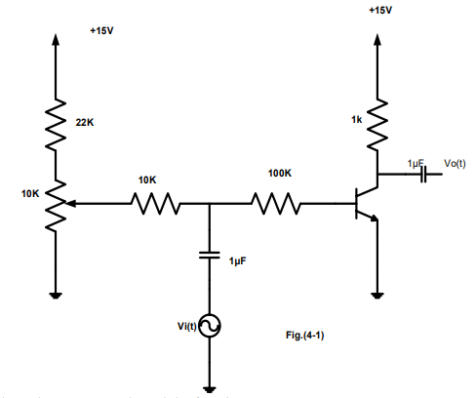

2. We were switched on the power supply and the function generator.

3. We were set the function generator frequency to 1 KHz sine wave and amplitude to zero.

4. We was adjusted the base bias potentiometer for a DC collector voltage (VC) of 8 volts.

5. We were switched on the oscilloscope and connected its channels to the base and the output of the circuit.

6. We were turned up the function generator output until the output of the circuit is 8 volts peak-to –peak.

7. We were calculated the voltage gain of the transistor.

8. We were used DMM and measured the AC currents for both the base and the collector of the transistor.

9. We were Calculated the current gain of the amplifier and the input impedance of the transistor amplifier

2. COMMON COLLECTER TRANSISTOR AMPLIFIER.

1. We was Connected the circuit as shown

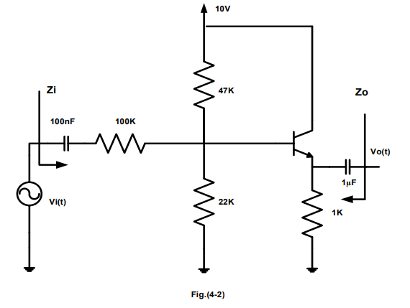

2. We ensured that the variable dc control is at min.

3. We was switched on the power supply and adjusted the

Variable dc voltage to give a Vcc of +10 volts.

4. We were set the sine wave generator to a frequency of 1 KHz, and no signal input to the circuit.

5. We was measured the quiescent bias voltages of the circuit, VE and VB ,using DVM.

6. We was Increased the output amplitude of the sine wave generator until an output amplitude from the amplifier is about 2volts peak-to-peak.

7. We was measured the ac input voltage needed to achieve this output.

8. We were calculated the voltage gain.

9. We were measured the ac voltage across the 100KΩ input resistor.

10. We was calculated the input current using our measured value of voltage across the input resistor.

11. We were calculated the ac output current.

12. We were calculated the current gain.

13 we were calculated the input impedance Zin.

14. We found the output impedance of the amplifier by taked off the input signal and replaced it with a short ckt, we connected the generator to the output and measured its output voltage and current

3. COMMON BASE TRANSISTOR AMPLIFIER.

1. We were Connected the circuit as shown

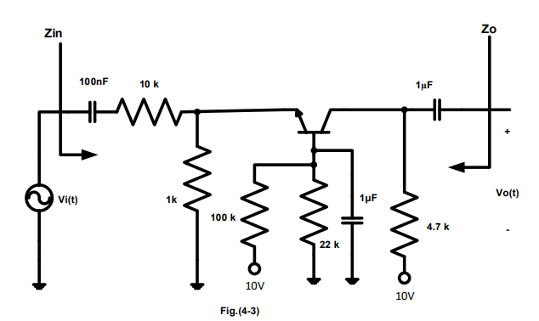

2. We was ensured that the variable dc control is at min.

3. We were switched on the power supply and adjust the variable dc voltage to give a Vcc of +10 volts.

4. We was Set the sine wave generator to a frequency of 1 kHz, and no ac signal input to the circuit.

5. We was Measured and recorded the quiescent bias voltages and currents IB, IC, VBE , VBC and VCE. ,using DVM.

6. We was Increased the output amplitude of the sine wave generator until an output amplitude from the amplifier is about 2volts peak-to-peak.

7. We was measured the ac input voltage needed to achieve this output.

8. We was calculated the voltage gain Av and wrote it.

9. We was measured the ac voltage across the 10 kΩ input resistor.

10. We was Calculated the input current using our measured value of voltage across the input resistor.

11we was calculating the current through the resistor.

* We were calculated the current gain.
* We were calculated the input impedance Zin.
* we found the output impedance of the amplifier by taked off the input signal and replaced it with a short ckt ,we connected the generator to the output and measured its output voltage and current

**Tables and calculations:**

Part 1:

Voltage gain:

|  |  |
| --- | --- |
| Vin | 2.68 volt |
| Vout | 7.038volt |
| Voltage gain | 7.038/2.68=2.626 |

Current gain

|  |  |
| --- | --- |
| Ic | 2.818 mA |
| Ib | 34.78 uA |
| Current gain | 81 |

The input impedance: Vin/ Ib=2.68/34.78u=77.056k

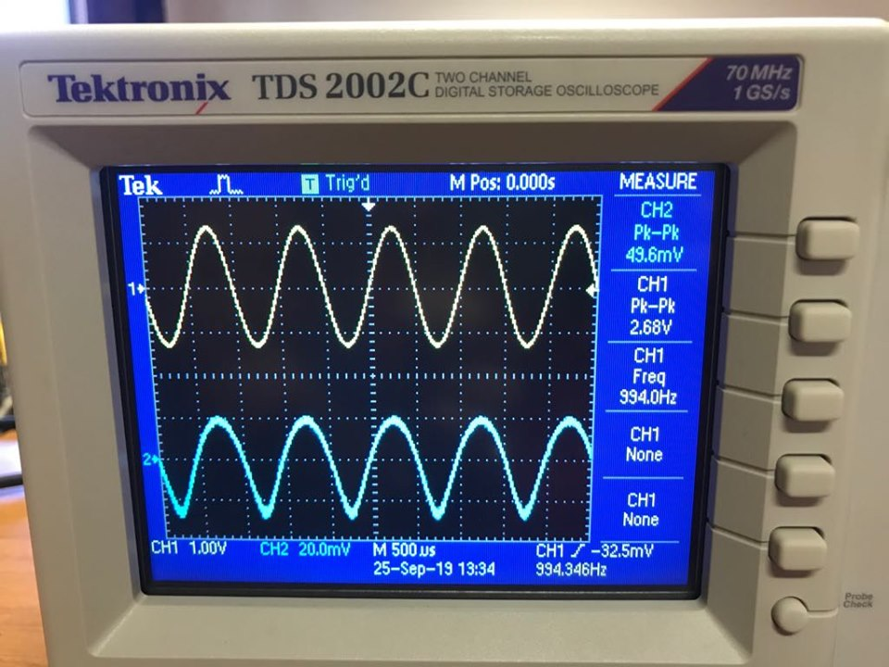

Part 2

When the sin wave equal zero

|  |  |
| --- | --- |
| VB | 3.045 volt |
| VE | 2.41 volt |
| VBE | 0.635volt |
| V out | 2 volt |
| V in | 17.0 volt |

|  |  |
| --- | --- |
| Ac Voltage across 100k | 4.568volt |
| Current through 100k | 4.568/100k=45.7 uA |

|  |  |
| --- | --- |
| Quantity | Measured value |
| V in | 8 volt |
| V out | 1 volt |
| I in | 47.3 uA |
| I out | 5.253 mA |
|  | Calculated value |
| Av | 0.125 |
| Ai | 111 |
| Z in | 169.13k |
| Z out | 1.44k |

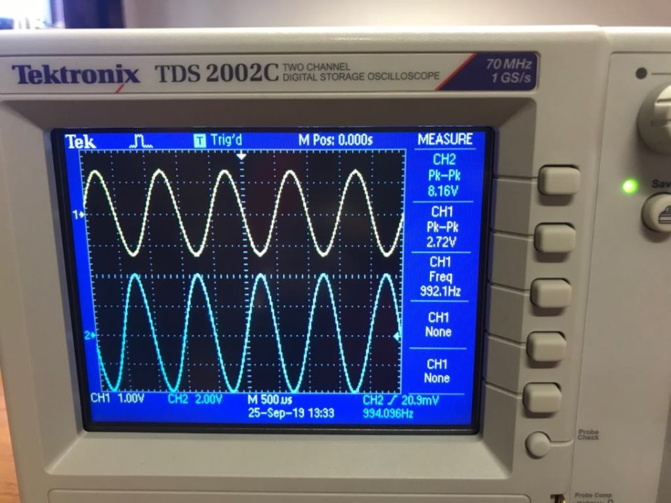

Part 3

|  |  |
| --- | --- |
| VBE | 0.625volt |
| VBC | 2.989volt |
| VCE | 3.64volt |
| IB | 79.63uA |
| IC | 1.17mA |

When the output ac voltage =2volt input ac voltage =4.60volt

|  |  |
| --- | --- |
| Ac voltage cross 10k | 6.48volt |
| Ac current through 10k calculate | 6.48*10^-4A |
| Ac output current (vout/R load) | 4.26*10^-4A |

The current gain =4.26/6.48=0.657

|  |  |
| --- | --- |
| **Quantity** | **Measured value** |
| **V in** | **1.562v** |
| **V out** | **1.553v** |
| **I in** | **425 uA** |
| **I out** | **0.327mA** |
|  | **Calculated value** |
| **Av** | **0.98** |
| **Ai** | **2.26** |
| **Z in** | **10.78k** |
| **Z out** | **4.75k** |

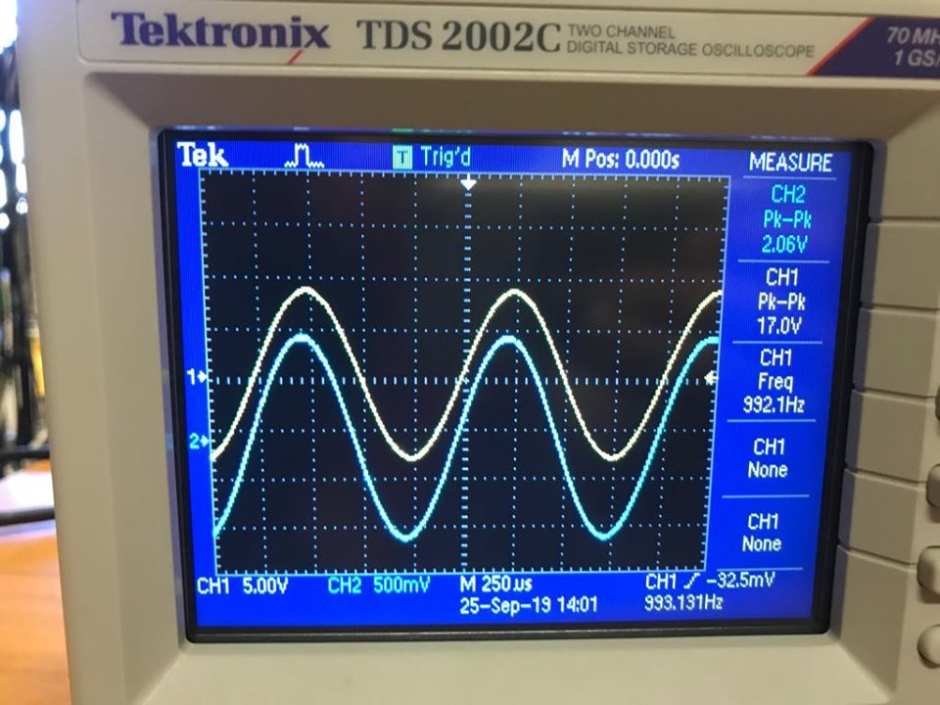

**Conclusion and answer of questions:**

As we talk in theory: the transistor maybe uses to increase the strength of the input signal and there are three ways to connect it:

Common Emitter: by connecting the input from base and take output from collector.

It makes the output signal bigger than the input signal (current and voltage gain).input impedance is large

Common Collector: by connecting the input from base and take output from emitter.

It makes output current bigger than the input current but the voltage is smaller .input impedance is large because the emitter not go to ground (RE is exist) and the output impedance is small

Common Base : by connecting the input from emitter and take output from collector

It makes output voltage bigger than the input voltage but the current is smaller but in this exp. Opposite is happened because the resistor exist after input signal, This make no voltage gain. (The input and output impedance are large).

Note: I didn’t make prelab for this exp. But our data are Proportionate with data in my partner’s prelab.

References:

[1] Electrical and computer engineering department, electronics lab manual.

[2] <http://www.rfwireless-world.com/Terminology/CB-vs-CE-vs-CC-transistorconfigurations.html>