

***Faculty of Engineering and Technology***

***Electrical and Computer Engineering Department***

***Electronic lab (ENEE3102)***

**Report of EX #6**

Multistage Amplifiers and Frequency Response " "

**Instructor :-**

Dr. Mohammad Jehad Ju'Beh

ENG . Amjad Shaalan

**#ID** **Student Name :-**

1172064 Mohammad AL-Battat

**Partner Name :-**

Mohammad Hammoudeh 0000000

Israa Musleh 0000000

Sec :- 2 Date:-15/10/2019

**Abstract :-**

In this experiment , will be discuss what happens on the gain of the frequency when transistor amplifier connected as a multi stages one after one and learn how to testing and design of a multi-stage amplifier . finally , studies the principle operation and models of differential amplifier .

Table of contents :-

Cover page ……………………………………………………………………………………………………………........(1)

Abstract …………………………………………………………………………………………………………………..……(2)

Theory …………………………………………………………………………………………………………………….……(4)

Procedure …………………………………………………………………………………………………………….……..(11)

Data , calculation , & results ……………………………………………………………………………............(13)

Conclusion ……………………………………………………………………………………………………………..……(21)

References ……………………………………………………………………………………………………….…………(22)

**Theory :-**

**A. Multi-stage amplifier:-**

The multi-stage could be definition , the output of first amplifier stage is connected to the input of another , the amplifier stages are said to be connected in cascade. That connected one after another .In real time applications, a single amplifier can’t provide enough output that causes a problem but we solve it by using two or more amplifier stages are cascaded (connected one after another) to provide greater output Such an arrangement is known as multistage amplifier Though the basic purpose of this arrangement is increase the overall gain, many new problems as a consequence of this, are to be taken care. For example problems such as the interaction between stages due to impedance and a noise etc .

A multi-stage amplifier is a complex circuit constructed by using a several of the basic designs are arrangement according to the output and input layer , it is classify a common collector and common emitter that we have studied. Typically, a multi-stage amplifier consists of 3 sections , show Figure A.1:

1. **The Input Stage** : This section has one purpose, to provide the multi-stage amplifier with a high input resistance. For differential amplifiers, this stage must also be a operate between input and output difference .

2. **The Gain Stages** : This section consists of one or more amplifiers stages with high open-circuit voltage gain . This section thus provides the required voltage gain for the multi-stage amplifier.

3. **The Output Stage** : The third and final section of the multi-section amplifier likewise has one purpose: to provide the multi-stage amplifier with a low output resistance. As such, this stage is often a common collector.

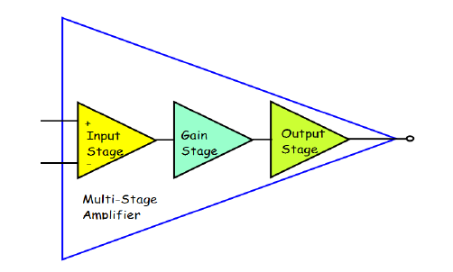

Fig A.1

Multi-stage amplifiers are amplifier circuits cascaded to increased gain. We can express gain in decibels(dB range).Two or more amplifiers can be connected to increase the gain of an ac signal. The overall gain can be calculated by simply multiplying each gain together The figure A.2 that shown below the block diagram of the multistage . and multi-stage amplifiers, the output of first stage is coupled to the input of next stage using a coupling device. These coupling devices can usually be a capacitor or a transformer. This process of joining two amplifier stages using a coupling device can be called as Cascading , figure A.3 that shown below an coupling stage between two stage .

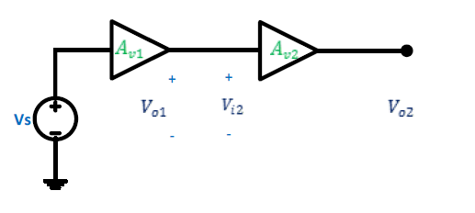

Fig A.2

*Av* = *Av1*Av2*Av3* ………………………………………………1

*AV*=*AV*1×*AV*2= $\frac{v2}{v1}*\frac{v0}{v2 }=\frac{v0}{v1}$………………………………………….2

Where $A_{V}$ = Overall gain, $A_{V1}$ = Voltage gain of 1st stage, and $A_{V2}$ = Voltage gain of 2nd stage.

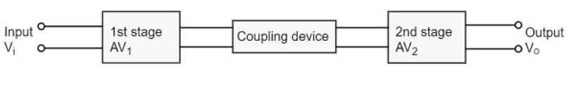

Fig A.3

There are a many type of multistage amplifier that we studied on the electronics book .

amplifier stages are category according to component connected .

**1. capacitor coupling amplifier.**

Capacitor coupled amplifier is the most widely used method of coupling in multistage amplifiers. In this case the capacitor C is connected in between the amplifiers. It is also called a blocking capacitor, since it will block DC voltage. The main disadvantage of this coupling method is that it causes some loss for the low frequency signals. However, for amplifying signals of frequencies greater than 10 Hz, this coupling is the best and least expensive method. It is usually applied in small signal amplifiers, such as in record players, tape recorders, radio receivers, etc. figure A.1.1 an e.g circuit of the Direct coupling amplifier

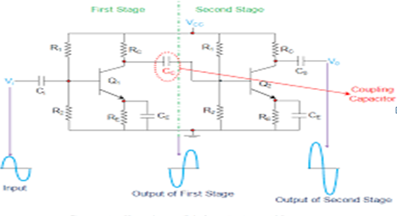

Fig A.1.1

### 2.Transformer Coupling amplifier .

The coupling method that uses a transformer as the coupling device can be called as Transformer coupling. There is no capacitor used in this method of coupling because the transformer itself conveys the AC component directly to the base of second stage. The secondary winding of the transformer provides a base return path and hence there is no need of base resistance. This coupling is popular for its efficiency and its impedance matching and hence it is mostly used. figure A.1.2 That shown below .

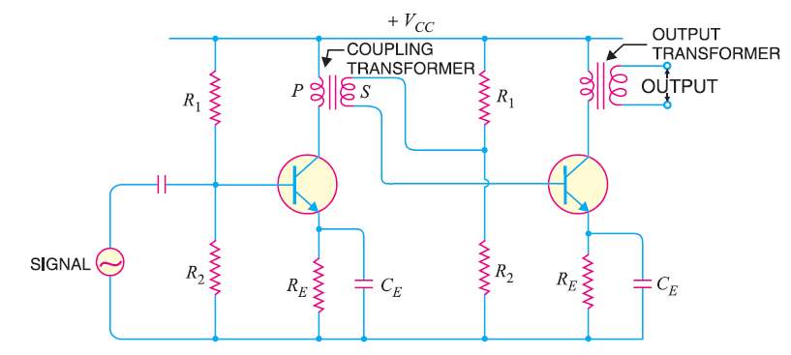

Fig A.1.2

### 3.Direct Coupling amplifier .

If the previous amplifier stage is connected to the next amplifier stage directly, it is called as direct coupling. The individual amplifier stage bias conditions are so designed that the stages can be directly connected without DC isolation. The direct coupling method is mostly used when the load is connected in series, with the output terminal of the active circuit element. Figure A.1.3

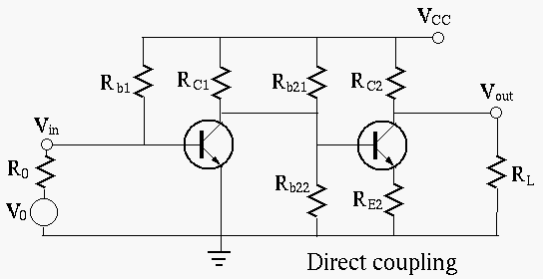

Fig A.1.3

**The multistage amplifier connection has many benefits:**

1. Additional amplification can be required.

2. Improving the performance of amplifier (High input impedance, High gain, and small output impedance).

3. Increase the bandwidth.

**B. Frequency Response:-**

Frequency Response of an electric or electronics circuit allows us to see exactly how the output gain (known as the magnitude response) and the phase (known as the phase response) changes at a particular single frequency, or over a whole range of different frequencies from 0Hz to many thousands of mega-hertz, (MHz) depending upon the design characteristics of the circuit . we can see in figure B.1 that the frequency response of any given circuit is the variation in its behavior with changes in the input signal frequency as it shows the band of frequencies over which the output (and the gain) remains fairly constant. The range of frequencies either big or small between ƒL and ƒH is called the circuits bandwidth. So from this we are able to determine at a glance the voltage gain (in dB) for any sinusoidal input within a given frequency range .

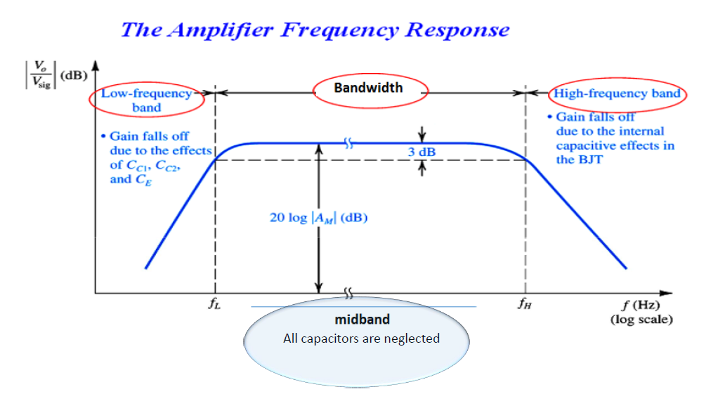

Fig B.1

Discuss fig B.1

Generally, the frequency response analysis of a circuit or system is shown by plotting its gain, that is the size of its output signal to its input signal, Output/Input against a frequency scale over which the circuit or system is expected to operate. Then by knowing the circuits gain, (or loss) at each frequency point helps us to understand how well the circuit can distinguish between signals of different frequencies.

As operating frequency decreases from the mid-band area of the curve, a point is reached where the power gain begins to drop off. The frequency at which power gain equals 50% of its mid-band value is called the lower cutoff frequency ƒL.

As operating frequency increases from the mid-band area of the curve, a point is reached where the power gain begins to drop off again. The frequency at which power gain equals 50% of its mid-band value is called the upper cutoff frequency ƒH .

Frequency points ƒL and ƒH relate to the lower corner or cut-off frequency and the upper corner or cut-off frequency points respectively were the circuits gain falls off at high and low frequencies. These points on a frequency response curve are known commonly as the -3dB (decibel) points. So the bandwidth is simply given as:

$bandwidth=ƒH-ƒL$…………………………………………………………………………………..****

-3dB corner frequency points define the frequency at which the output gain is reduced to 70.71% of its maximum value. Then we can correctly say that the -3dB point is also the frequency at which the systems gain has reduced to 0.707 of its maximum value.

**The equations of the high and low frequency response :-**

$ω_{Cs}=\frac{1}{R_{th}×C_{s}}………………………………………………………………………..(1)$.

$ω_{Cc}=\frac{1}{R_{th}×C_{c}}……………………………………………………………………………(2)$

$ω_{C_{E}}=\frac{1}{R_{th}×C_{E}}…………………………………………………………………………….(3)$

If $ω_{C_{s} }> ω_{C_{c}}>ω_{C_{E}}$……………………………………………………………….(4)

Then the low-frequency responses $\left(ω_{L}\right)=FL$………………………………………………………..(5)

$ω_{C_{s} }+ ω_{C_{c}}+ω_{C_{E}}>ω_{L}>{ω_{C}}_{S}$………………………………………………….(6)

$ω_{C_{bc}}\left(ω_{A}\right)=\frac{1}{R_{th}×C_{bc}}……………………………………………(7)$

$$ω_{C_{be}}\left(ω_{B}\right)=\frac{1}{R_{th}×C_{be}}……………………………………………….(8)$$

If $ω_{A}<ω_{B}$ Then the high-frequency responses $(ω_{L})$

$$\frac{1}{\frac{1}{ω_{A}}+\frac{1}{ω_{B}}}<ω_{H}<ω_{A }…………………………………………………………..(9)$$

$$Midband=0.1ω_{H}-10ω_{L}…………………………………………………………(10)$$

**C. Differential Amplifier:**-

A differential amplifier is a type of electronic amplifier that amplifies the difference between two input voltage signals but suppresses any voltage common to the two inputs figure c.1 that shown the circuit e.g. It is an [analog circuit](https://en.wikipedia.org/wiki/Analog_circuit) with two inputs ${Vi}^{-}$ and ${Vi}^{+}$ and one output ${Vout}^{}$. which the output is ideally proportional to the difference between the two voltages. $Vout=A({Vi}^{+}$- ${Vi}^{-}$)

**Common-mode**

Common –mode signal is the component of an [analog signal](https://en.wikipedia.org/wiki/Analog_signal) which is present with one sign on all considered [conductors](https://en.wikipedia.org/wiki/Electrical_conductor). In [telecommunication](https://en.wikipedia.org/wiki/Telecommunication), common-mode signal on a [transmission line](https://en.wikipedia.org/wiki/Transmission_line) is known as longitudinal voltage. The common mode signal is a .

VC= $\frac{V2+V1}{2}$

$$Ad=\frac{vo}{vd}ꟾvc=0$$

**The common mode rejection ratio (CMRR)**.

The common mode rejection ratio (CMRR) of a [differential amplifier](https://en.wikipedia.org/wiki/Differential_amplifier) (or other device) is a [metric](https://en.wiktionary.org/wiki/metric#Noun) used to quantify the ability of the device to reject common-mode signals, such that those that appear simultaneously and in-phase on both inputs. An ideal differential amplifier would have infinite CMR .

$Ac=\frac{vo}{vc}ꟾ$ vd=0 CMR= $ꟾ\frac{Ad}{Ac}$ ꟾ

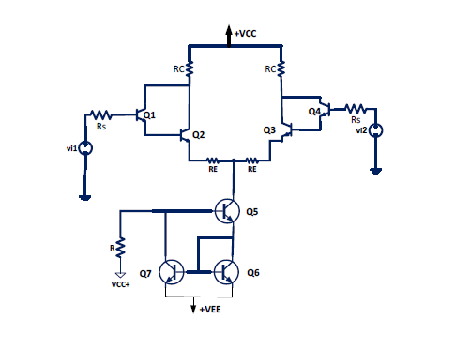

c.1

**Procedure :-**

**1.1-Multi-stage amplifier :-**

Design the circuit as a two stages amplifier with a voltage gain peak to peak output of 2.5 volt , connected the two stages in cascade , the design instruct under a parameter

hie = 4 ${10}^{3}$*Ω

hoe = ${10}^{-4}$ 1\Ω

hfe = 300

hre = 10-3

Vcc = 10v

The all calculation found in the pre-lab . the circuit results from the calculation that shown in the figure 1.1.a below . firstly connected the first stage of the circuit and before that made sure on the variable dc voltage be +10 volt and made a input sinusoidal be minimum 16mVp-p and frequency 1khz . measure VB,VE,VCE & Vp-p(out).

Secondly connected the second stage and made the input of it stage equal the output of the first stage and measure the VB2,VE2,VCE2 & Vp-p(out) , record data for the before two cases .

Finally connected the circuit that shown in the figure 1.1.a that shown below , made sure the input of the multi-stage was minimum value it less than 16mv and taken the data from oscilloscope .

**1.2 frequency response :-**

Keep the circuit of the previous part the same but before that .connected the two channel of the oscilloscope . and change the input frequency according to the table 1.2.T and taken the input and output Vp-p(out).

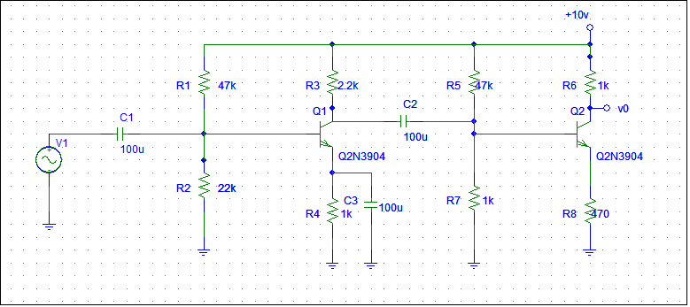

Fig 1.1.a

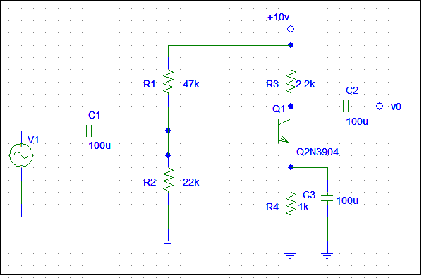

Input stage (First stage ).

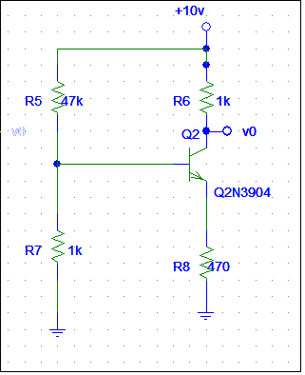

Output stage .( second stage)

**1.3 differential amplifier :-**

Connected the circuit that shown in the figure 1.3.c . sure the dc power supply on +15 &-15

And keep the V1 &V2 are same according to the table 1.3.T* . taken the Vo and record data .

Finally keep the circuit , but keep the V2=-V1 . taken the Vo and record data on the table 1.3.T**

**note :-The tables are shown in the data and results part .

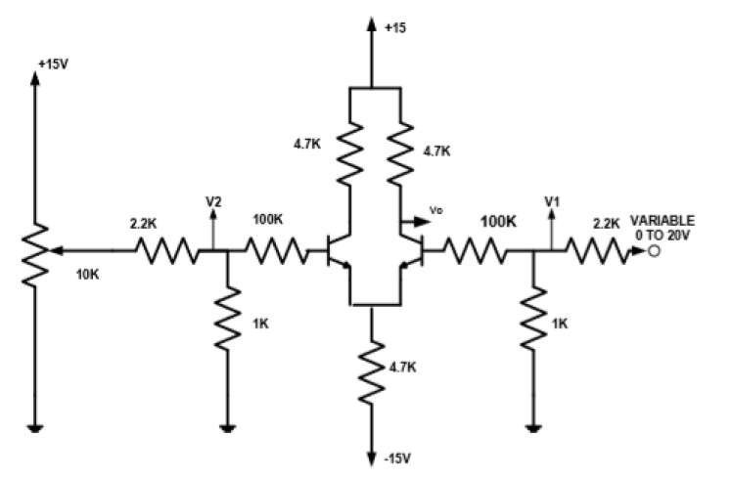

Fig 1.3.c

**Data ,calculation & results :-**

**1-multi-stage amplifier :-**

Stage 1: input stage figure

$$V_{B1}=2.939 V$$

$$V_{E1}=2.308 V$$

$$V_{Ce1}=2.816V$$

$V_{in}$ = 16mV

$V_{out}$ = 2.08V

$A_{v1}=\frac{2.08}{16×{10}^{-3}}$ = 130

Figure c1 that shown the oscilloscope output .

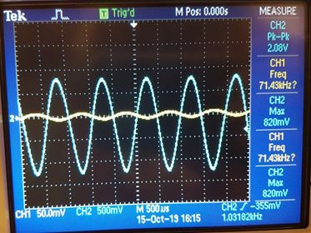

Fig c1

Note :-   
*𝑝 $hase=180 degree, out of phase$*,

Stage 2 : output stage

$$V_{B2}=2.326V$$

$$V_{E2}=6.547V$$

$$V_{Ce2}=4.837V$$

${ V}_{in}$ = 2.08V

${ V}_{out}$ = 4.20V

${ A}_{v2}=\frac{4.20}{2.08}$ = 2.019

Figure c2 that shown the oscilloscope output

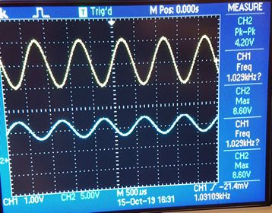

Fig c2

Note :-   
*𝑝 $hase=180 degree , out of phase$*

Multi-stage : represent stage 1 & 2 connected in cascade

$V_{in}$ = 16.00 mV

${ V}_{out}$ = 3.60 V

$A_{v}=\frac{3.60}{16×{10}^{-3}}$ = 225 when connected the two stages in cascade .

Total gian=Av1*Av2

=2.019*130=262.47 for stage 1&2

Figure c3 that shown the oscilloscope output

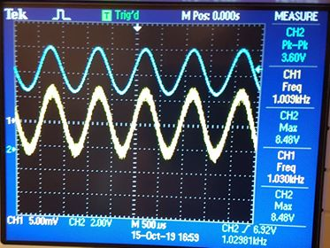

Fig c3

Note :-

$$Phase=0 degree in phase$$

**Questions :-**

* What is the gain of your stage

${ A}_{v1}$ = 130 ${ A}_{v2}$ = 2.019

* What is the voltage gain of the two stage amplifier?

$A_{v }$ = 225

* What would happen if the coupling capacitor used did not have negligible impedance at 1 kHz?

Capacitors are designed to provide negligible impedance at frequencies of interest and provide open circuits at dc , and if we negligible impedance at 1 kHz, we will deal with as short circuit.

Comments about the results :-

we observe when we connect two amplifiers 'multi-stage amplifiers' and the total gain is almost equal gain of first stage multiply the gain of the second stage also we note the actual gain less than theoretical gain. This comes from potential loading effects when two amplifiers .

**2-frequency response :-**

Table results 1.2.T

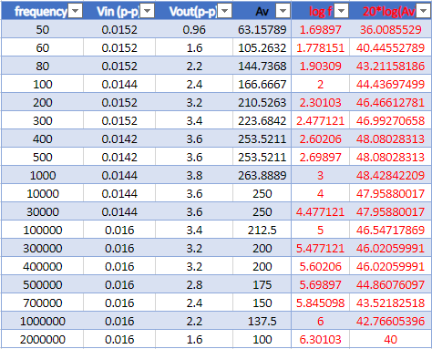

The graph of magnitude frequency response (20 log (Av) **vs** log f) i.e. dB/Decade scale figure p.1 that shown below .

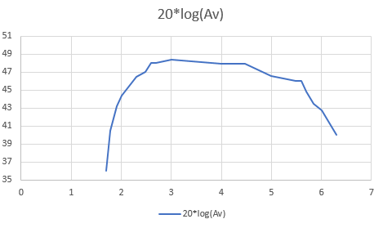

Fig p.1 frequency response

**Questions :-**

* Does the output amplitude vary with frequency?

It was variable (Increasing, constant, and decreasing).

* What happens to the output amplitude at low frequency?

It was small at first then start increasing

* What causes this effect at low frequencies?

The coupling capacitor has effective impedance and this reduces the gain.

* What would you expect happen to the gain of the circuit at high frequencies?

The gain will decrease because of internal capacitor in transistor.

* Between which frequency limits does the amplifier have a constant gain?

form 400hz to 30khz according to the table .

* At which frequencies is the gain 0.707 times the maximum gain?

At fL = 3000 Hz and fH = 30kHz.

* What is the difference between these two frequencies? $$Bandwidth=f_{H}-f_{L}=30000-3000=27000$$

Comments about the output results :-

shows the frequency response will often start to fall at a very low frequency when operated in its open loop mode , Also the effect of input frequency on amplifier gain. Where in low frequency in capacitor of coupling has large impedance decreasing in time and the gain increase and start deal with it as a short circuit, then in bandwidth db decade scale becomes constant.

**3.differential amplifier :-**

Table 1.3.T*:-

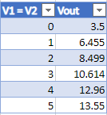

The graph of Vout against V1 = V2 . in figure p.2 that shown below .

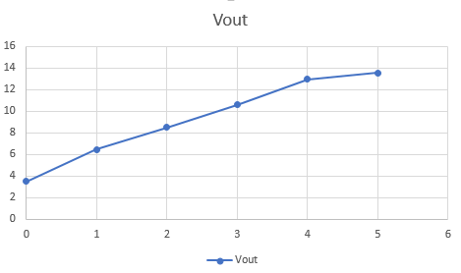

Fig p.2

**Questions :-**

* What is the slope of the graph?
$$\frac{11-9}{3-2}=2$$

* As $V_{out}$ = ${ A}_{C}$ $V_{C}$, what does the slope of the graph represent ?

The slope equal ${ A}_{C}$

* What is your experimental value of ${ A}_{C}$?

2.019

* If $V_{C}$ is made zero instead of $V_{d}$, what will the expression of Vout become?

$V_{out}$ = $A_{d}$ × ${ V}_{d}$

Table 1.3.T**:-

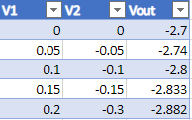

The graph of these results in the figure p.3 that shown below , and calculate the slope of the graph

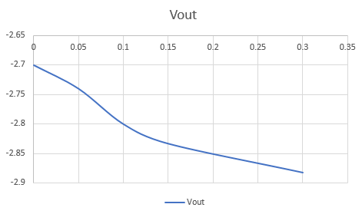

Fig p.3

$$slope=\frac{-2.85+2.75}{0.2-0.05}=-0.667$$

**Question :-**

* What does the slop represent?

Ad: differential Voltage gain.

* What is your experimental value of Ad?

-0.667

* From the Ac and Ad values found, calculate the common mode rejection ratio of the amplifier?

$$CMRR=\left|\frac{A_{d}}{A_{c}}\right|=\left|\frac{-0.667}{2}\right|=0.3335$$

Comments about the output results :-

The differential amplifier circuit was taken the difference between the two input voltages signal , and the gain when the two input was small cause a large differential gain .

**Conclusion :-**

In this experiment will be discuss the multistage amplifier and how it operational principle . and describes ways to design an amplifier connection by used a method to connected over one has to take a large amount of amplifier gain . also Frequency effect in voltage gain. In addition to another type of amplifier differential amplifier. This amplifies the difference between two input voltages. This may be useful for eliminating the noise from the devices that make up the circuit.

Finally , we will shown the difference between the experimentally and theoretically results .this difference it been from error in the digital multi meter resistance and digit of significant to read the output voltage, the carbonic resister value could be changed , and the internal resistor of the function generator .

**References :-**

1- Microelectronic Circuits, Sedra / Smith, Seventh edition , 2014

2- electronics lab-manual

3-google (snap shot photo )

