

Faculty of Engineering and Technology

Electrical and Computer Engineering Department

Electronics Laboratory (ENEE3102)

**Report of Experiment 6**

**“Multistage Amplifiers and Frequency Response”**

Prepared by:

Name: Jana Al-Zeer Number:1161228

Partners:

Name: Tuqa Remawi Number: 1160899

Name: Hanen Zahran Number:1162549

Instructor: Mohammad Ju’beh TA: Eng.Qassam Barghouthi

Section: 2

Date: 4 / 7 / 2019

***Abstract:***

The purpose of this experiment is to study and design multistage amplifiers ,To investigate what happens when transistor amplifier stages are connected one after another And the effect of frequency changes on the gain of the amplifier and the deferential amplifier and its functions.

***Table of Contents***

1. Theory..................................................................................................................... 1

2. Procedure................................................................................................................. 4

3. Data and calculation................................................................................................ 8

4. Conclusion............................................................................................................. 14

5. References: ........................................................................................................... 15

***Table of figure***

1. Figure (1) .....................................................................................................................1

2. Figure (2)..................................................................................................................... 2

3. Figure (3)..................................................................................................................... 3

4.Figure (4): .................................................................................................................... 4

5. Figure (5): ................................................................................................................... 4

6. Figure (6): ................................................................................................................... 5

7. Figure (7): ................................................................................................................... 6

8. Figure (8): ................................................................................................................... 7

9. Figure (9): ....................................................................................................................7 10.Figure (10): ................................................................................................................ 8

11.Figure (11): .................................................................................................................9

12.Figure (12): ................................................................................................................ 9

13.Figure (13): ................................................................................................................ 11

14.Figure (14): ................................................................................................................ 12

15.Figure (15): ................................................................................................................ 13

***Table of table***

1. Table(1) ...................................................................................................................... 10

2. Table(2)....................................................................................................................... 12

3. Table(3):...................................................................................................................... 13

***Theory:***

**I. Multistage amplifier design:**

For many applications, the performance obtainable from a single-stage [amplifier](https://en.wikipedia.org/wiki/Amplifier) is often insufficient , hence several stages may be combined forming a multistage amplifier. These stages are connected in [cascade](https://en.wikipedia.org/wiki/Cascade_amplifier), i.e. output of the first stage is connected to the input of second stage, whose output becomes input of third stage, and so on.



**Fig (1)”multistage amplifier”**

The overall gain is the product of voltage gain of individual stages.

A V =A V1 ×A V2 ×… ×An ……… (1)

Connecting amplifiers in cascade can be achieved using three methods: 1) capacitive coupling 2) transformer coupling 3) direct coupling. The first and second methods block DC currents .

Transistor amplifier may be connected in any of the three configurations namely common emitter (CE), common base (CB) and common collector (CC). However, in cascade amplifier meant for providing high gain, only CE amplifier stage are connected in cascade. CB and CC configurations can not be used for this purpose.

designing a multistage amplifier one must first design the dc biasing of each stage alone, then design the ac small signal circuit for the whole multistage amplifier.

1

**II. Frequency Response:**

The frequency has a big role of the amplification and on the bandwidth of the circuit; bandwidth*gain=const.; this response results from the circuit capacitors.

For a speech and music , they are a combination of many different sine-waves occurring simultaneously with different amplifications & different frequency in the range 20Hz-20KHz.

In order for an output to be an amplifier version of the input ,an amplifier must amplify every frequency component in the signal by the same amount.

Thus in the audio signals, the bandwidth must cover the entire range of frequency component if undistorted amplification is to be activated.

At lower frequency, the output voltage and the gain will be reduced .the same changes will be at higher frequency but by larger factors.

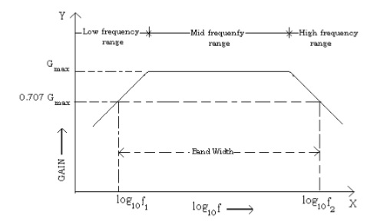

**Fig.(2):”Frequency response of an amplifier”**

**III. The Differential Amplifier:**

A differential amplifier amplifies the difference between its two input signals. Usually the two parts of the differential amplifier are identical resulting in a zero output when the two input signals are equal.

2

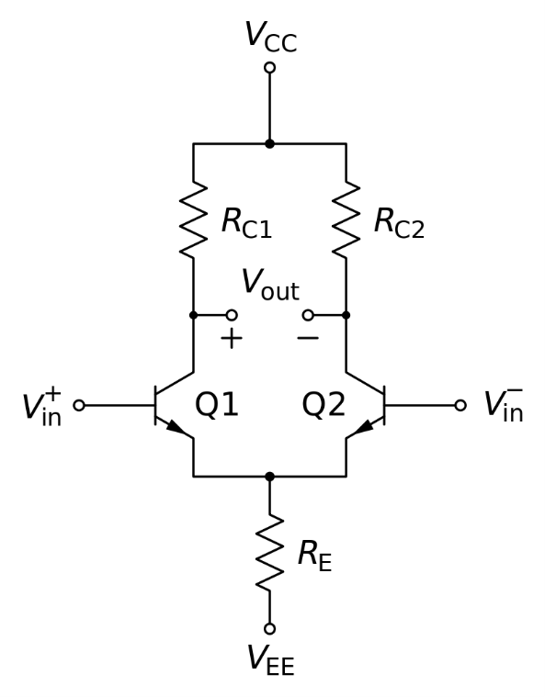

**Fig.(3) :” Differential amplifier”**

3

***Procedure :***

**I.MULTISTAGE AMPLIFIER DESIGN:**

1. a two stage amplifier was designed with a voltage gain of 200 to give a peak to peak output of 2.5V , As shown in Fig.(4) : Av1 = 100, Av2 = 2, Vi = 16 mVp-p .

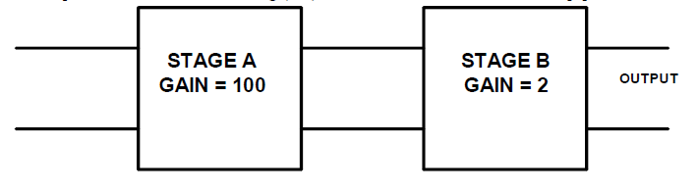

**Fig.(4):”** **two stage amplifier with”**

The first stage of the amplifier designed for the h- parameters of a BC107 transistor are: hie = 4x103 Ω , hoe = 10-4 Ʊ , hfe = 300 , hre = 10-3 ,VCC =10V.

2. a capacitor of 100 µF was connected in parallel with RE of first stage .

3. The first stage was connected.

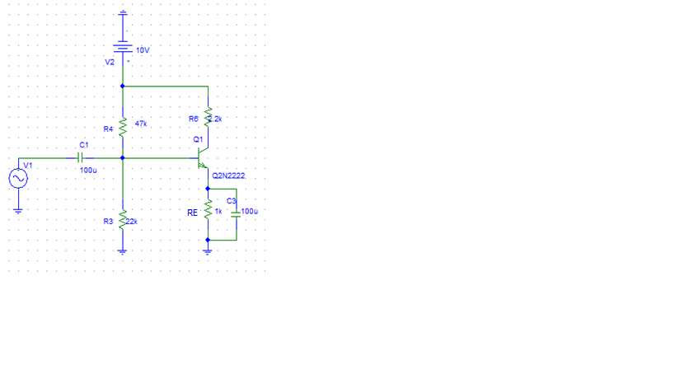

**Fig.(5)”first stage of the amplifier”**

4

4. The quiescent voltage of the collector, the emitter and base with respect to ground was measured.

5. the sine wave generator was connected via a 100 μF capacitor to the base of the transistor Q1, and the generator output was adjusted to 16mVp-p at f = 1 kHz.

6. the output from the first stage was measured, and compared with the required output.

7. the second stage was connected .

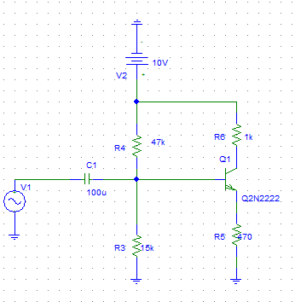

**Fig.(6)”second stage of the amplifier”**

8. The quiescent voltage of the collector, the emitter and base with respect to ground was measured.

9. the sine wave generator was Connected via a 100μF capacitor to the base of the transistor Q2, and the generator output was adjusted to 1.6Vp-p at 1 kHz frequency.

10. the output from the second stage was measured.

11. The two stages must be connected together to form the complete amplifier.

5

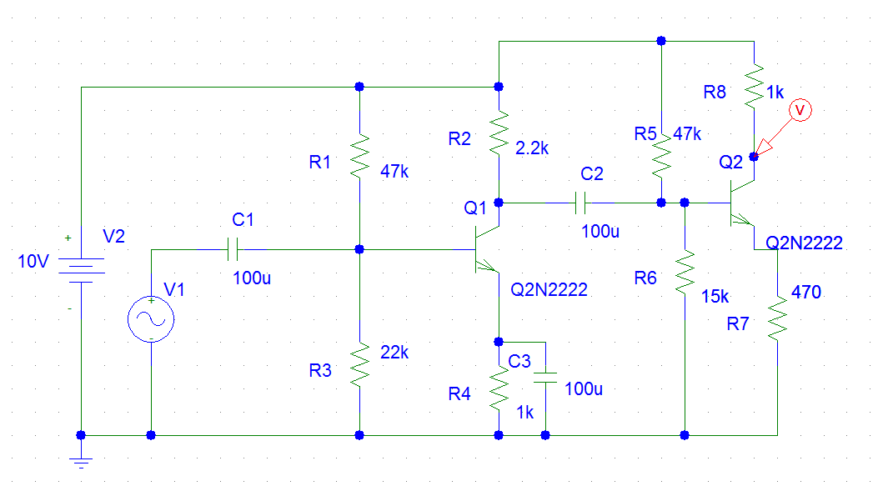

**Fig.(7)”the two stage connected together”**

12. the generator connected to the input of first stage to 12.5mVp-p at f = 1 kHz and the output from the second stage was measured.

***II. FREQUENCY RESPONSE.***

1. For the same circuit of part I , the output amplitude of the sine wave generator was adjusted to a suitable value and measured the output amplitude from the amplifier for the frequency 50Hz , 100 Hz ,200,300,400,500Hz, 1 kHz , 50 , 30, 100 ,300 , 500, 700, 1000 and 2000 kHz

2. Recorded the results in table (1).

***III. DIFFERENTIAL AMPLIFIER.***

1. the circuit was Set up as shown in Fig. (8).

6

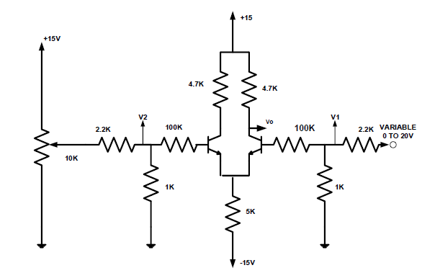

**Fig. (8):” DIFFERENTIAL AMPLIFIER”**

2. the power supply was switched on .

3. the output voltage Vout was measured for input voltage V1 and V2 of 0, 1, 2, 3, 4 and 5V.

4. the results recorded in table (2).

5. the circuit was Set up as shown in Fig. (9).

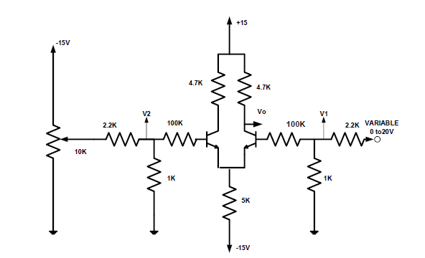

**Fig.(9):” DIFFERENTIAL AMPLIFIER”**

6.the voltmeter was Connected between each of the amplifier inputs(V1 and V2) and 0 vol.

7. Recorded the resultant Vout .

8. Vout was Measured and recorded for V1, V2 as indicated in table 3.

7

***Data and calculation:***

**I.MULTISTAGE AMPLIFIER DESIGN:**

For the Dc analysis of the first stage. The following measurements were taken: VB1=2.92 V , VE1=2.31 V , VCE=2.76 V.

**Question:**

* What is the gain of your stage ?

After feeding the first stage by 16m Vp-p with 1 KHz frequency the output was Vo1=2.08 Vp-p. the first stage has a gain of Av1=130 .

The first stage input and output is shown in fig.(10) .

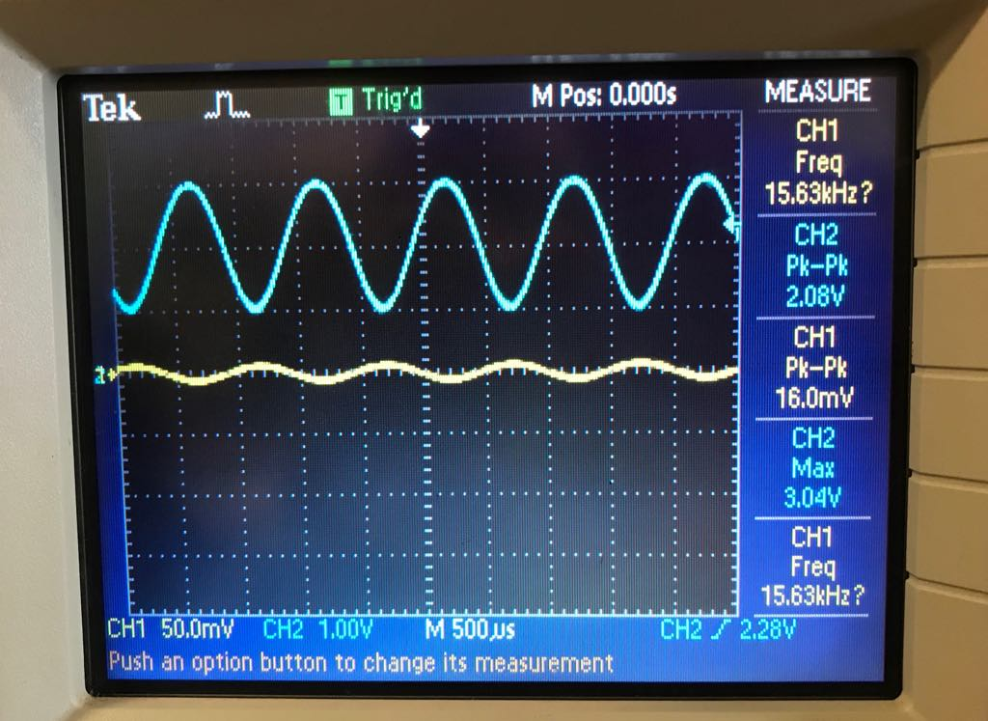

**Fig.(10):”output and input of first stage”**

For the dc analysis of the second stage. The following measurements were taken: VB2=8.8 V , VE2=8.23 V , VCE2=8.32 V.

***Question:***

* What is the voltage gain of the two stage amplifier?

8

After feeding the second stage by 1.60 Vp-p with 1 KHz frequency the output was Vo2=3.30 Vp-p Thus, the second stage has a gain of Av2=2.06.

The second stage input and output is shown in fig (11).

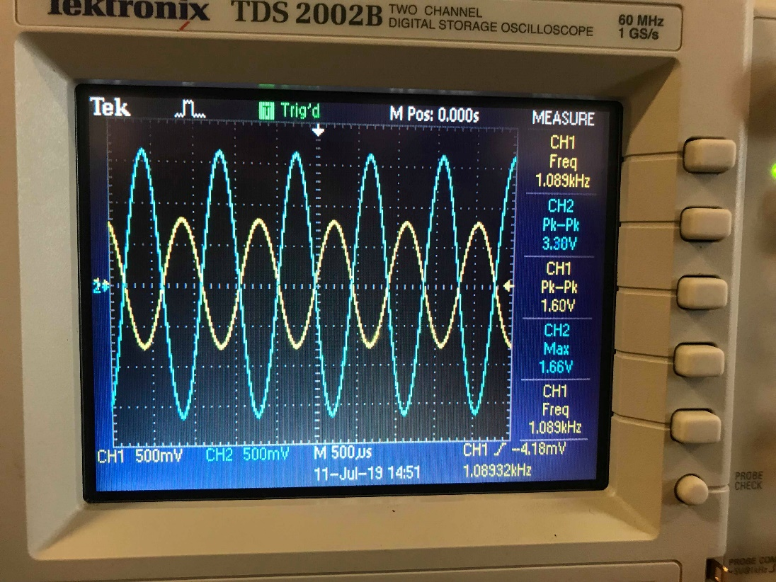

**Fig.(11):”output and input of second stage”**

When the two stages were connected together again in cascade and a sinewave input of16.4m Vp-p was fed to the input with 1KHz frequency. The output was Vo=3.52 Vp-p. The voltage gain Av=214.6 Which is less than the theoretical total gain ((130×2.06) = 267.8) which is expected due to losses in the circuit.

The multistage input and output is shown in fig (12) .

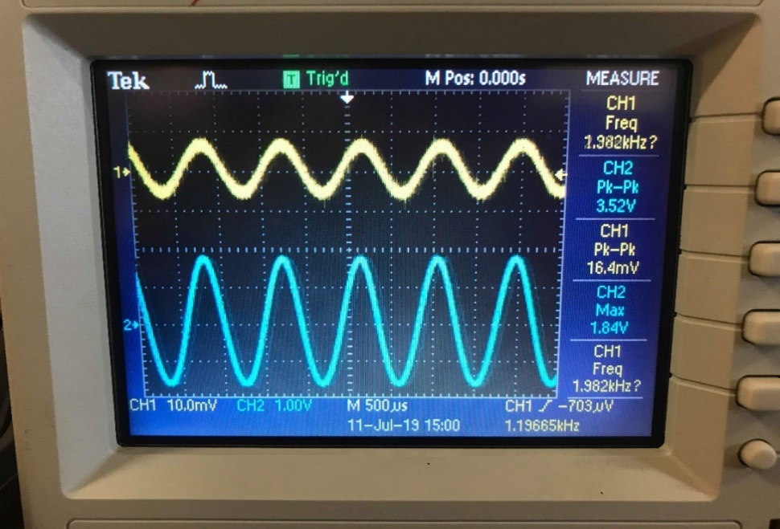

**Fig.(12):”output and input of two stage”**

9

**Question:**

* What would happen if the coupling capacitor used did not have negligible impedance at 1 kHz?

if the coupling capacitor didn’t have a negligible impedance at the source frequency then the voltage gain would drop drastically due to a voltage drop across the capacitor.

**II.FREQUENCY RESPONSE:**

For the same circuit in part one the frequency is changed from 10 Hz to 2MHz and the gain , log (f) and 20*log(Av) is calculated.

|  |  |  |  |  |  |
| --- | --- | --- | --- | --- | --- |
| **Frequency(Hz)** | **Vin(Vp-p)** | **Vout(Vp-p)** | **Av** | **Log(f)** | **20*log(Av)** |
| **50** | 8m | 1.04 | 130 | 1.698 | 42.278 |
| **60** | 10m | 1.44 | 144 | 1.778 | 43.167 |
| **80** | 12m | 1.90 | 158.3 | 1.903 | 43.989 |
| **100** | 14m | 2.22 | 158.6 | 2.000 | 44.00 |
| **200** | 16m | 3.12 | 195.0 | 2.301 | 45.800 |
| **300** | 16m | 3.24 | 202.5 | 2.477 | 46.128 |
| **400** | 16m | 3.42 | 213.7 | 2.602 | 46.59 |
| **500** | 16m | 3.44 | 215.0 | 2.698 | 46.64 |
| **1k** | 18mv | 3.56 | 197.7 | 3 | 45.92 |
| **10k** | 16m | 3.54 | 221.3 | 4 | 46.89 |
| **30k** | 18m | 3.52 | 195.5 | 4.477 | 45.822 |
| **100k** | 20m | 3.46 | 173.0 | 5 | 44.76 |
| **300k** | 18m | 3.02 | 167.7 | 5.477 | 44.49 |
| **400k** | 18m | 2.64 | 146.6 | 5.602 | 43.32 |
| **500k** | 18m | 2.44 | 135.5 | 5.698 | 42.63 |
| **700k** | 18m | 1.96 | 108.8 | 5.845 | 40.73 |
| **1000k** | 18m | 1.38 | 76.6 | 6 | 37.68 |
| **2000k** | 14m | 520m | 37.1 | 6.301 | 31.38 |

**Table(1)**

10

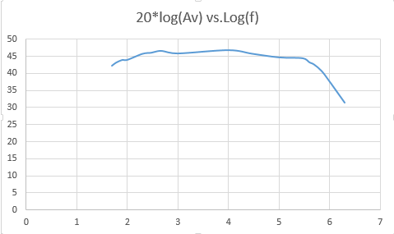

**Fig.(13) “ Frequency Response Curve”**

**Questions:**

* Does the output amplitude vary with frequency?

Yes,The output amplitude depends on the frequency

* What happens to the output amplitude at low frequency?

At low frequencies the output amplitude is amplified by a small amount.

* What causes this effect at low frequencies?

The Capacitors.

* What would you expect happen to the gain of the circuit at high frequencies?

At high frequencies similar effects happen to the gain as it gets attenuated.

III.DIFFERENTIAL AMPLIFIER:

Part(1):

11

When V1=V2 :

|  |  |
| --- | --- |
| **V1=V2(V)** | **Vout(V)** |
| **0** | **15.026** |
| **1** | **14.849** |
| **2** | **14.459** |
| **3** | **13.924** |
| **4** | **13.75** |
| **5** | **12.108** |

**Table(2)**

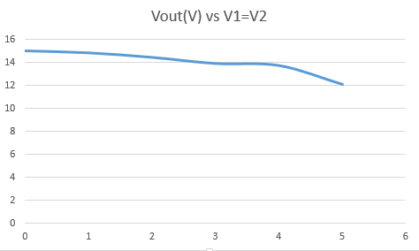

**Fig.(14):” Vout against V1 = V2 ”**

The graph in fig.(14) has a slope of (-2.5)This slop represents the common mode gain. The experimental value of Ac is the slope=-2.5.

12

Part(2):

|  |  |  |
| --- | --- | --- |
| ***V1(V)*** | ***V2(V)*** | ***Vout(V)*** |
| ***0*** | ***0*** | ***12.39*** |
| ***0.05*** | ***-0.05*** | ***12.379*** |
| ***0.1*** | ***-0.1*** | ***12.35*** |
| ***0.15*** | ***-0.15*** | ***12.344*** |
| ***0.2*** | ***-0.2*** | ***12.334*** |

**Table(3)**

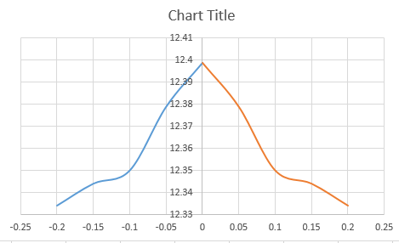

**Fig.(15):” Vout against V1 & V2”**

**Questions:**

* What does the slop represent ?

The slope of the graph in figure 10 represents the differential mode gain Ad.

* What is your experimental value of Ad ?

0.28

* From the Ac and Ad values found, calculate the common mode rejection ratio of the amplifier .

CMRR=Ad/Ac=0.112

13

***Calculation:***

The data obtained in this experiment coincides with expected data from a theoretical point of view. Errors were found in the experiment due to incompetence in measurement or due to uncalibrated instruments, but it was negligible. Theoretical laws were confirmed such as the multiplication of the gains when cascading amplifiers and the frequency response plot.

14

***References :***

* Electronics lab manual
* <https://en.wikipedia.org/wiki/Differential_amplifier>
* https://www.academia.edu/9445729/Chapter_7_Amplifier_Frequency_Response

15