

Faculty of Engineering and Technology

Electrical and Computer Engineering

Department

ENEE3102

Electronics Laboratory

Experiment #7

Power amplifiers

Name : Isra'a Muslleh ID # : 1172321

Partners name :

Mohammad Al Battat

Mohammad Hmouda

Table of Contents:

Abstract …………………………………3

Theory …………………………………3-11

Procedure

Part 1 …………………………………12

Part2 …………………………………13

Part 3 …………………………………14

Tables , graphs and calculations

Part 1 …………………………………11

Part 2 …………………………………..12

Part 3 ………………………………….13

Conclusion and notes …………………….14

*Abstract :*

The aims of doing this experiment :

***To understand the classes of power amplifier: class A,B nd AB . to know how to design of a power amplifier using push-pull techniques.***

The method used :

***by connecting the circuits as shown in procedure part and saw the figures of all classes of amplifier***

*Theory :*

***An electronic amplifier consists of several parts, including at least one transistor or electronic valve that processes an analog signal to amplify its properties and amplify the output. One of the qualities of a manager is that he has a higher ability than the next ability. Both panels receive an electrical source, such as a battery or power source such as a home user. There are constant and constant voltage current amplifiers as there are AC currents and hence AC voltage.***

***Is an electronic circuit that amplifies the input signal or the input signal tension. At the output of the amplifier, we receive a signal that is similar to the incoming signal, but with its value***

Class A

***A Class A power amplifier is a type of power amplifier where the output transistor is in full-time mode and the output stream flows throughout the input wave model cycle. The Class A power amplifier is the simplest of all power amplifier configurations. They have high precision and are fully shielded to distort the crossover. Although the Class A power amplifier has a few good features, it is not the first choice because of its low efficiency. Since the transistors are biased forward full-time, some current will flow through them even though there is no input signal and this is the main cause of inefficiency. The Class A amplifier output characteristics are shown in the figure below***

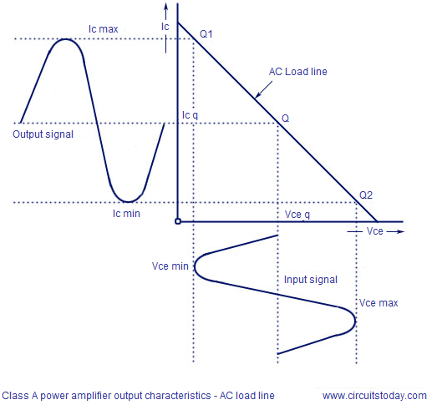

***From the above figure its is clear that the Q-point is placed exactly at the center of the DC load line and the transistor conducts  for every point in the input waveform. The theoretical maximum efficiency of a Class A power amplifier is 50%. In practical scenario, with capacitive coupling and inductive loads (loud speakers), the efficiency can come down as low as 25%. This means 75% of power drawn by the amplifier from the supply line is wasted. Majority of the power wasted is lost as heat on the active elements (transistor).As a result, even a moderately powered Class A power amplifier require a large power supply and a large heatsink.***

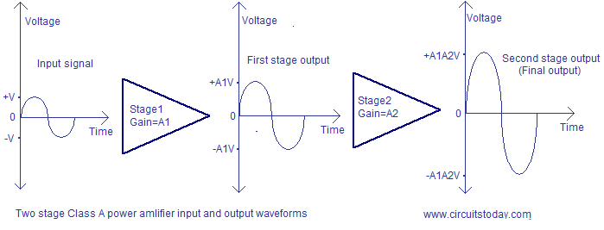

*Advantages of Class A power amplifier.*

* ***Class A design is the simplest.***
* ***High fidelity because input signal will be exactly reproduced at the output.***
* ***Since the active device is on full time, no time is required for the turn on and this improves high frequency response.***
* ***Since the active device conducts for the entire cycle of the input signal, there will be no cross over distortion.***
* ***Single ended configuration can be practically realized in Class A amplifier. Single ended means only one active device (transistor) in the output stage.***

*Disadvantages of Class A power amplifier*.

* ***Main disadvantage is poor efficiency.***
* ***Steps for improving efficiency like transformer coupling etc affects the frequency response.***
* ***Powerful Class A power amplifiers are costly and bulky due to the large power supply and heatsink.***

Class B

***Class B amplifier is a type of power amplifier where the active device (transistor) conducts only for one half cycle of the input signal. That means the conduction angle is 180° for a Class B amplifier. Since the active device is switched off for half the input cycle, the active device dissipates less powe r and hence the efficiency is improved. Theoretical maximum efficiency of Class B power amplifier is 78.5%. The schematic of a single ended Class B amplifier and input , output waveforms are shown in the figure below.***

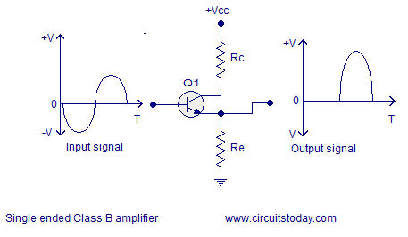

***From the above circuit it is clear that the base of the transistor Q1 is not biased and the negative half cycle of the input waveform is missing in the output. Even though it improves the power efficiency, it creates a lot of distortion. Only half the information present in the input will be available in the output and that is a bad thing.Single ended Class B amplifiers are not used in present day practical audio amplifier application and they can be found only in some earlier gadgets. Another place where you can find them is the RF power amplifiers where the distortion is not a matter of major concern. Anyway, Class C amplifiers are more often used in RF power amplifier applications. Output characteristics of a  single ended Class B power amplifier is shown in the figure below.***

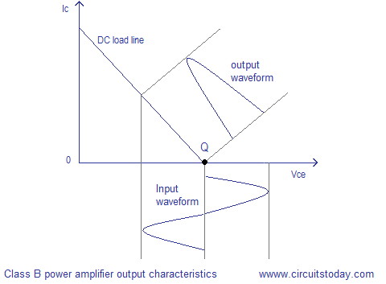

#### Transformer coupled Class B amplifier.

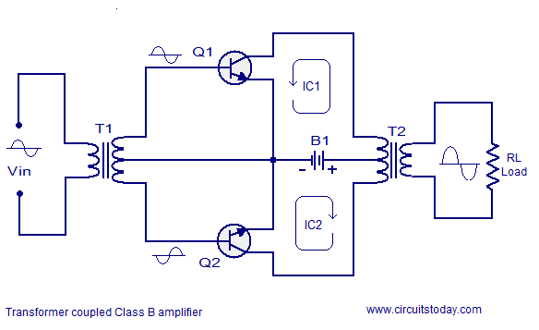

***The circuit diagram of a simple transformer coupled class B power amplifier is shown in the figure above. Transistor Q1 and Q2 are the active elements. The transformer T1 reproduces the input signal into two copies which are 180° out of phase. From the above figure you can see that the transistor Q1 amplifies the positive half of the input signal and transistor Q2 amplifies the negative half of the input signal. Current flow path of the two transistors are also depicted in the above figure. The amplified two halves are joined together by the transformer T2. If an ideal transformer is used the DC components of the collector current of each transistors will flow in opposite directions through the transformer primary and they will cancel each other. That means there is no core saturation and there will be no DC components in the output.***

***Since the transistors are not biased they remains OFF when there is no input signal and no current flows through the load. Each transistor starts conduction only when the amplitude of the input signal goes above the base-emitter voltage (V*be*) of the transistor which is about 0.7 V. This improves the efficiency but creates a problem called cross-over distortion.***

Cross over distortion.

***Since the active elements start conduction only after the input signal amplitude has risen above 0.7V, the regions of the input signal where the amplitude is less than 0.7V will be missing in the output signal and it is called cross over distortion. The schematic representation of cross-over distortion is shown in the figure below. In the figure, you can see that the regions of the input waveform which are under 0.7V are missing in the output waveform.***

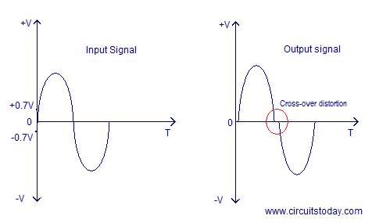

Advantages of Class B amplifier.

* ***High efficiency when compared to the Class A configurations.***
* ***Push-pull mechanism avoids even harmonics.***
* ***No DC components in the output (in ideal case).***

Disadvantages of Class B amplifier.

* ***The major disadvantage is the cross-over distortion.***
* ***Coupling transformers increases the cost and size.***
* ***It is difficult to find ideal transformers.***
* ***Transformer coupling causes hum in the output and also affects the low frequency response.***
* ***Transformer coupling is not practical in case of huge loads.***

#### Class AB power amplifier.

***In Class AB configuration, the active elements (transistors)  are slightly biased so that the conduction angle is slightly more than 180° but much less than 360°. The transistors conduct for more than a half cycle but much less than the full cycle. That means there will be no instant where both transistors are OFF simultaneously and thus cross-over distortion is eliminated. Class AB configuration is actually a trade-off between Class A and Class B configurations where efficiency is slightly compromised for fidelity. Class AB power amplifiers are slightly inefficient than the Class B configurations but far better in terms of distortion when compared to Class A configurations. Since the active devices are slightly pre-biased there will be a small amount of collector current flowing and this is the reason behind the slightly reduced efficiency. Typical efficiency of a well designed class AB power amplifier is around 70%. The output characteristics of a single ended Class AB power amplifier is shown in the figure below.***

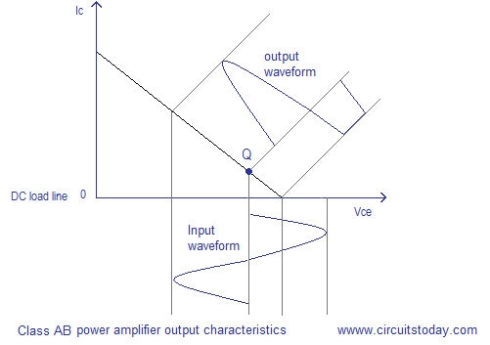

***From the above figure it is clear that the Q-point is not positioned at cut-off unlike the Class B characteristics and there will be a small amount of collector current flowing at zero input. As a result, some part of the negative going half cycle will be also reproduced at the output. The amount of negative going half cycle reproduced at the output depends on the amount of pre-bias given to the transistor.***

**Practical Class AB power amplifier.**

***Single ended Class AB configurations are not practical just because a major portion of one half cycle will be missing at the output. Just like the Class B configuration, push-pull mechanism is essential for realizing practical Class AB power amplifiers. Circuit diagram of a typical Class AB push-pull amplifier is shown in the figure below.***

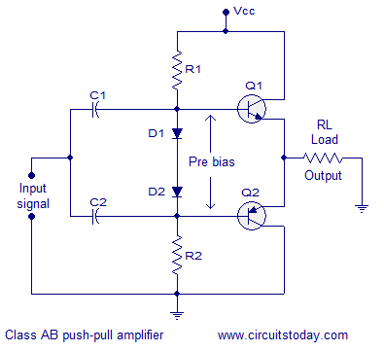

***The exact technical designation of the above circuit is ” Complementary- symmetry Class AB power amplifier”. The active elements used in this circuit (transistor Q1 and Q2) are complementary symmetric and it means the the transistor are similar in all aspects except one is NPN and the other is PNP. The use of this complementary pair eliminates the bulky transformer for phase splitting the input signal for driving the individual transistors. The NPN transistor alone will conduct the positive half cycle and PNP transistor alone will conduct the negative half cycle.***

***Slight pre-biasing is given to the transistors using the network comprising of resistors R1, R2 and biasing diodes D1 and D2. As you know, an NPN transistor will start conducting when its base voltage is above the base emitter voltage (Vbe~0.7V)  and a PNP transistor will start conducting when its base  voltage is below the base emitter voltage (Vbe~ -0.7V).  A forward biased diode will drop approximately 0.7V across it and*** ***the biasing diodes used here will keep the transistor slightly forward biased even if there is no input signal.***

***One important thing while choosing the biasing diodes (also called compensating diodes) is that their characteristics must match as close as possible to the transistors. Resistors R1 and R2 are actually used for forward biasing the diodes so that they drop 0.7V across it for biasing the individual transistors. C1 and C2 are input DC decoupling capacitors. Input and output waveforms of a typical class AB push pull amplifier is shown in the figure below.***

[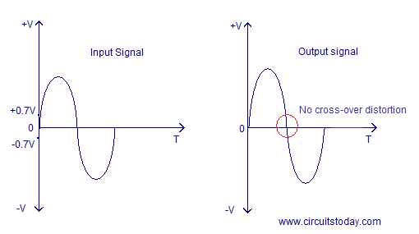](http://www.circuitstoday.com/wp-content/uploads/2009/08/class-ab-amplifier-input-and-output-waveform.png)

***Since both the transistors are slightly conducting at zero input, no information in the input signal  is lost at the output during the zero-crossing of the input signal and thus cross-over distortion is completely eliminated at a cost of slightly reduced efficiency.***

***Advantages of Class AB power amplifier.***

* ***No cross over distortion.***
* ***No need for the bulky coupling transformers.***
* ***No hum in the output.***

***Disadvantages of Class AB power amplifier.***

* ***Efficiency is slightly less when compared to Class B configuration.***
* ***There will be some DC components in the output as the load is directly coupled.***
* ***Capacitive coupling can eliminate DC components but it is not practical in case of heavy loads.***

***Procedure 1- The circuit shown was connected .***

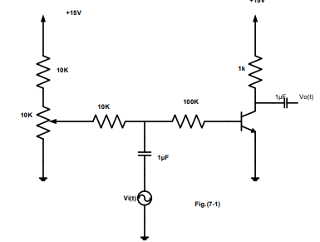

***2. the power supply, function generator, and oscilloscope switch were on.***

***3. the bias control was started at zero(fully clockwise).***

***4. the oscilloscope channels were connected to the input and output of the circuit.***

***5. the output of the function generator was turned up and until a waveform that shown in Fig.(7- 2.a) was seen .***

***6. the signal amplitude was turned down to a little , and the bias potentiometer was turned up and until a waveform that shown in Fig.(7- 2.b) was seen .***

***7. the bias was turned up , and the output waveform was look like Fig.(7-2.c),the transistor was saturated.***

***8. the function generator output was set to zero, then the bias was reseted to give a collector voltage of about 7.5V on the meter , and an output was liked Fig.(7-2.b), then the signal amplitude was turned up until a waveform like fig.7.2(d) was displayed.***

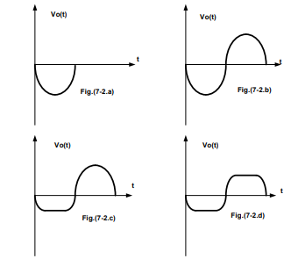

II. PUSH-PULL AMPLIFIER.

1. ***the circuit as shown was Connected***

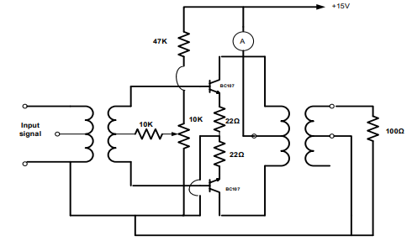

1. ***the equipment switched was on and the DC supply current was set to zero by setting the bias potentiometer fully anticlockwise to zero.***
2. ***the function generator output was set to zero.***
3. ***the function generator output was Turned up to give a peak-to-peak voltage of 4 volts at 1KHz.***
4. ***the oscilloscope Switch was on and its channels were connected to the input and output of the circuit .***
5. ***The output waveform was shown as severe crossover distortion.***
6. ***the input was reduced to 0.5 volt peak-to-peak, then the output was disappeared.***
7. ***The bias was applied Slowly by turning the potentiometer clockwise.***
8. ***the function generator was setted so that the output of the amplifier was 4V peak-to-peak and the bias potentiometer was adjusted to eliminate crossover distortion.***
9. ***the load resistor was Changed , and was entered the output voltage in table .***

***11.each output voltage reading was Converted to its root mean square equivalent by using the formula: Vrms= VPK−PK 2√2***

***And the output power was calculated using the formula:***

***Power=(Vrms) 2 /Rload***

***12.the resistor that matches the output impedance was Selected most closely, and was replace the load resistor with it.***

***13.the function generator output was Turned up for maximum undistorted output***

***waveform .***

***14. the output power of the amplifier was Measured by measured the peak-to-peak output voltage***

***15. the supply current was Measured and was used the formula :***

***Pin=Vsupply*Isupply. the input power to the amplifier was Calculated.***

***16. the efficiency of the amplifier was Calculated***.

III. COMPLEMENTARY PUSH-PULL AMPLIFIER.

1. ***t the circuit was Connected as shown***

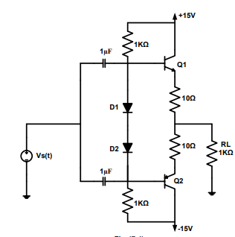

***2. the function generator output was Turned up to give 1 volt peak - to - peak at 2KHz.***

***3. the power efficiency of the amplifier was Calculated.***

***4. steps (1 – 3) were repeated for RL = 100Ω .***

Graphs : part A

***the output of the function generator until a waveform that shown in Fig.(7- 2.a)this is called power amplifier class B***

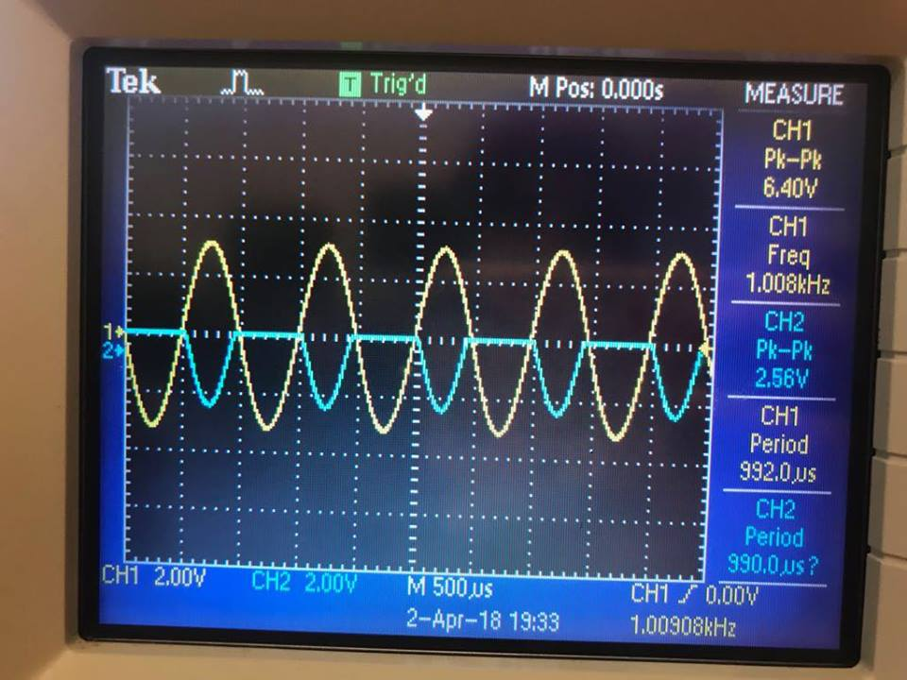

***the output of the function generator until a waveform that shown in Fig.(7- 2.b)this is called power amplifier class A***

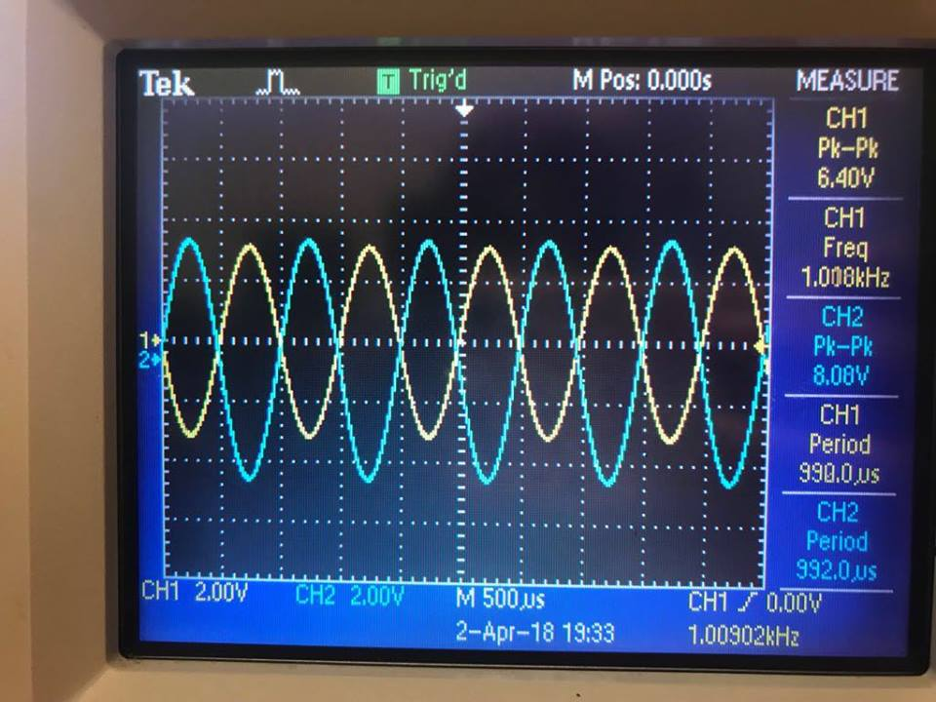

the output of the function generator until a waveform that shown in Fig.(7- 2.c)this is called power amplifier class AB , This is so since the transistor started entering the saturation region . 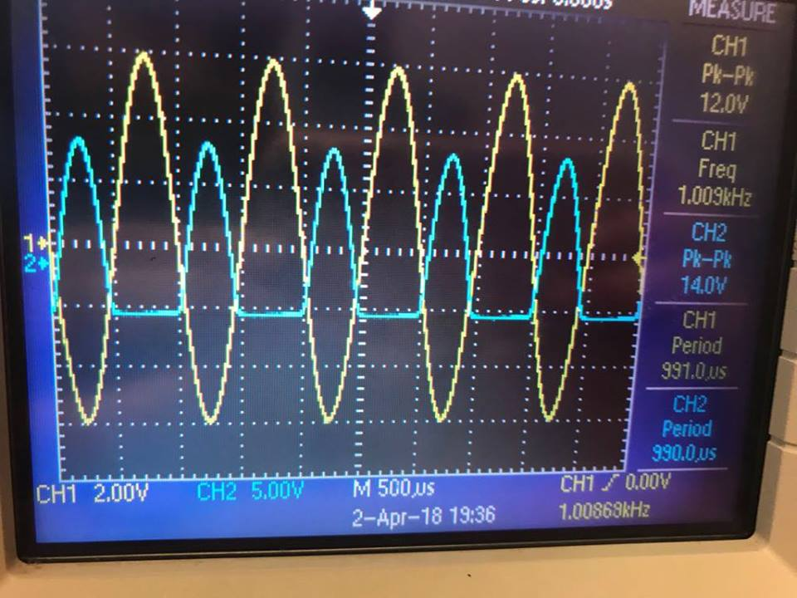

the output of the function generator until a waveform that shown in Fig.(7- 2.d), the transistor works in both the saturation and cutoff regions

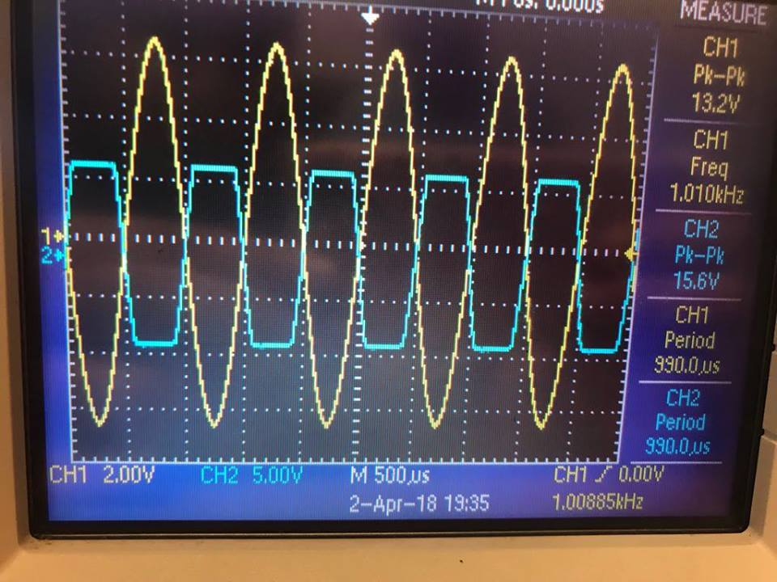

Part B

the DC supply current zero when the bias potentiometer fully anticlockwise to zero.

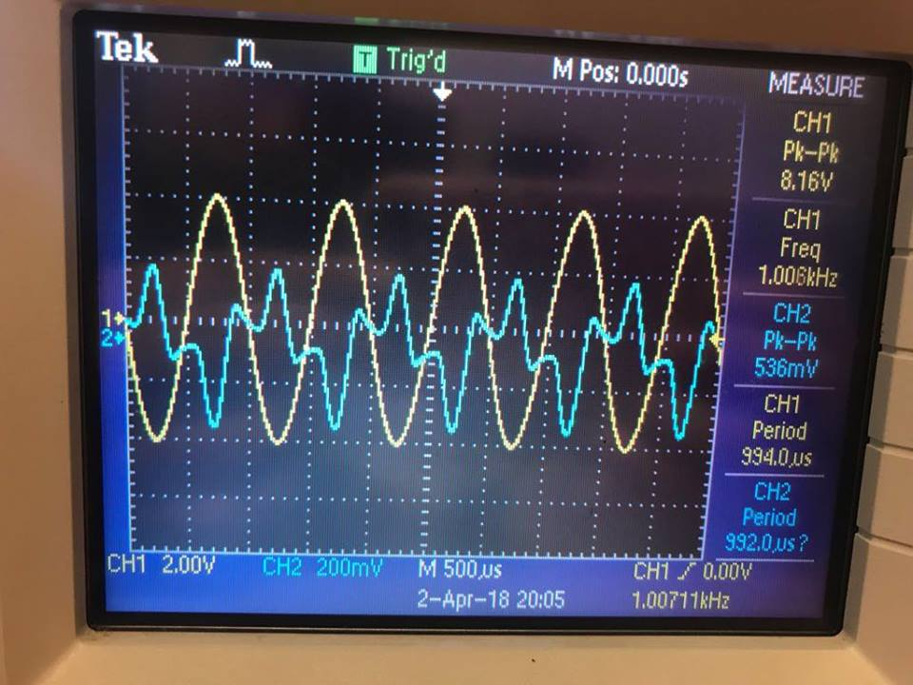

The function generator output when the input peak-to-peak voltage equal 4 volts at 1KHz.( the cross over distortion problem)

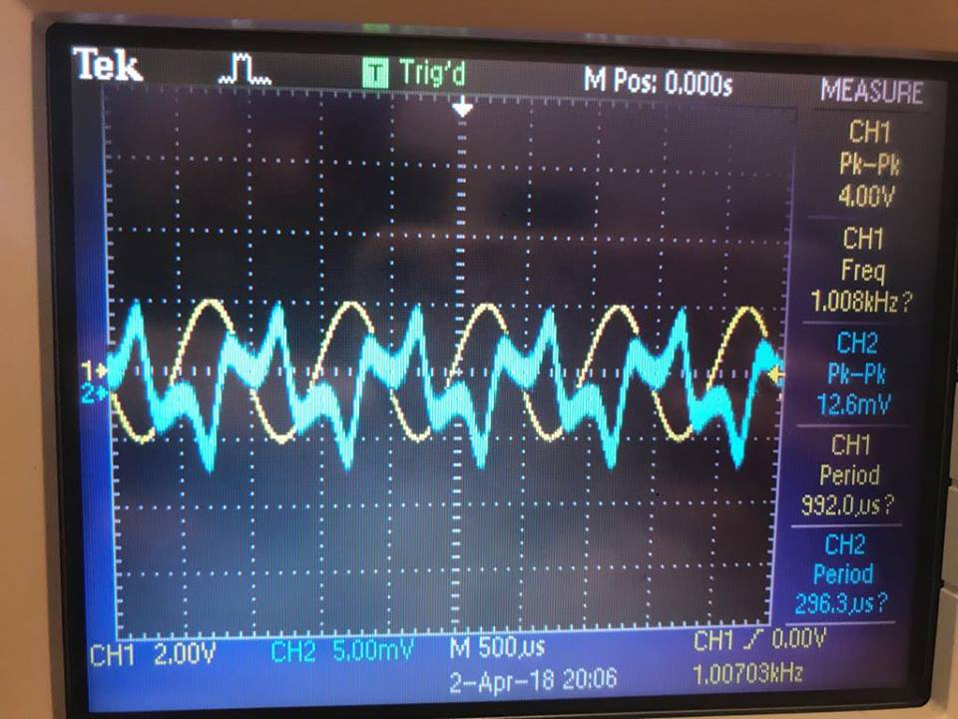

When the input voltage = 0.5 volt peak-to-peak , the output disappeared .

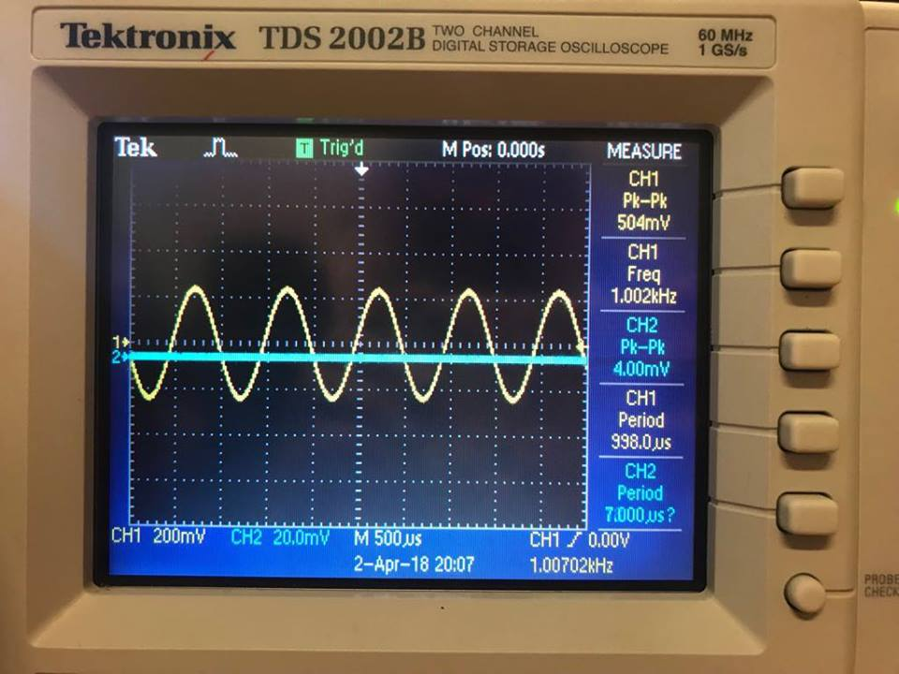

When the cross over distortion disappear

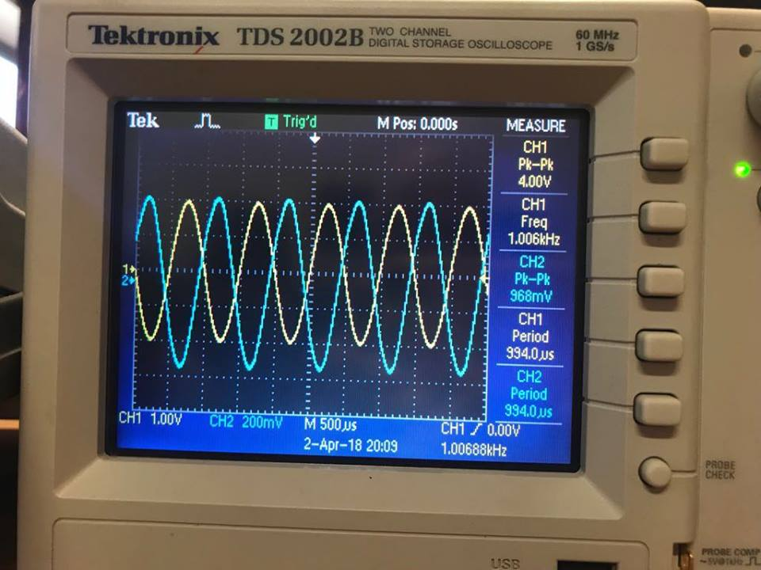

Table of output voltages at each reading of load resistor :

|  |  |  |  |
| --- | --- | --- | --- |
| Load resistor (ohm) | Output voltage (volts )  p-p (m volt) RMS | | Output power  (Mw) |
| 320 | 320 | 113.13 | 39.9 |
| 220 | 300 | 106.06 | 51.07 |
| 150 | 280 | 98.9 | 65.208 |
| 100 | 250 | 88.38 | 78.11 |
| 69 | 224 | 79.19 | 89.58 |
| 50 | 196 | 69.29 | 96.02 |
| 41 | 176 | 62.22 | 96.78 |

Vrms= VPK−PK 2√2

** We didn’t calculate the output voltage in rms we measured it practically and we calculated the power using this equation :

Power=(Vrms) 2 /Rload

Then ,We selected the resistor that gives max power , it is 41ohm

We used this formula to calculate input power amplifier : pin =Vsupply*Isupply

V supply=15volt , I supply=.3835mA

Then the input power =15*.3835mA=5.75V.mA

The output power =96.78 mW

The efficiency of the amplifier= P out / P in =96.78/5.75*100%=16.8 %

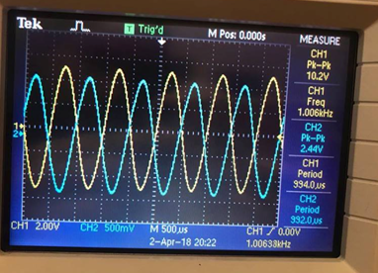

Part C

When the RL=100ohm ( the input and output voltage in phase and there was no distortion )

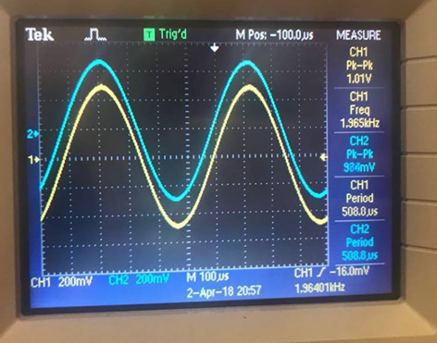

When the RL=1k

I out=18.97mA, vout =19.8volt

When the RL=100ohm

I out =-18.481mA , Vout=-19.5volt

Conclusion and answer of questions :

Note : I didn’t make prelab for this exp. But our data obtained in this experiment match the expected data in theory.

In conclusion This experiment was conducted in order to learn the properties of classes of power amplifier, learn what is the cross over distortion .

** the distortion caused by the nonlinear transistor input, in order to over come the problem of cross over distortion , the transistor must operate in class AB mode .

**Few errors were found in the experiment due to inefficiency in electronic

**The power efficiency is very small .

** The output disappears while the input is reduced since the transistor needs about +0.7 V for VBE in order to start working .So for our case (no dc bias) even if there is an input but less than 0.7 ;there will be no output .