

Faculty of Engineering and Technology

Electrical and Computer Engineering Department

**ENEE 3102 – Electronics Lab**

Experiment No. 7

**Power Amplifier**

Prepared By:

Name: Suhaeb Qadan Number: 1160297

Instructor: Dr. Mohammad Al Jubeh

TA: Eng. Almo`tassem Billah

Date: 30/10/2019

Sec#: 1

**Abstract**  In this experiment, some concept was studied about power amplifier. The aim of this experiment is to identifies the classes of the power amplifiers and distinguish between them according to their outputs. Moreover, to understand and acknowledge the design of a power amplifier using push-pull techniques, and that can be done by using an oscilloscope to observe the outputs of the different power amplifiers.

Equipment's List:

* DC power supply.
* nPn BJT Transistor.
* Resistors, Capacitors and Potentiometer.
* 3-Φ Transformers.
* Electrical Kit.
* Wires.

**Table of Contents**

**Abstract** 1

**Theory** 4

• **Class A** 4

• **Class B (push-pull)** 5

• **Class AB** 6

**Procedure, Data and Discussion** 7

**Part A: THE CLASSES OF POWER AMPLIFIER** 7

**Part B: Push Pull Amplifier** 10

**Part C: Complementary Push-Pull Amplifier** 13

**Conclusion** 16

**References** 17

**List of Figures**

Figure 1: The Block Diagram of a Power Amplifier Using in Audio Amplifier Circuit 5

Figure 2: Operating Curve of Class A Power Amplifier 6

Figure 3: Operating Curve of Class B Power Amplifier 7

Figure 4: Operating Curve of Class AB Power Amplifier 7

Figure 5: Circuit to modify the characteristic of the classes of power amplifier 8

Figure 6 9

Figure 7 9

Figure 8 10

Figure 9 10

Figure 10 11

Figure 11: *The Crossover Distortion in the Output Signal* 12

Figure 12: The output waveform when Vin = 0.5 Vp-p 12

Figure 13: The output waveform when Vin = 4 Vp-p 13

Figure 14 14

Figure 15: The output waveform when Vin = 1 Vp-p for RL = 1 kΩ 15

Figure 16: The output waveform when Vin = 1 Vp-p for RL = 100 Ω 15

# 

# **Theory**

A power amplifier circuit is a circuit used to deliver a high amount of power with a good efficiency. It is often the last stage of any amplifier system like Op-Amps. The Figure 1 illustrates a block diagram of a circuit using a power amplifier for audio cases.

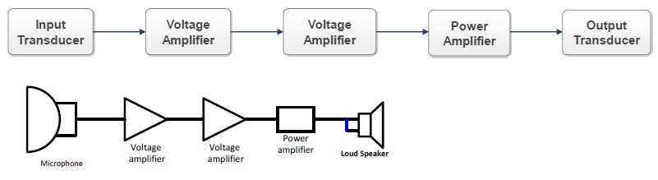

Figure : The Block Diagram of a Power Amplifier Using in Audio Amplifier Circuit …(2)

According to the position of the bias point, the power amplifiers have been classified to A, B, AB, C, and other classes

## **Class A**

They are the most common type of power amplifier due mainly to their simple construction (design).

The bias point of this class is in the middle of the ac load line, which justify the maximum symmetrical swing condition. In other words, the amplifier doesn’t enter the cut off or the saturation region during its operation. However, this type of amplifier has the worst efficiency (which can be calculated using the formula 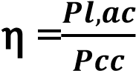; where η is the efficiency, Pl,ac the ac power delivered to the load, Pcc the power delivered from the source to the amplifier circuit) which is about 50% commonly… (1)

Although the simplicity of this class is one of its advantages, but due to the choosing of the bias point (which meets the maximum symmetrical swing) makes the amplifier consuming the power whether there is an input signal or not, which makes the circuit needs sufficiently **Heat Sinks**.

Figure 2 illustrate the operating curve of Class A power amplifier.

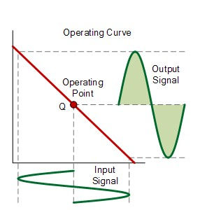

Figure : Operating Curve of Class A Power Amplifier … (2)

## **Class B (push-pull)**

This class was designed to solve the problem of the efficiency and the heat in class A. the basic idea of the construction is to use 2 transistors (either BJT, FET, or even IGBT) everyone amplifies half of the signal. Class B is designed without using any bias sources (the input signal itself biasing the transistors). Ideally, class B just loss its linearity, but practically, there would be a cross over distortion in the output due to the location of the bias point. That problem was solved almost using the class AB… (1)

Figure 3 illustrates the operating curve of class B (the input and the output of one of the transistors).

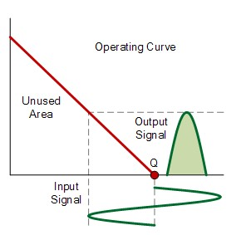

Figure : Operating Curve of Class B Power Amplifier… (2)

## **Class AB**

This class was designed to solve the cross over distortion problem in class B, and it was named as AB, because the class A works for 360o and class B works for 180o, however class AB works between them. In other words, class AB has a bias source but not like class A. Figure 4 illustrates the operating region of class AB amplifier which shows the input and the output of one of the transistors…(1)

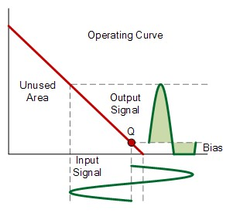

Figure : Operating Curve of Class AB Power Amplifier… (2)

# **Procedure****, Data and Discussion**

## **Part A: THE CLASSES OF POWER AMPLIFIER**

1. The circuit was connected in Figure 5 as shown below:

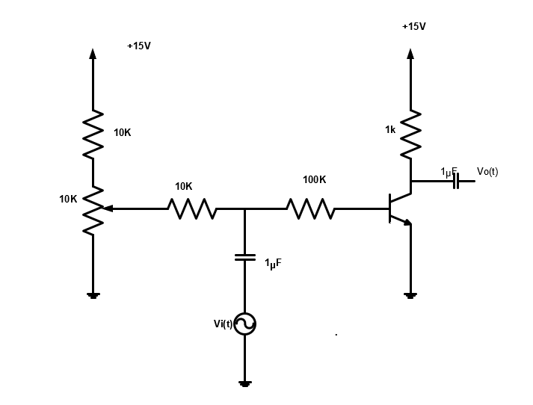

Figure : Circuit to modify the characteristic of the classes of power amplifier

1. The oscilloscope was connected to the input and the output of the circuit, and the potentiometer was put at fully clockwise (the bias control was zero).
2. The output of the function generator (the input to the circuit) was increased until the Figure 6 was occurred.
3. The bias potentiometer was turned up until the output looked like Figure 7.
4. The bias potentiometer was turned up further till the output looked like Figure8.
5. Using the signals that was used in step 4 (as illustrated in Figure 7), the output of the function generator was increased till the output looked like Figure 9.

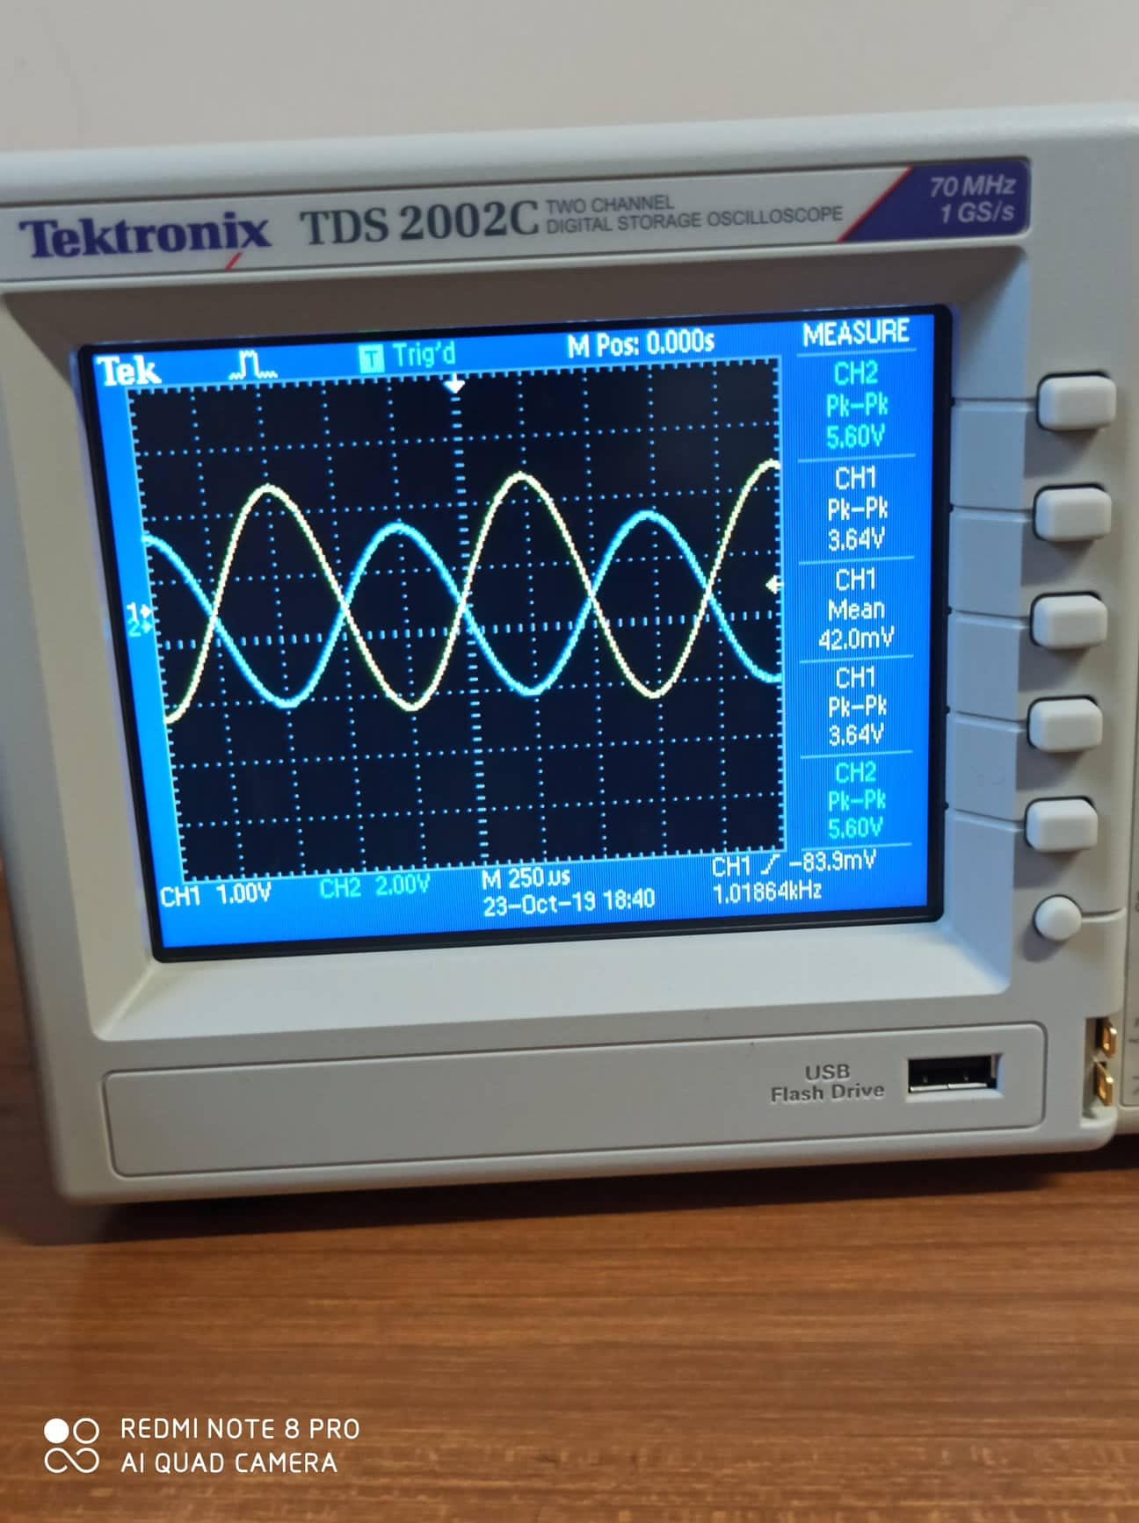

Figure

It could be seen from Figure 6, that the output is a inverted-scaled replica of the input, and that means that there is no distortion and the amplifier is working in the total 360o (the bias point is chosen such that it meets the maximum symmetrical swing case). And so, **the class of the amplifier is A.**

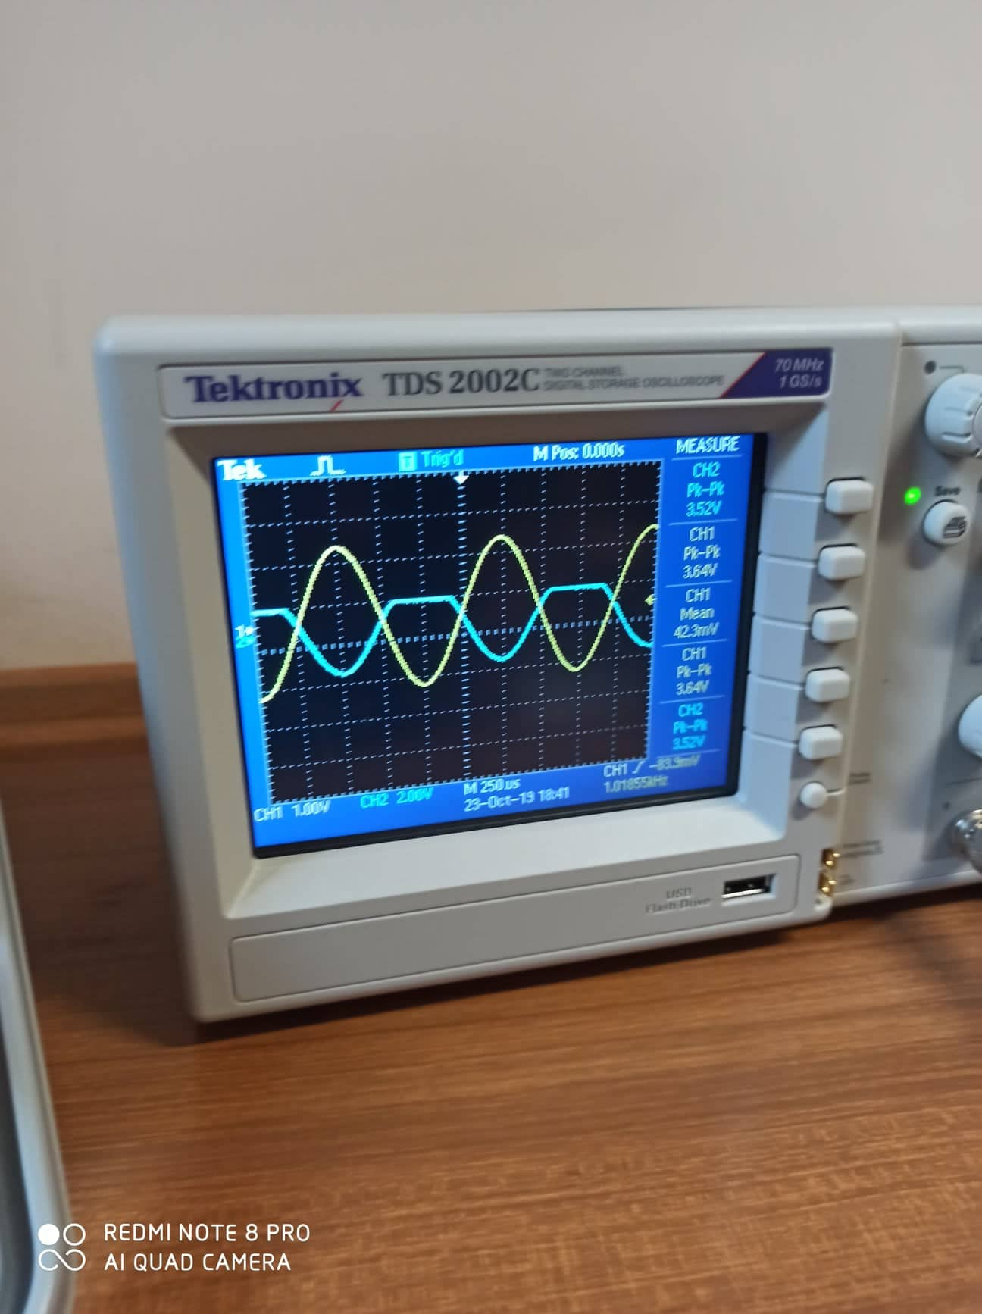

Figure

From Figure7, the amplifier is working in just half of the cycle (180o), and that means that the bias point is not chosen to meet maximum symmetrical swing. In other words, **the class of the amplifier is B.**

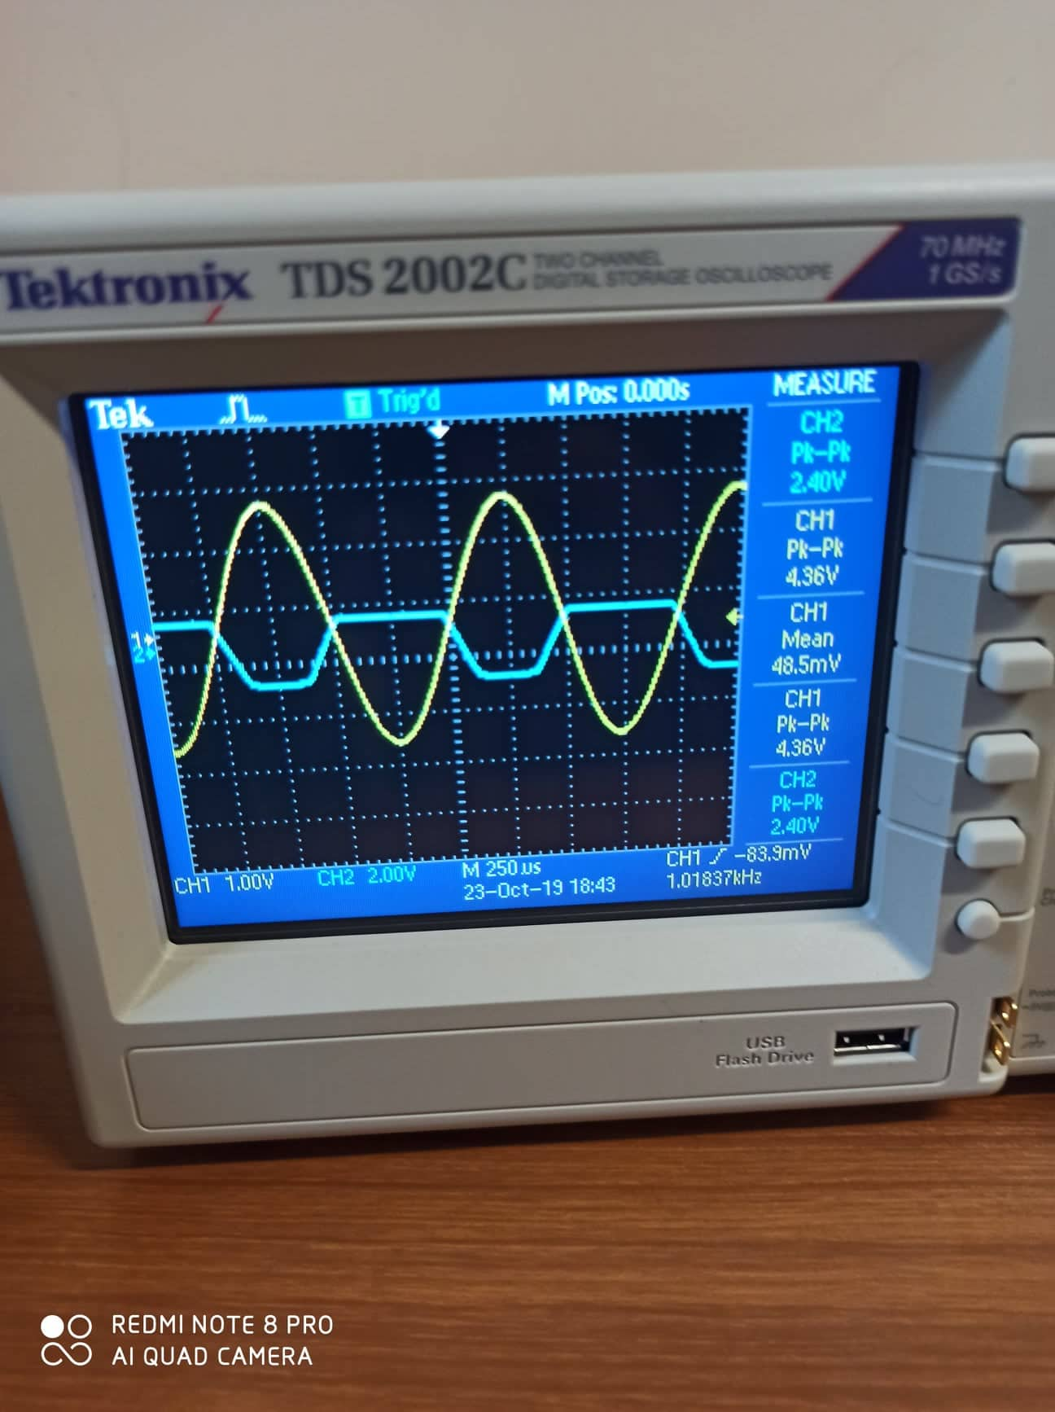

Figure

In Figure 8, both the upper and lower side of the output signal are distorted, and that means that the amplitude of the output signal is larger than the bias voltage (the output is a scaled of the input and that means that the factor times the amplitude of the input is larger than the bias voltage), than **the amplifier is not one of the basic classes.**

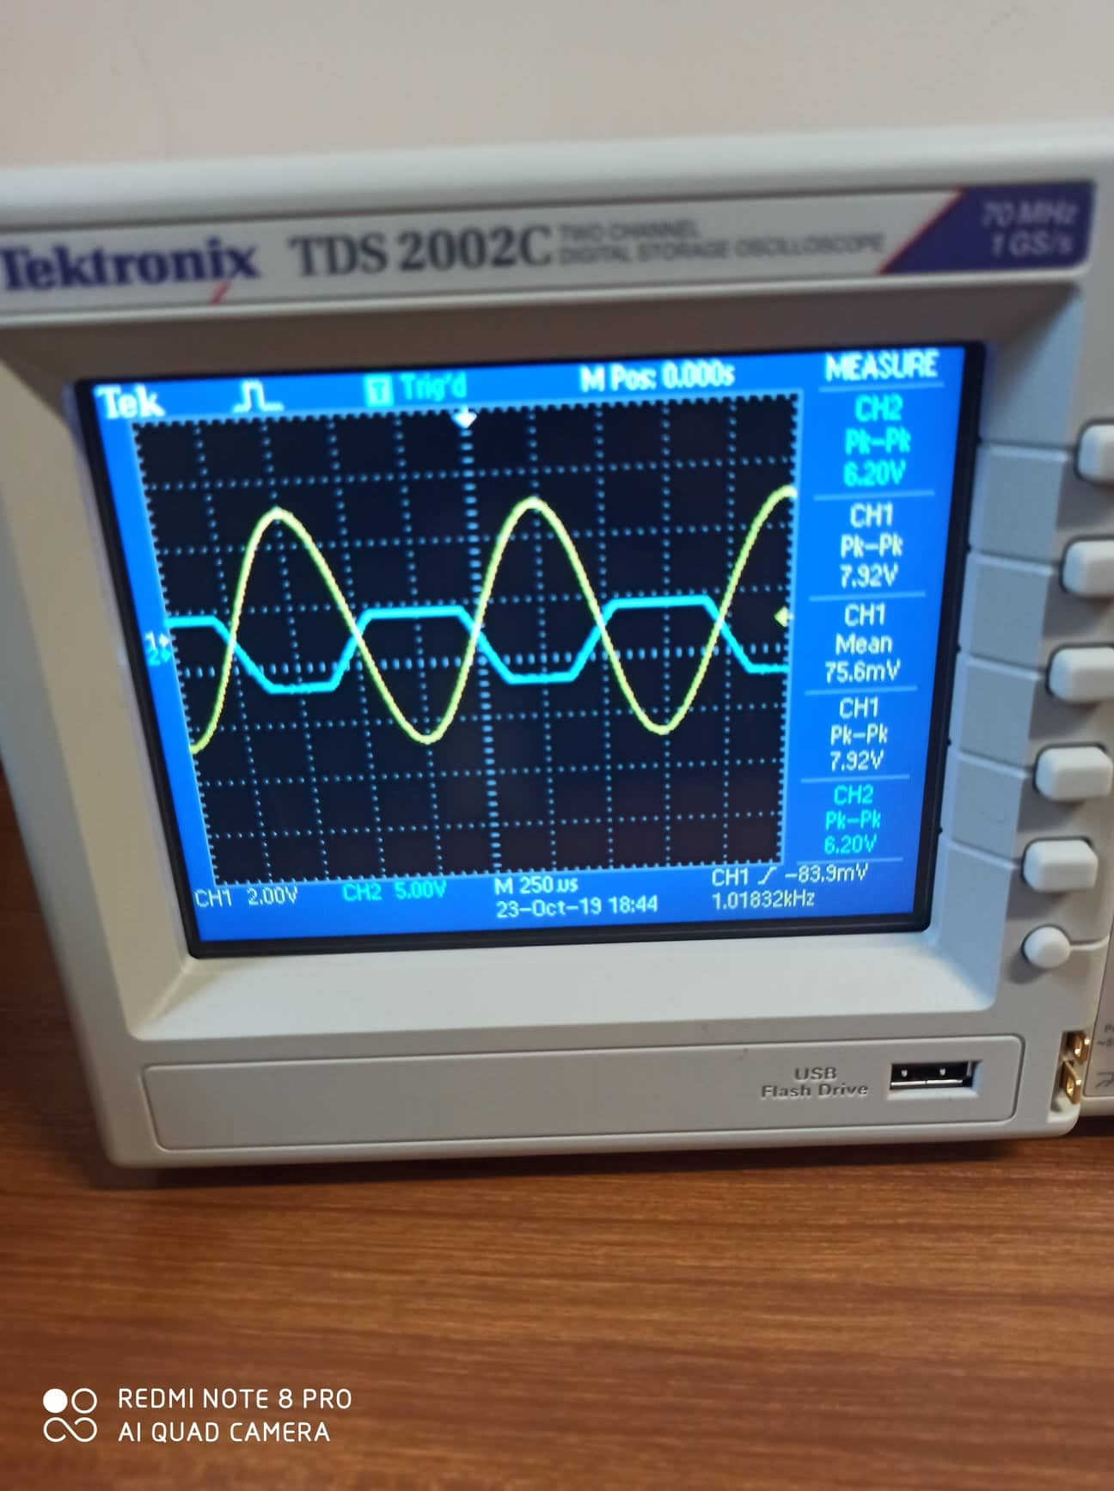

Figure

It could be seen from Figure 9 that the amplifier is working more than half of the cycle (greater than 180o), and that looks like class B but with bias voltage, which means that **the class of the amplifier is AB.**

## **Part B: Push Pull Amplifier**

1. The circuit was connected in Figure 10 as shown below:

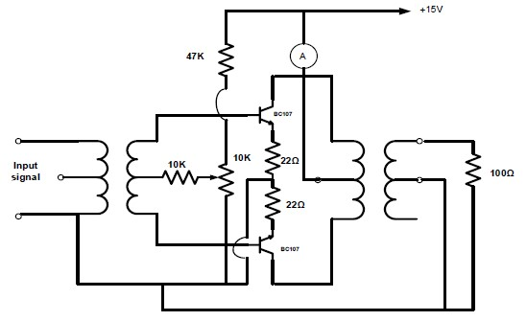

Figure

1. Using the potentiometer, the DC supply current was set to zero.
2. The output of the function generator was turned up to give a 4 Vp-p and 1kHz frequency.
3. A photo was taken to the output of the previous setting.
4. The input signal was changed such that the amplitude is 0.5 Vp-p.
5. The output of the function generator was reset such that 4 Vp-p was got and the bias was used to eliminate the crossover distortion.

7. Using variable resistor, the output RMS voltages was measured, and the results was recorded at Table 1.

8. The resistor that matches the output of the amplifier was selected and connected to the circuit, and then the function generator output was increased to the maximum value before the distortion occur.

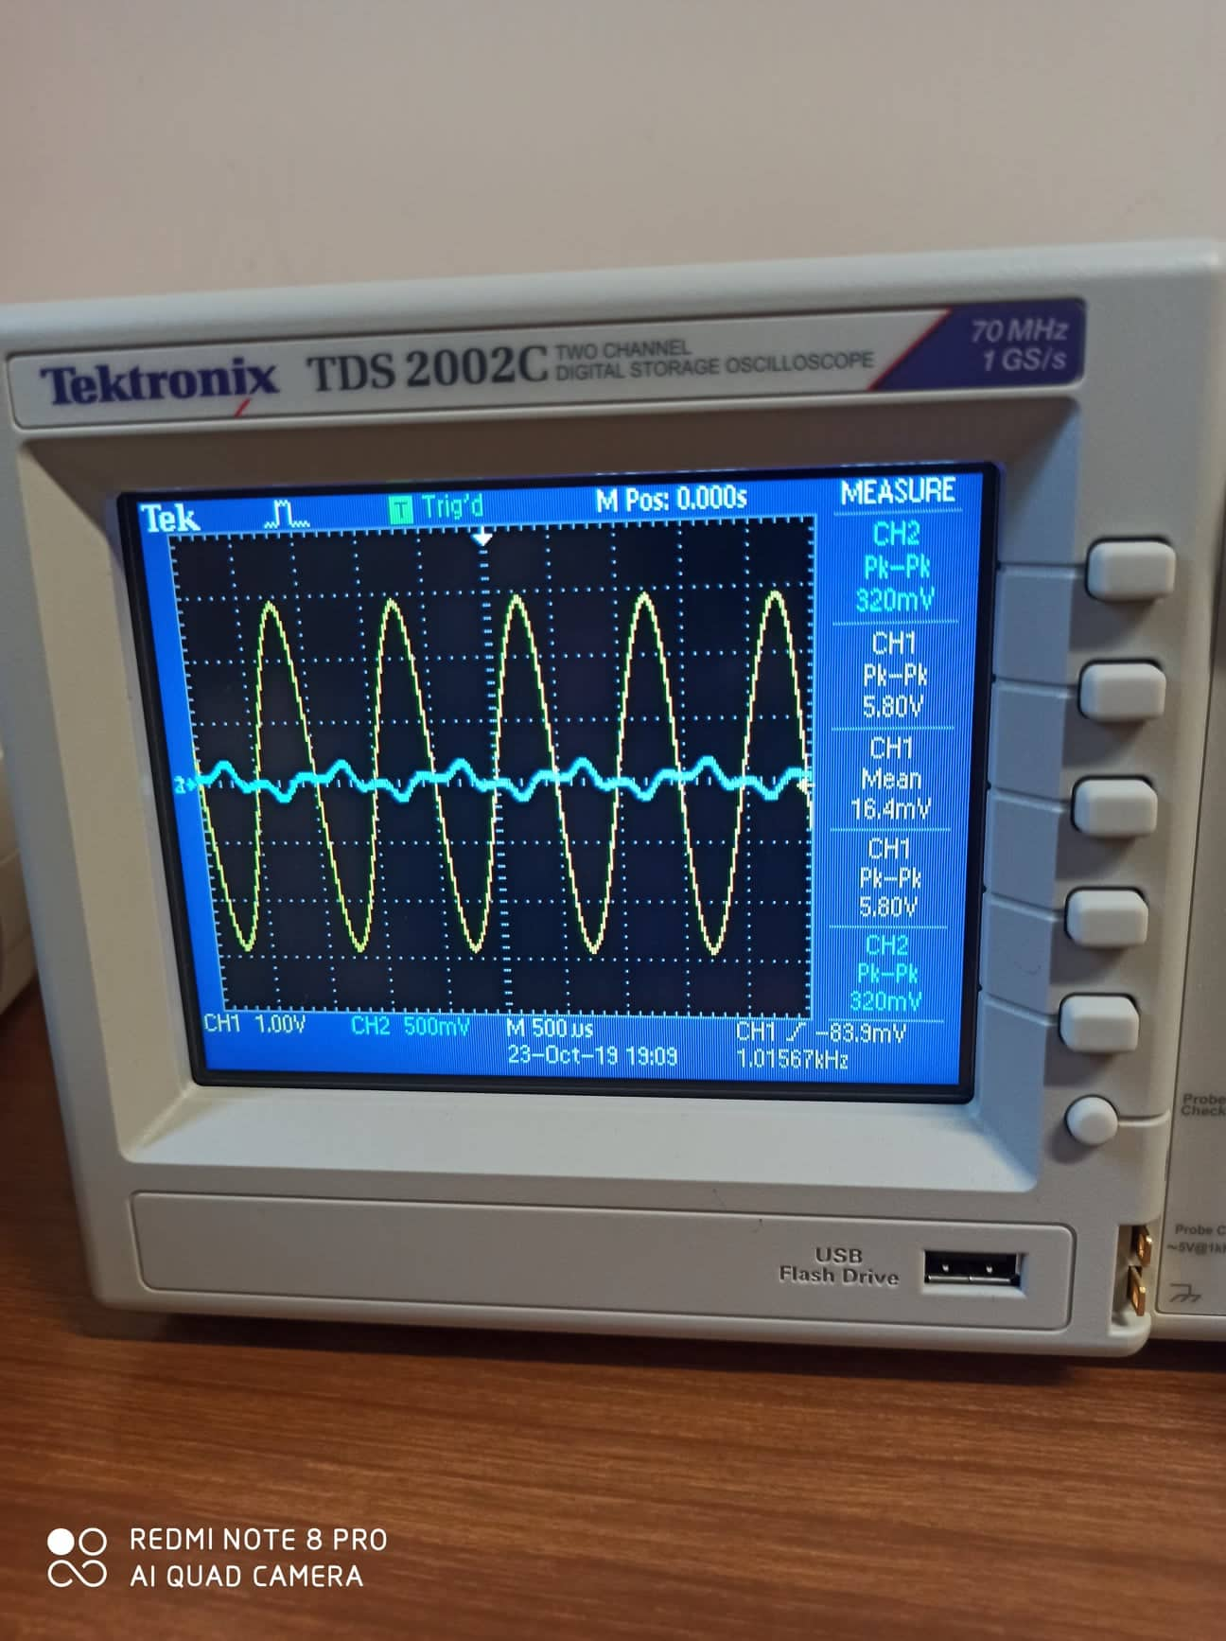

Figure : *The Crossover Distortion in the Output Signal*

The crossover distortion that occurs in Figure 11 due to the lacking of biasing; then the input signal itself is the bias for the transistor, then when the input signal is less than about 0.7, then the output is zero. Otherwise, there is an output.

The output waveform when Vin = 0.5 Vp-p shown in Figure below:

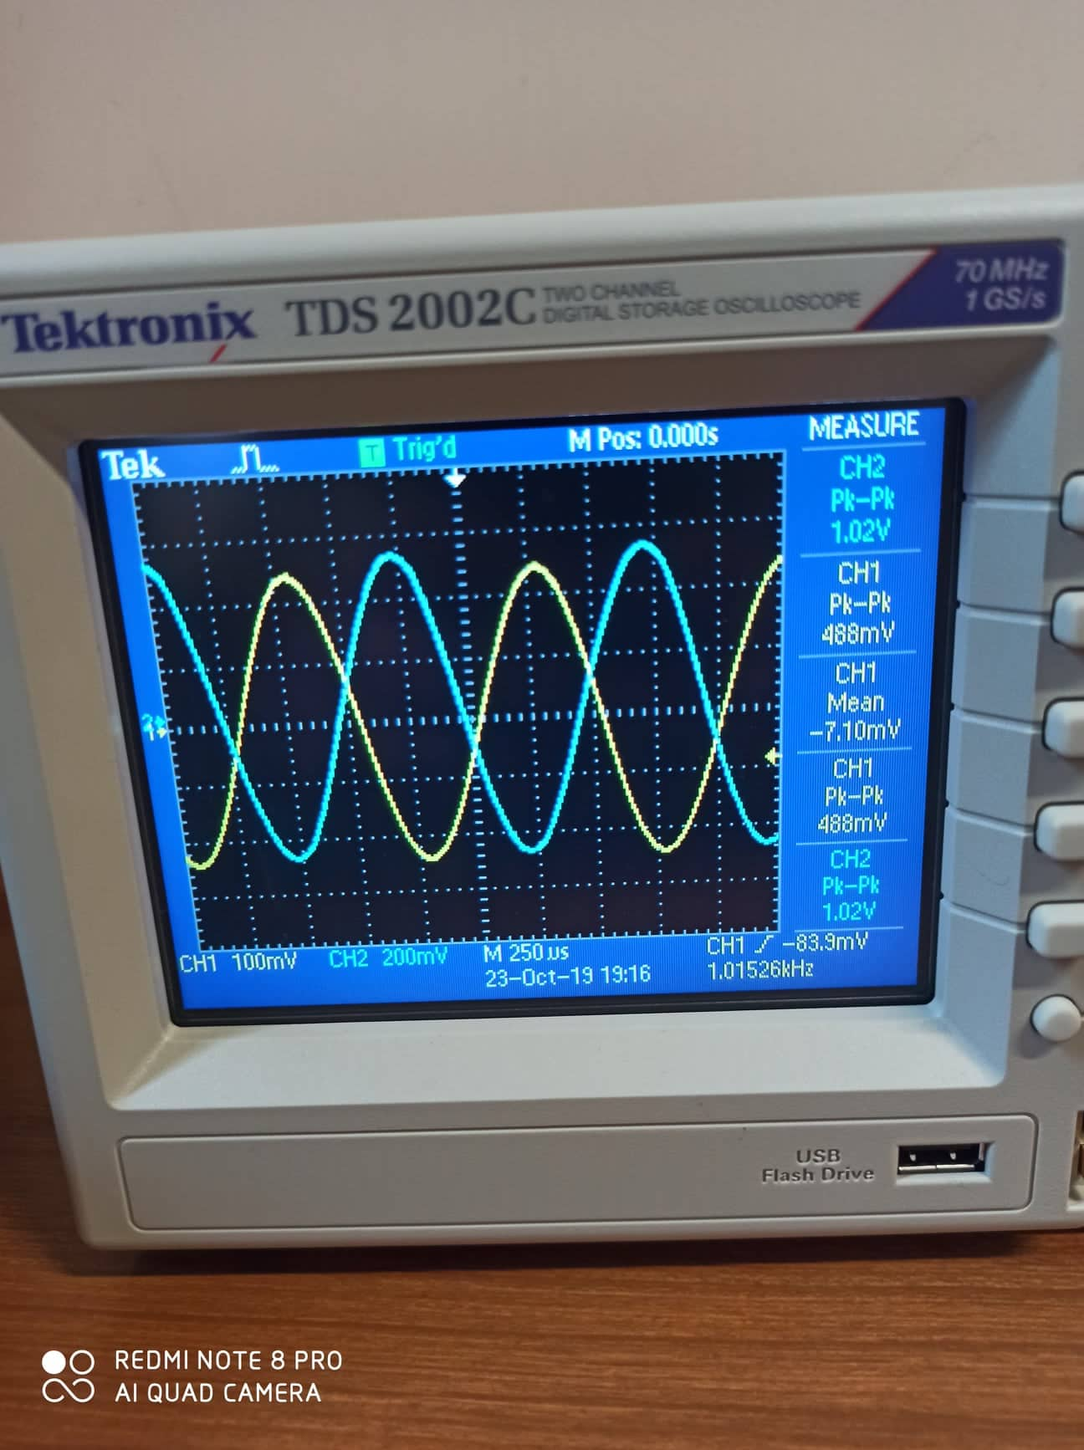

Figure : The output waveform when Vin = 0.5 Vp-p

The output waveform when Vin = 4 Vp-p shown in Figure below:

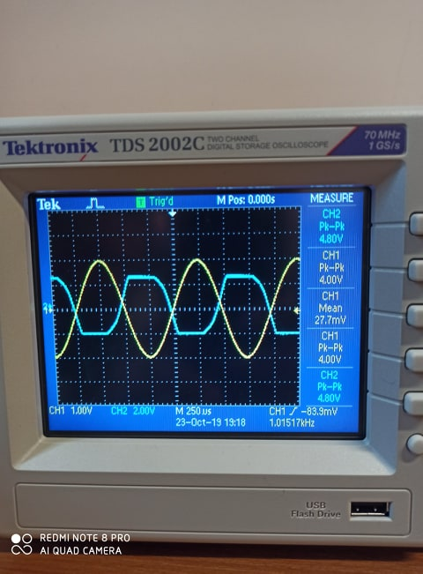

Figure : The output waveform when Vin = 4 Vp-p

Table

|  |  |  |  |
| --- | --- | --- | --- |
| Resistor (Ω) | (Volts) | | Power (mW) |
| Peak-to-Peak [V] | RMS [V] |
| 320 | 3.48 | 1.3 | 5.28 |
| 220 | 3.56 | 1.12 | 6.65 |
| 150 | 3.16 | 1.09 | 7.92 |
| 100 | 2.76 | 0.947 | 8.97 |
| 69 | 2.36 | 0.807 | 9.4 |
| 50 | 1.96 | 0.678 | 9.19 |
| 41 | 1.72 | 0.591 | 8.61 |

The results were got using the formulas:

VRMS 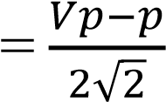 , Power = 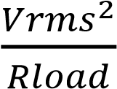

From the Table 1, the resistor that almost matches the output impedance of the amplifier is the resistor which gives the maximum power which is the **69Ω**. This result is got depending on the maximum power transfer theorem which states that the maximum power can be transferred to the load if the load impedance equals to the equivalent impedance seen by the load (RThevenin).Then input current (the current of Vcc) is 9.1 mA

* Pin = Vsuppy * Isupply = 15*9.1m=136.5 mW

Then the efficiency of the amplifier is

η = $\frac{P_{out}}{P_{in}}$ = 8.07 %

It could be seen that the efficiency is very low in compare with the theoretical one (75%) and that is because the β of the transistors used is not equal, and due to the tolerance in the resistors.

## **Part C: Complementary Push-Pull Amplifier**

1. The circuit was connected in Figure 14 as shown below:

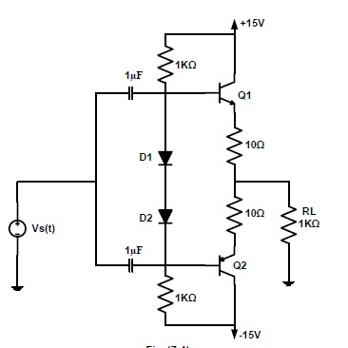

Figure

The output of the circuit was observed using oscilloscope, the current and the power efficiency for RL =1kΩ and RL = 100Ω where calculated, after measuring the supplies currents. All results were recorded in Table 2.

The output waveform when Vin = 1 Vp-p for RL = 1 kΩ shown in Figure below:

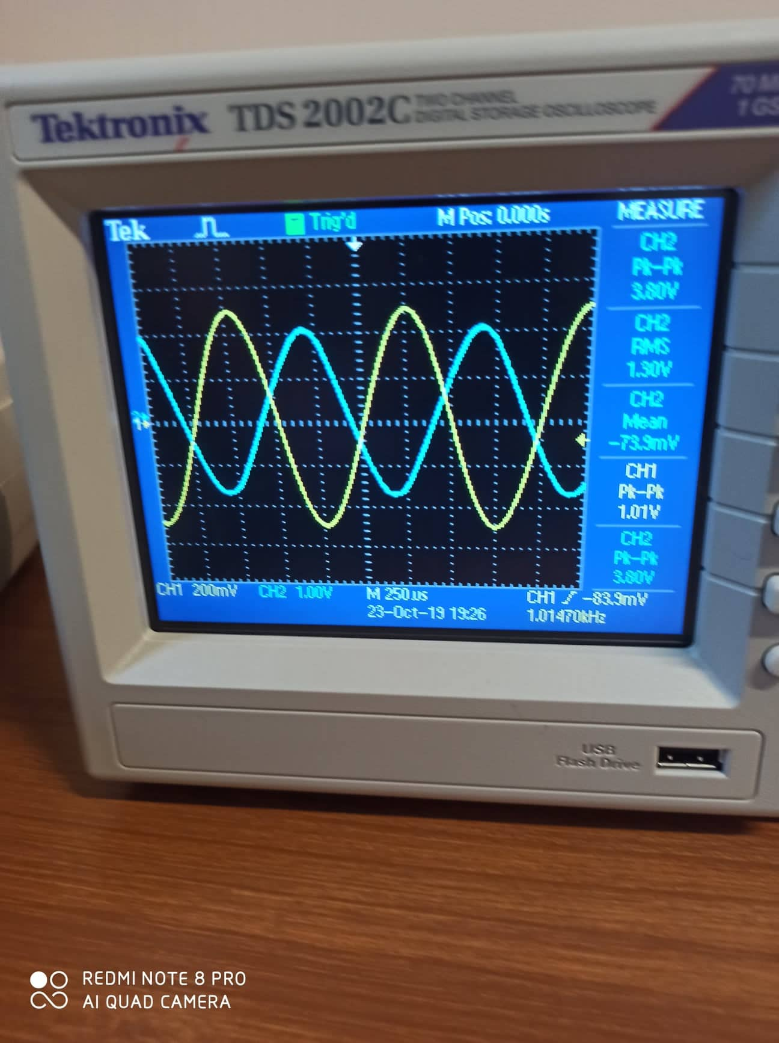

Figure : The output waveform when Vin = 1 Vp-p for RL = 1 kΩ

The output waveform when Vin = 1 Vp-p for RL = 100 Ω shown in Figure below:

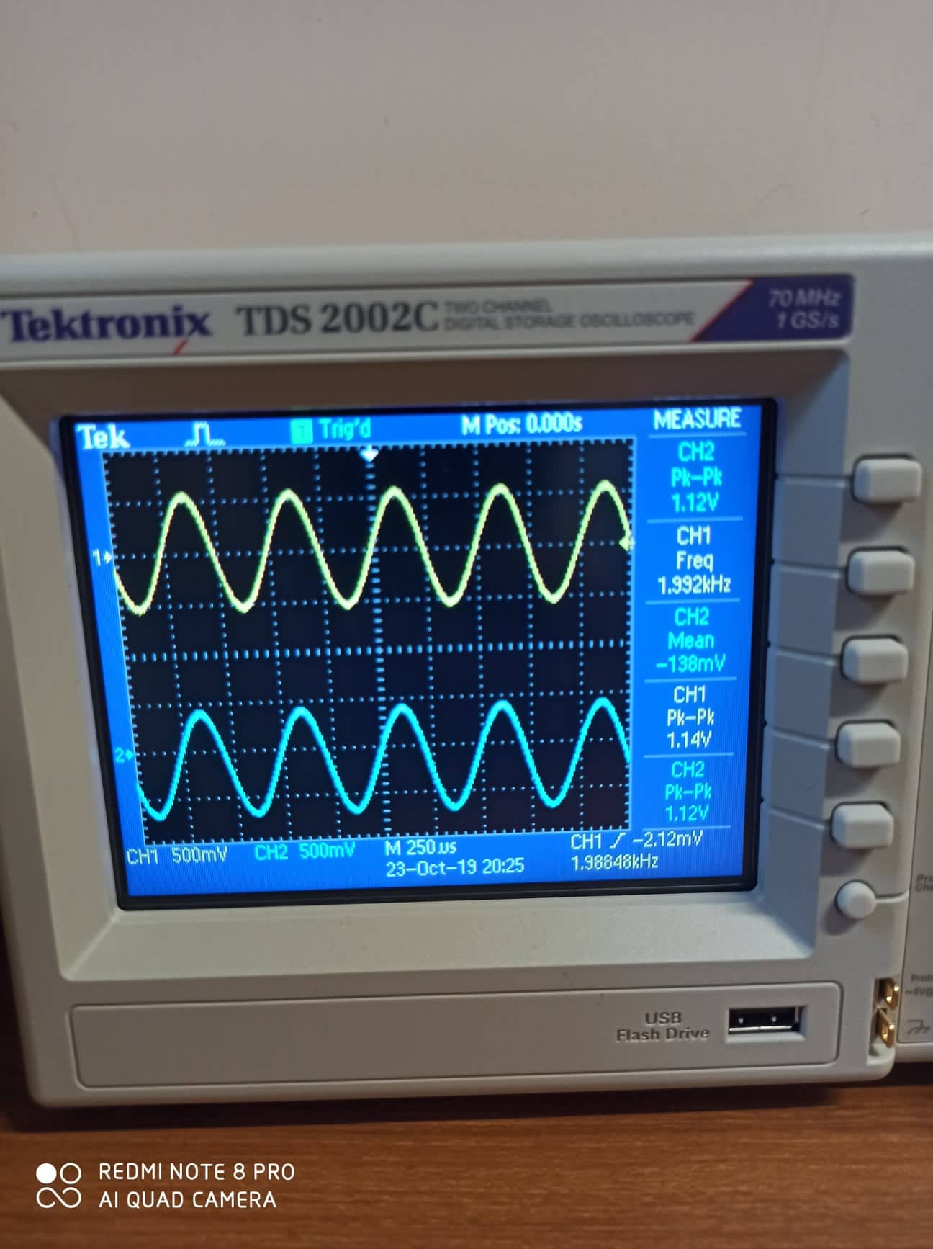

Figure : The output waveform when Vin = 1 Vp-p for RL = 100 Ω

|  |  |  |  |  |
| --- | --- | --- | --- | --- |
| RLoad | Isupply | Pin = Vsupply * Isupply | Pout | η = Pout / Pin |
| 1kΩ | 17.8 mA | 2×15×17.8=534 mW | 0.0125 mW | 0.00234 % |
| 100 Ω | 18.44 mA | 2×15×18.44=553.2mW | 0.125 mW | 0.0226 % |

The complementary push-pull amplifier is connected such that it prevents the occurrence (as much as possible) of the crossover distortion. However, since the connection is common collector, then the output signal is less than the input one.

Note that: the theoretical values are different from the practical ones due to the problems in the transistors, since the transistors are not identical as the theory assumed. And may the tolerance of the resistors affect the results. That is in addition to the approximation feature in the DMM and the oscilloscope.

# **Conclusion**

The experiment was conducted successfully, we implemented it and saw how it works effectively, in addition, practically we saw all the models for transistor operation and the classes of it from class A to B and AB, the purpose of each one and how to use it, on the other hand, we noticed how the input and the output characteristic appear, for the problem of cross over distortion, and the solution of this problem by the complementary symmetry circuits and the biasing of it by using the model of the diode, however, we faced some problem by calibration the values and to get the small output values. .

# **References**

1. Electronic Devices and Circuit Theory, R. Boylston &L.Nashelsky, Prentice Hall , 2009 10th Edition.

3:30 AM, October 28 ,2019

1. https://www.electronics-tutorials.ws/amplifier/amplifier-classes.html

4:00 AM, October 28 ,2019