

**Faculty of Engineering and Technology**

**Electrical and Computer Systems Engineering**

ENEE3102

Instructor: Dr. Nasser Ismail

ــــــــــــــــــــــــــــــــــــــــــــــــــــــــــــــــــــــــــــــــــــــــــــــــــــــــــــــــــــــــــــــــــــــــــــــــــــــــــــــــــــــــــــــــــــــ

***Course Name***

ELECTRONICS LAB (section 2)

***Experiment No. 7***

The SCR ,DIAC, and UJT.

Prepared by:

Dana Abu Hussein 1131657

***Group Members***

Hajar karajeh

Hiam arar

***Date of Experiment***

April 2, 2016

***Date Submitted***

April 9, 2016

**-** **Abstract:**

**- Objective:**

The aim of this experiment is to learn about some Thyristors and other Devices such as SCR, DIAC and UJT. And to know its characteristic and application.

**- Theory:**

Thyristors**:** Devices constructed of four semiconductor layer, they act as open circuits capable of withstanding a certain rated voltage until they are triggered.

When triggered , they turn on and become low- resistance current path , and remains on , even after the trigger is removed , until the current is reduced to a certain level or they or they are triggered off , depending on the type of the device .

THE SILICON CONTROLLED RECTIFIER: SCR Fig (1)

It is a three terminal device.

-It is four layer pn pn device.

- Acts as a switch.

-In the off state; it acts as an open circuit between Anode and Cathod .

-In the on state it; it acts as short circuit from Anode and Cathod .

THE DIAC: Fig (2)

-It is a two terminal device.

-It can conduct current in either direction when properly activated.

-Conduction occurs when the breakover voltage is reached with either polarity.

-The device turns off when the current drops below the holding value.

-The device function like two parallel Shockley diode turned in opposite direction.

THE UNIJUNCTION TRANSISTOR: UJT Fig (3)

-UJT is a three terminal device.

-UJT has one pn junction.

**- Experimental / Procedure:**

*I. THE SCR.*

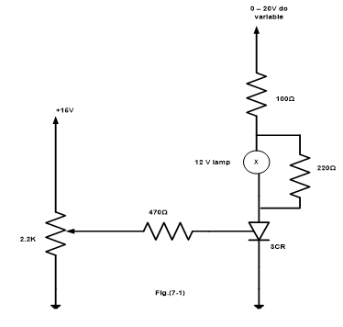

*II. THE DIAC.*

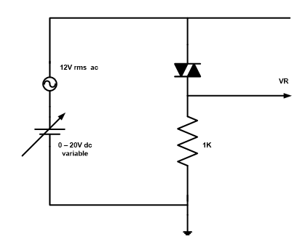

*III. THE UJT.*

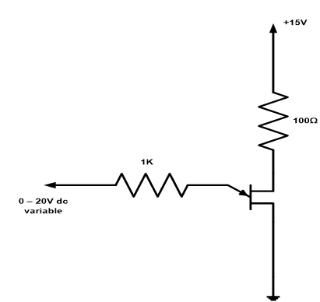

*IV. USAGE OF A UJT IN A RELAXATION OSCILLATOR.*

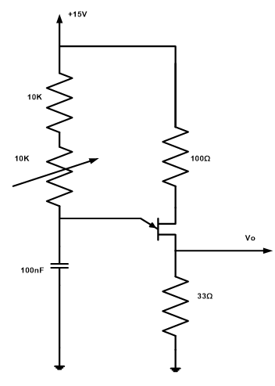

**-Results & *Calculations &* Discussion of Results:**

***I. THE SCR.***

IG =47 $μA$

VAK =0.8 v

IH =1.2 mA

***II. THE DIAC.***

VBR = + 14.5

***III. THE UJT.***

|  |  |  |
| --- | --- | --- |
| ***Condition*** | ***IE ( mA)*** | ***VBE (v)*** |
| ***Just before switch on*** | ***0*** | ***11.2*** |
| ***Just after switch on*** | ***9.68*** | ***1.23*** |
| ***Just before switch off*** | ***1.1*** | ***1.3*** |
| ***Just after switch off*** | ***0*** | ***2.17*** |

***IV. USAGE OF A UJT IN A RELAXATION OSCILLATOR.***

|  |  |
| --- | --- |
| **R(KΩ)** | **Frequency(KHz)** |
| **1** | **0.65** |
| **2** | **0.596** |
| **3** | **0.551** |
| **4** | **0.511** |
| **5** | **0.478** |

**- Conclusion:**

**- Appendix:**

**- References:**