

**Faculty of Engineering and Technology Electrical and Computer Engineering Department Circuit’s**

**lab (ENEE3102)**

**Experiment no.7**

***Power Amplifier***

**Student Name:** **Juomah Bader**

**Student Number:**  **1162462**

**Section:** **(1)**

**Date: 30/ 10/ 2019**

**Instructor: Dr. Mohammad Jehad AL Jubeh**

***Abstract:***

The aim of the experiment:

It was to understand the different classes of power amplifiers. Also, to have knowledge of their design using push-pull techniques.  
Three different circuits were connected and analyzed. The first circuit was used to construct all the classes and the output signal was observed for each class. In addition, a normal and complementary push pull circuits were connected and the input and output powers were calculated. Also, the efficiencies of the push pull circuits were calculated.  
The practical and theoretical results of the experiment were matched and so the experiment was successful.

Equipment we used:

1. Transistors.
2. Resistors and potentiometer.
3. Wires.
4. The Power supply.

***Theory:***

One of the basic elements in any digital or analog circuits was the transistor; hence we have many types of such transistor, one of the most important kinds which is the power amplifier.

A Power amplifier defined as one that is used to deliver large amount of power to a load with a good efficiency, a block diagram that describe the function of the power amplifier shown in Fig.1:

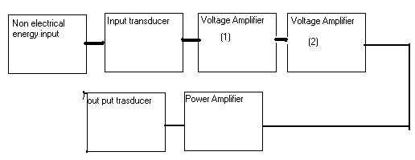

**Fig.1, An amplifier system block diagram.**

To achieve such a occupation, our amplifier should itself capable of dissipating large amount of power and it usually exists in the last stage of the amplifier system.

According to the percent of time in which the transistor is on; the power amplifier is confidential into three classes which are:

1. Class A
2. Class B
3. Class AB
4. Class C amplifier.

**Class A**:

These classes of transistors are conducting 100% of the time of the period; the maximum efficiency for this class can be up to 50%.

**Class B**:

These classes of transistors are conducting 50% of the time of the period; the maximum efficiency for this class can be up to 78.5%.

**Class AB**:

These classes of transistors are between class A and class B transistors, in which the transistor is conducting between 100% and 50% of the time of the period, the maximum efficiency for this class can be up to between 50% and 78.5%.

**Class C**:

This type transistor is conducting less than 50% of the time of the period.

***Push-Pull Amplifier:***

The push-pull amplifiers are a kind of the power amplifiers of class B, or class AB. That’s depend on if we are using a DC voltage supply to bias the transistors. So that the output will not be distorted when the base voltage is less than the voltage that is required to let the transistor base-emitter junction on. If we are not using this DC supply then it is class B, if we use it then it is class AB.

Procedures & Calculations:

***I. THE CLASSES OF POWER AMPLIFIER.***

1. Connect the circuit of fig.2:

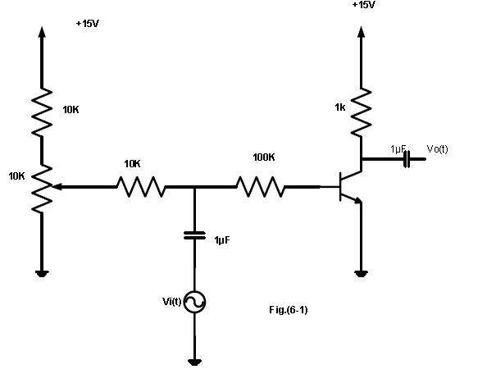

**Fig.2, The circuits diagram.**

We set the potentiometer to zero resistance and see the output of the circuits-class B- as shown in Fig.3:

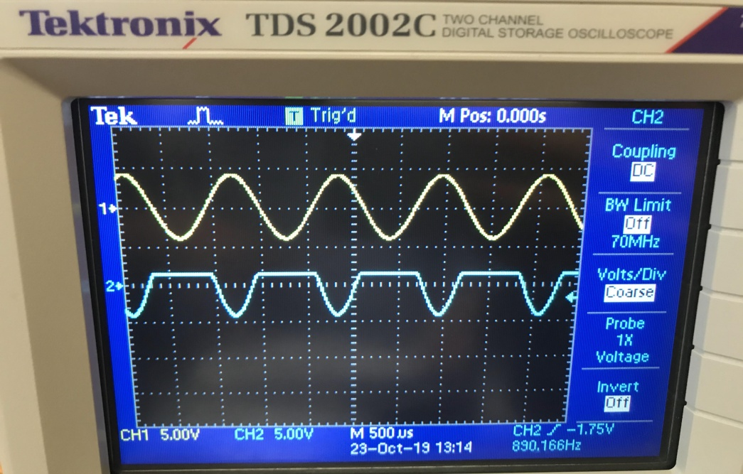

**Fig.3, The output of the circuits.**

Now, we increase the potentiometer set point up and observe the output-Class A- of the circuits as shown in Fig.4:

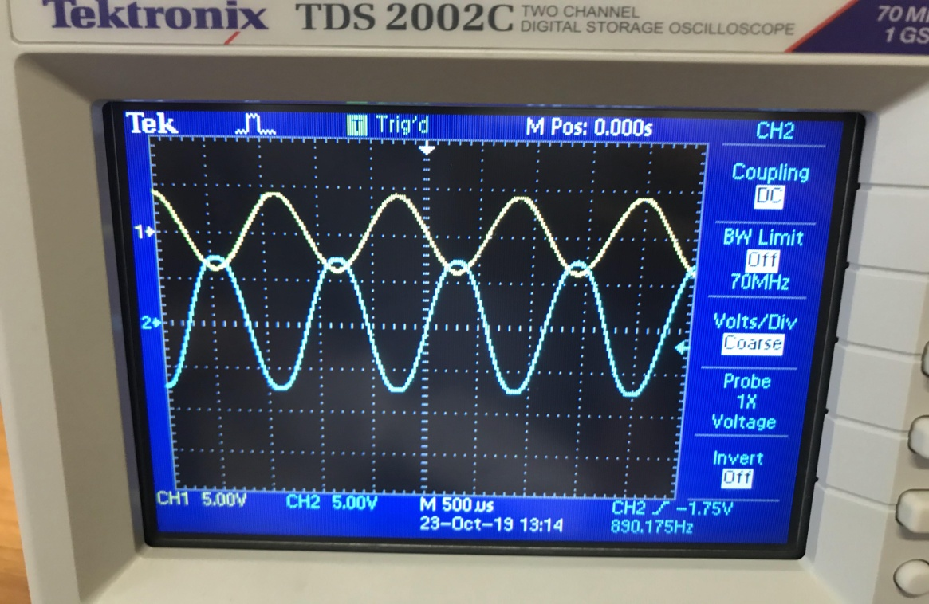

**Fig.4, The output of the circuts.**

As we farther turn up the biasing set point of the potentiometer, we get the following output-class AB- as shown in Fig.5:

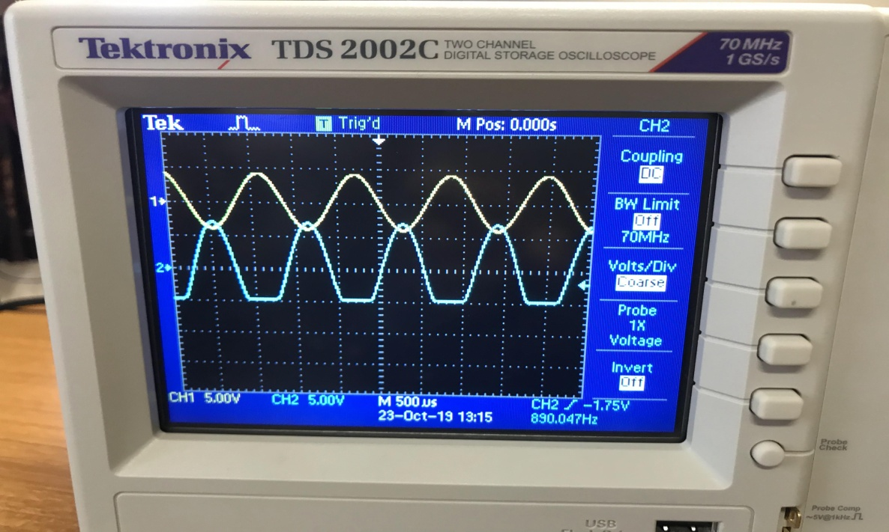

**Fig.5, The output of the circuts.**

As we can see from Fig.5,the transistor join the cutoff region and we can see that the transistor in the saturation region as a farther increasing via the biasing, if that happened, we get the following plot as shown in fig.6:

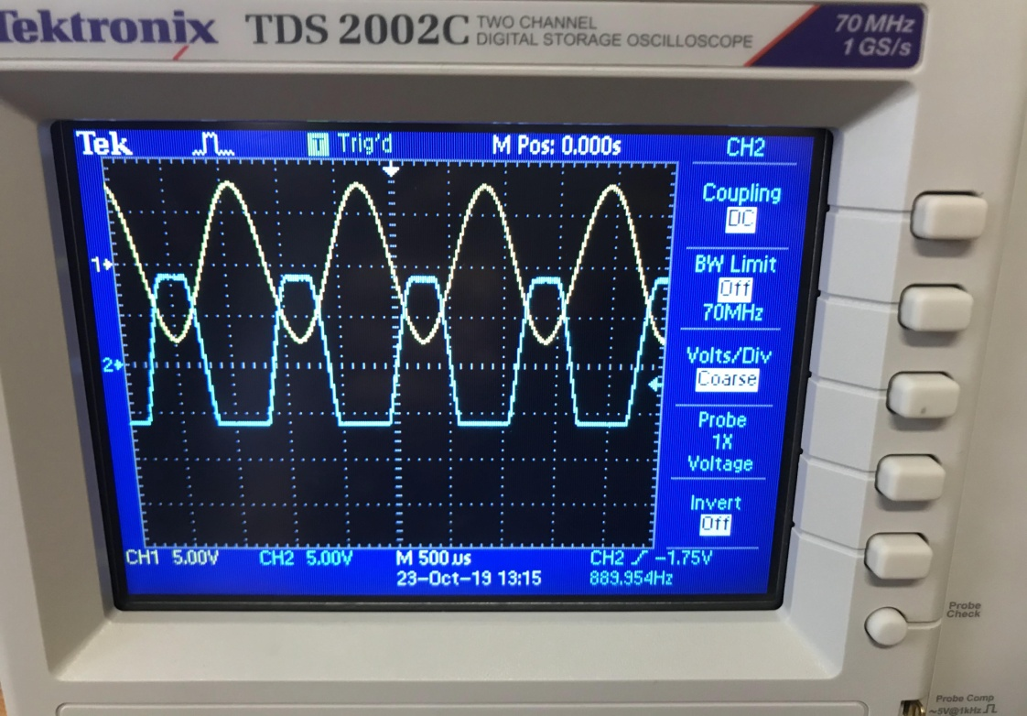

**Fig.6, The output of the circuts.**

1. ***Push-Pull Amplifier :***
2. Connect the circuit as shown in Fig.7:

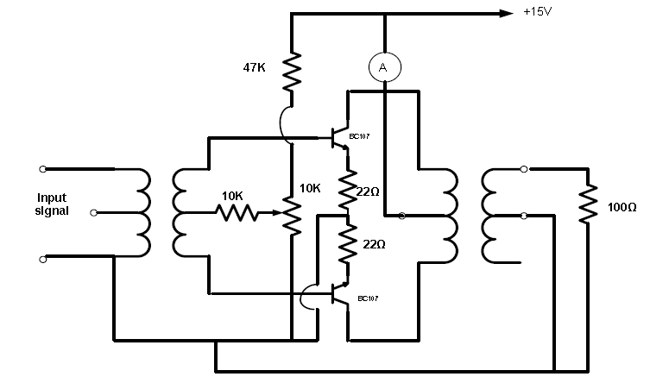

**Fig.7, The circuits Diagram.**

Next, we turn on the potentiometer to have a zero biasing and as a result zero input, then we the generator to 4 P-P volts, and 1 kHz frequency, we get the following output with cross over distortion as shown in Fig.8:

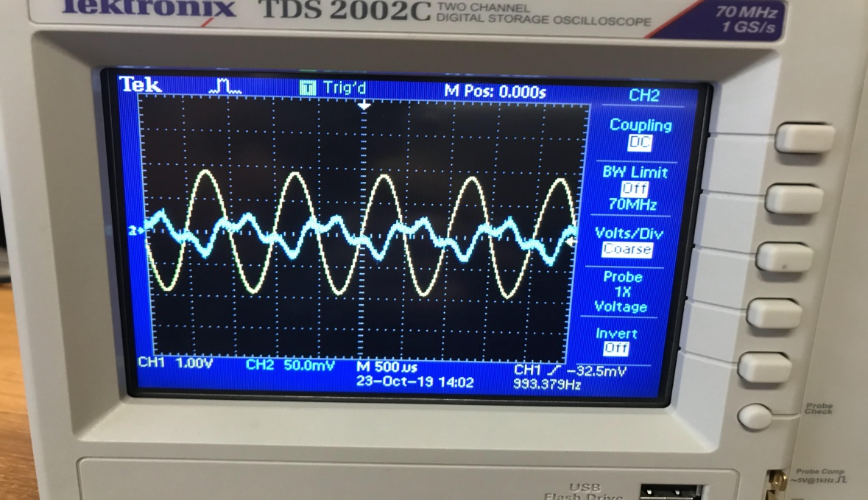

**Fig.8, The output of the circuts.**

For this problem of distortion, we turning up the potentiometer and so increasing the biasing we got the output of fig.9, which can be considered as a solution to the cross over distortion.

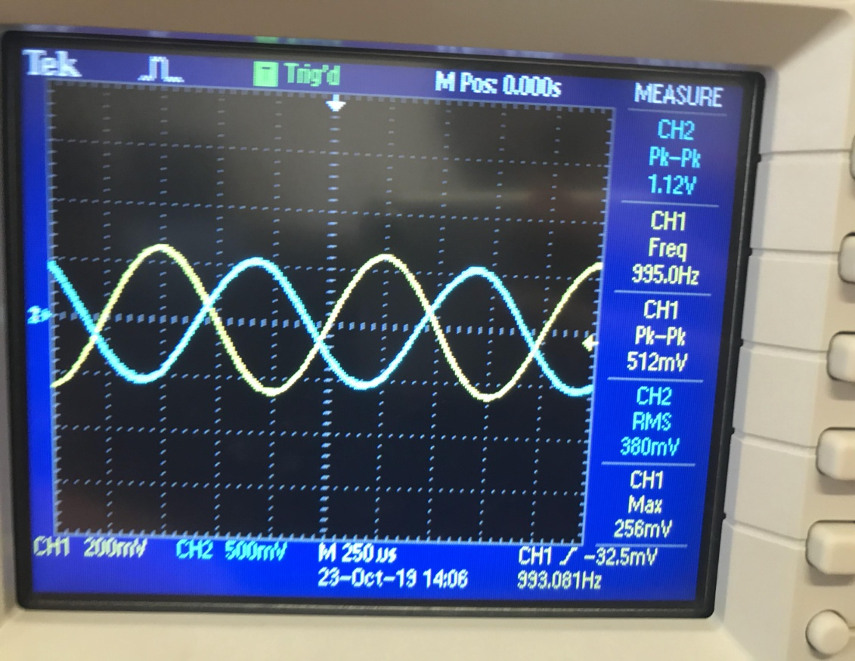

**Fig.9, The output of the circuits.**

After we eliminate the problem of cross over distortion, we fill such table.1 which need for our experiment:

|  |  |  |  |
| --- | --- | --- | --- |
| **Load**  **Resistor**  **(Ω)** | **Output Voltage**  **(volts)** | | **Output**  **Power**  **(mW)** |
| **Peak-to-peak** | **RMS** |
| **320** | **4.00v** | **1.35V** | **5.70** |
| **220** | **3.68v** | **1.25V** | **7.10** |
| **150** | **3.20v** | **1.12V** | **8.36** |
| **100** | **2.88v** | **0.97V** | **9.70** |
| **69** | **2.40v** | **0.82V** | **9.62** |
| **50** | **1.92v** | **0.68V** | **9.25** |
| **41** | **1.76v** | **0.59V** | **8.50** |

From the table; Pout (max) = 9.7 mw which is related

to RL = 100 ohm .Note that this value is equal to the output Thevenin impedance of the amplifier circuit according to the max power transfer concept .

We observed that the supply current increased with the input applied to the amplifier, and approximately very small output current when there was no output power. This is so since the consumed current (and so the consumed power) is a function of the input current:

PLac = 0.5*Tcm^2*RL

Where: PLac : output power .

RL : load resistance.

Lcm: peak of input current .

We measured the supply current and found that in = 0.243mA

But we know that Pin = Vcc*1/T ∫ is(t) dt

But the dc value of the current we measured represents the integration.

And so Pin = Vcc*I supply = 15*8.18*10^-3 = 40.9mw

And so max efficiency % = Pout (max) / Pin = 23.72%

***III. COMPLEMENTARY PUSH-PULL AMPLIFIER.***

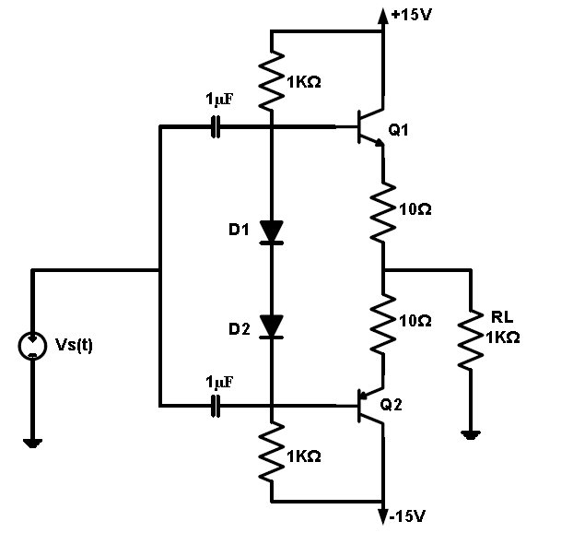

3. Connect the circuit as shown in fig.10:

**Fig.10, The circutis diagram.**

By measuring the rms voltage, which is 1.2869 volts, and we have 100-ohm resistor we can calculate the power which is 19mW.

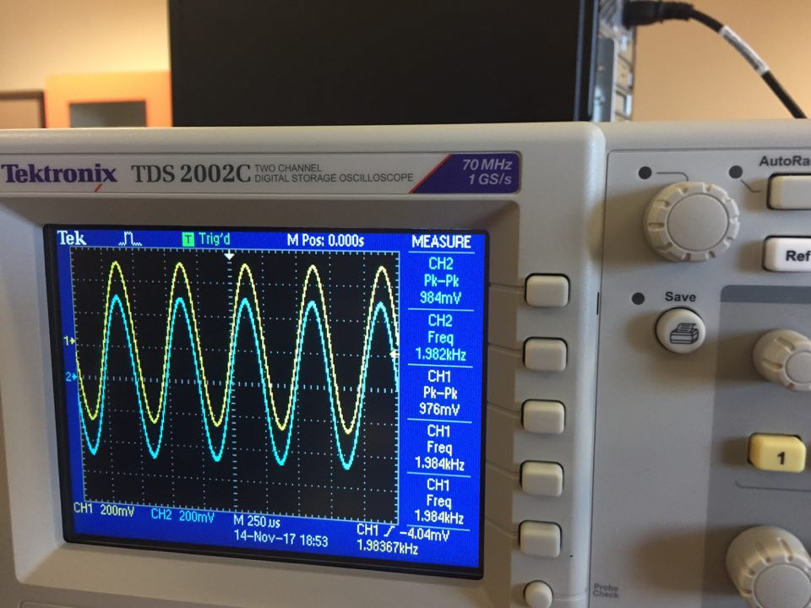

IQ1=19.29mA IQ2=-19.29mA

When R =100 Ohm then I=18.7mA

*The Answer of Questions:*

Q1. It is class B power amplifier since the transistor output is on in the half of the period of the input signal (because of zero bias )

Q2. It is class A since the transistor works in the whole period (there is bias) .

Q3. The output disappears while the input is reduced (but not zero) since the transistor needs about +0.7 V for VBE in order to start working .So for our case (no dc bias) even if there is an input but less than 0.7 ;there will be no output .

Q4. The value we got is equal to the output impedance of the amplifier and it seems relatively small .

**Conclusion:**

The experiment in overall was successful. Input and output powers were calculated in push-pull circuits. In the first circuit, we observed and pointed out classes A, B and AB using the oscilloscope.. Also, the over-cross distortion was observed. In the last circuit the efficiency was 23.72% which is too low but acceptable. Moreover, the equipment that had been used to measure the needed voltages and currents weren’t very accurate.