

Faculty of Engineering and Technology

Electrical and Computer Engineering Department

Electronics LAB (ENEE3102)

Report on Experiment #9

The Operational Amplifier

Prepared by:

Name: Sara Totah Student ID: 1181779

Instructor:

Mohammad Jehad Al Jubeh

Date:

6/12/2020

Section: #1

# **Abstract:**

This experiment aims to explore and examine some of the Op-Amp applications such as; Adding Application, Voltage Follower Application, Comparator Application, Integrator and Differentiator, Schmitt trigger and Active Clipping Circuit.

Equipment needed to implement the experiment:

1. Function Generator
2. DC power supply
3. Some passive elements; resistors, capacitors and inductor.
4. Op-Amps

Table of Contents

**Abstract:** 1

**Theory:** 3

Operational Amplifier: 3

The Transfer Characteristics of the Op-Amp: 3

The Inverting Adder/: 4

Voltage Follower Application: 5

Comparator Application: 6

Integrator and Differentiator: 6

Schmitt Trigger circuit: 9

Active clipping Circuit: 10

**The procedure, Data and results:** 11

I. Adding Application: 11

II. Voltage Follower Application: 12

III. Comparator Application: 13

IV. Integrator and Differentiator 15

V. To investigate the effect of adding hysteresis (Schmitt trigger): 19

VI. Active Clipping Circuit: 20

**Discussion:** 22

I. Adding Application: 22

II. Voltage Follower Application: 22

III. Comparator Application: 22

IV. Integrator and Differentiator: 22

V. To investigate the effect of adding hysteresis: 23

VI. Active Clipping Circuit: 23

Conclusion: 24

References: 24

# **Theory:**

## Operational Amplifier:

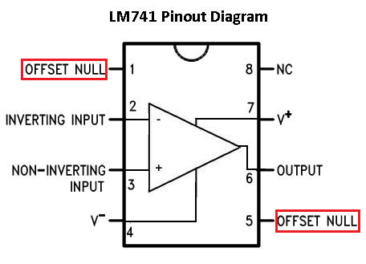

Figure 1: Op-Amp Pinout Diagram

The OpAmp is an active element which has eight terminals shown in the figure above, five of them were examined the inverting input, non-inverting input, VCC, -VCC and output.

The Ideal Operational Amplifier:

In the Ideal operational amplifier, the inverting voltage equals the non-inverting voltage, and there are no current flows in the inverting and the non-inverting inputs.

|  |  |  |
| --- | --- | --- |
|  | V(+) = V(-) | (1) |
|  | I(+) = I(-) = 0 | (2) |

## The Transfer Characteristics of the Op-Amp:

The op-amp has three regions of operation when the magnitude of the output is small, it behaves as a linear region, otherwise, the operational amplifier saturates and it’s no longer a linear device

|  |  |  |
| --- | --- | --- |
|  | Vd = V(+) – V(-) | (3) |
|  | VO = | (4) |

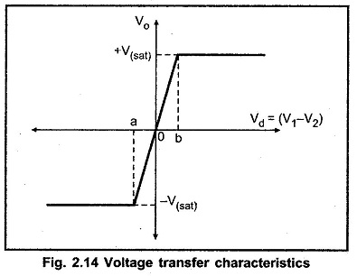

Figure 2: Voltage transfer characteristics

## The Inverting Adder/:

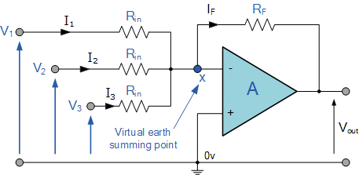

Figure 3: Adding Application

The output voltage of the adder amplifier is an inverted summation of the input voltages applied to the amplifier

|  |  |  |
| --- | --- | --- |
|  | V(+) = V(-) = 0  I1 =  I2 =  I3 =  I(-) = 0  IS = IF = I1 + I2 + I3 | (5)  (6)  (7)  (8) |
|  | Vo = -RFIF  = -( | (9)  (10) |

## Voltage Follower Application:

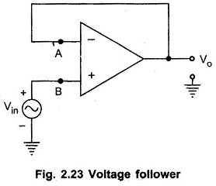

Figure 4: Voltage Follower

Its also called Buffer or Unity gain and it’s a special case of the non-inverting amplifier and the output voltage equals the input in case of the ideal amplifier.

|  |  |  |
| --- | --- | --- |
|  | V(+) = V(-) = VS  VO = V(-) = VS | (11) |

## Comparator Application:

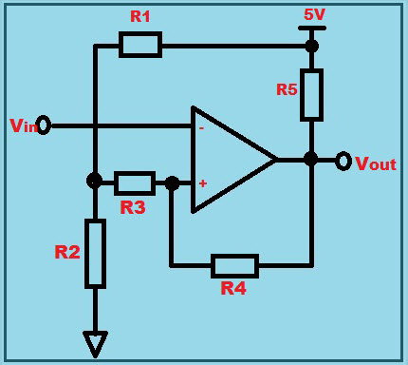

Figure 5: Comparator Op-Amp

The op-amp circuit is a device which it’s output depends on the input voltage with respect to the DC voltage level

The output voltage equals the positive VCC when the non-inverting input is greater than the inverter input, while the output equals the negative VCC when the non-inverting input is less than the inverting input.

|  |  |  |
| --- | --- | --- |
|  | $$\left\{\begin{aligned}V\left(+\right)>V\left(-\right) Vo= +Vcc \\ V\left(+\right)<V\left(-\right) Vo= -Vcc\end{aligned}\right\}$$ |  |

## Integrator and Differentiator:

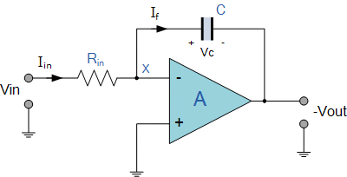

Figure 6: Integrator Op-Amp

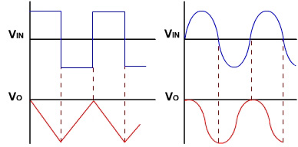

|  |  |  |
| --- | --- | --- |
|  | V(+) = v(-) = 0  Iin =  IF = -C [$\frac{dVout}{dt}$] | (12)  (13) |
|  | $\frac{V_{in}}{R_{in}}$ = -C [$\frac{dVout}{dt}$] $\int_{0}^{t}{\frac{V_{in}}{R_{in}} dt}$ = -C $\int_{0}^{t}{ \frac{dVout}{dt} dt}$ $\int_{0}^{t}{\frac{V_{in}}{R_{in}} dt}$ = -C Vout  Vout = | (14) |

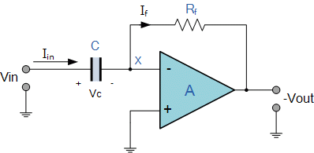

Figure 7: Differentiator Op-Amp

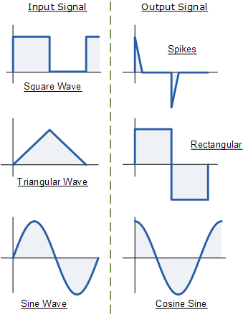

|  |  |  |
| --- | --- | --- |
|  | V(+) = V(-) = 0 |  |
|  | Iin = C [$\frac{dVin}{dt}$]  IF = -  C [$\frac{dVin}{dt}$] = - $\frac{V_{out}}{R_{in}}$ Vout = -C.R. $\frac{dVin}{dt}$ | (15)  (16)  (17) |

## Schmitt Trigger circuit:

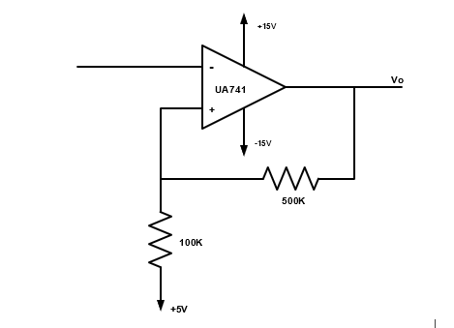

Figure 8: Schmitt Trigger circuit

|  |  |  |
| --- | --- | --- |
| KVL on the non-inverting input  Let VO = Vsat  Upper Threshold voltage | $$\frac{V\left(+\right)-5}{100k}+ \frac{V_{O}-V(+)}{500k}$$ $$\frac{V\left(+\right)-5}{100k}= \frac{V\left(+\right)-V_{O}}{500k}$$ 500V(+) – 2500 = 100 $V_{O}$– 100V(+)  V(+) = $\frac{100k}{600k}V_{sat}+\frac{2500}{600}$ | (18)  (19) |
| Let VO = - Vsat  Lower Threshold voltage | 500V(+) – 2500 = 100 $V_{O}$– 100V(+)  V(+) = - $\frac{100k}{600k}V_{sat}+\frac{2500}{600}$ | (20) |

## Active clipping Circuit:

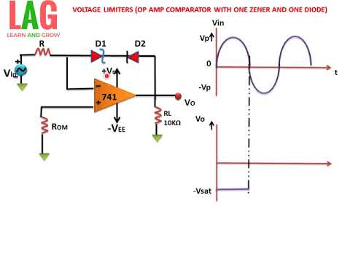

Figure 9: active clipping circuit

The whole idea of the clipping circuit is that the output signal is the same as the input signal despite of the clipped part, so it can be concluded that the peak to peak voltage of the output is smaller that the peak to peak voltage of the input.

# **The procedure, Data and results:**

## Adding Application:

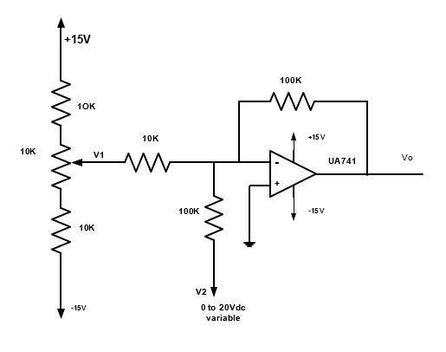

Figure (10): Adding Application

The circuit in figure 10 was connected, and the output voltage was measured for different values of V1 and V2 and the results were recorded in table1

|  |  |  |  |
| --- | --- | --- | --- |
| **Input Voltage** | | **Output Voltage** | |
| **V1** | **V2** | **VO** | **Calculated voltage** |
| **0.5** | **2** | -7.07 | -7 |
| **0.1** | **6** | -7.006 | -7 |
| **0.3** | **4** | -7.001 | -7 |
| **-0.9** | **2** | 7.002 | 7 |
| **-1.1** | **4** | 7.004 | 7 |
| **-1.5** | **6** | 9.172 | 9 |

Table 1

The expected voltage was calculated using the formula:

VO = - (

## Voltage Follower Application:

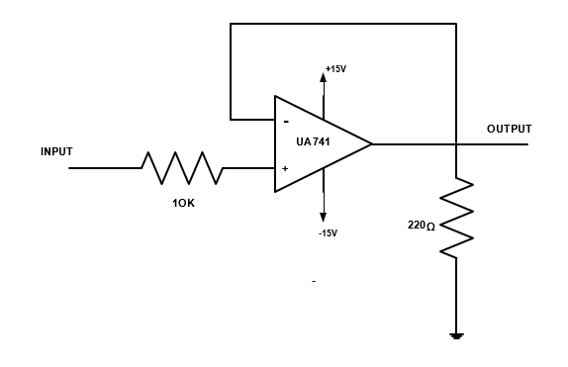

Figure 11: Voltage Follower

The circuit in figure 11 was connected, then the output voltage for several values of the input voltage was measured and recorded in table 2, a picture of the output voltage wave was taken for 2VP-P input voltage with 100Hz frequency.

Then the value of the load resistor was changed to 1k, and the output voltage value was measured and recorded in table 3.

|  |  |  |  |  |  |  |  |
| --- | --- | --- | --- | --- | --- | --- | --- |
| Vi | 1v | 2v | 3v | 4v | 5v | 6v | 7v |
| Vo | 1.006 | 2.05 | 2.99 | 3.992 | 5.023 | 5.957 | 4.748 |

Table 2

|  |  |  |  |  |  |
| --- | --- | --- | --- | --- | --- |
| Vi | 6v | 8v | 10v | 12v | 15v |
| Vo | 6.081 | 8.126 | 9.980 | 12.016 | 12.843 |

Table 3

The output voltage for Vi = 2VP-P sinusoidal with 100 Hz frequency:

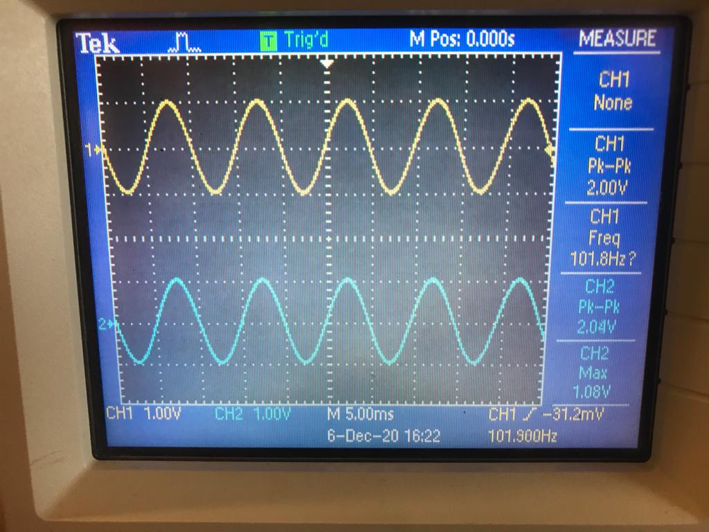

Figure 12: The output voltage

## Comparator Application:

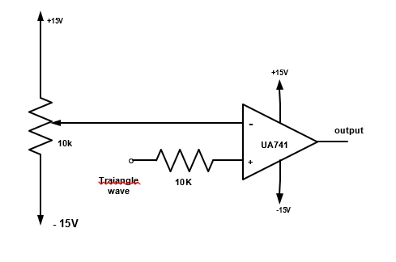

Figure 13: Comparator Application

The circuit in figure 12 was connected, and the input voltage was set to 2 VP-P with frequency 1 kHz, then the dc reference voltage was changed to obtain the positive saturation voltage, the negative saturation voltage, and a normal square wave.

The output waveform of the output voltage when the input is a triangular signal:

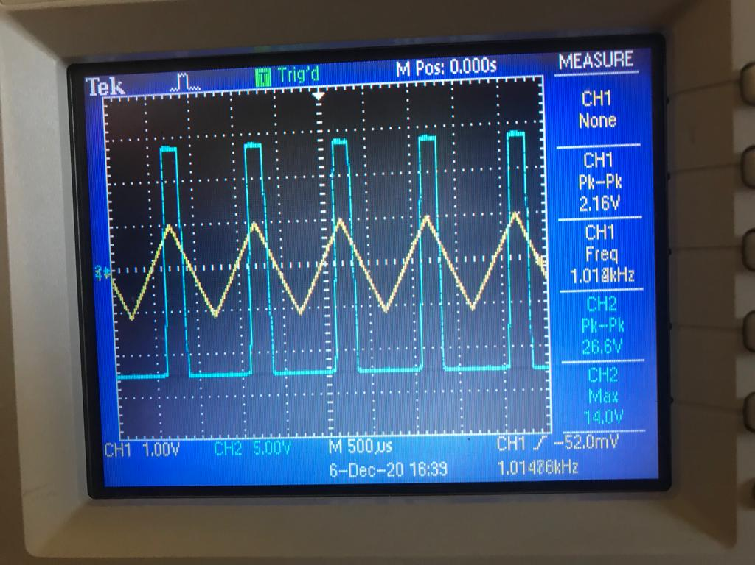

Figure 14: Square wave output

The DC reference voltage = 0.62

The waveform of the output voltage when the output = -VSAT and the input is a triangular signal.

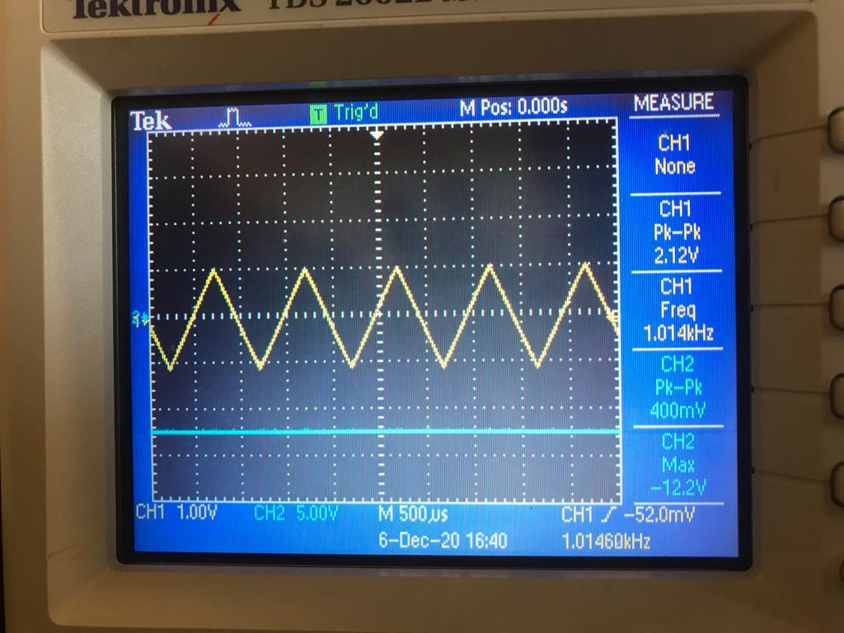

Figure 15: the output of negative Vsat

The DC reference voltage = 0.86v

The waveform of the output voltage when the output = +VSAT and the input is a triangular signal.

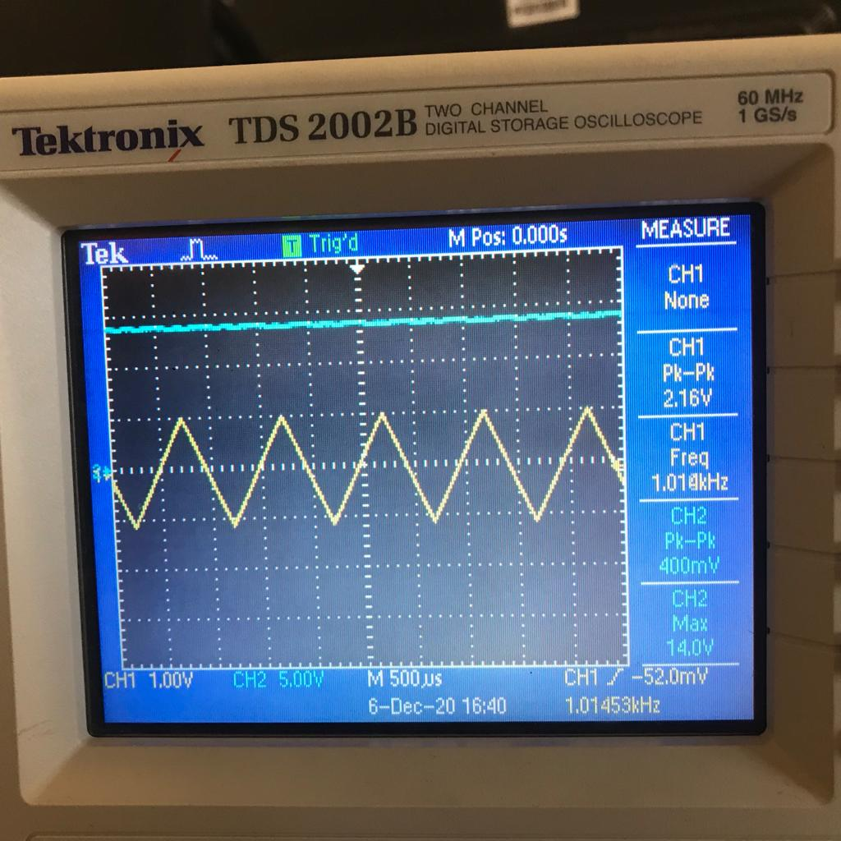

Figure 16: the output of positive Vsat

The DC reference voltage = -4.26v

## Integrator and Differentiator

* The Integration Amplifier:

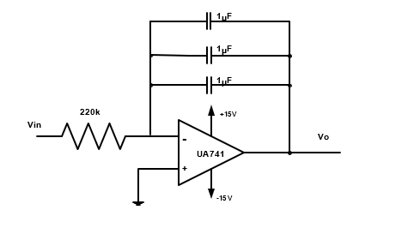

Figure 17: Integrator Amplifier

The circuit in figure 13 was connected, and the input voltage was set to 10 VP-P and frequency of 100Hz and the output signal was drawn for all types of the input signal in the function generator.

The output waveform for a sinusoidal input signal with 10VP-P:

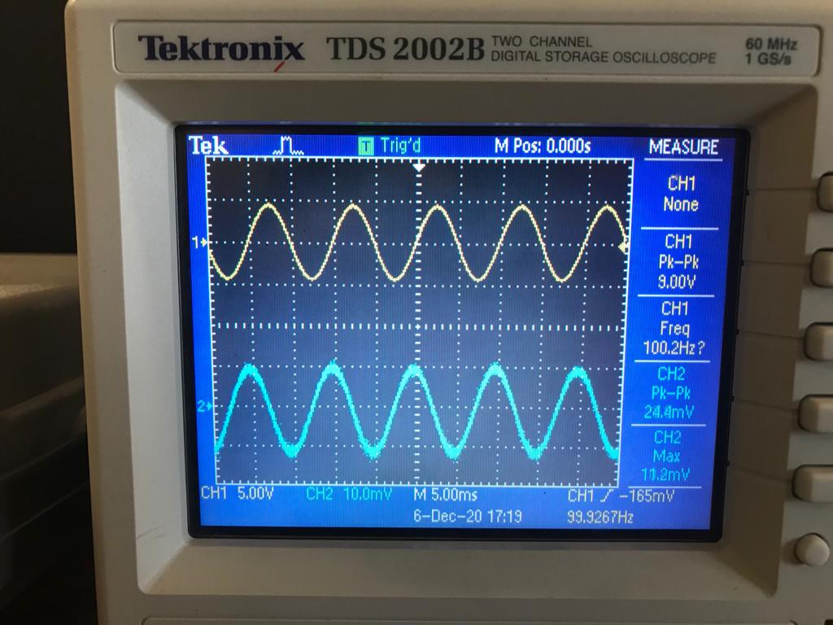

Figure 18: The output waveform for Sinusoidal input signal

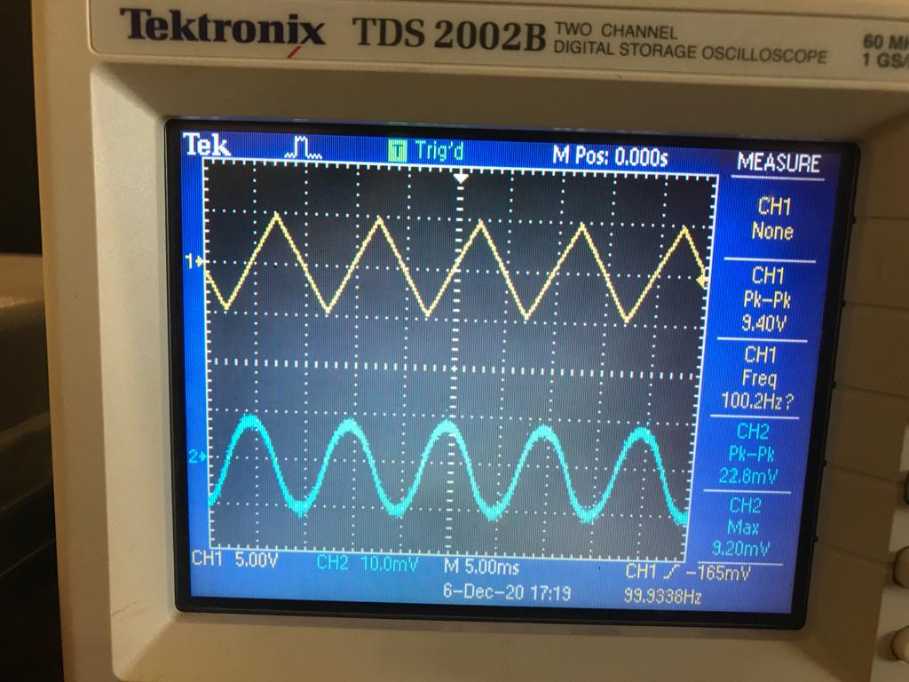

Figure 19: The output waveform for Triangular input signal

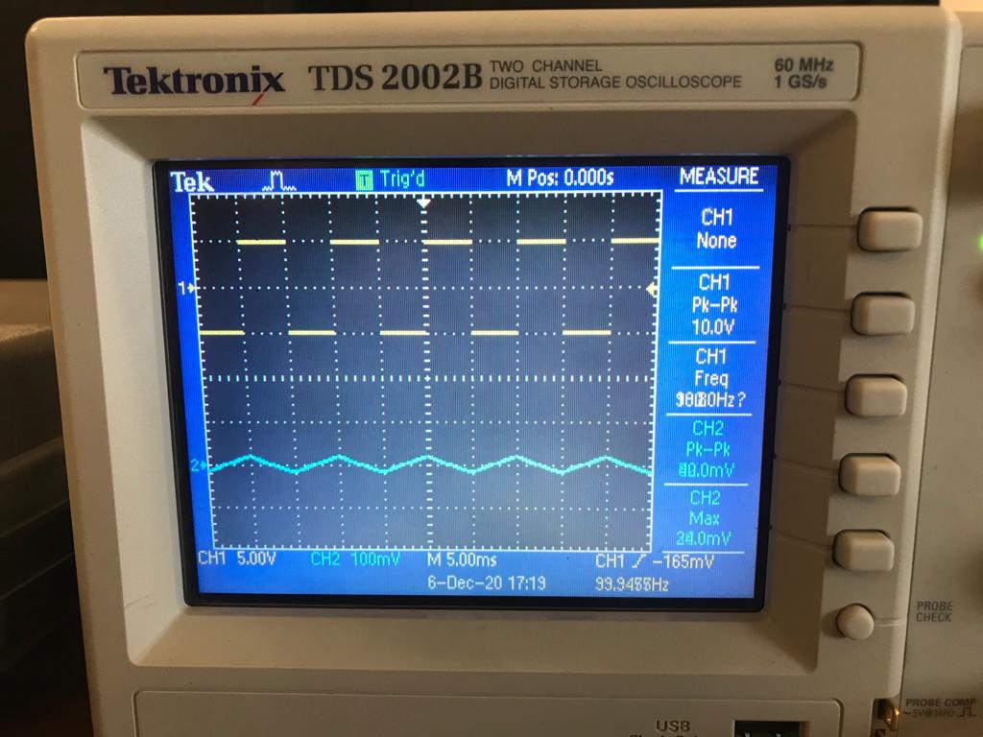

Figure 20: The output waveform for Rectangular input signal

* The Differentiation amplifier:

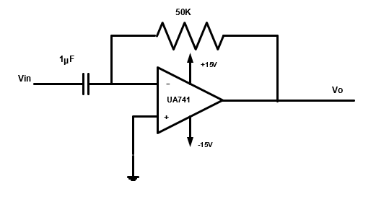

Figure 21: Differentiator Amplifier

The circuit in figure 14 was connected, and the input voltage was set to 10 VP-P and frequency of 100Hz and the output signal was drawn for all types of the input signal in the function generator.

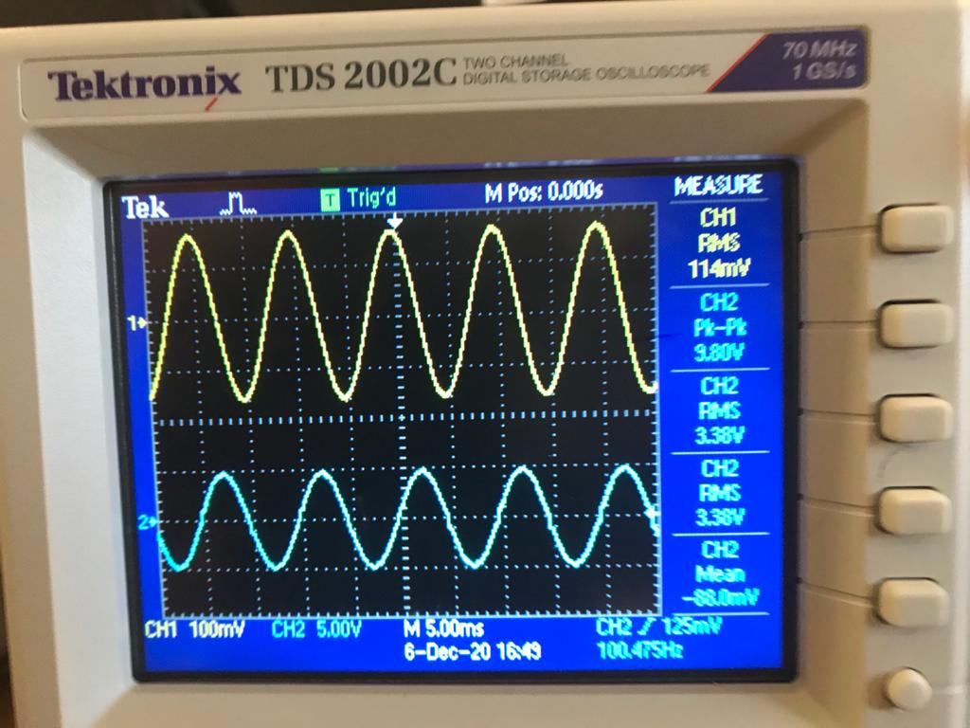

Figure 21: The output waveform for Sinusoidal input signal

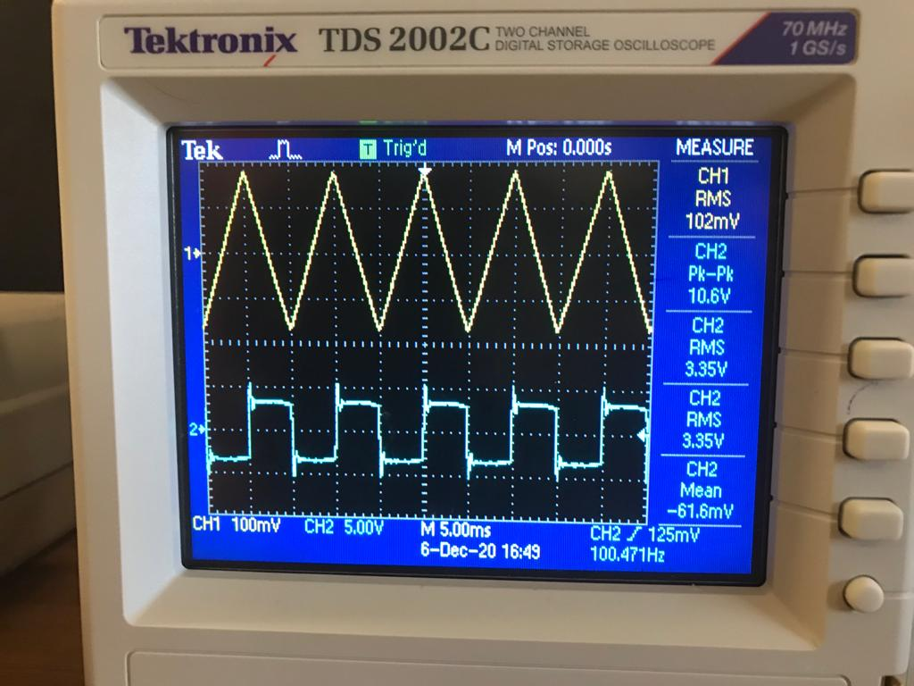

Figure 22: The output waveform for Triangular input signal

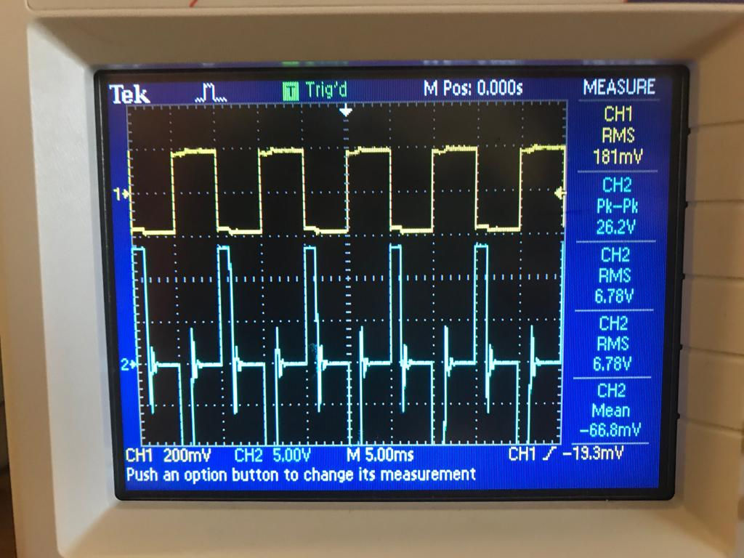

Figure 23: The output waveform for Rectangular input signal

## To investigate the effect of adding hysteresis (Schmitt trigger):



Figure 24: Schmitt circuit

The circuit in the figure above was connected, and the input voltage was set to 15 VP-P sine wave with a frequency of 1kHz, and the output voltage was sketched with respect to the input voltage and the levels of Vin were indicated where Vo changes its level.

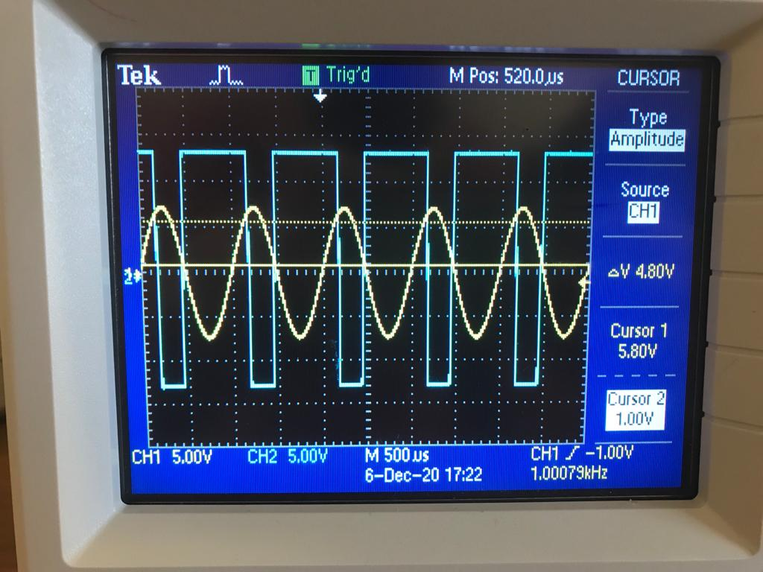

Figure 26: The output waveform

* Practical lower and upper trigger levels:

Upper trigger level = 5.80v

Lower trigger level = 1.00v

* Theoretical lower and upper trigger levels:

Upper trigger level = V(+) = $\frac{100k}{600k}V_{sat}+\frac{2500}{600}$ = V(+) = $\frac{100k}{600k}*15+\frac{2500}{600}$ = 6.66v

Upper trigger level = - $\frac{100k}{600k}V_{sat}+\frac{2500}{600}$ = V(+) = $-\frac{100k}{600k}*15+\frac{2500}{600}$ = 1.66v

## Active Clipping Circuit:

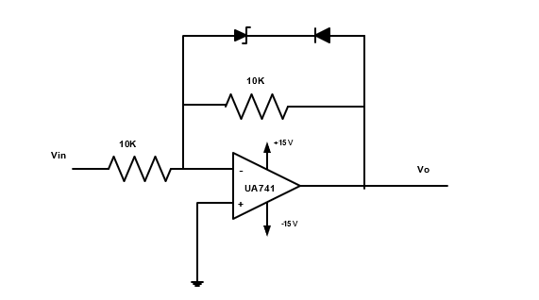

Figure 27: Active Clipping Circuit

The circuit was connected in Figure 22 as shown above, and the amplitude of the input voltage was varied until the clipped output voltage appeared.

The output voltage was sketched with respect to the input voltage and the values of the output voltage were recorded before and after reversing the diode.

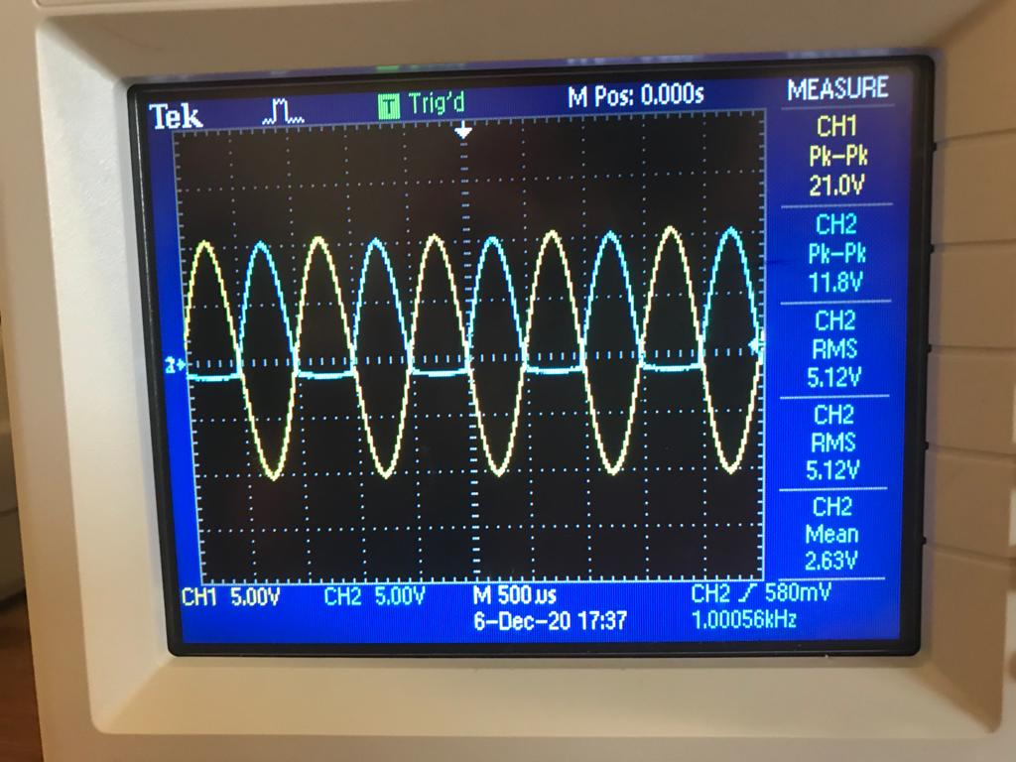

Figure 28: The clipped output waveform

After reversing the diodes:

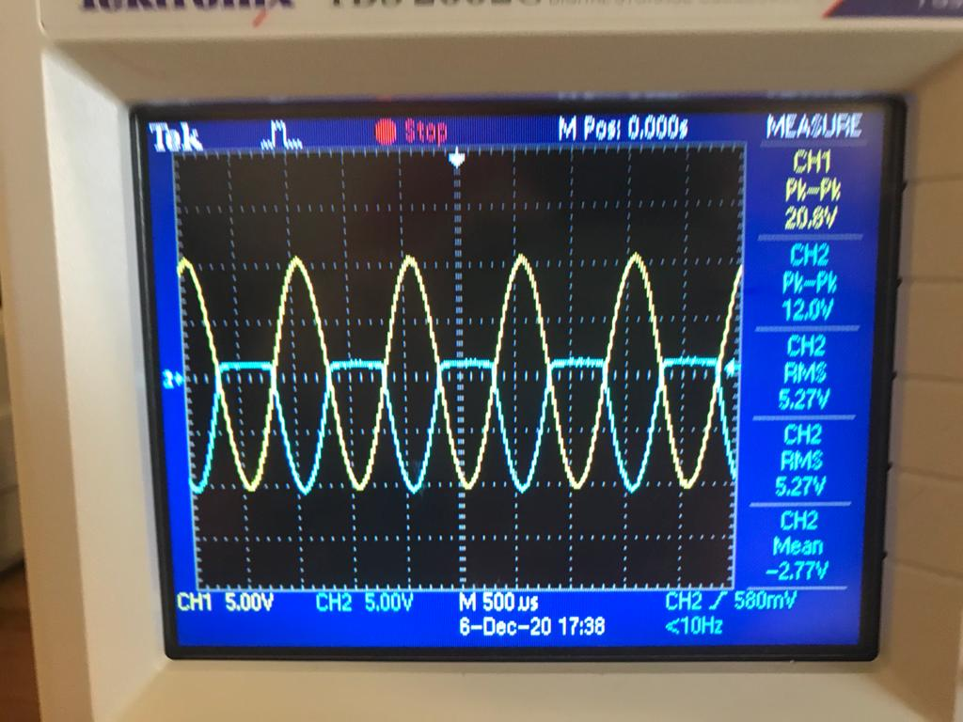

Figure 29: The clipped output waveform

# **Discussion:**

## Adding Application:

From table 1, it’s clear that there is a very small error between the measured and the calculated voltage, it’s almost neglectable, so it can be said that the results are satisfying.

## Voltage Follower Application:

The voltage follower, also known as Buffer Amplifier, its output follows the input voltage which provides a voltage gain equals 1, and it’s similar to the emitter follower which is known for having a voltage gain between 0.-0.999, and both of them have high input impedance, and a lower output impedance.

As mentioned before the voltage follower can be used as a buffer because it produces a small current due to the high input impedance it has.

The ratio between the output voltage and the input voltage is:

$$\frac{V_{O}}{V_{i}} ≈1$$

## Comparator Application:

As mentioned in the theory above, if the non-inverting input is less than the inverting input, the output will be at the negative saturation voltage, when the non-inverting input starts to increase the output will switch rapidly to the positive saturation voltage.

## Integrator and Differentiator:

* Integration Amplifier:

According to the theory the square waveform when it’s applied to the integrator amplifier, the output should be a triangular waveform, while if the input was a sinusoidal wave the output should be cosine wave, and that’s the results concluded in the lab.

* Differentiation Amplifier

According to the theory above if the input for the differentiator amplifier was a sinusoidal waveform and the output should be a cosine wave, while if the input was a triangular wave the output should be a square wave, finally, if the input was a square wave the output should be spikes as shown in the lab.

## To investigate the effect of adding hysteresis:

There were small errors between the practical trigger levels values and the theoretical ones, probably due to some problems in measuring the practical values, but these errors can be neglected, so it can be concluded that the results are satisfying.

## Active Clipping Circuit:

Before reversing the diode, The output of the amplifier was negative, but after reversing the diode, The output of the amplifier was positive.

# Conclusion:

After comparing our results with theory part, it’s clear that our results are satisfying, and thee calculated values were very close to the measured ones, finally, this experiment ran well in the lab with some problems in the devices, but it was solved with the help of the teacher assistant and the instructor of the course.

# References:

1. Electronics Lab ENEE3102 Lab Manual
2. Microelectronic_Circuits_6th_Edition
3. Electric Circuits tenth edition James W. Nilsson and Susan A. Riedel.