

Faculty of Engineering and Technology

Electrical and Computer Engineering Department

**ENEE 3102 – Electronics Lab**

Experiment No. 9

**The Operational Amplifier**

Prepared By:

Name: Suhaeb Qadan Number: 1160297

Instructor: Dr. Mohammad Al Jubeh

TA: Eng. Almo`tassem Billah

Date: 20/11/2019

Sec#: 1

**Abstract**  In this experiment, some concept was studied about operational amplifier. The aim of this experiment is to identifies the application of the op. amp circuits and distinguish between them according to their outputs. Moreover, to understand and acknowledge the process that op. amp can do such as adding, voltage follower, comparator, integrator and differentiator, and that can be done by using an oscilloscope to observe the outputs of the different operational amplifiers circuit.

Equipment's List:

* DC power supply.
* AC power supply.
* OP. AMPS.
* Diodes.
* Resistors, Capacitors and Potentiometer.
* Electrical Kit.
* Wires.

**Table of Contents**

**Abstract** 1

**Theory** 4

**Procedure, Data and Calculation** 7

**Part A: Adding Application** 7

**Part B: Voltage Follower Application** 8

**Part C: Comparator Application** 9

**Part D: Integrator** 12

**Part E: Differentiator** 14

**Part F: To investigate the effect of adding hysteresis (Schmitt trigger)** 17

**Part G: Active Clipping Circuit** 20

**Discussion** 22

**Conclusion** 26

**References** 27

**List of Figures**

Figure 1: The equivalent circuit of an ideal OP. AMP… (1) 6

Figure 2: Summing Amplifier Circuit using for Adding Application 9

Figure 3: The voltage follower operational circuit 10

Figure 4: The output waveform when Vi = 2Vp-p with 100 Hz 11

Figure 5: The operational circuit that used as a comparator 11

Figure 6: The output waveform of the output voltage when the input was triangular signal with 2 Vp-p 12

Figure 7: The waveform of the output voltage for an output of negative Vsat when the input was triangular signal 13

Figure 8: The waveform of the output voltage for an output of positive Vsat when the input was triangular signal 13

Figure 9: Circuit of Operational amplifier using as an Integrator 14

Figure 10: The output waveform using sinusoidal input voltage with 10Vp-p 14

Figure 11: The output waveform using triangular input voltage with 10Vp-p 15

Figure 12: The output waveform using rectangular input voltage with 10Vp-p 15

Figure 13: Circuit of Operational amplifier using as an Differentiator 16

Figure 14: The output waveform using sinusoidal input voltage with 10Vp-p 16

Figure 15: The output waveform using triangular input voltage with 10Vp-p 17

Figure 16: The output waveform using rectangular input voltage with 10Vp-p 17

Figure 17: Schmitt Trigger Circuit 18

Figure 18: The output waveform when the input voltage is 15Vp-p 18

Figure 19 19

Figure 20 19

Figure 21 20

Figure 22: Operational Amplifier using as a clipping circuit 21

Figure 23: The clipped output voltage before reversing the diode 21

Figure 24: The clipped output voltage after reversing the diode 22

**List of Tables**

Table 1: The measured and calculated value of the output voltage for V1 and V2 9

Table 2: The measured value of VO at different values of Vin when RL = 220 Ω 10

Table 3: The measured value of VO at different values of Vin when RL = 1 kΩ 10

# **Theory**

**Definition of the operational amplifier**

Operational amplifiers are linear devices that have all the properties required for nearly ideal DC amplification and are therefore used extensively in signal conditioning, filtering or to perform mathematical operations such as add, subtract, integration and differentiation.

An **Operational Amplifier**, or op-amp for short, is fundamentally a voltage amplifying device designed to be used with external feedback components such as resistors and capacitors between its output and input terminals. These feedback components determine the resulting function or “operation” of the amplifier and by virtue of the different feedback configurations whether resistive, capacitive or both, the amplifier can perform a variety of different operations, giving rise to its name of “Operational Amplifier”.

An Operational Amplifier is basically a three-terminal device which consists of two high impedance inputs. One of the inputs is called the Inverting Input, marked with a negative or “minus” sign, (–). The other input is called the Non-inverting Input, marked with a positive or “plus” sign (+) … (1)

**Equivalent circuit of an ideal OP. AMP**

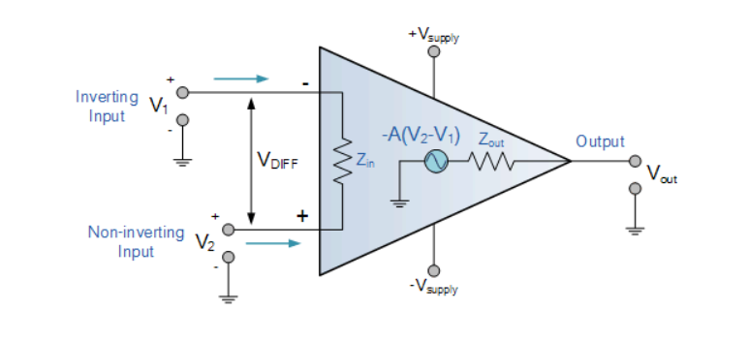

Figure : The equivalent circuit of an ideal OP. AMP… (1)

**The Summing Amplifier**

The **Summing Amplifier** is another type of operational amplifier circuit configuration that is used to combine the voltages present on two or more inputs into a single output voltage. In this type of operational amplifier, the output voltage of the OP. AMP will become proportional to the some of the input voltages V1 and V2 multiplying by a gain of the inverting OP. AMP… (1)

The formula of the output equation:

… (1)

**Voltage Follower Application**

A voltage follower (also called a unity-gain amplifier, a buffer amplifier, and an isolation amplifier) is an op-amp circuit which has a voltage gain of 1.

This means that the op amp does not provide any amplification to the signal. The reason it is called a voltage follower is because the output voltage directly follows the input voltage, meaning the output voltage is the same as the input voltage.

The purpose of using voltage follower is that They draw very little current, not disturbing the original circuit, and give the same voltage signal as output. They act as isolation buffers, isolating a circuit so that the power of the circuit is disturbed very little… (2)

**OP. AMP Comparator**

The comparator is an electronic decision-making circuit that makes use of an operational amplifiers very high gain in its open-loop state, that is, there is no feedback resistor.

The **Op-amp comparator** compares one analogue voltage level with another analogue voltage level, or some preset reference voltage, VREF and produces an output signal based on this voltage comparison. In other words, the op-amp voltage comparator compares the magnitudes of two voltage inputs and determines which is the largest of the two… (1)

**The Differentiator Amplifier**

The basic operational amplifier differentiator circuit produces an output signal which is the first derivative of the input signal.

This operational amplifier circuit performs the mathematical operation of **Differentiation**, that is it *“*produces a voltage output which is directly proportional to the input voltage’s rate-of-change with respect to time *“.* In other words, the faster or larger the change to the input voltage signal, the greater the input current, the greater will be the output voltage change in response, becoming more of a “spike” in shape.

As with the integrator circuit, we have a resistor and capacitor forming an RC Network across the operational amplifier and the reactance (Xc) of the capacitor plays a major role in the performance of an **Op-amp Differentiator**… (1)

**The Integrator Amplifier**

The integrator Op-amp produces an output voltage that is both proportional to the amplitude and duration of the input signal.

As its name implies, the **Op-amp Integrator** is an operational amplifier circuit that performs the mathematical operation of **Integration**, that can cause the output to respond to changes in the input voltage over time as the op-amp integrator produces an output voltage which is proportional to the integral of the input voltage*…* (1)

**Schmitt Trigger Amplifier**

The Schmitt Trigger is a logic input type that provides hysteresis or two different threshold voltage levels for rising and falling edge. This is useful because it can avoid the errors when we have noisy input signals from which we want to get square wave signals.

A Schmitt trigger circuit is also called a regenerative comparator circuit. The circuit is designed with a positive feedback and hence will have a regenerative action which will make the output switch levels. Also, the use of positive voltage feedback instead of a negative feedback, aids the feedback voltage to the input voltage, instead of opposing it. The use of a regenerative circuit is to remove the difficulties in a [zero-crossing detector circuit](http://www.circuitstoday.com/zero-crossing-detector) due to low frequency signals and input noise voltages… (3)

**Active Clipping Circuit**

A clipper is an electronic circuit that produces an output by removing a part of the input above or below a reference value. That means, the output of a clipper will be same as that of the input for other than the clipped part. Due to this, the peak to peak amplitude of the output of a clipper will be always less than that of the input.

The main advantage of clippers is that they eliminate the unwanted noise present in the amplitude of an ac signal… (4)

Clippers can be classified into the following two types based on the clipping portion of the input:

* Positive Clipper
* Negative Clipper

# **Procedure, Data and Calculation**

## **Part A: Adding Application**

1. The circuit was connected in Figure 2 as shown below:

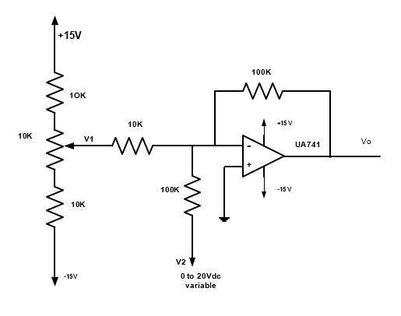

Figure : Summing Amplifier Circuit using for Adding Application

1. V1 is controlled by the potentiometer and V2 is obtained from the variable DC source on the trainer.
2. The output voltage for V1 and V2 was measured and calculated in table 1 below:

Table : The measured and calculated value of the output voltage for V1 and V2

|  |  |  |  |
| --- | --- | --- | --- |
| **Input voltage** | | **Out** | **put voltage** |
| **V1** | **V2** | **VO** | **Calculated voltage** |
| **0.5** | **2** | -7.2 | -7 |
| **0.1** | **6** | -7.28 | -7 |
| **0.3** | **4** | -7.201 | -7 |
| **-0.9** | **2** | 7.14 | 7 |
| **-1.1** | **4** | 7.174 | 7 |
| **-1.5** | **6** | 9.207 | 9 |

## **Part B: Voltage Follower Application**

1. The circuit was connected in Figure 3 as shown below:

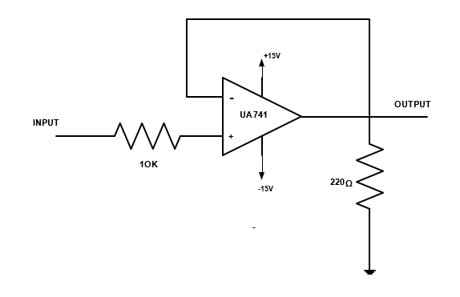

Figure : The voltage follower operational circuit

1. The output voltage was measured and recorded when Vi (1V, 2V, 3V, 4V, 5V, 6V and 7V) in table 2 below:

Table : The measured value of VO at different values of Vin when RL = 220 Ω

|  |  |  |  |  |  |  |  |
| --- | --- | --- | --- | --- | --- | --- | --- |
| Vin [V] | 1 | 2 | 3 | 4 | 5 | 6 | 7 |
| Vo [V] | 1 | 2 | 3 | 4 | 5 | 5.78 | 5.8 |

1. The load resistor was changed to 1 kΩ, and the output voltage was measured and recorded when Vi (6V, 8V, 10V, 12V and 15V) in table 3 below:

Table : The measured value of VO at different values of Vin when RL = 1 kΩ

|  |  |  |  |  |  |
| --- | --- | --- | --- | --- | --- |
| Vin [V] | 6 | 8 | 10 | 12 | 15 |
| Vo [V] | 6 | 8.01 | 10.1 | 12.01 | 12.902 |

1. VO was drawn when Vi = 2Vp-p sinusoidal with 100 Hz as shown in figure below:

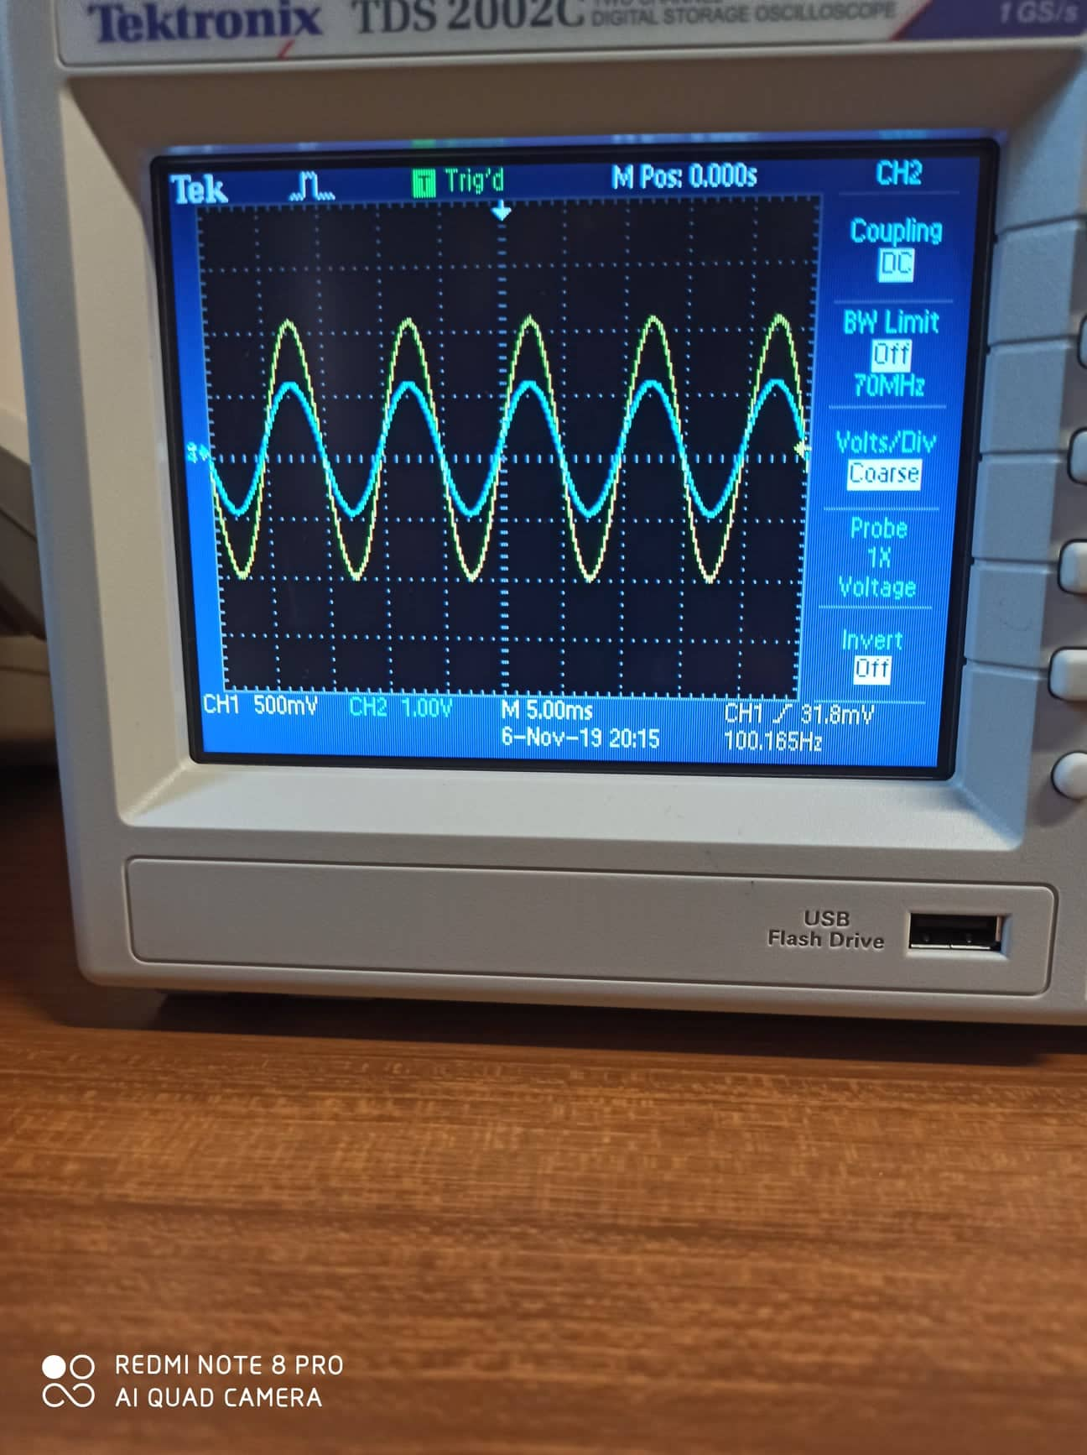

Figure : The output waveform when Vi = 2Vp-p with 100 Hz

**Noticed that the scaling of the input signal is greater than the scaling of the output signal by 2.5 square.**

## **Part C: Comparator Application**

1. The circuit was connected in Figure 5 as shown below:

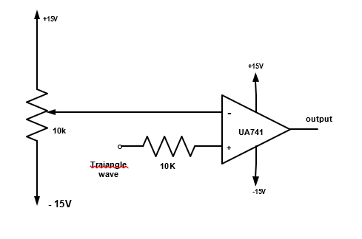

Figure : The operational circuit that used as a comparator

1. Triangular input signal was used from the function generator with 1 kHz.
2. The Triangular input signal was set to 2Vp-p and the DC reference voltage was changed until obtain an output of negative Vsat then positive Vsat and a square output wave voltage.
3. The Figures below will show the waveform of each case with the value of the DC reference voltage.

The output waveform of the output voltage when the input was triangular signal is shown in figure 6 below:

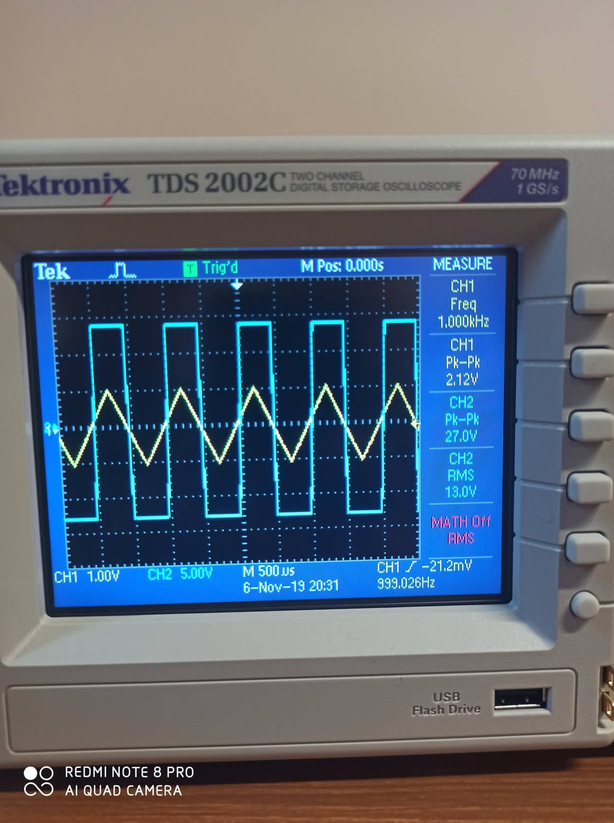

Figure : The output waveform of the output voltage when the input was triangular signal with 2 Vp-p

The DC reference voltage in this case = 0.0886 V.

The waveform of the output voltage for an output of negative Vsat when the input was triangular signal is shown in figure 7 below:

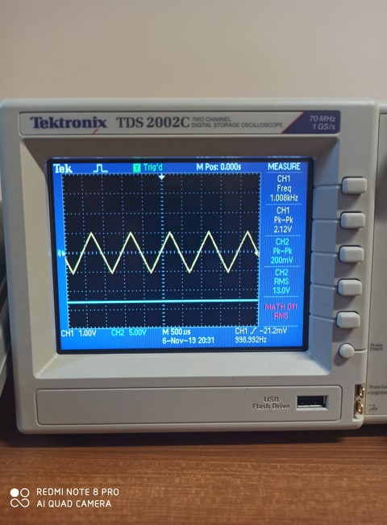

Figure : The waveform of the output voltage for an output of negative Vsat when the input was triangular signal

The DC reference voltage in this case = 1.146 V.

The waveform of the output voltage for an output of positive Vsat when the input was triangular signal is shown in figure 8 below:

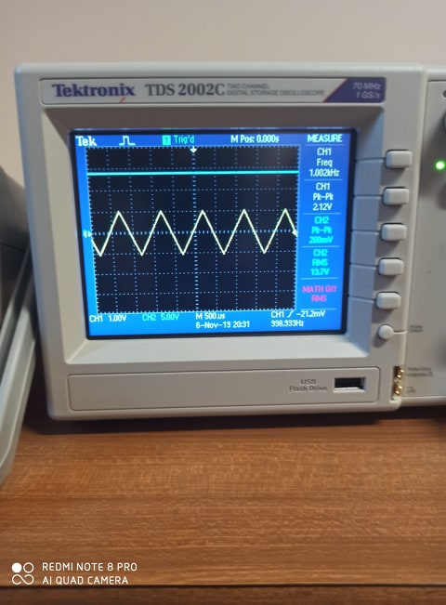

Figure : The waveform of the output voltage for an output of positive Vsat when the input was triangular signal

The DC reference voltage in this case = -1.913 V.

## **Part D: Integrator**

1. The circuit was connected in Figure 9 as shown below:

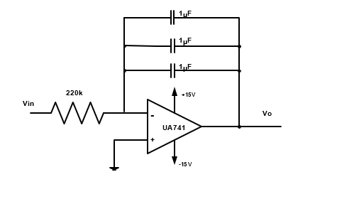

Figure : Circuit of Operational amplifier using as an Integrator

1. The input signal was set with 10Vp-p and a frequency of 100Hz.
2. The output signal was drawn for all types of input signal of the generator.

The output waveform using sinusoidal input voltage with 10Vp-p shown below:

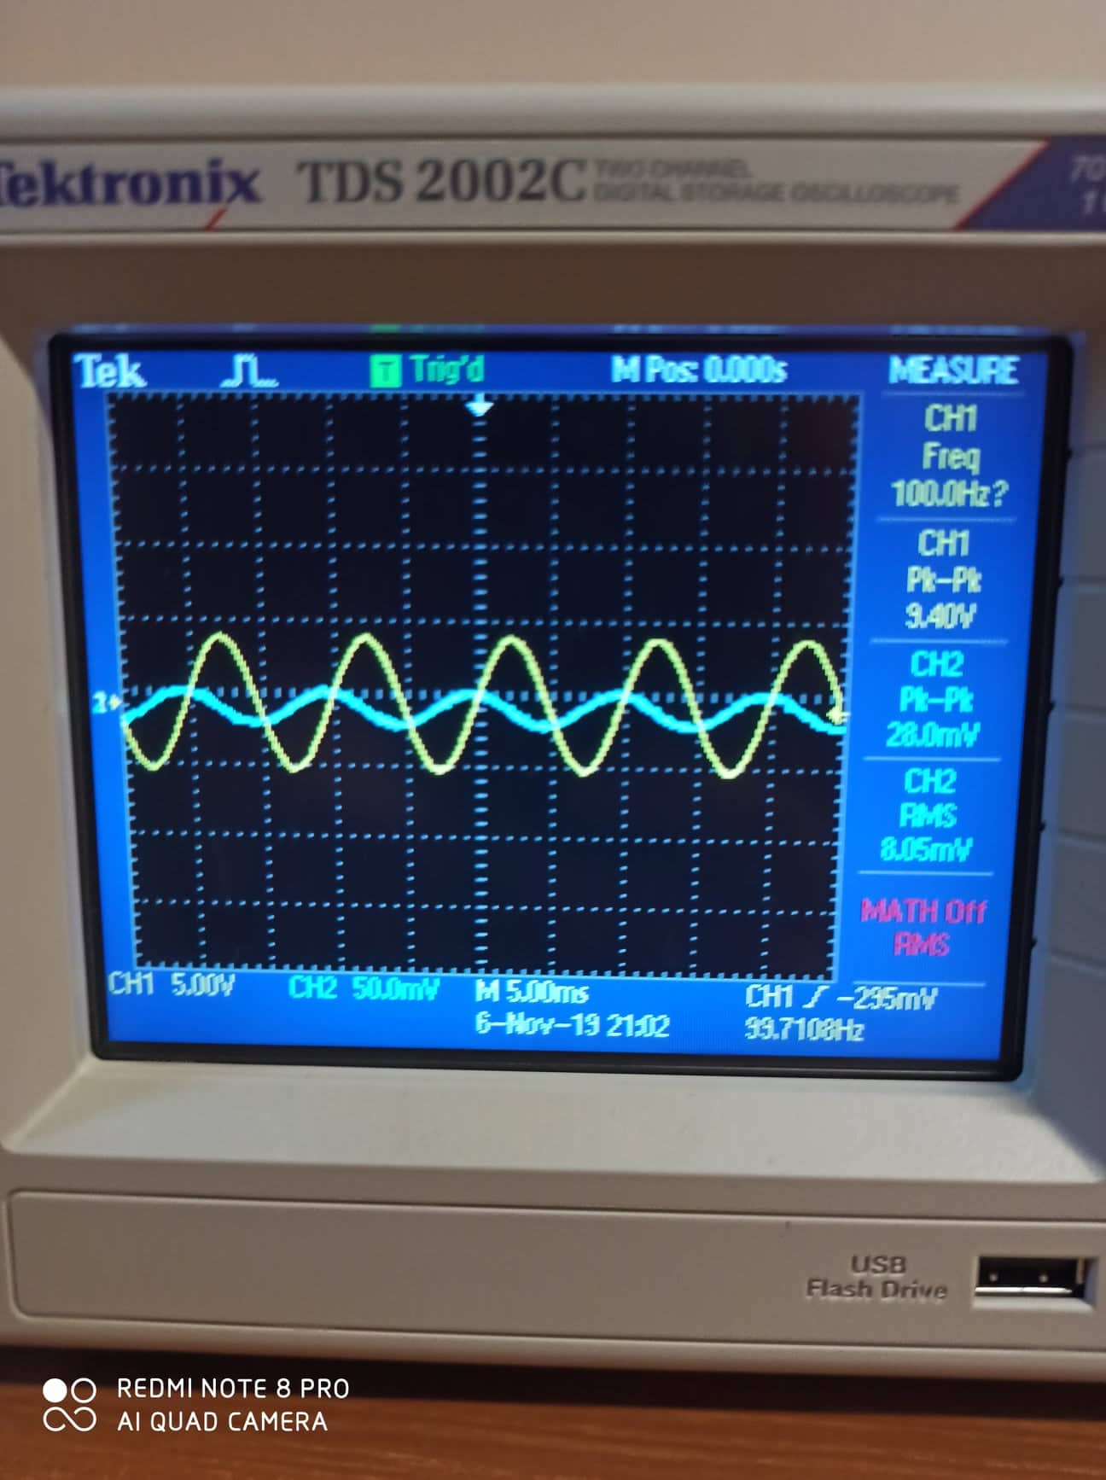

Figure : The output waveform using sinusoidal input voltage with 10Vp-p

The output waveform using triangular input voltage with 10Vp-p shown below:

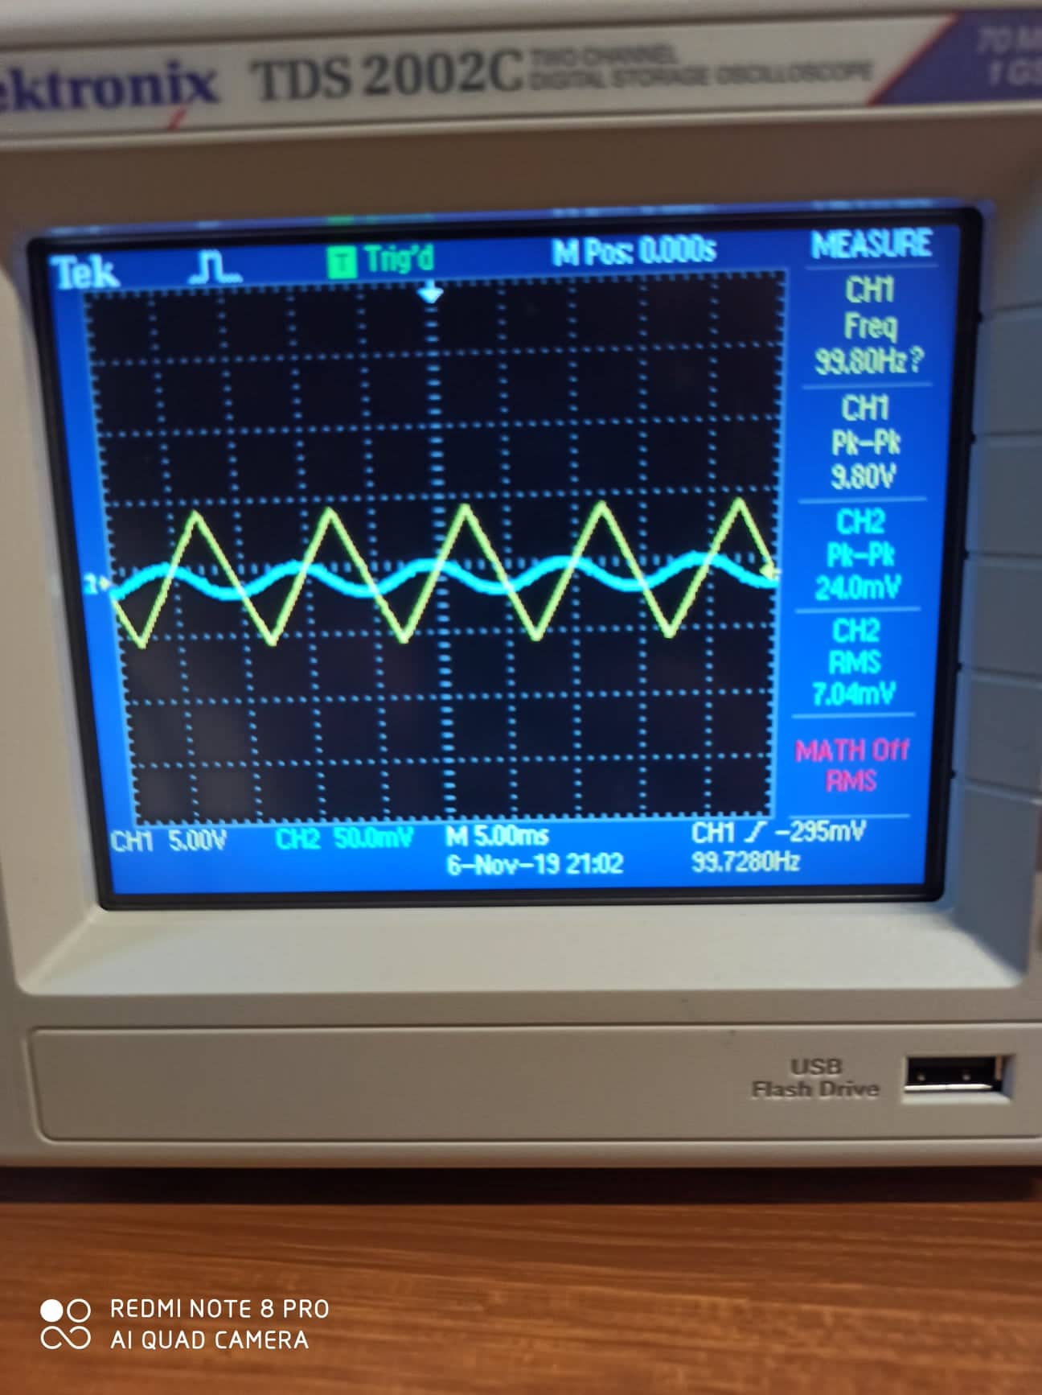

Figure : The output waveform using triangular input voltage with 10Vp-p

The output waveform using rectangular input voltage with 10Vp-p shown below:

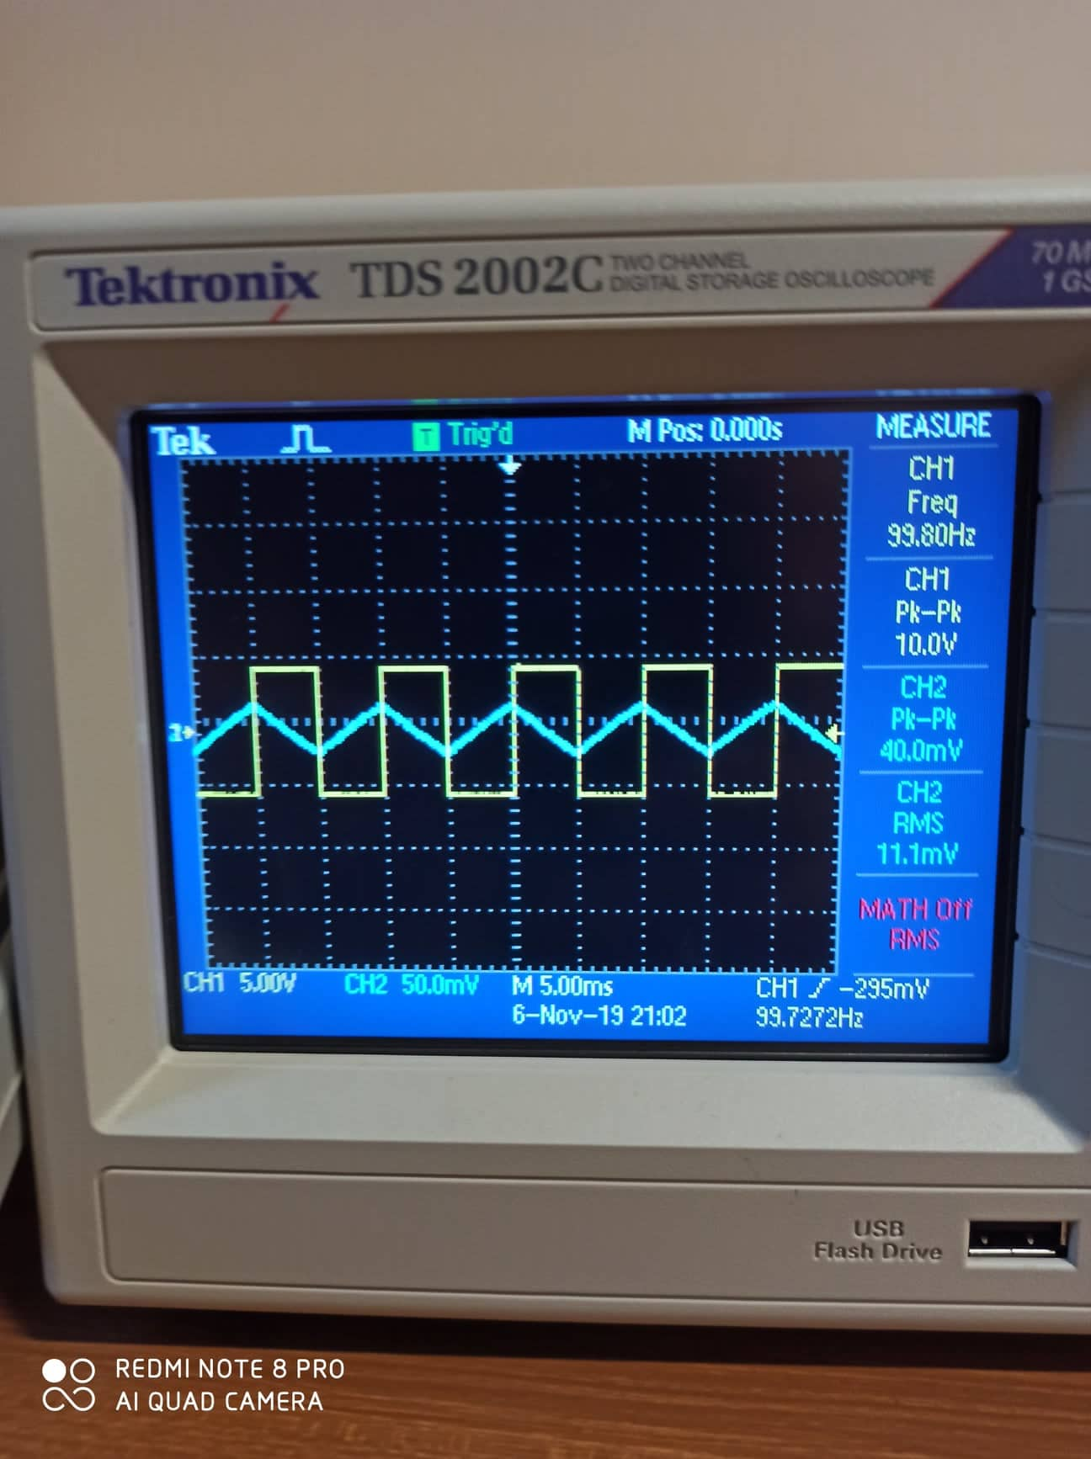

Figure : The output waveform using rectangular input voltage with 10Vp-p

## **Part E: Differentiator**

1. The circuit was connected in Figure 13 as shown below:

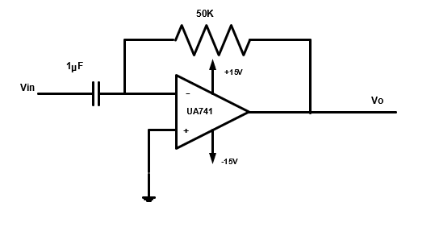

Figure : Circuit of Operational amplifier using as an Differentiator

1. The input signal was set with 10Vp-p and a frequency of 100Hz.
2. The output signal was drawn for all types of input signal of the generator.

The output waveform using sinusoidal input voltage with 10Vp-p shown below:

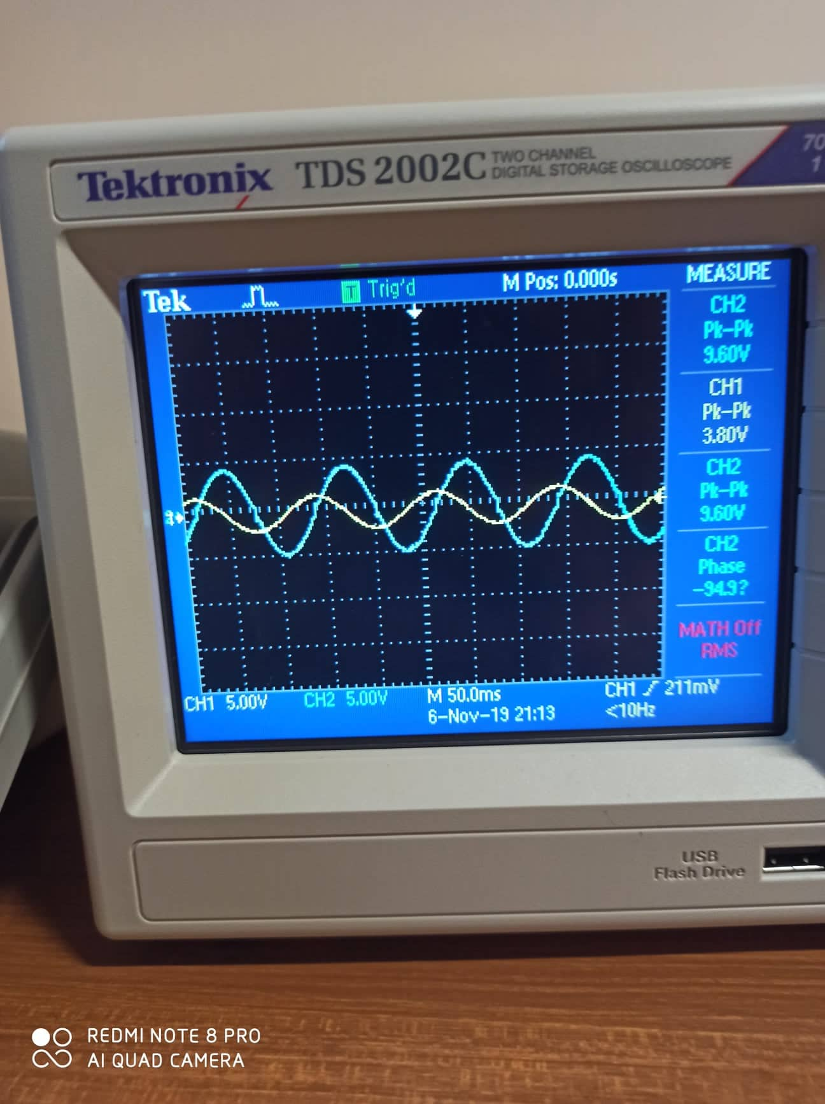

Figure : The output waveform using sinusoidal input voltage with 10Vp-p

The output waveform using triangular input voltage with 10Vp-p shown below:

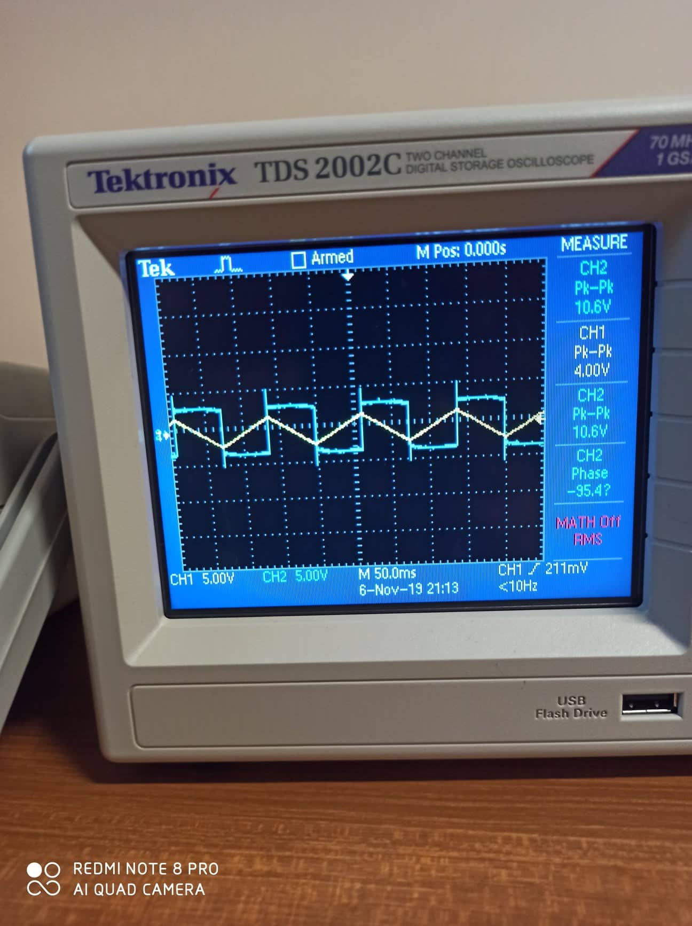

Figure : The output waveform using triangular input voltage with 10Vp-p

The output waveform using rectangular input voltage with 10Vp-p shown below:

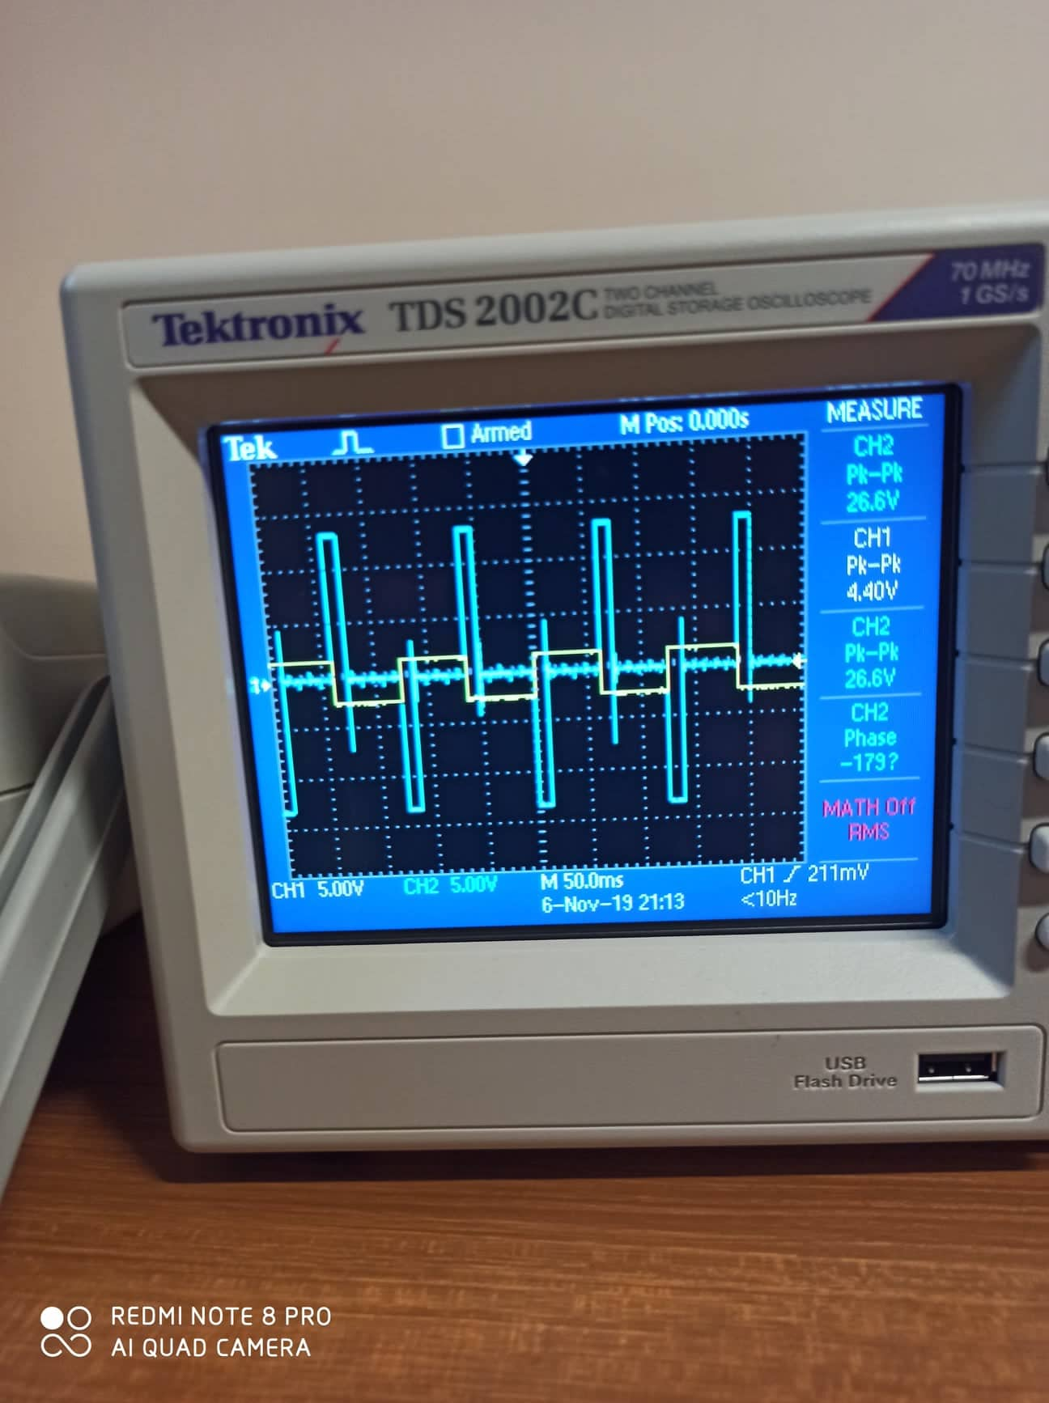

Figure : The output waveform using rectangular input voltage with 10Vp-p

## **Part F: To investigate the effect of adding hysteresis (Schmitt trigger)**

1. The circuit was connected in Figure 13 as shown below:

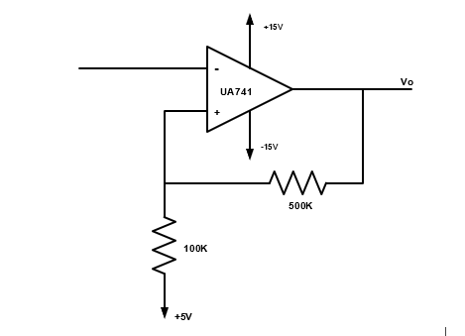

Figure : Schmitt Trigger Circuit

1. The input voltage was set to 15Vp-p sine wave with frequency of 1 kHz.
2. The output voltage was sketched with respect to the input voltage and the levels of Vin(t) were indicated where Vo(t) changes its level.

The output waveform when the input voltage is 15Vp-p shown in figure below:

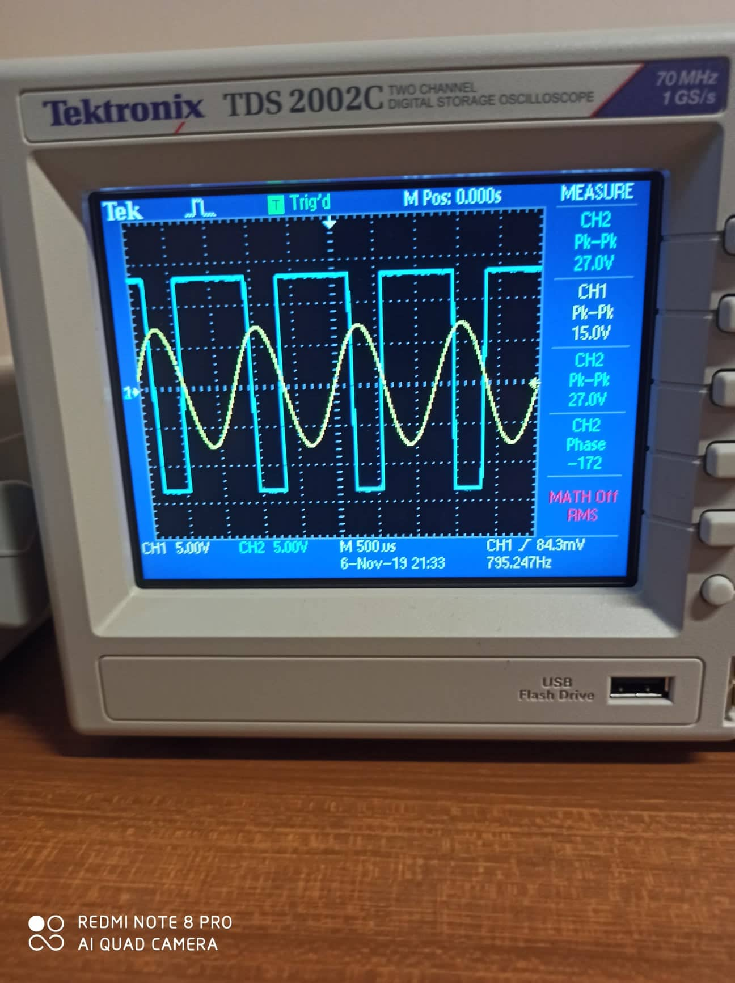

Figure : The output waveform when the input voltage is 15Vp-p

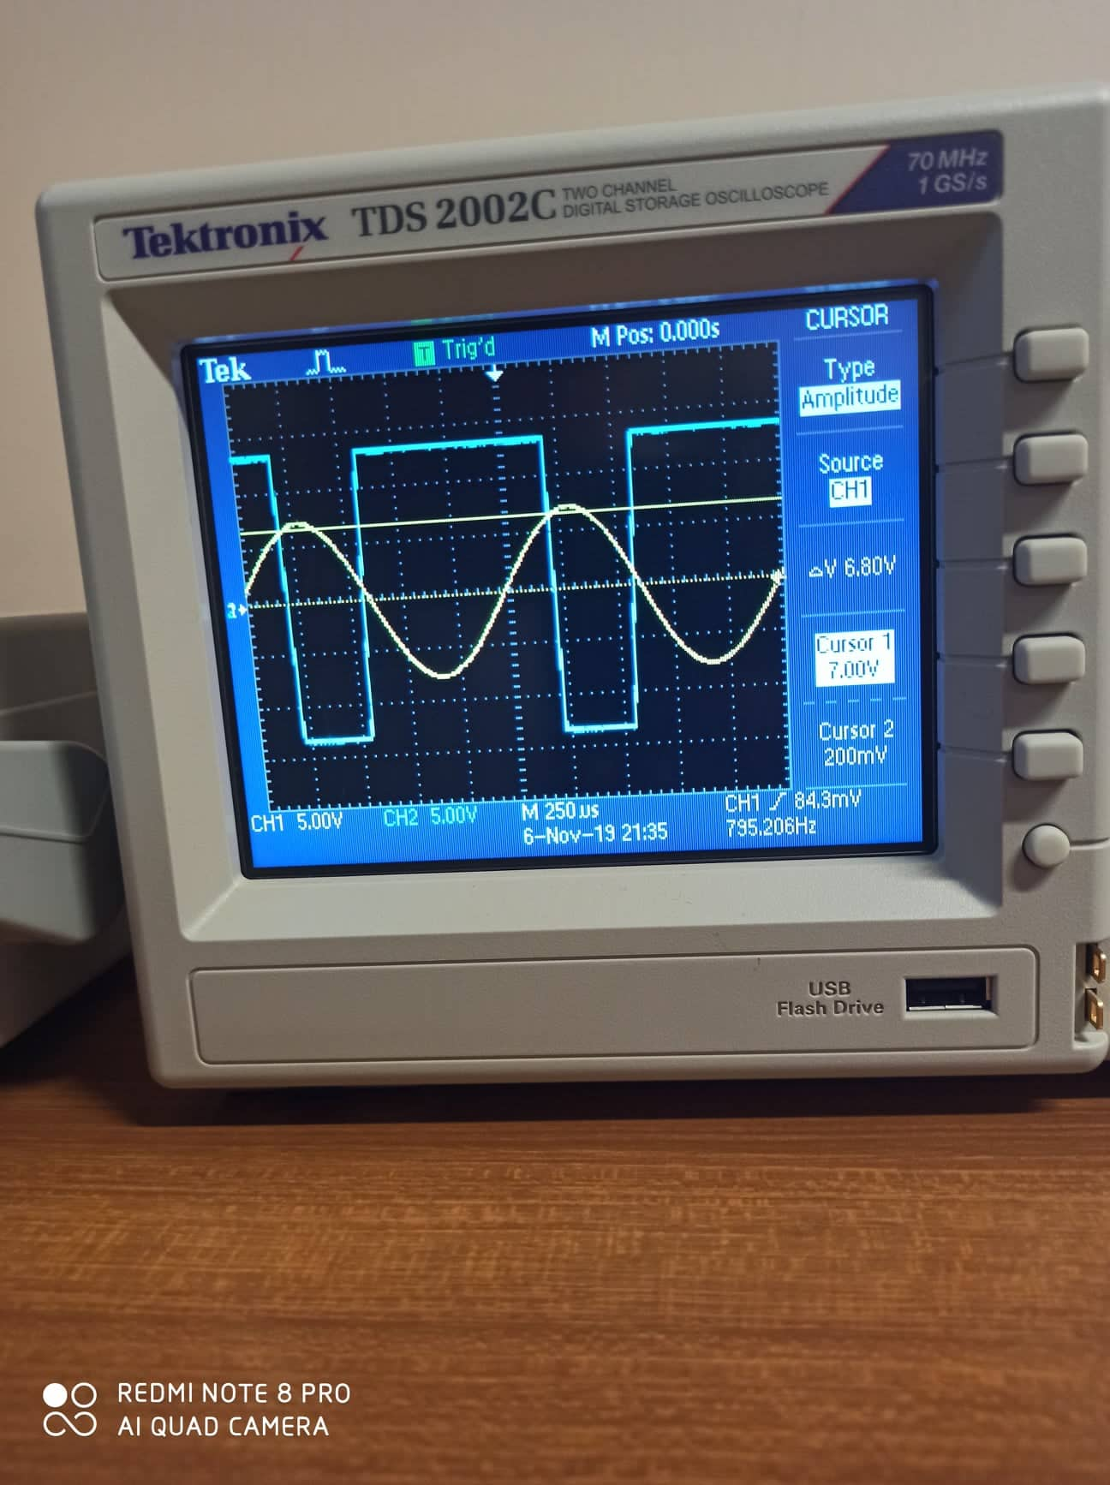

Figure

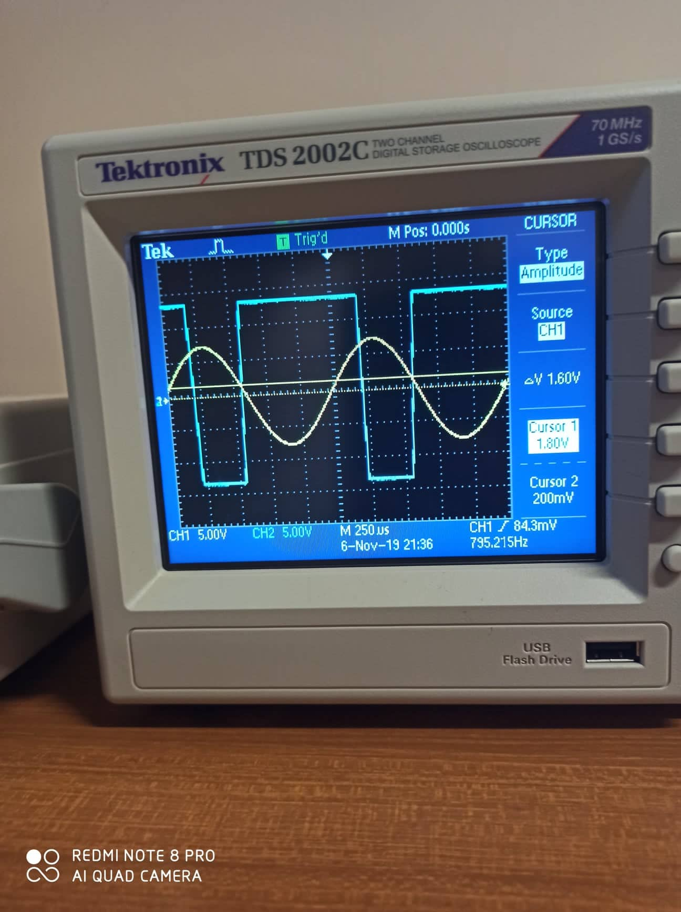

Figure

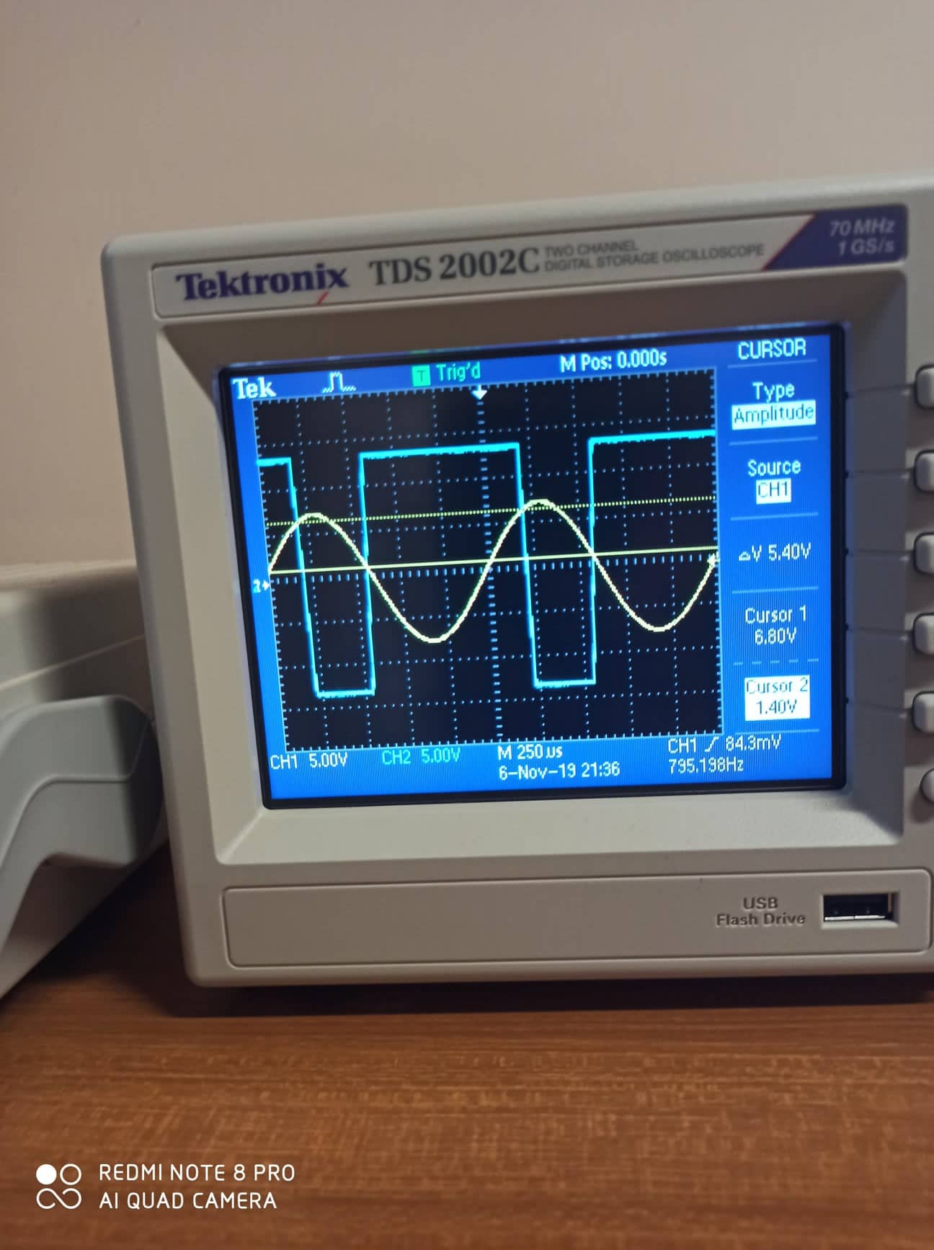

Figure

Measured Values:

Upper triggered Value: 6.8V

Lower triggered Value: 200mV

Theoretical Values:

Upper triggered Value: $\frac{R2}{R2+R1}$ (+Vsat) = $\frac{100}{100+500}$ (13) = 2.16V

Lower triggered Value: $\frac{R2}{R2+R1}$ (-Vsat) = $\frac{100}{100+500}$ (-13) = - 2.16V

The measured values have an error due to the inaccuracy of taking measurements using cursors.

## **Part G: Active Clipping Circuit**

1. The circuit was connected in Figure 22 as shown below:

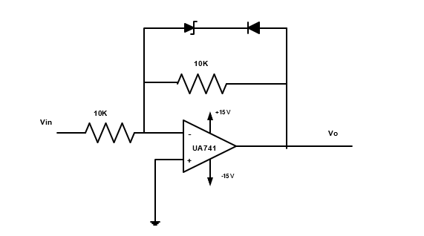

Figure : Operational Amplifier using as a clipping circuit

1. The amplitude of the input voltage was varied until the clipped output voltage is shown.
2. The output voltage was sketched with respect to the input voltage and the values of the output voltage was recorded before and after reversing the diode.

Before rversing the diode, The ouput waveform is shown in figure below:

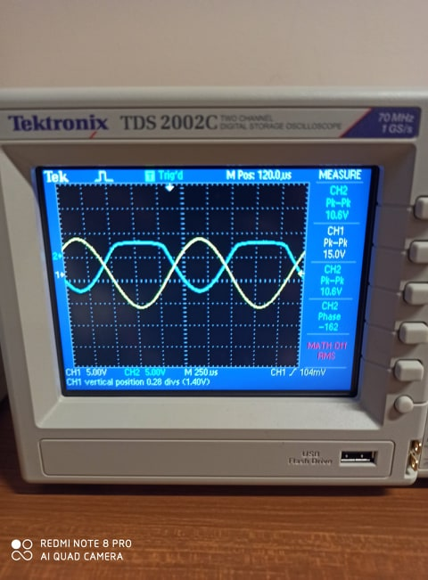

Figure : The clipped output voltage before reversing the diode

The output voltage = 10.6 Vp-p

After rversing the diode, The ouput waveform is shown in figure below:

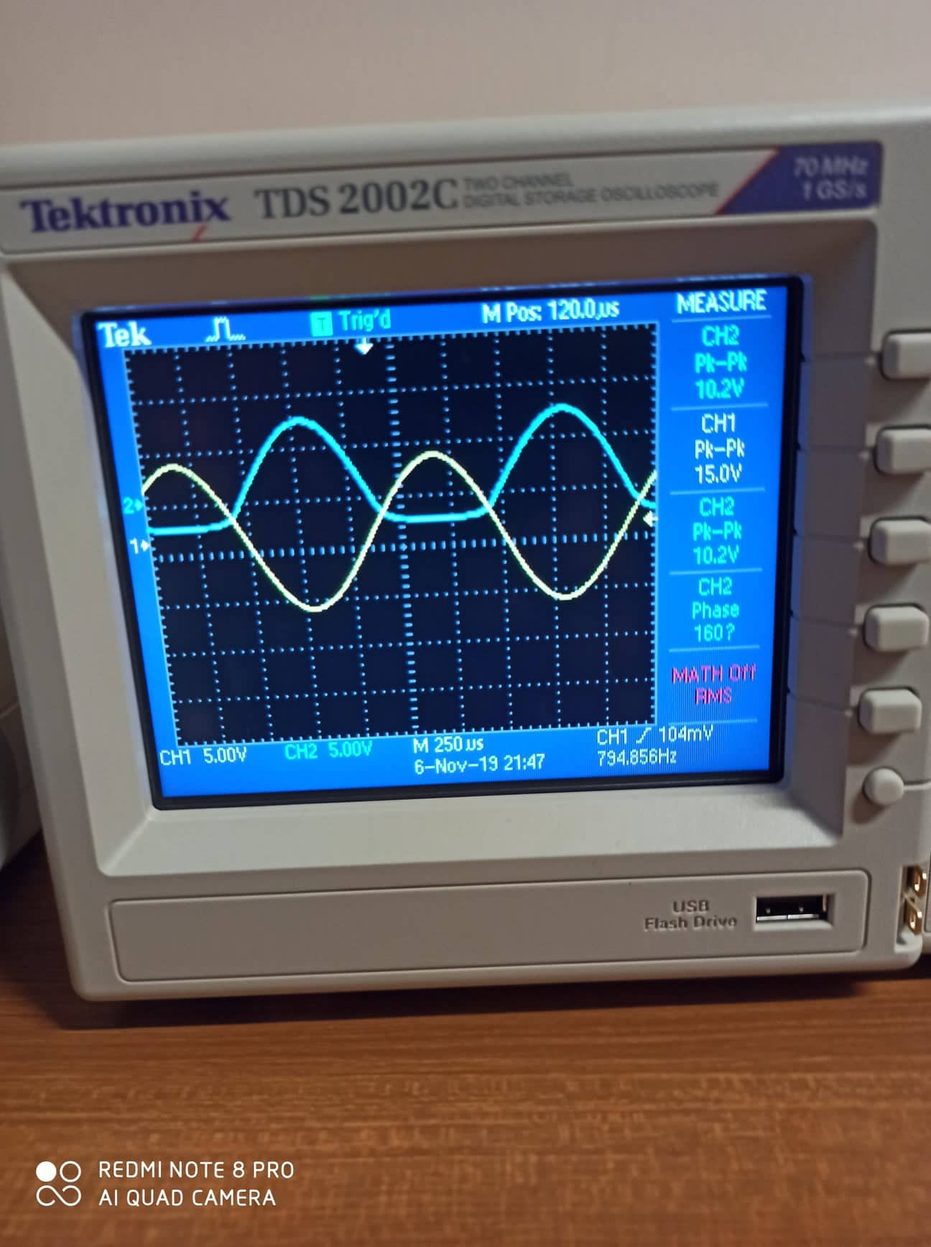

Figure : The clipped output voltage after reversing the diode

The output voltage = 10.2 Vp-p

# **Discussion**

**Part A: Adding Application**

From the measued values of Table 1, noticed that it have a small error than the calculated one. This due to the inaccuracy of taking the measurments. The limitation of the current in the OP AMP also affect on the results.

The **Summing Amplifier** is a very flexible circuit indeed, enabling us to effectively add or sum together several individual input signals. If the inputs resistors, R1, R2, R3 etc., are all equal a “unity gain inverting adder” will be made. However, if the input resistors are of different values a “scaling summing amplifier” is produced which will output a weighted sum of the input signals.

**Part B: Voltage Follower Application**

In this type of OP AMP, the operational circuit works as a buffer with a unity gain.

Since V (+) = Vin and V (+) = V (-)

VO = V (-) = Vin

Rin = ꝏ and Rf = 0 for the OP AMP.

The OP AMP will work in this way until setting input voltage 6V, in this case an increasing in the input voltage will cause an increase of the output current, this leads to cause a voltage drop between the voltage applied on the OP AMP and the voltage across RO in the OP AMP. So, RO causes a loading effect which affect to the value of the output voltage (limitation for the voltage).

**Questions:**

* Absolutely yes, because both of them have the same operational principle (Buffer with a unity gain).
* It is used in the application that has a low impedance load. Also, its important in the voltage divider circuit.
* Both almost have the same magnitude of the voltage, but it could be a small amount of error due to non-linearity of the OP-AMP. Also, both have the same frequency.

**Part C: Comparator Application**

From the circuit in the procedure part, noticed that an increase of the input voltage, Vin so that its value is greater than the reference voltage VREF on the inverting input, the output voltage rapidly switches HIGH towards the positive supply voltage, +VCC resulting in a positive saturation of the output. If we reduce again the input voltage Vin, so that it is slightly less than the reference voltage, the op-amp’s output switches back to its negative saturation voltage acting as a threshold detector.

Also, noticed that the op-amp voltage comparator is a device whose output is dependent on the value of the input voltage, Vin with respect to some DC voltage level as the output is HIGH when the voltage on the non-inverting input is greater than the voltage on the inverting input, and LOW when the non-inverting input is less than the inverting input voltage. This condition is true regardless of whether the input signal is connected to the inverting or the non-inverting input of the comparator.

**Questions:**

* The output voltage was described with details above, this circuit is used for applications like the humidity monitoring system of soil based on wireless sensor networks using Arduino, Heartbeat Sensor Circuit and Smoke Alarm Circuit.
* Yes, it is similar to the differential amplifier since it subtracts the input voltages and it depends on Vd (Vd = V (+) – (-) ), both have low input impedance and it could have the same output.

**Part D: Integrator**

From the circuit that was shown in procedure part, noticed the following:

* If the square wave is provided as an input to Integrator Amplifier, the produced output will be [a triangular wave or saw tooth wave](https://circuitdigest.com/electronic-circuits/sawtooth-waveform-generator-circuit-using-op-amp). In such a case, the circuit is called a **Ramp generator.** In square wave, voltage levels change from Low to High or high to low, which makes the capacitor gets charged or discharged.
* If the input across an op-amp based Integrator circuit is a sine wave, the Op-amp in integrator configuration produces a 90 degree out of phase sine wave across the output. This is called a **cosine wave**. During this situation, when the input is a sine wave, the integrator circuit acts as an [active low pass filter](https://circuitdigest.com/tutorial/active-low-pass-filter).
* In triangular wave input, the op-amp again produces a sinusoidal wave. As the amplifier act as a low pass filter, the high-frequency harmonics are greatly reduced. The output sine wave only consists of low-frequency harmonics and the output will of low amplitude.

**Applications of Op-amp Integrator**

1. In function generator, the integrator circuit is used to produce the triangular wave.
2. Integrator is used in wave shaping circuit such as a different kind of charge amplifier.
3. Integrator circuit is also widely used in analog to the digital converter.

**Part E: Differentiator**

From the circuit that was shown in procedure part, noticed the following:

* As a differentiator circuit has an output that is proportional to the input change, some of the standard waveforms such as sine waves, square waves and triangular waves give very different waveforms at the output of the differentiator circuit.
* For these waveforms it can be seen that greater the change, the higher output. In fact, for the square wave input, only very short spikes should be seen. The spikes will be limited by the slope of the edges of the input waveform and also the maximum output of the circuit. The spikes should also decay swiftly.
* The triangular wave input transforms to a square wave in line with the rising and falling levels of the input waveform.
* The sine wave is converted to a cosine waveform - giving 90° of phase shift of the signal.

**Applications of Op-amp Differentiator**

1. Analogue computers where it is able to provide a differentiation manipulation on the input analogue voltage.
2. the differentiator circuit is used most widely in process instrumentation.

**Part F: Schmitt Trigger**

A Schmitt trigger is basically constructed by using operational amplifier with positive feedback. In a Schmitt trigger circuit, the output changes when the input signal coincide a certain voltage level known as threshold voltage.

It can be seen from the waveform that whenever the input sinusoidal signal reaches a certain level, the output swings from positive to negative saturation. The threshold voltage (VT) is known as Upper threshold (VUT) and Lower threshold (VLT) respectively for positive and negative output (Vo) of the Schmitt trigger. Consider Vo is positive, threshold voltage is +VT and is given by VUT = β(+Vo).

where β =RF / (RF+Rin)

Now when the input signal slightly becomes greater than VUT, the output switches from +Vo to –Vo and the threshold voltage becomes -VT and is given by:

VLT = β(-Vo)

The hysteresis voltage (Vhy) is given by Vhy=2β (Vo) Thus the hysteresis of a Schmitt trigger depends upon its β.

**Part G: Active Clipping Circuit**

Before rversing the diode, The ouput of the OP AMP is negative and the diode remains in off condition.

After rversing the diode, The ouput of the OP AMP is positive and the diode remains in on condition.

# **Conclusion**

In this excitement, it`s clearly that by adding more input resistors to either the inverting or non-inverting inputs Voltage Adders or Summers can be made. Voltage follower op-amps can be added to the inputs of Differential amplifiers to produce high impedance amplifiers. The Differential Amplifier produces an output that is proportional to the difference between the two input voltages. The Integrator Amplifier produces an output that is the mathematical operation of integration. The Differentiator Amplifier produces an output that is the mathematical operation of differentiation. Both the Integrator and Differentiator Amplifiers have a resistor and capacitor connected across the op-amp and are affected by its RC time constant. All objectives in experiment were conserved and every goal was achieved.

At the end of this experiment, after comparing our measured values with the calculated ones, a small error was encountered which is due to systematic errors, thus having these values very close to the calculated ones theoretically from PSpice simulation. Finally, this experiment is very important for each electrical engineering student, because knowing the operating principle of OP AMP and how it works in all regions is very important.

# **References**

[1] <https://www.electronics-tutorials.ws/opamp/opamp_1.html>

8:20 AM, November 15 ,2019

[2] <http://www.learningaboutelectronics.com/Articles/Voltage-follower>

9:20 AM, November 15 ,2019

[3] <http://www.circuitstoday.com/schmitt-trigger-using-op-amp>

9:56 AM, November 15 ,2019

[4]<https://www.tutorialspoint.com/linear_integrated_circuits_applications/linear_integrated_circuits_applications_clippers.htm>

10:01 AM, November 15,2019