

Faculty of Engineering and Technology
Department of Electrical and Computer Engineering
Power electronics
Assignment 2

Instructor:
DR.Muhammad abu - khaizaran

Prepared by:

Student name : ahmad saeed
Number: 1141909

Abstract:
In this project we need to design Power Supply Using Rectifiers and Voltage Regulators. To convert AC to Dc

Theory:

RECTIFIERS; are power electronics circuits desineged to convert Ac voltage to DC Voltage.

voltage regulator is designed to automatically maintain a constant voltage level. A voltage regulator may be a simple "feed-forward" design or may include negative feedback control loops. It may use an electromechanical mechanism, or electronic components. Depending on the design, it may be used to regulate one or more AC or DC voltages.

Electronic voltage regulators are found in devices such as computer power supplies where they stabilize the DC voltages used by the processor and other elements. In automobile alternators and central power station generator plants, voltage regulators control the output of the plant. In an electric power distribution system, voltage regulators may be installed at a substation or along distribution lines so that all customers receive steady voltage independent of how much power is drawn from the line.

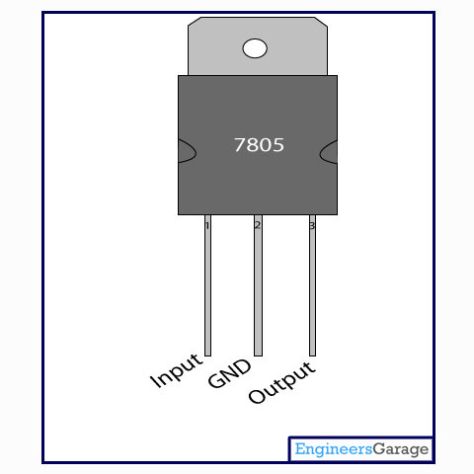

Step down Transformer
1) Vamp= 1.41 * 220 = 311 Volt
Vamp in secondary = (48+ voltage drop)
Let V= 54.5 volte
Let voltage drop on diode = 1v
Voltage drop on regulator = 2v
2) Step down transformer
Choose L1=10uH
L2=32mH
V on primary
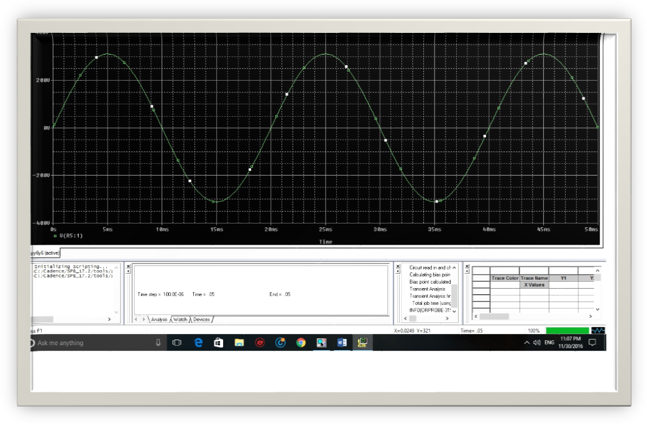

V on secondary

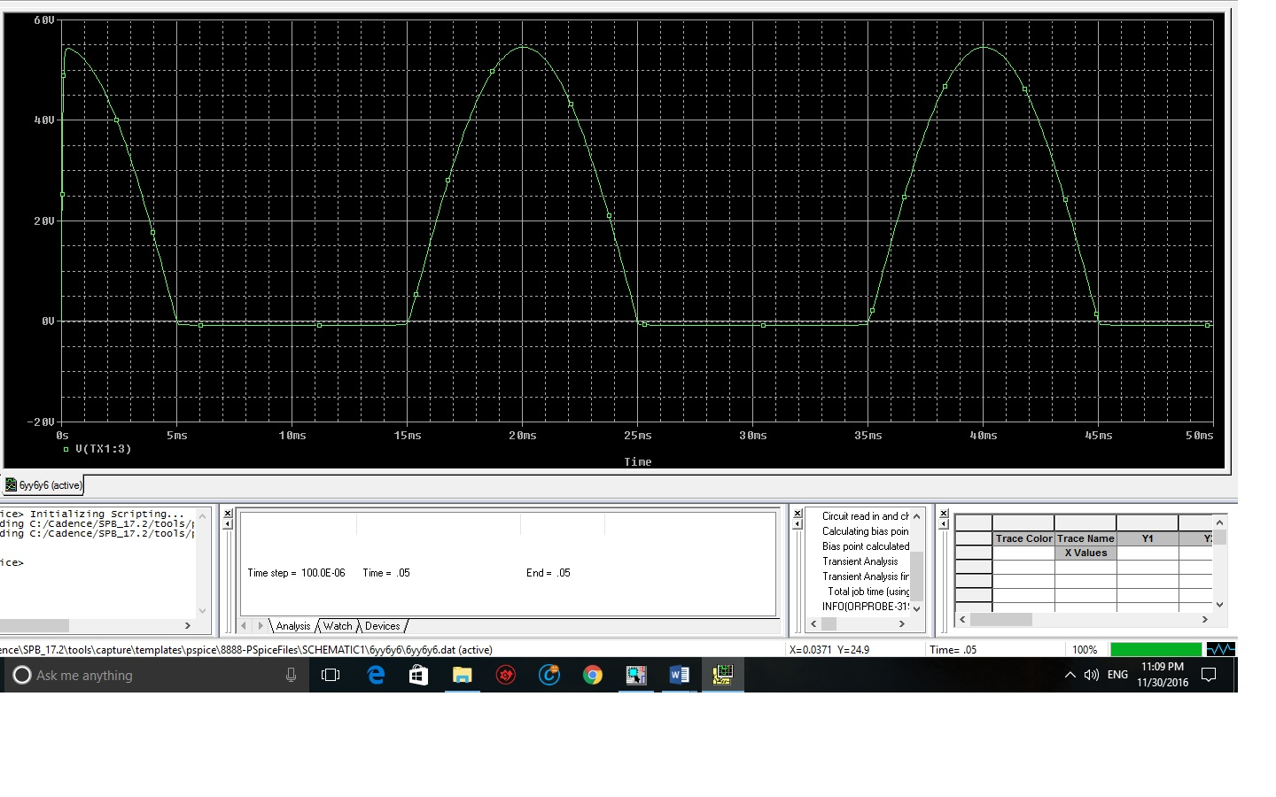
V after full wave rectifier

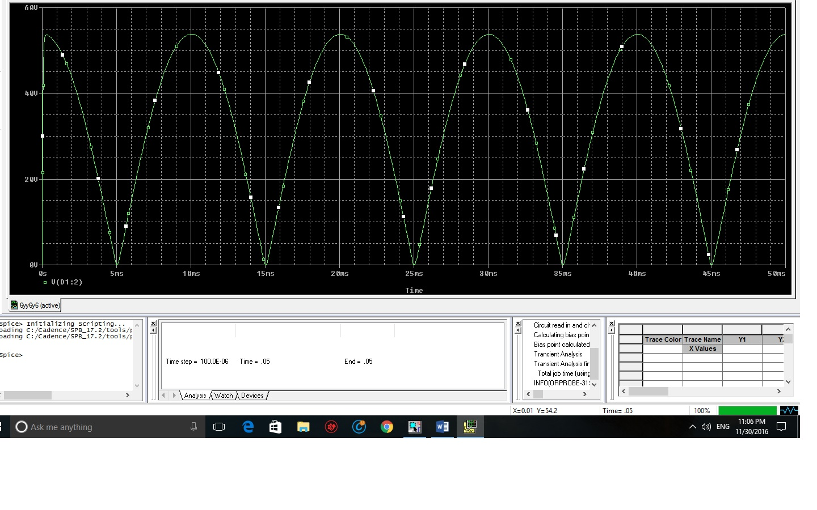
V after add capacitor
Vm=54.5
Vmax=54.5-1
Vmax= 53.5
Vmin=48+2
= 50
^v=Vmax-Vmin
=3.5
^v=1/2fc
C=0.28mf
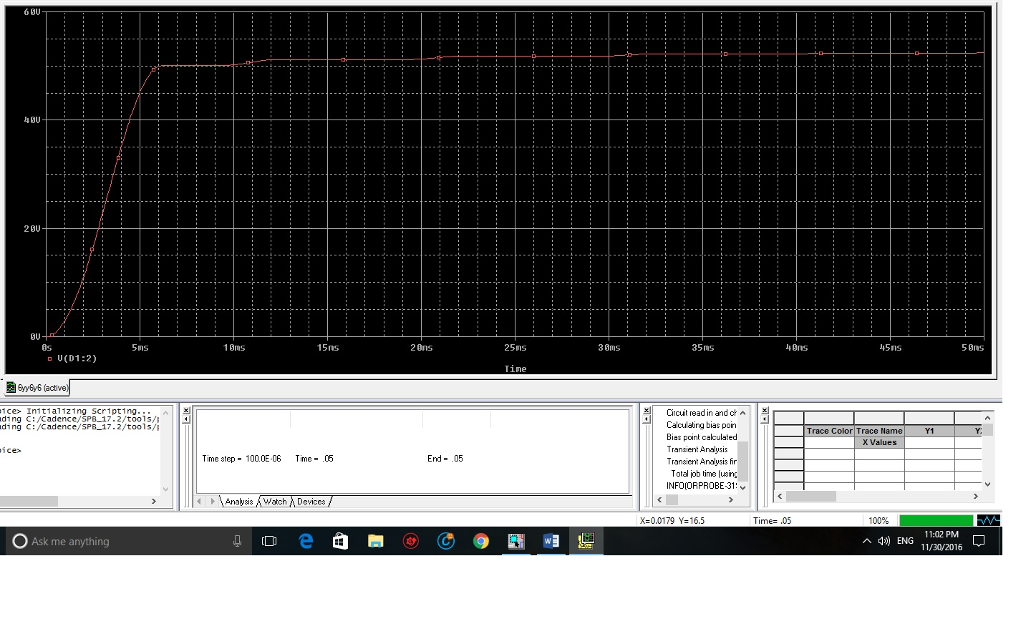

After the regulator
Vo=(1+R1/R2)Vref
48=(1+R1/R2)4
11= R1/R2
R1=11k
R2=1k
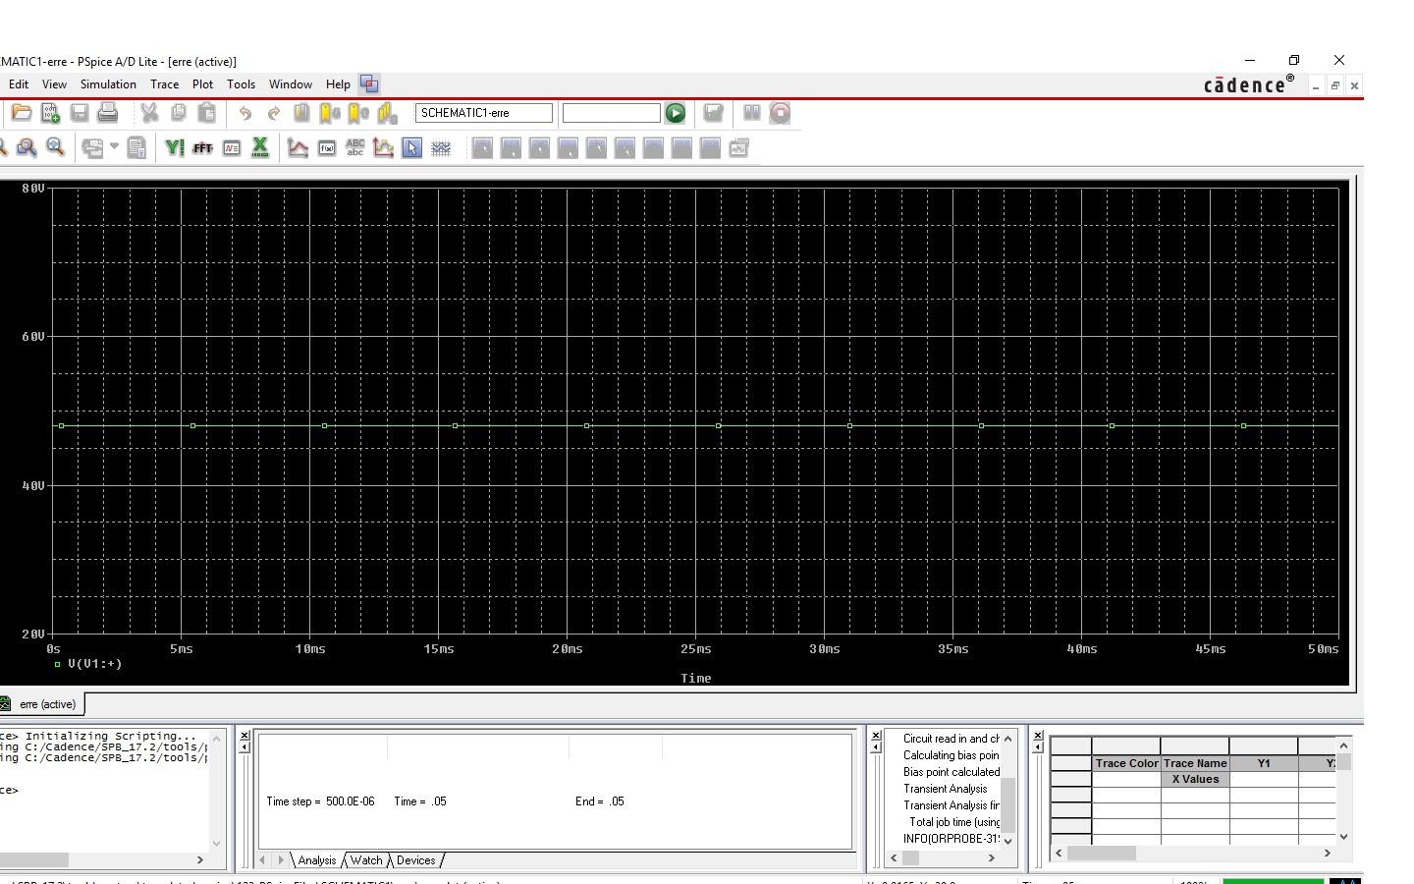
) Ripple
V_{m}=1.41 *48= 67.68 V
^V= 3.5 V
V_{max}=67.68-7=60.68 V
V_{min}=50+ 7 =57 V
Δv=3.68 V

