

Faculty of Engineering and Technology
Department of Electrical and Computer Engineering
Power electronics
Assignment 1

Instructor:
Muhammad abu - khaizaran

Prepared by:

Student name : ahmad saeed
Number: 1141909

Abstract:
The igbt is voltage controlled device .need charging and discharcing current .
the Igbt turn on fast . Here we will examine chopper circuit with inductive load
and chopper circuit with inductive load

Theory:

insulated-gate bipolar transistor (IGBT) is a three-terminal power semiconductor device primarily used as an electronic switch which, as it was developed, came to combine high efficiency and fast switching. It switches electric power in many modern appliances: variable-frequency drives (VFDs), electric cars, trains, variable speed refrigerators, lamp ballasts, air-conditioners and even stereo systems with switching amplifiers. Since it is designed to turn on and off rapidly, amplifiers that use it often synthesize complex waveforms with pulse-width modulation and low-pass filters. In switching applications modern devices feature pulse repetition rates well into the ultrasonic range—frequencies which are at least ten times the highest audio frequency handled by the device when used as an analog audio amplifier.
The IGBT combines the simple gate-drive characteristics of MOSFETs with the high-current and low-saturation-voltage capability of bipolar transistors. The IGBT combines an isolated-gate FET for the control input and a bipolar power transistor as a switch in a single device. The IGBT is used in medium- to high-power applications like switched-mode power supplies, traction motor control and induction heating. Large IGBT modules typically consist of many devices in parallel and can have very high current-handling capabilities in the order of hundreds of amperes with blocking voltages of 6000 V. These IGBTs can control loads of hundreds of kilowatts.
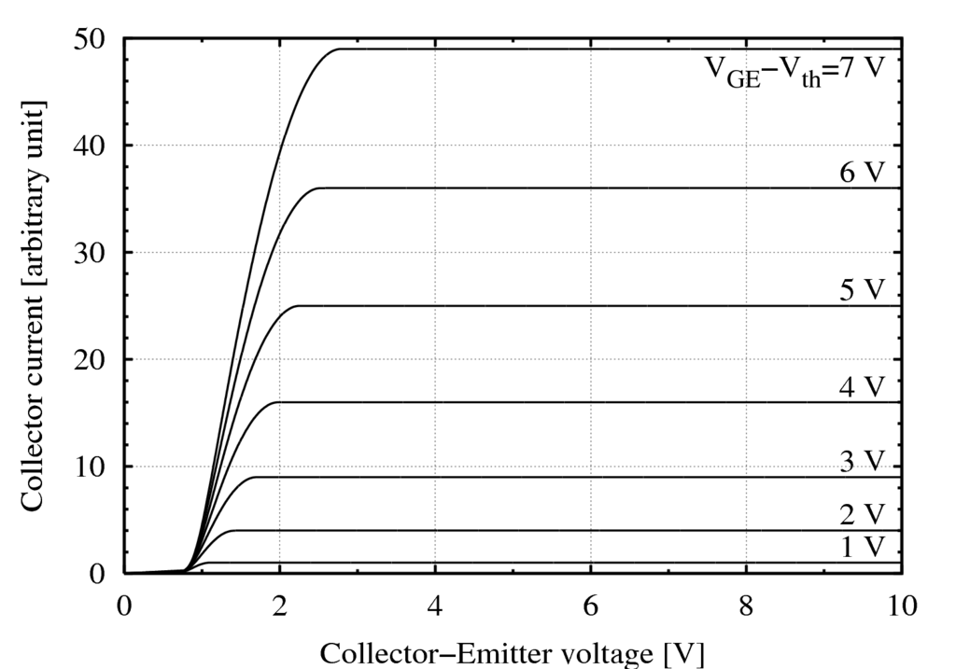

IGBT models
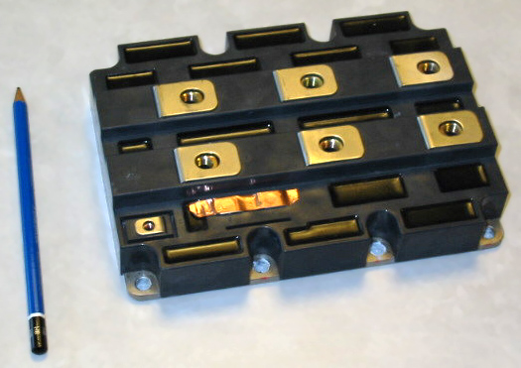

A chopper circuit supplying a highly inductive load and having an IGBT (BSM150GB100D) as a switch, has the following parameters: Io=50A (use a current source of 50A to represent the RL load), Vd=800V, fs=30kHz, Ls=500nH and ton=20us. Assume linear voltage and current falls and rises during switching to:
i) calculate the conduction and the switching power losses if tc(on) =200ns, tc(off)=250ns, assuming that Von=4V using the appropriate derived formulas

- The average conduction power losses
PS=0.5*Fc*Vd*Io*(Tcon+Toff)
=270 w
ii) In ORCAD/PSPICE, simulate a chopper circuit implementing an IGBT (BSM150GB100D) as a switch to supply a highly inductive load which has the following parameters: Io=50A, Vd=800V, fs=30kHz, Ls=500nH and ton=20us. In the results, show the turn-on and turn-off transitions (magnified) for the voltage, current and power loss in the IGBT.

The chopper circuit shown in figure 1
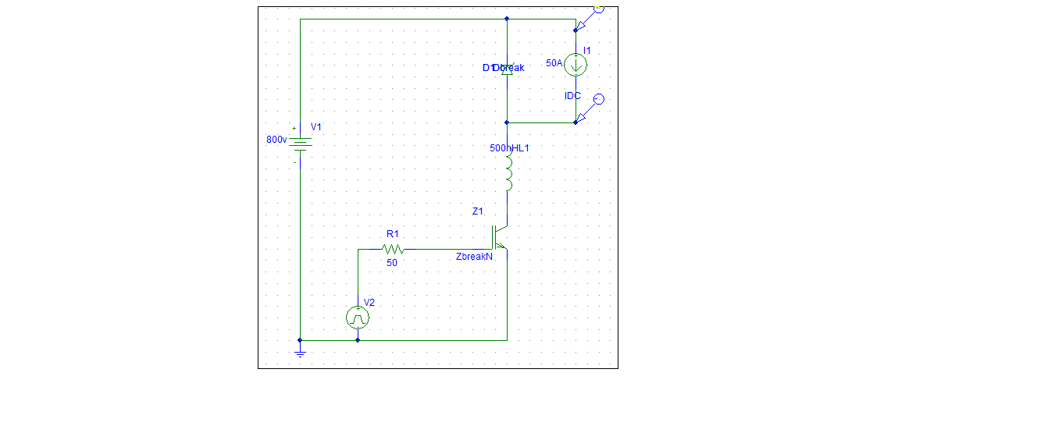
V input
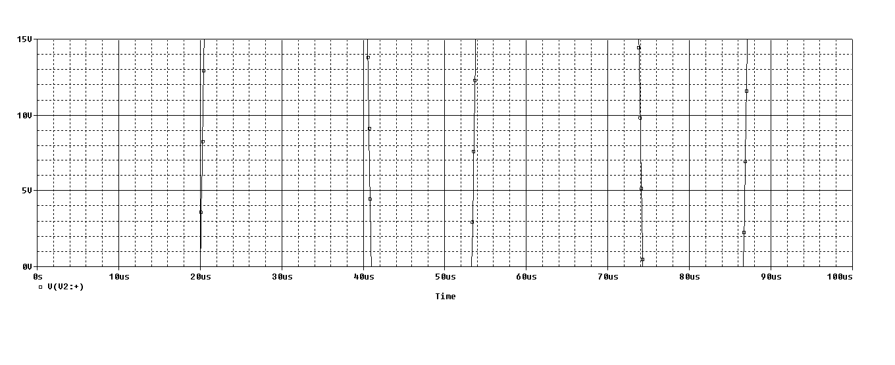
V after magnified in the IGBT
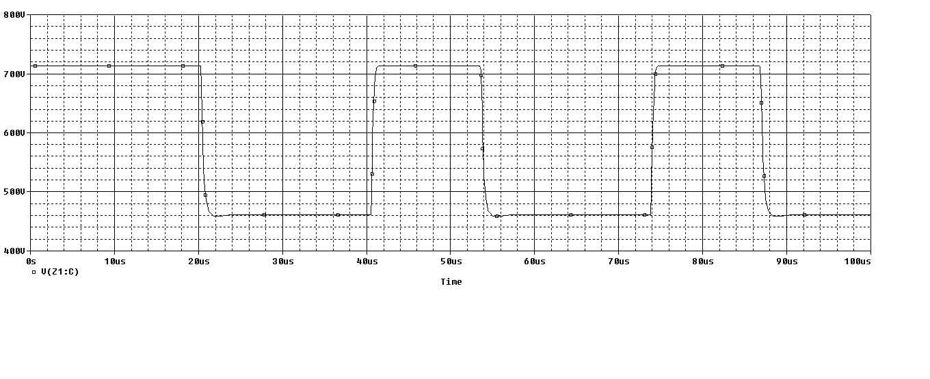

v output 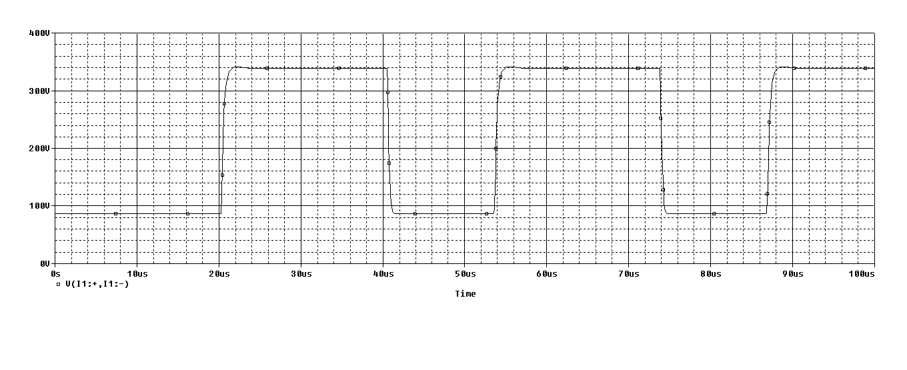
I input
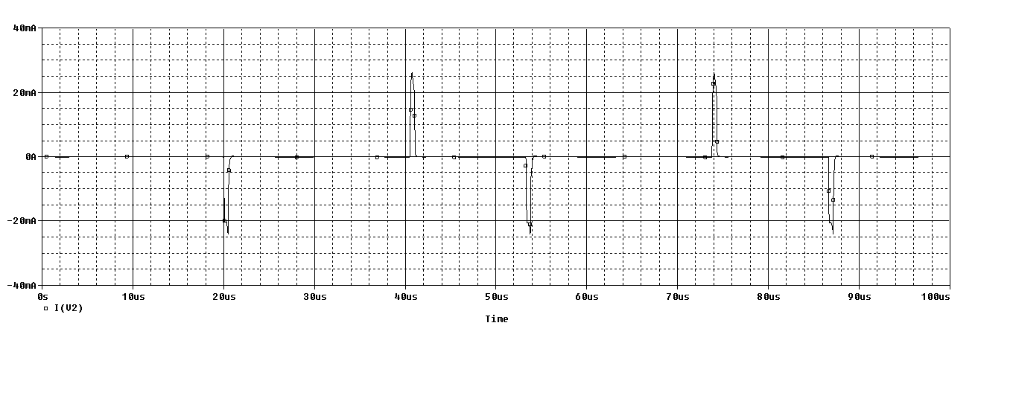

I after magnified in the IGBT
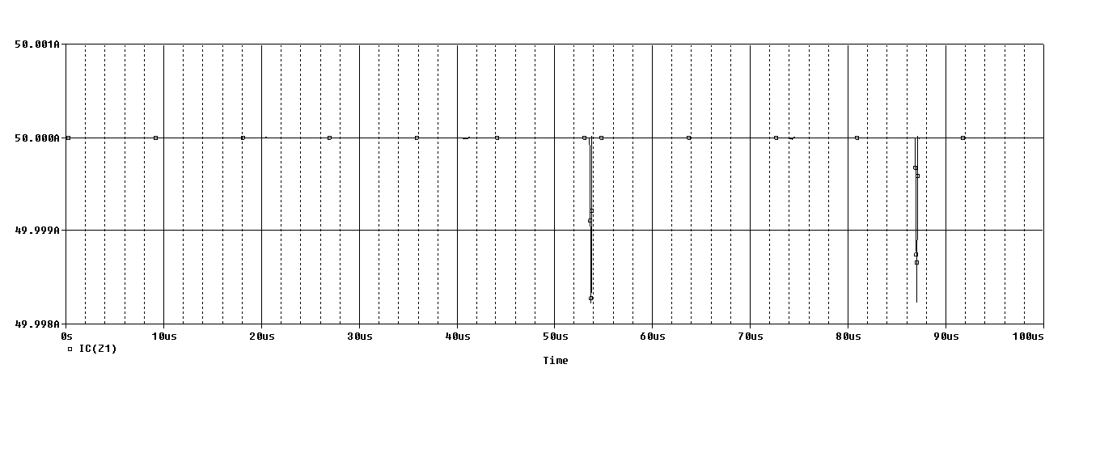
I out put 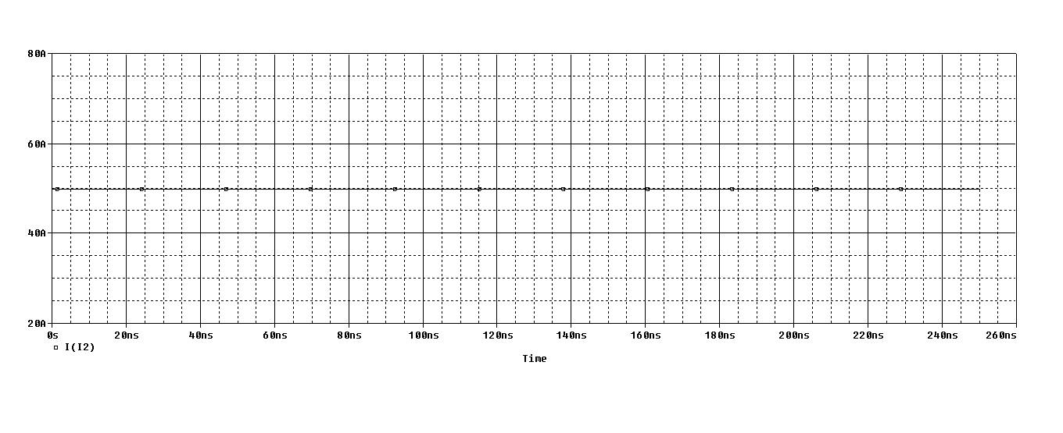

Power losses in igbt switching
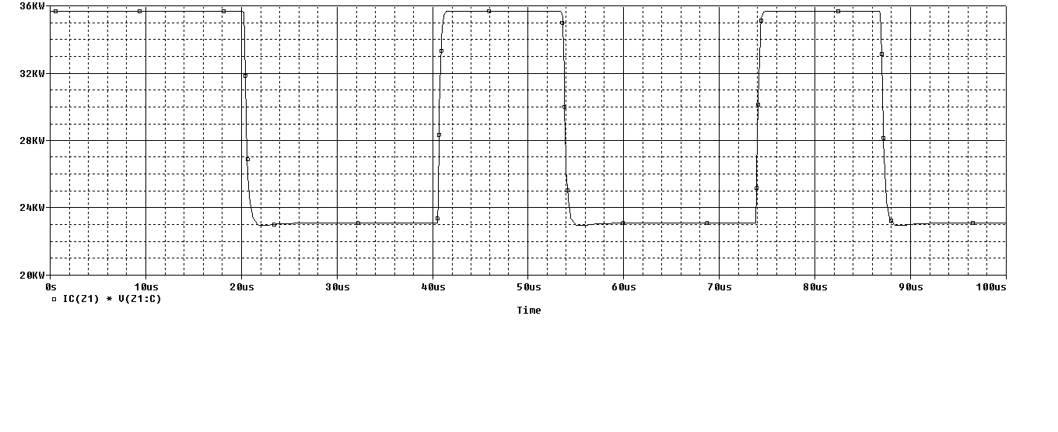
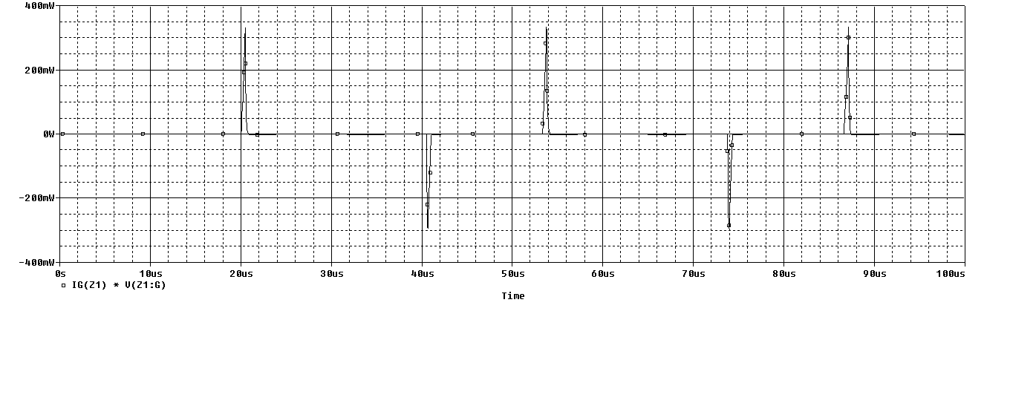
2) If the chopper circuit is now supplying a purely resistive load of 16 Ohms (no parallel diode) and implementing the IGBT model. Assume linear voltage and current falls and rises during switching to:
a) calculate the conduction and the switching power losses if Vd=800V, fs=30kHz, ton=20us, tc(on) =400ns, tc(off)=500ns, Ls=500nH and Von=4V using the appropriate derived formulas
b) simulate the circuit in 2) using ORCAD/PSPICE and plot the magnified turn-on and turn off transitions of the voltage, current and power loss in the IGBT.
c) calculate the average power losses in the IGBT

the chopper circuit shown in figure 2
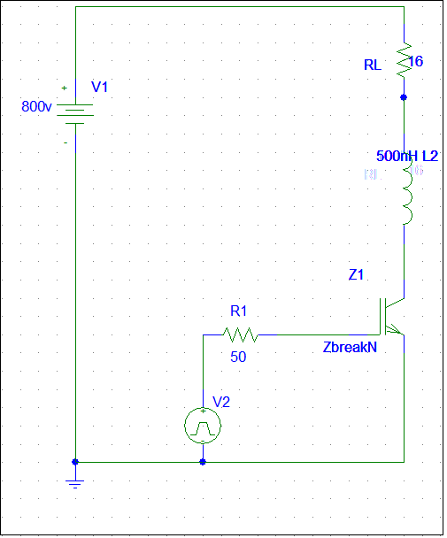

1)The average conduction power losses
PS=1/6*Fc*Vd*Io*(Tcon+Toff)
=90w

V input
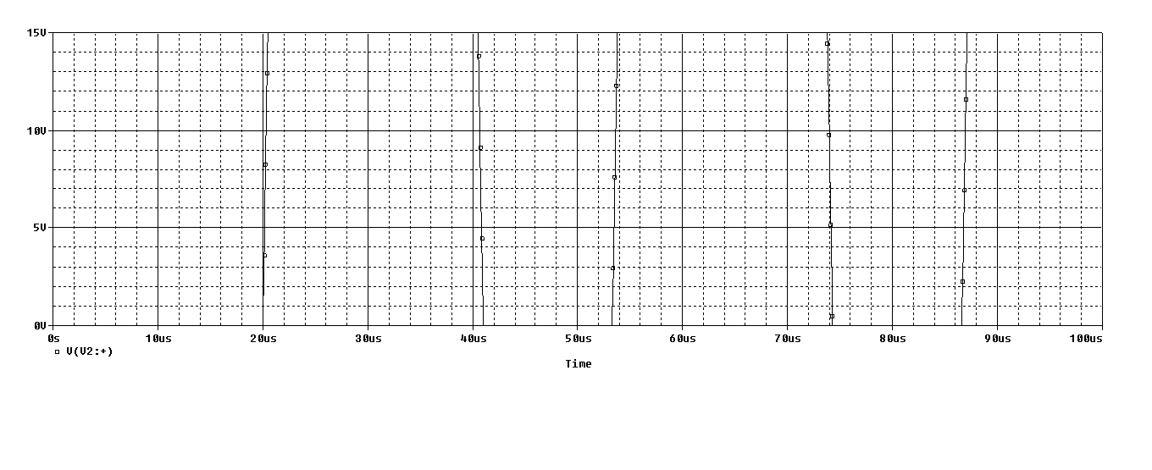

V after magnified in the IGBT
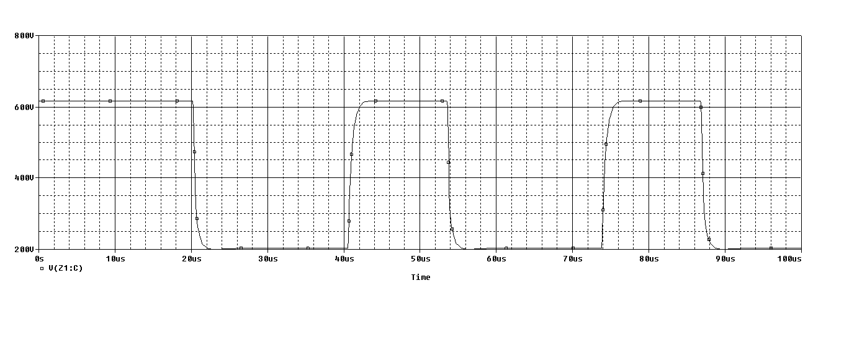
V out put
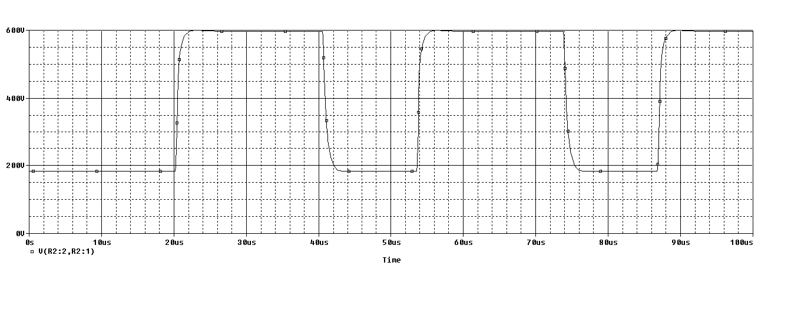

I input
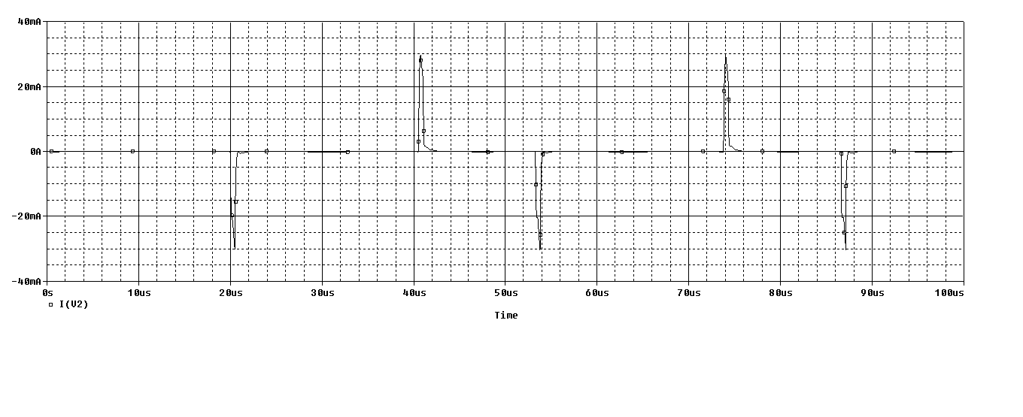

I after magnified in the IGBT
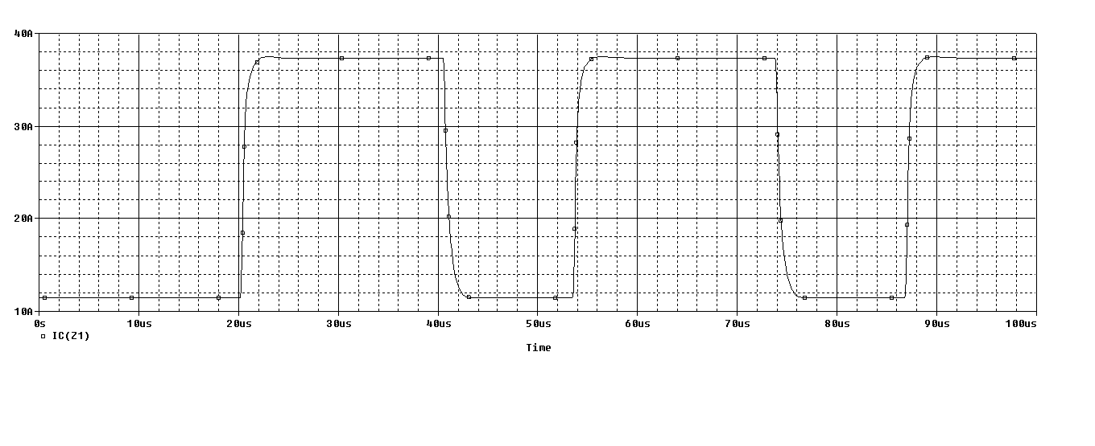
I out put
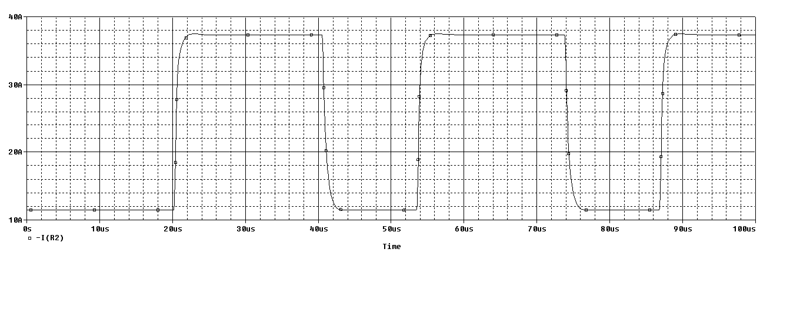

Power losses in igbt switching

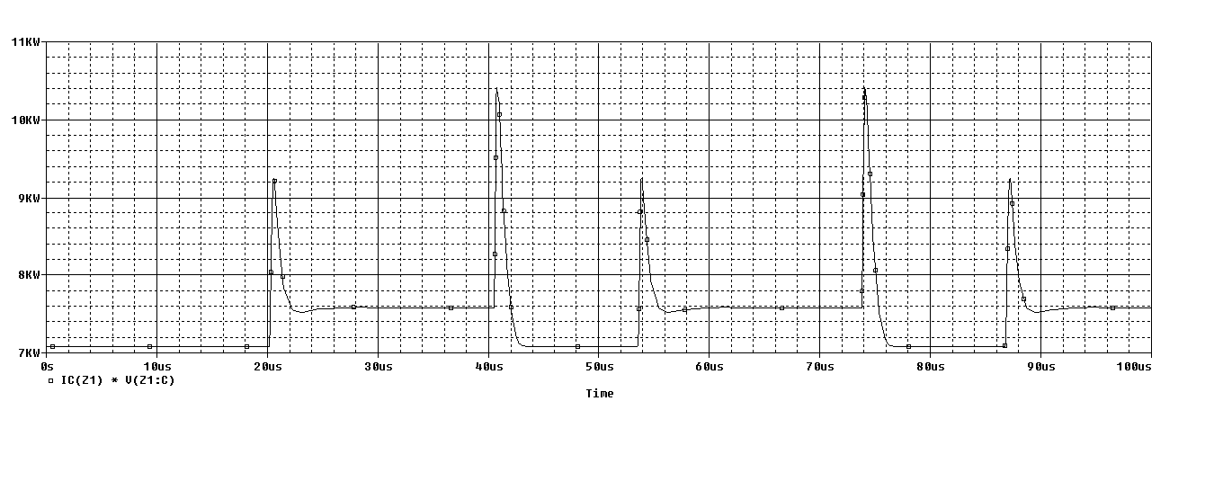
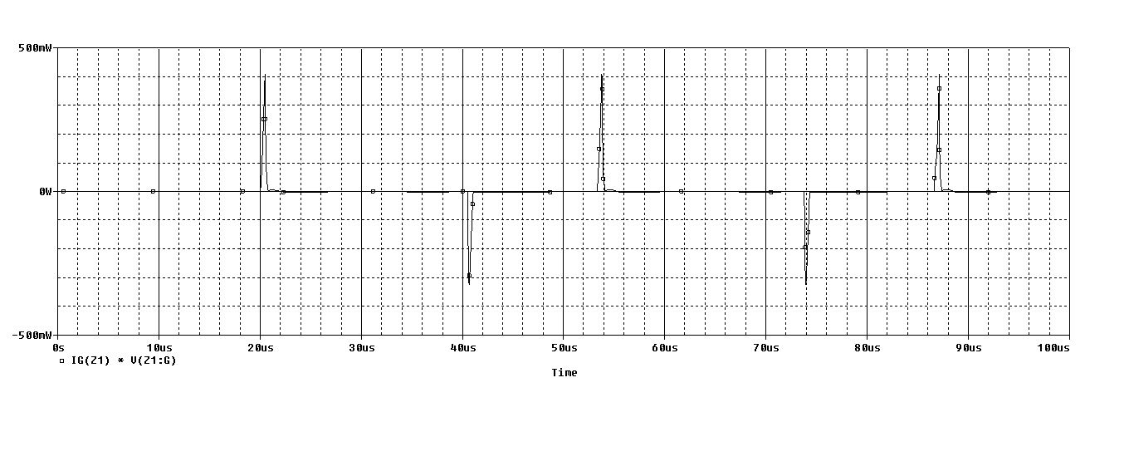

Conclusion :
a purely resistive load is better than inductive load. Because the power losses
in the resistive load is less than inductive load

