EE302 Problem Set 8

Complete the following problems from the textbook Principles of Electronic Communication Systems, 3rd ed.

Chapter 3
Questions: 22, 23, 27
Problems: 13

Additional Problems

- In this problem we will consider modulating a high frequency carrier with the band-limited square wave depicted below. This modulating signal consists of just the 1st, 3rd, and 5th harmonics of a square wave.

  - What is the period (T) of this signal ? (note: two cycles are depicted) ______

  - Write the Fourier series expansion of this modulating signal v_{m}(t).

  - Based on the previous expansion, sketch the frequency-domain plot of this waveform labeling the harmonic frequencies and their amplitudes.

Now consider amplitude modulating this signal with a f_{c} = 50-kHz carrier as depicted below. The amplitude of the carrier (V_{c}) is 10-V.

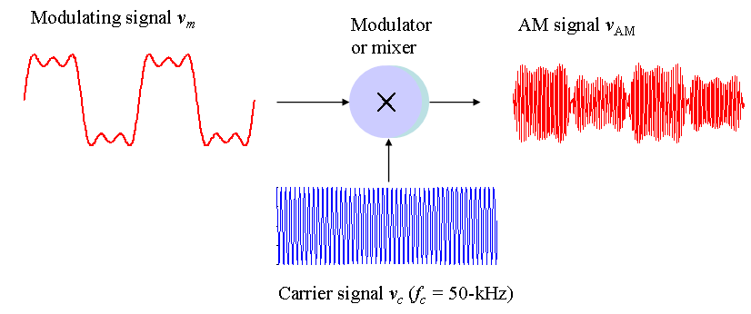
  - Use your knowledge of amplitude modulation, sketch the resulting AM signal in the frequency domain labeling all of the frequency components and amplitudes.

