I. Purpose.

This lab demonstrates an Amplitude Modulated waveform as described in class and the text. In this lab you will identify the different waveform parameters from the carrier signal and information signal that combine to produce the Amplitude Modulated waveform displayed on an oscilloscope. From this information you will calculate the modulation index, solve for the equation of an Amplitude Modulated waveform as seen below in Figure 1, and answer questions regarding the signal’s bandwidth.

V_{c}
V_{m}
V_{m}
Modulating signal
envelope
V_{min}
V_{max}
Figure 1. An AM wave showing peaks (Vmax) and troughs (Vmin)

II. Equipment.

Standard Lab Bench setup (Each Lab bench always has a Function Generator, Power Supply, Oscilloscope, 2 x Digital Multimeters, and a Quad Board with cables).

III. Lab Procedure.

For this lab you are using two Amplitude Modulated signals that are stored in the function generator at your lab bench. The setup is depicted on the next page in Figure 2.

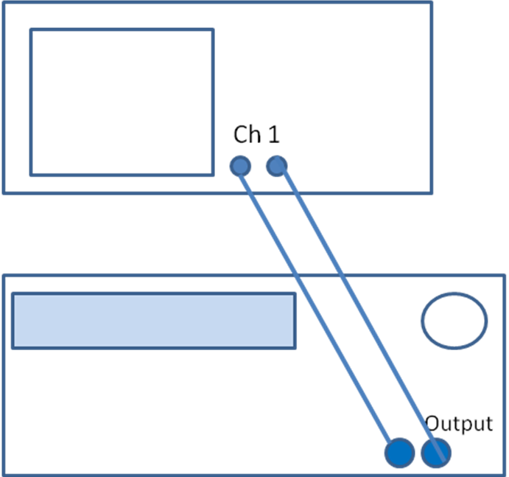
Figure 2. Equipment Set-up for AM Signal #1.

Step 1. Connect the signal from the function generator to channel 1 on the oscilloscope (shown above). Select Store/Recall (the button should light up), then Recall State. STATE_1 should appear on the generator face, push Recall State. If STATE_2 appears, select STATE_1. The unknown AM wave should appear. Adjust the oscilloscope display settings until the waveform displayed resembles the Amplitude Modulated waveforms seen in Figure 1. Pushing the Run/Stop button will freeze the waveform for measurement.

Step 2. Once the display is properly adjusted, use the cursors to measure the following parameters and record your results in Table 1:
- Measure V_{min} and V_{max} (shown in Figure 1) using the cursor functions in voltage mode.
- Measure the period of the carrier, T_{carrier} (higher frequency signal).
- Measure T_{message}, the period of the message (lower frequency signal) using the cursor functions. Note: T_{message} is the wave that rides along the top of the carrier as the carrier is modulated.
- Calculate m, f_{carrier}, f_{message},V_{carrier}, and V_{message} using the equations of Table 2 and the measured values.
V_{max} | V_{min} | V_{c} | V_{m} | T_{c} | T_{m} | f_{c} | f_{m} | m
Table 1: Measured Signal Parameters for AM Signal from AM Signal #1.

Step 3. Using the equation from Table 2, solve for the equation of the amplitude modulated waveform displayed on the oscilloscope. Record your answer in the Step 4.

Table 2: AM Equations

Step 4.

v_{AM1}(t) = _____________________________________________________

Step 5. Switch the function generator to display the second signal on channel 1 of the oscilloscope. Push MOD once, then push it a second time. This will clear STATE_1 and the light on the MOD button should extinguish. Select Store/Recall (the button should light up), then Recall State. Select STATE_2, push Recall State. The unknown AM wave should appear. Again, adjust the oscilloscope display settings until the waveform displayed resembles the Amplitude Modulated waveforms seen in the text and class.
Step 6. Once the display is properly adjusted, use the cursors to measure the following parameters and record your results in Table 3:
- Measure V_{min} and V_{max} using the cursor functions in voltage mode.
- Measure the period of the carrier, T_{carrier}.
- Measure the period of the message, T_{message,} using the cursor functions. Note: T_{message} is the wave that rides along the top of the carrier as the carrier is modulated.
- Calculate m, f_{carrier}, f_{message},V_{carrier}, and V_{message} using the equations of Table 2 and the measured values.

V_{max} | V_{min} | V_{c} | V_{m} | T_{c} | T_{m} | f_{c} | f_{m} | m
Table 3: Measured Signal Parameters for AM Signal from AM Signal #2.

Step 7. Using the equation from Table 2, solve for the equation of the amplitude modulated waveform displayed on the oscilloscope. Record your answer in Step 8.

Step 8.

v_{AM2}(t) = _____________________________________________________

Step 9. Sketch the Amplitude Modulated waveform from AM Signal #2 in Figure 4.

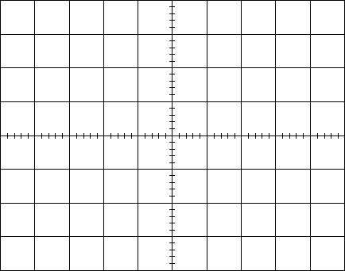
Figure 4. Oscilloscope Display

Critical Thinking.

- From AM Signal #1, what is the lowest frequency, highest frequency and the bandwidth of the Amplitude Modulated waveform (Hint: think of the signal in the frequency domain)?

- If the carrier signal in the AM Signal #1 was equivalent to the tuning frequency on an AM Radio dial, would this signal be within the range of AM Radio frequencies?

- If the Amplitude Modulated signal from AM Signal #1 were broadcast over AM Radio, what would the message (information being transmitted) sound like?

- If the Amplitude Modulated signal from AM Signal #1 contained many frequencies in the information signal (higher than the f_{m} seen in Table 1), how would this affect the bandwidth of the Amplitude Modulated Waveform?

- What is the maximum bandwidth with which any U.S. AM Radio station may transmit?

