
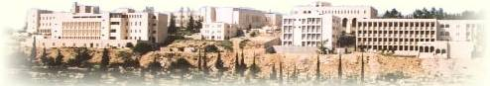

COMMUNICATION SYSTEMS

Student Name : Ala’ Nabil Abu Farha
Student # : 1011201

Instructor: Dr. Wasel Ghanem

