**1.Introduction**

Electrical communication transmitter and receiver techniques strive toward obtaining reliable communication at a low cost, with maximum utilization of the channel

resources. The information transmitted by the source is received by the destination via a physical medium called a channel. This physical medium, which may be wired or wireless, introduces distortion, noise and interference in the transmitted information bearing signal. To counteract these effects is one of the requirements while designing a transmitter and receiver end technique. The other requirements are power and bandwidth efficiency at a low implementation complexity.[1]

* 1. **Modulation**

Modulation is a process of encoding information from a message source in a manner suitable for transmission. It involves translating a baseband message signal to a passband signal. The baseband signal is called the modulating signal and the passband signal is called the modulated signal. Modulation can be done by varying certain characteristics of carrier waves according to the message signal. Demodulation is the reciprocal process of modulation which involves extraction of original baseband signal from the modulated passband signal.[2].

* + 1. **Why Modulate?**

Why do we have to modulate a signal for transmission? Why can't the signal be sent as it is? There are two main reasons for modulation. The first reason has to do with the laws of electromagnetic propagation, which dictate that the size of the radiating element, the antenna, be a significant fraction of the wavelength of the signal being transmitted. For example, if we want to transmit a 1 kHz signal by a quarter-wave antenna, the size of the antenna would need to be 75 km. On the other hand, if the signal is being transmitted on a high frequency carrier, say 630 kHz, the corresponding size of the radiating antenna needs to be only 119 m.

The second reason is for the simultaneous transmission of different signals. As audio signals relevant to humans lie from a few hertz to a few thousand hertz, we could roadcast only one baseband signal at a time. Simultaneous transmission would cause the overlap of signals and we would not be able to separate them. However, through modulation, we can transmit many signals simultaneously by shifting their spectra using different carrier frequencies. [2][3].

**1.1.2 Types of Modulation**

There are 3 basic types of modulation:

* **amplitude modulation**

a type of modulation where the amplitude of the carrier signal is modulated (changed) in proportion to the message signal while the frequency and phase are kept constant.

* **frequency modulation**

a type of modulation where the frequency of the carrier signal is modulated (changed) in proportion to the message signal while the amplitude and phase are kept constant.

* **phase modulation**

a type of modulation where the phase of the carrier signal is varied accordance to the low frequency of the message signal is known as phase modulation.[3]

* 1. **AM Modulation** 
     1. **Theory**

In the amplitude modulation, amplitude of carrier signal wave is varied in accordance with the modulating or message signal by keeping the phase and frequency of the signals constant. The carrier signal frequency would be greater than the modulating signal frequency. Amplitude modulation is first type of modulation used for transmitting messages for long distances by the mankind. The AM radio ranges in between 535 to 1705 kHz which is great. But when compared to frequency modulation, the Amplitude modulation is weak, but still it is used for transmitting messages. Bandwidth of amplitude modulation should be twice the frequency of modulating signal or message signal. If the modulating signal frequency is 10 kHz then the Amplitude modulation frequency should be around 20 kHz. In AM radio broadcasting, the modulating signal or message signal is 15 kHz. Hence the AM modulated signal which is used for broadcasting should be 30 kHz.[4]

[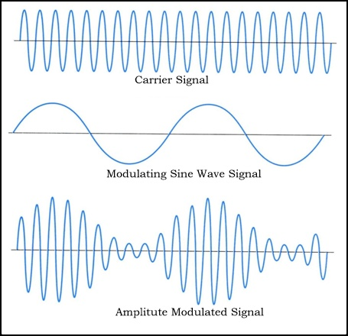](http://www.electronicshub.org/wp-content/uploads/2013/10/Amplitude-Modulation.jpg)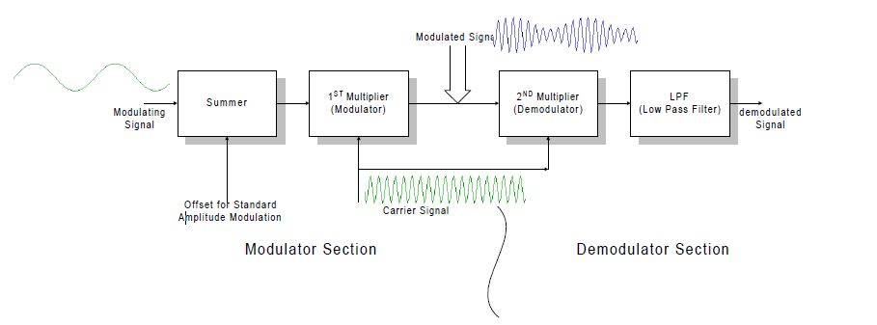

**Figure 1**: The Amplitude modulation System

#### 1.2.2 Advantages of Amplitude Modulation:

* Because of amplitude modulation wavelength, AM signals can propagate longer distances.
* For amplitude modulation, we use simple and low cost circuit; we don’t need any special equipment and complex circuits that are used in frequency modulation.
* The Amplitude modulation receiver will be wider when compared to the FM receiver. Because, atmospheric propagation is good for amplitude modulated signals.
* Bandwidths limit is also big advantage for Amplitude modulation, which doesn’t have in frequency modulation.
* Transmitter and receiver are simple in Amplitude modulation. When we take a demodulation unit of AM receiver, it consists of RC filter and a diode which will demodulate the message signal or modulating signal from modulated AM signal, which is unlike in Frequency modulation.[1][4].

#### 1.2.3 Disadvantages of Amplitude Modulation:

* Adding of noise for amplitude modulated signal will be more when compared to frequency modulated signals. Data loss is also more in amplitude modulation due to noise addition. Demodulators cannot reproduce the exact message signal or modulating signal due to noise.
* More power is required during modulation because Amplitude modulated signal frequency should be double than modulating signal or message signal frequency. Due to this reason more power is required for amplitude modulation.
* Sidebands are also transmitted during the transmission of carrier signal. More chances of getting different signal interfaces and adding of noise is more when compared to frequency modulation. Noise addition and signal interferences are less for frequency modulation. That is why Amplitude modulation is not used for broadcasting songs or music.[1][4].

#### 1.2.4 Applications of Amplitude Modulation:

* Used to carry message signals in early telephone lines.
* Used to transmit Morse code using radio and other communication systems.
* Used in Navy and Aviation for communications as AM signals can travel longer distances.
* Widely used in amateur radio.[4].

**2. Designing and Simulating an AM Modulator/Demodulator**

**2.1 Matlab Implementation**

**2.1.1 Source code of the modulation software**

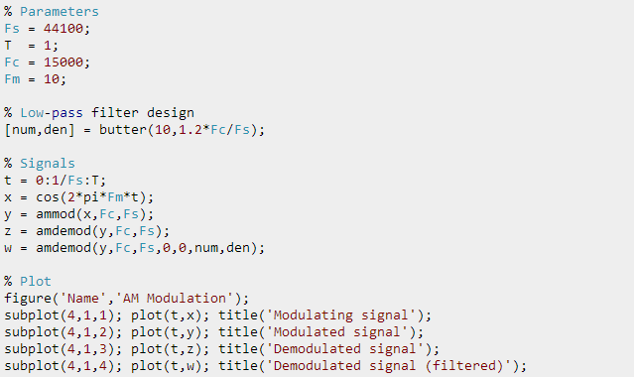

**Listing 1** AM modulation

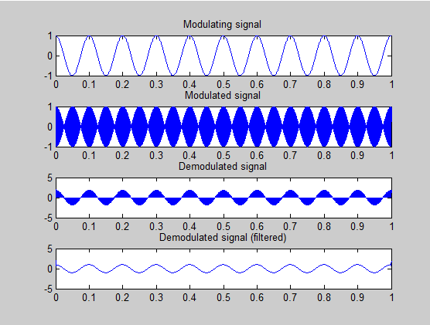

**Figure 2:** Simulation result of AM modulation

**2.1.2 Block Diagram of AM modulation**

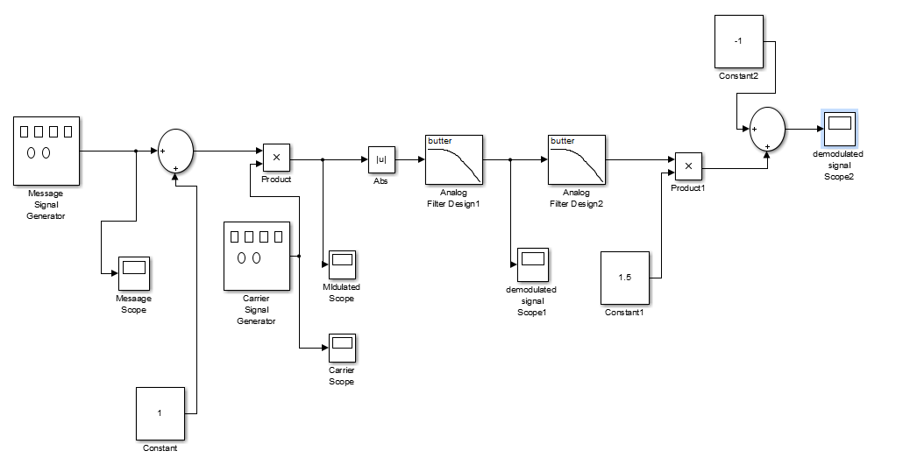

**Figure 3**: Block Diagram of AM modulation

**2.1.3 Simulation**

The purpose of a simulation is to better understand what is expected from a system when it is

actually implemented. I will simulate things and then move to implementing them on the hardware. Start, then, by building the AM modulator in Simulink. It should look like figures below.

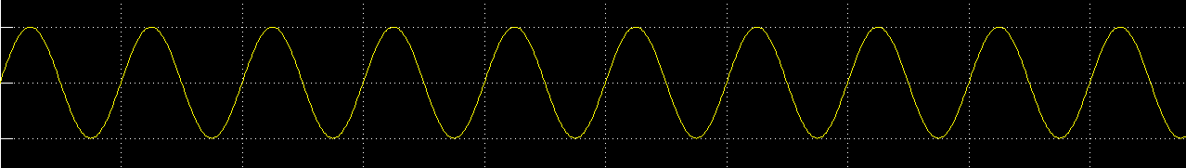

**Figure 4**:Massage Signal

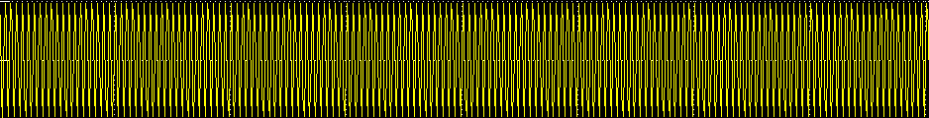

**Figure 5**: Carrier Scope

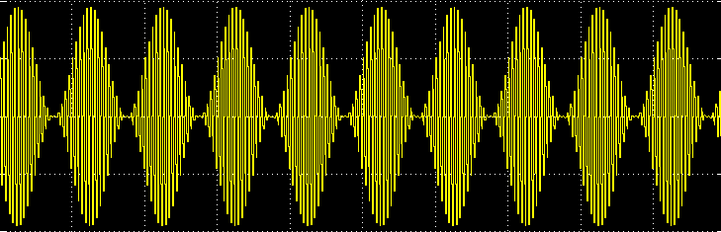

**Figure 6** :The Modulated Scope

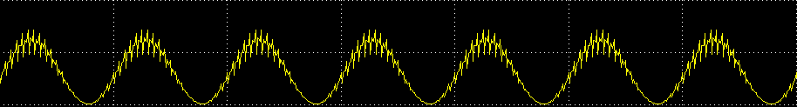

**Figure 7**:The Demodulated Scope 1

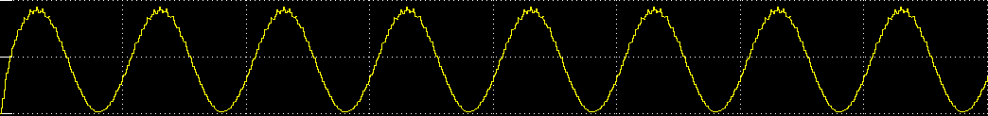

**Figure 8**:The Demodulated Scope 2

**2.2 Multisim implementation**

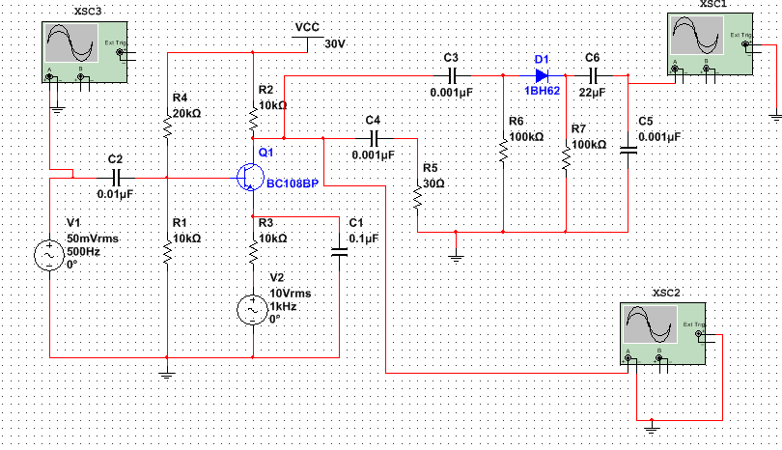

**Figure 9:** The AM circuit

**2.2.2 Simulation**

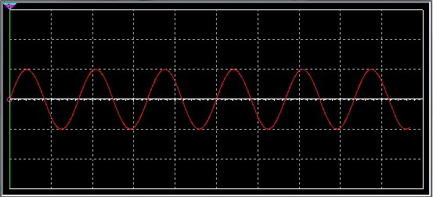 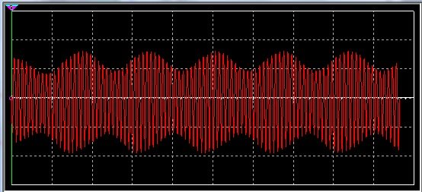 

**Figure 10:** The input signal,modulated signal and the demodulated signal

**3.Result and Analysis**

If m(t) is the information signal and C(t) = Ac sin 2 $π$ fc t is the carrier, the amplitude of the carrier signal is varied proportional to the m(t ) .

The peak amplitude of carrier after modulation at any instant is given by

[ A c + m(t ) ] The carrier signal after modulation or the modulated signal is represented by the equation 3.2.

s(t ) = [A c + m(t )] cos (2 π fct) -- (3.2)

s(t ) = A c [1 + k a m(t )] cos ( 2 $π$ f t) -- (3.3)

where fc=500KHz,fm=1KHz ,Ac=50 mV ,Am=10V ,So the C(t) and S(t) will be

C(t) = 50m sin 2 $π$ (500k)t

s(t ) = 50m [1 + (1/50m) m(t )] cos ( 2 $π$ (500k) t)

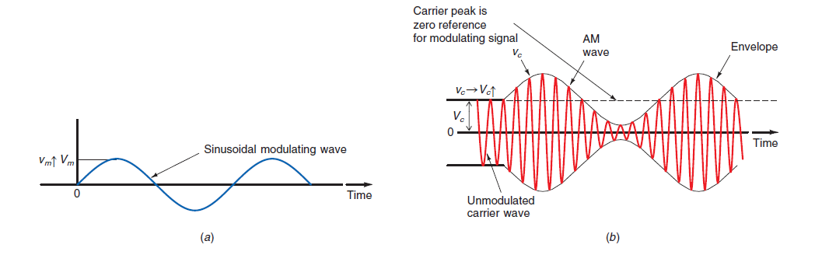**Figure 11**: (*a*) The modulating or information signal. (*b*) The modulated carrier.[5]

Where *ka =1/Ac* is called amplitude sensitivity of the modulator.

The equation (3.3) is the standard expression for Amplitude Modulated signal.

Let *m*(*t* ) = Am cos 2 $π$ fm t be the message signal of frequency *f m* and peak

amplitude *A m*. Then single-tone modulated signal is given by the equation 3.4.

*s*(*t* ) = A c [1 + k a Am cos ( 2 $π$ fm t ) ] cos (2 π fct)

= A c [1 + A m/ Ac  cos ( 2 $π$ fm t ) ] cos (2 π fct)

=50m[1 +10/50m cos ( 2 $π$ (1K) t ) ] cos (2 π (500k)t) -- (3.4)

where

*m* = A m/ Ac  is called modulation index or depth of modulation.

The modulation index *m* of AM system is defined as the ratio of peak amplitude

of message signal to peak amplitude of carrier signal.

m= A m/ Ac  =10/50mV. -- (2.5)

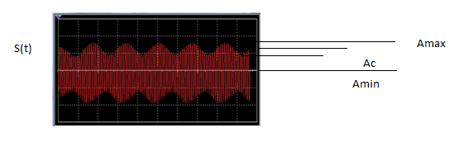

Figure 12:Resulting AM signal (After simulation)

From the figure 12, we get

$Am=\frac{Amax-Amin}{\begin{aligned}2 \\ \end{aligned}}$--(3.6)

$Ac=Amax-\frac{Amax-Amin}{2}$

$Ac=\frac{Amax+Amin}{\begin{aligned}2 \\ \end{aligned}}$--(3.7)

Dividing the equation (3.7) by (3.6), we get

$m=\frac{Amax-Amin}{\begin{aligned}2 \\ \end{aligned}}$--(3.9)

Here Amax is the maximum amplitude and Amin is minimum amplitude of the modulated

signal.

* **Single tone Amplitude Modulation/ Sinusoidal AM**

the corresponding single-tone AM wave is given by

*s*(*t* ) =50m [1 + 0.2 cos ( 2 $π$ (1K) t ) ] cos (2 π (500K)t) --(3.10)

Expanding the equation (2.12), we get

 --(3.11)

The Fourier transform of *s*(*t* ) is obtained as follows.

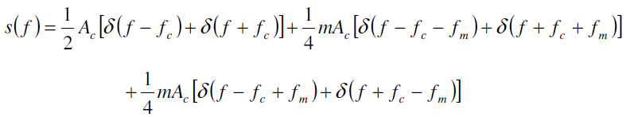--(3.12)

So s(f) will be as following

S(f)=0.2*103((f-500k)+5cos[2 $π$ (501k)t]+5cos[2 $π$ (499k)t]

The spectrum for positive frequencies is as shown in figure 13.

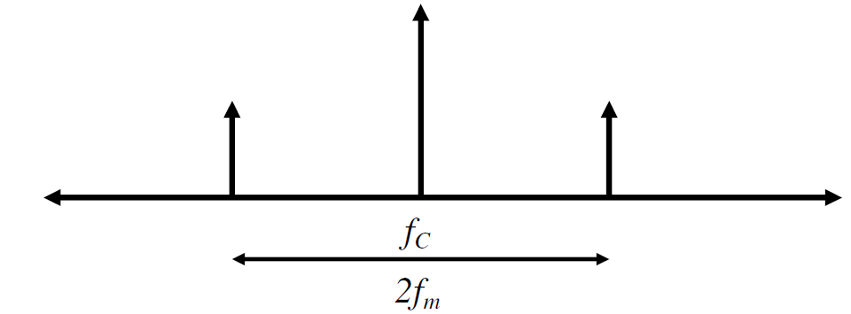

**Figure 13:** Frequency-domain characteristics of single tone AM

* **Frequency spectrum of AM wave:**

Consider the standard expression for AM wave

*s*(*t* ) = A c [1 + k a Am cos ( 2 $π$ fm t ) ] cos (2 π fct) . The carrier frequency *f c* is much greater than the highest frequency component *W* of the message signal.

The Fourier transform*S*( *f* ) of AM wave *s*(*t* ) is given by

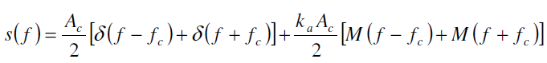

Suppose that the base band signal *m*(*t* ) is band limited to the interval

−*W* ≤ *f* ≤*W* as shown in figure 14.

**Figure 14:** Spectrum of message and AM waves

The AM wave *s*(*t* ) is a voltage or current wave. In either case, the average power delivered to 1W resistor by *s*(*t* ) is comprised of three components.

Carrier power =Ac2/2 =50m2/2

Upper side-frequency power =m2 Ac2/8

Lower side-frequency power = m2 Ac2/8

**4. Required equipment and accessories**

Transistor BC108, Resistors, Capacitors, Diode 0A79, oscilloscope ,DC power supply, Breadboard and connecting wires.

**5.Hardware Description**

The circuit connection is made as shown in the Figure15 .

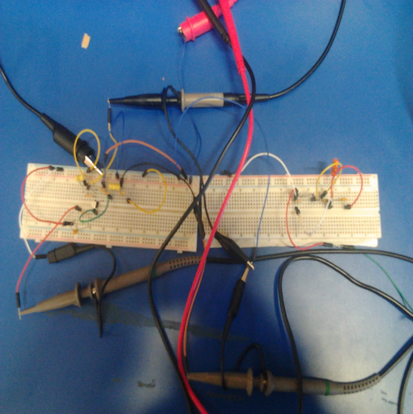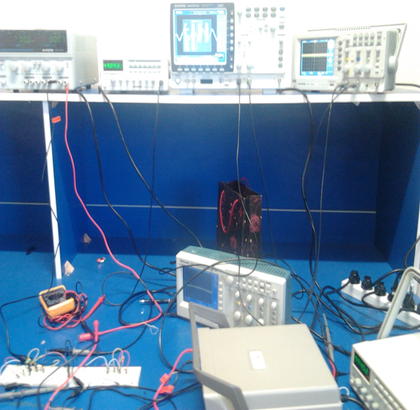

**Figure 15**:The AM hardware

The power supply is connected to the collector of the Transistor,modulated Output is taken from the collector of the Transistor.

After connect the circuit with the oscilloscope, the result is as shown in figure 16.

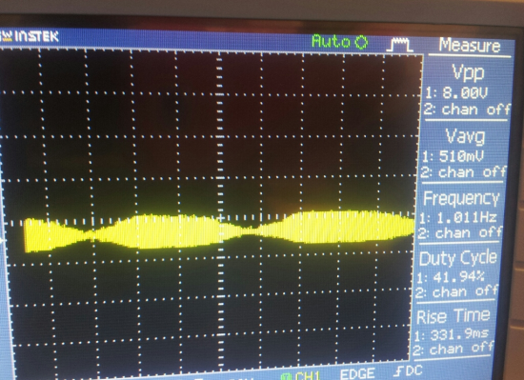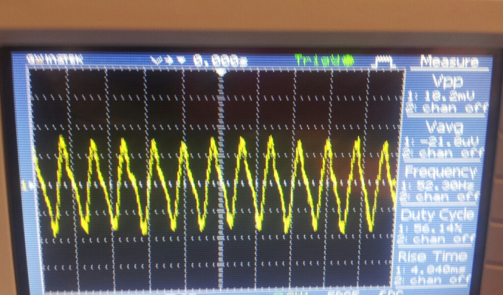

**Figure 16 :**The hardware Result(The modulated and demodulated signal)

**6.Conclusion**

Although amplitude modulation is used since the first days of the 20th century, it is still very popular. The advantages of AM are the easy and cheap way of realization and the little consumption of bandwidth. And it has a very simple circuit implementation (especially for reception), creating widespread adoption quickly. AM modulation however wastes power and bandwidth in a signal. The carrier requires the majority of the signal power, but actually does not hold any information. AM uses twice the required bandwidth by transmitting redundant information in both the upper and lower sidebands. The disadvantages are the poor signal to noise ratio and the proneness to amplitude distortions.

An important part of amplitude modulation is the measuring of the modulation depth m. The modulation depth can be either determined by directly obtaining the ratio of the modulating and the carrier signal

Through the construction process of this system, the modulation methods can be studied more than the class in which only the theory part is known. What’s more, the equipment is simple and easy. To do this practice only one laptop installed with Matlab is enough. Thus this system is suitable for students to study radio communication by themselves. Another benefit from this project is practicing the ability of signal processing. When programming in Matlab, a lot signal processing method is needed.

**7.References**

[1] <http://www.iitg.ernet.in/scifac/qip/public_html/cd_cell/chapters/a_mitra_mobile_communication/chapter6.pdf> . Accessed 5 Jun 2014.

[2] <http://www.eie.polyu.edu.hk/~em/dtss05pdf/00g%20Passband.pdf> .access ed 5 Jun 2014.

[3] <http://www.srmuniv.ac.in/downloads/lab1.pdf> .Accessed 6 Jun 2014.

[4] <https://www.youtube.com/watch?v=0bZHvmwET1M>. Accessed 6 Jun 2014.

[5] <https://www.google.ps/search?q=%D8%B5%D9%88%D8%B1+AM+modulation+and+demodulation&noj=1&tbm=isch&tbo=u&source=univ&sa=X&ei=JziSU-fMPKeF4gSY44G4Cg&ved=0CCQQsAQ&biw=1366&bih=667>. Accessed 8 Jun 2014.