EE302 Problem Set 5

Problems

- A common concern in the design of an audio amplifier is blocking the 60-Hz AC power line frequency from the audio output. If not blocked, then a 60-Hz buzz will be produced by the speakers. What type of filter could one employ to specifically block a 60-Hz signal?
A band-reject filter.

- What value of resistor would you need for a low-pass RL filter to have a cut-off frequency of 20 kHz using a 10 mH inductor?

- Commonly, FM radio receivers employ a bandpass filter with a bandwidth of 200-kHz (corresponding to bandwidth of an FM channel). Consider tuning an FM station at 104.1 MHz.
  - If the filtering were done at 104.1 MHz (f_{r} = 104.1 MHz) , what would be the required quality factor Q of the filter to pass a 200 kHz bandwidth.
  - Now, say we were able to mix the received signal down and do the filtering at 10.7 MHz instead (f_{r} = 10.7 MHz). What would Q be now?
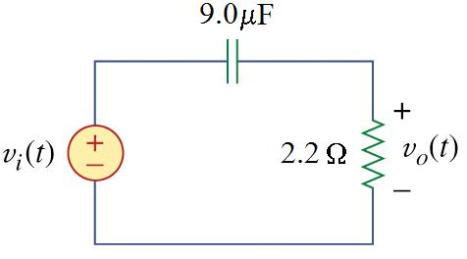
- Consider the filter circuit depicted to the right in which the output is measured across the resistor.
  - What type of filter is this? Highpass filter
  - What is the filter’s cutoff frequency f_{co} ?
  - Now consider that you would like to construct this same type of filter using the 2.2 Ω resistor with an inductor, instead of a capacitor. What inductor value L would be required to keep the same cutoff frequency? Sketch this circuit with component values and indicate the location of v_{o}(t).

- Consider the series RLC bandpass filter shown below with L = 6.366 mH,
C = 15.92 μF, and R = 1 Ω.
  - Compute the resonant frequency, the bandwidth, and Q.
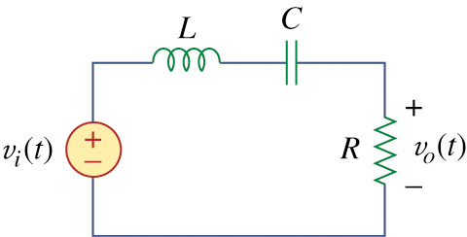
  - If the source v_{i} has an amplitude of 2.0 V_{rms}, what is the average power dissipated by R at the resonant frequency?
By the voltage divider rule, we can determine that the output voltage is:
where Z_{R} = R and Z_{ser} is the total impedance of the series-RLC circuit (Z_{ser} = R + jX_{L} - jX_{C}). At resonance, X_{L} = X_{C} so that Z_{ser} reduces to Z_{ser} = R. Therefore,
If the frequency of the source is changed to f = 512.5 Hz, what is the power dissipated by R (it may be useful to consider what you calculated in part a ).
The parenthetical hint clues us in to the fact that 512.5 Hz is the upper cutoff frequency. First, we recognize that this is a high-Q circuit since Q ≥ 10. This enables us to assume that the peak's bandwidth is symmetric about f_{r} and thus f₁ = f_{r} – BW/2 and f₂ = f_{r} + BW/2. A mental calculation of the upper cutoff frequency yields f₂ ≈ 512.5 Hz. We know that cutoff frequencies are defined as the frequencies at which power P_{R} dissipated in the resistor drops to one half of its peak (resonant) value. We calculated the peak value to be 4 W, so P_{R} at the cutoff frequency f = 512.5 Hz is 2 W.

