EE303 Problem Set 9

The illustration above shows an AM radio receiver. The receiver shown within the dashed line is the original AM radio receiver. There are none more simple.

1. By 1900, radio transmission had been demonstrated, but further development hinged on the discovery of a reliable “rectifier.” In the above diagram, the diode, D₁, is the rectifier. It was discovered through a process of trial and error; the original inventors did not recognize that they were using a semiconductor device. Its central criticality to radio operation prompted a vast research effort and the theory of semiconductors was born. Today, the entire microchip industry is based around this one discovery.

Question: A mechanical check valve allows fluid to flow in one direction only. Describe the function of a “diode rectifier” in terms of what it does with electrical current.

A diode allows current to flow in only one direction. In this circuit, it allows current to flow through R2 in such a way that the voltage across R2 is always non-negative. Thus, negative voltages are removed from the received AM waveform.

2. Tuning. Components L₁ and C₁ act together as a parallel resonant circuit. C₁ = 5 μF and
L₁ = 9.25 nH. L₁ has a winding resistance R_{L1} = 581.2 μΩ.

- Find the resonant frequency f_{r} of L₁/C₁ (you may use the same equations we did for the series RLC circuit).
- Find Q.

- Find the bandwidth of L₁/C₁.

- What is the purpose of L₁/C₁?
L₁/C₁ provide a bandpass filter to isolate an individual radio station.

- For AM radio in the U.S., is this bandwidth appropriate?
Yes.

3. Selectivity. Assume that Q is fixed at the value found above. A variable capacitor (constructed with parallel plates that slide past each other such that effective plate area is varied) or a tapped inductor (constructed by a coil of wire with adjustable connection points) can be used to tune the receiver.

If the receiver were tuned to 1480AM (in other words C is adjusted such that f_{r} = 1480 kHz), what would be the resulting BW, assuming Q is the same? Is it now over-selective (too selective or too restrictive), under-selective, or is the bandwidth appropriate for broadcast AM?

If Q is fixed at 74 and the radio is tuned such that f_{r} = 1480 kHz, bandwidth is
The filter is now under-selective because its passband is too wide.

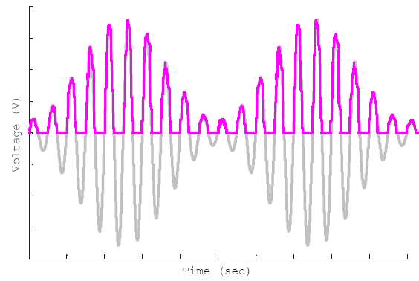
4. Receiver Operation. The components to the right of diode D₁ are removed and an oscilloscope is connected as shown.

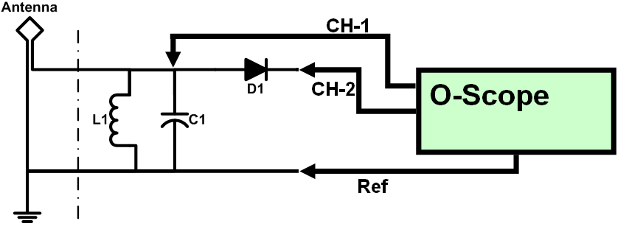

Channel 1 will be display the AM waveform as depicted to the right. Sketch the rectified AM waveform (channel 2) on the this plot .

5. Envelope Detector & DC Blocking. Components R₂, C₂, and C₃ are added back.
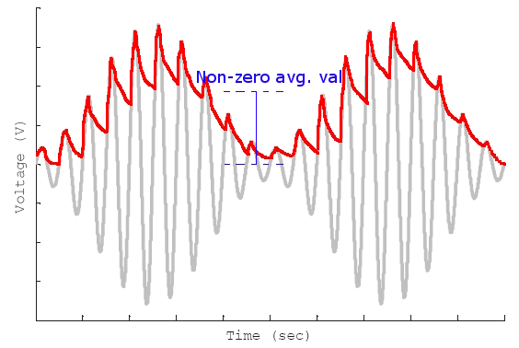
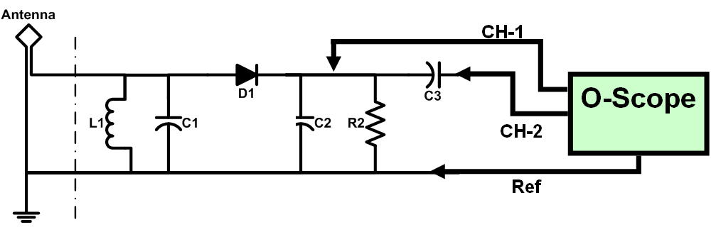

- R₂ and C₂ act together as an envelope detector. On the figure to the right, sketch the oscilloscope channel 1. This drawing should show a non-zero DC offset (i.e., a non-zero average value).

- The signal from part (a) consists of two components: a DC component and an AC component as follows . C₃ is a large capacitor which tends to make Z_{C3} very small for frequencies other than f = 0 Hz (DC), therefore the capacitor blocks DC voltages. Sketch the signal at channel 2 .
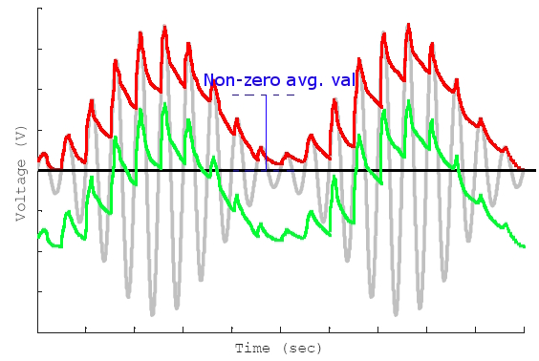

The envelope of the rectified wave for Problem 5.a is shown in red. The output of the DC-blocking capacitor for Problem 5.b is shown in green.

