

**Faculty of Engineering and Technology**

**Department of Electrical and Computer Engineering**

**ENEE339, COMMUNICATION SYSTEMS**

**FM Receiver/Transmitter Radio**

**Dr. Wasel Ghanem**

Done by:

Yazeed Obaid1130036

Hussein Dhahir 1131138

Mohammad Sehweil 1131253

Mahmoud Abdelkareem 1130786

# Abstract

The aim of this experiment was to make a simple FM Radio transmitting as well as a receiving circuit. The goal was to use simple parts to assemble both of them and be able to hear the output of the audio passed from the transmitter to the receiver.

Table of Contents

Abstract 2

Introduction: 4

I. Broadcast bands 4

II. Modulation characteristics 4

III. Super Heterodyne Receiver 5

Mixing and the super heterodyne receiver: 5

Concept of the super heterodyne receiver 6

Image Response: 7

Transmitter[3]: 7

Main Components 9

Microphone 9

2N2222ATransistor 10

I. Theory: 10

Receiver 12

PSPICE: 14

Conclusion: 17

References 18

# Introduction:

FM broadcasting is radio broadcasting using frequency modulation (FM) technology. Invented in 1933 by American engineer Edwin Armstrong, it is used worldwide to provide high-fidelity sound over broadcast radio. FM broadcasting is capable of better sound quality than AM broadcasting, the chief competing radio broadcasting technology, so it is used for most music broadcasts. FM radio stations use the VHF frequencies. The term "FM band" describes the frequency band in a given country which is dedicated to FM broadcasting.

1. Broadcast bands[1]:

Throughout the world, the FM broadcast band falls within the VHF part of the radio spectrum. Usually 87.5 to 108.0 MHz is used, or some portion thereof.

The frequency of an FM broadcast station (more strictly its assigned nominal center frequency) is usually an exact multiple of 100 kHz. In most of South Korea, the Americas, the Philippines and the Caribbean, only odd multiples are used. In some parts of Europe, Greenland and Africa, only even multiples are used. In the UK odd or even are used. In Italy, multiples of 50 kHz are used.

1. Modulation characteristics[1]:

Frequency modulation or FM is a form of modulation which conveys information by varying the frequency of a carrier wave; the older amplitude modulation or AM varies the amplitude of the carrier, with its frequency remaining constant. With FM, frequency deviation from the assigned carrier frequency at any instant is directly proportional to the amplitude of the input signal, determining the instantaneous frequency of the transmitted signal. Because transmitted FM signals use more bandwidth than AM signals, this form of modulation is commonly used with the higher (VHF or UHF) frequencies used by TV, the FM broadcast band, and land mobile radio systems.



1. Super Heterodyne Receiver[2]:

The superhet radio or to give it its full name the superheterodyne receiver is one of the most popular forms of receiver in use today in a variety of applications from broadcast receivers to two way radio communications links as well as many mobile radio communications systems.

Although other forms of radio receiver are used, the superheterodyne receiver is one of the most widely used forms. Although initially developed in the early days of radio, or wireless technology, the superhet or superheterodyne receiver offers significant advantages in many applications. Naturally the basic concept has been developed since its early days, and more complicated and sophisticated versions are used, but the basic concept still remains the same.

### Mixing and the super heterodyne receiver:

The idea of the super heterodyne receiver revolves around the process of mixing. Here RF mixers are used to multiply two signals together. (This is not the same as mixers used in audio desks where the signals are added together). When two signals are multiplied together the output is the product of the instantaneous level of the signal at one input and the instantaneous level of the signal at the other input. It is found that the output contains signals at frequencies other than the two input frequencies. New signals are seen at frequencies that are the sum and difference of the two input signals, i.e. if the two input frequencies are f1 and f2, then new signals are seen at frequencies of (f1+f2) and (f1-f2). To take an example, if two signals, one at a frequency of 5 MHz and another at a frequency of 6 MHz are mixed together then new signals at frequencies of 11 MHz and 1 MHz are generated.

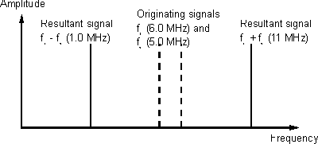

### Concept of the super heterodyne receiver

In the superhet radio, the received signal enters one inputs of the mixer. A locally generated signal (local oscillator signal) is fed into the other. The result is that new signals are generated. These are applied to a fixed frequency intermediate frequency (IF) amplifier and filter. Any signals that are converted down and then fall within the pass-band of the IF amplifier will be amplified and passed on to the next stages. Those that fall outside the pass-band of the IF are rejected. Tuning is accomplished very simply by varying the frequency of the local oscillator. The advantage of this process is that very selective fixed frequency filters can be used and these far out perform any variable frequency ones. They are also normally at a lower frequency than the incoming signal and again this enables their performance to be better and less costly.

To see how this operates in reality take the example of two signals, one at 6 MHz and another at 6.1 MHz. Also take the example of an IF situated at 1 MHz. If the local oscillator is set to 5 MHz, then the two signals generated by the mixer as a result of the 6 MHz signal fall at 1 MHz and 11 MHz. Naturally the 11 MHz signal is rejected, but the one at 1 MHz passes through the IF stages. The signal at 6.1 MHz produces a signal at 1.1 MHz (and 11.1 MHz) and this falls outside bandwidth of the IF so the only signal to pass through the IF is that from the signal on 6 MHz.

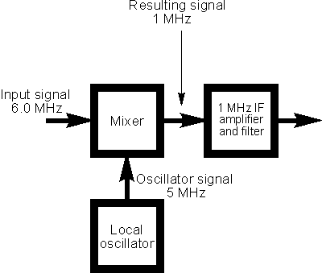

If the local oscillator frequency is moved up by 0.1 MHz to 5.1 MHz then the signal at 6.1 MHz will give rise to a signal at 1 MHz and this will pass through the IF. The signal at 6 MHz will give rise to a signal of 0.9 MHz at the IF and will be rejected. In this way the receiver acts as a variable frequency filter, and tuning is accomplished.

### Image Response:

The basic concept of the superheterodyne receiver appears to be fine, but there is a problem. There are two signals that can enter the IF. With the local oscillator set to 5 MHz and with an IF it has already been seen that a signal at 6 MHz mixes with the local oscillator to produce a signal at 1 MHz that will pass through the IF filter. However if a signal at 4 MHz enters the mixer it produces two mix products, namely one at the sum frequency which is 10 MHz, whilst the difference frequency appears at 1 MHz. This would prove to be a problem because it is perfectly possible for two signals on completely different frequencies to enter the IF. The unwanted frequency is known as the image. Fortunately it is possible to place a tuned circuit before the mixer to prevent the signal entering the mixer, or more correctly reduce its level to an acceptable value.

Fortunately this tuned circuit does not need to be very sharp. It does not need to reject signals on adjacent channels, but instead it needs to reject signals on the image frequency. These will be separated from the wanted channel by a frequency equal to twice the IF. In other words with an IF at 1 MHz, the image will be 2 MHz away from the wanted frequency.

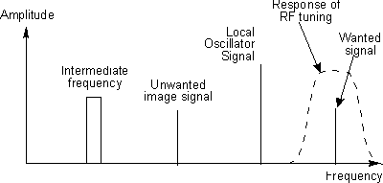

# 

# Transmitter[3]:

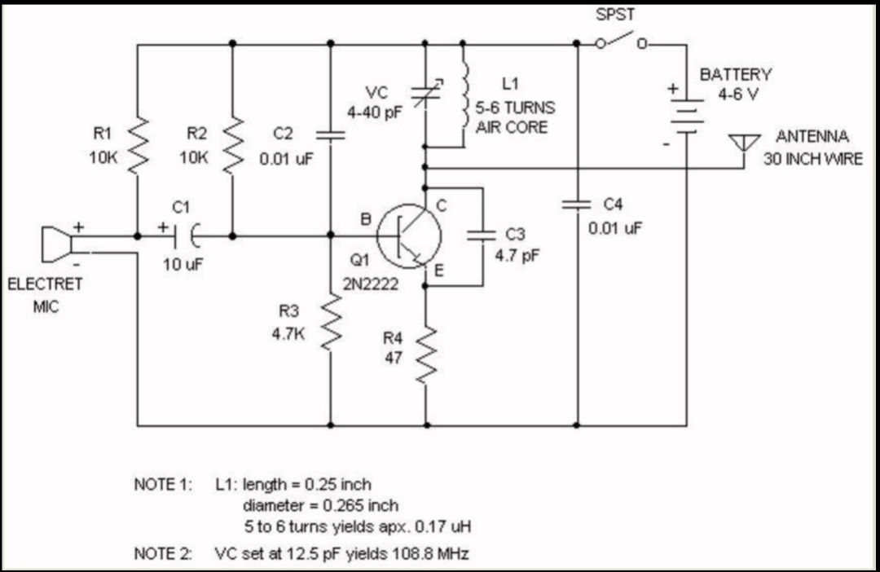 The below figure shows the transmitting circuit that was considered for this course (and it’s components were provided by the departments club):

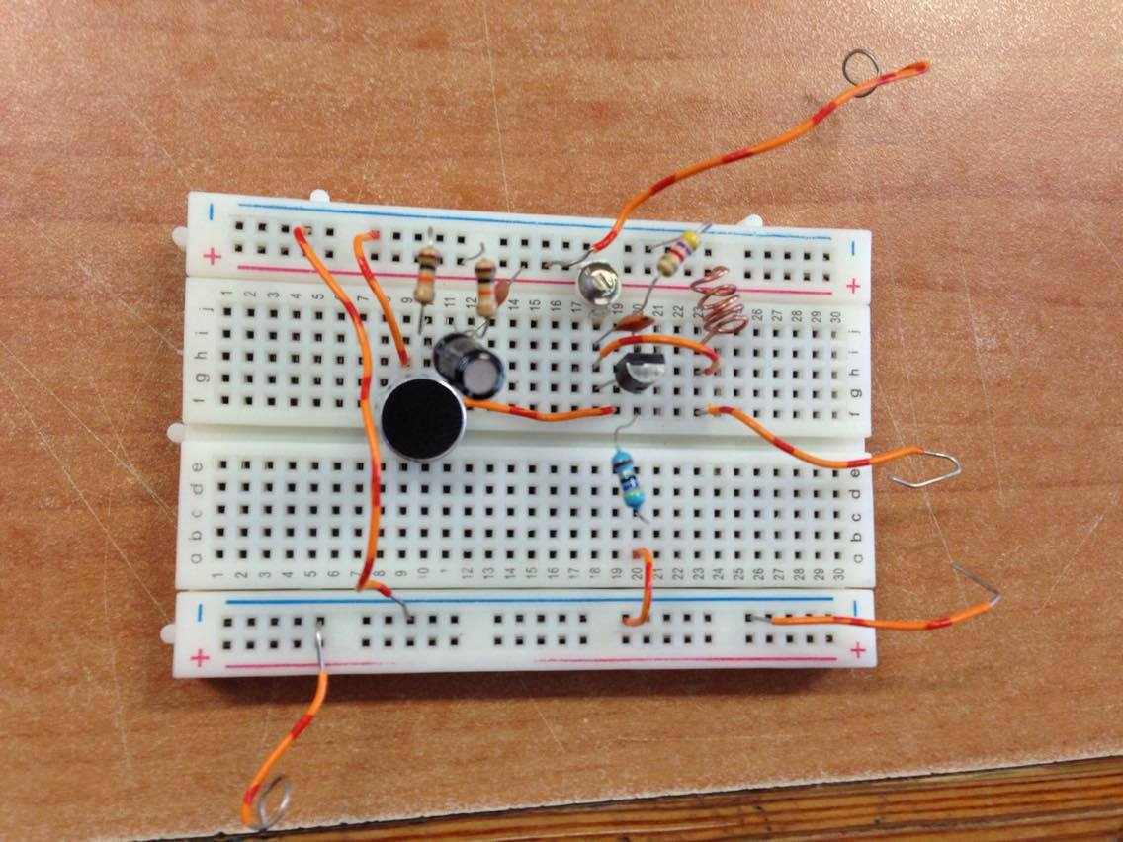

For this circuit we faced some problems, or at least with the parts that were provided. The main problem is there were too many lose wires that caused a lot of noise, to avoid this we used PCB (printed circuit board) to get rid of all the wires. Before we tested it, we reassembled the circuit again using the breadboard and it worked fine, but needed simple tuning to get to a frequency we could listen to on the radio.A combination of wire wrapping and soldering was used to construct the FM transmitter.The variable capacitor and the inductor will be the components we will be able to change to get frequencies in the FM radio band (88 to 108 MHz). The electret microphone has a resistance that depends on how loudly you speak into it. This microphone is battery powered and according to the V=IR Ohm's Law, changes in resistance for fixed voltage will result in proportional changes in current.

Our transmitter worked properly and we was able to hear the transmitted message signals on the radio at frequency (100.7 MHz).

## Main Components

### Microphone

An electret microphone is a type of electrostatic capacitor-based microphone, which eliminates the need for a polarizing power supply by using a permanently charged material. It has two pins which connect to the positive and negative leads of a battery.

### 2N2222ATransistor

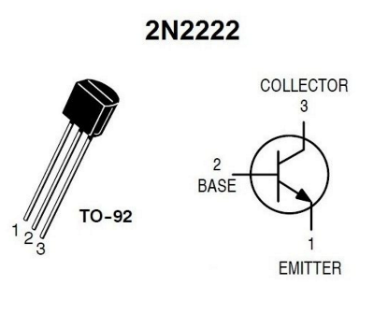 The 2N2222A is a very common NPN transistor. Its three pins are for the transistor's base (B), collector (C) and emitter (E). There is no standard pinout for transistors. As such, request the transistor's spec sheet when ordering it to identify the pinout, or if you own a multi-meter with a transistor tester, use it.

## Theory:

The variable capacitor and your self-made inductor will vibrate at frequencies in the FM radio band (88 to 108 MHz). The electret microphone has a resistance that depends on how loudly you speak into it. This microphone is battery powered and according to the V=IR Ohm's Law, changes in resistance for fixed voltage will result in proportional changes in current. This current feeds into the base of the 2N2222 NPN transistor which is connected to your variable capacitor, inductor and antenna. The net effect is that depending on your variable capacitor's value, your voice will be modulated to transmit at a frequency between 88 and 108 MHz. If a nearby pocket FM radio is tuned to this frequency, you'll be heard when speaking into your transmitter.

* Resonant Frequency of a Parallel LC Circuit:

FM radio stations operate on frequencies between 88 and 108 MHz. The variable capacitor and your self-made inductor constitute a parallel LC circuit. It is also called a tank circuit and will vibrate at a resonant frequency which will be picked up your pocket FM radio.

The variable capacitor ranges from 4 to 34 pF, so our tank circuit will resonant between 66 and 192 MHz, well within the FM radio range.

#### Fixed Capacitors:

Referring to the schematic, C2 and C4 act as decoupling capacitors and typically 0.01 uF (or 0.1 uF) are used. C4 attempts to maintain a constant voltage across the entire circuit despite voltage fluctuations as the battery dies.

A capacitor can be thought of as a frequency-dependent resistor (called reactance). Speech consists of different frequencies and the capacitor C1 impedes them. The net effect is that C1 modulates the current going into the transistor. Using a large value for C1 reinforces bass (low frequencies) while smaller values boost treble (high frequencies).

The C3 capacitor across the 2N2222A transistor serves to keep the tank circuit vibrating. In theory, as long as there is a supply voltage across the parallel inductor and variable capacitor, it should vibrate at the resonant frequency indefinetely. In reality however, the frequency decays due to heating losses. C3 is used to prevent decay and the 2N2222A spec sheet suggests a capacitance between 4 to 10 pF.

* Resistors and the 2N2222A:

The 2N2222A transistor has rated maximums thus demanding a voltage divider made with R2 and R3 and emitter current limiting with R4.

The 2N2222A's maximum rated power is Pmax = 0.5 W. This power ultimately affects the distance you can transmit. Overpowering the transistor will heat and destroy it. To avoid this, one can calculate that the FM transmitter outputs approximately 124 mW and is well below the rated maximum.The power is intimately related to the transmission range. At 124 mW and 30% radiation efficiencies, the maximum distance between your FM transmitter and a battery-powered radio will range betweem 35 to 112 feet.

# Receiver

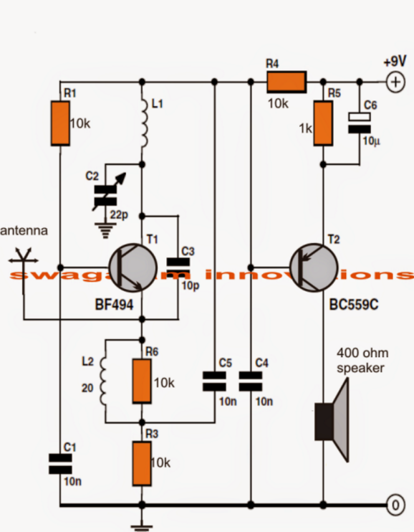 Shown below is the figure of the transmitting circuit that was used for this project:

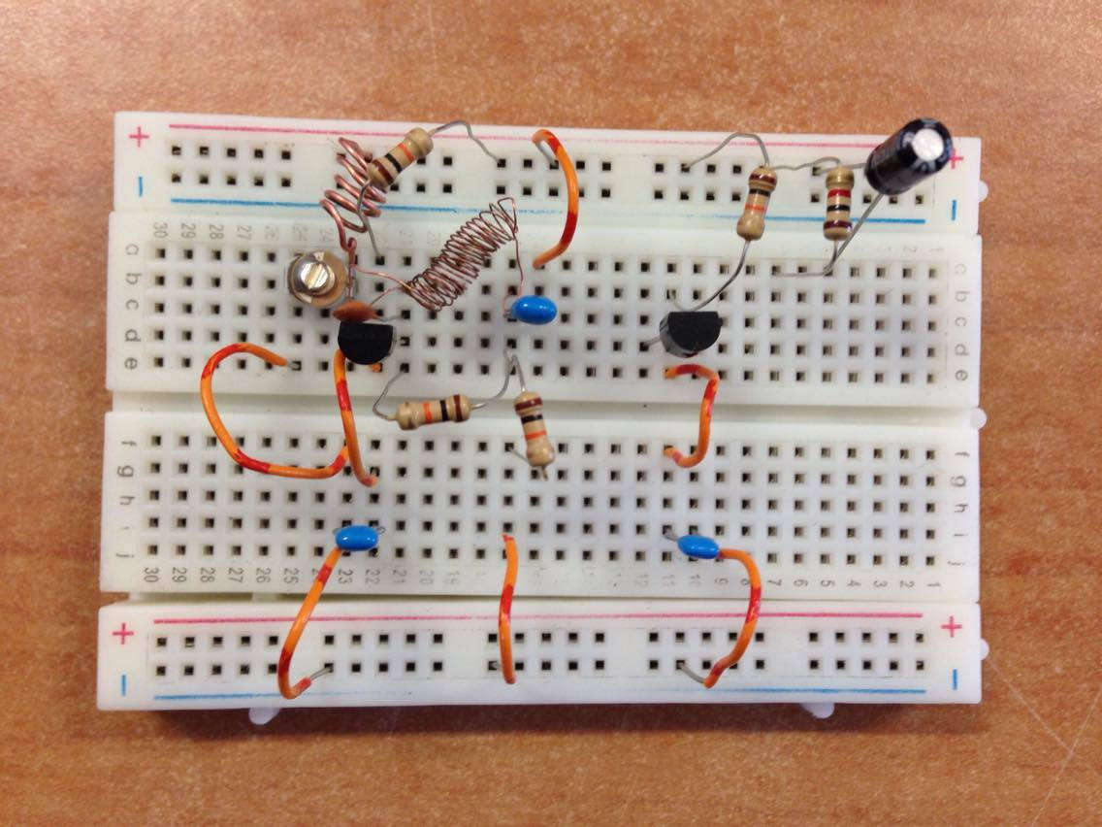

We faced some problems in this design, since there was a lot of noise we could not get the frequency to the same frequency we were broadcasting at in the transmitter. This meant that we could not hear the transmission of the sound that was fed to the mic.Initially when the circuit is switched ON, the output will be accompanied with substantial background noise which will gradually tend to disappear on detection of am FM station. This may be done by carefully tuning C2 with the help of an insulated screwdriver. Try to keep the tuning at the edge of the band of the particular FM station, with some practice and patience this would get easier with time. Once tuned, the circuit would respond to that reception every time its switched without the need for further alignment.

The BC559C transistor is used as an audio amplifier, it amplify the signal so that we can hear it throw the speaker, it’s used to hear the sound of music.

R4, R5, and C6 are the envelope detector circuit, they trace the envelope of the transmitter signal so that to get the message signal.

C2, and L1 are the tunable local oscillator circuit, they used to set the frequency of thereceiver to that of the transmitter. The other components on the same line are the Mixer circuit.

# PSPICE:

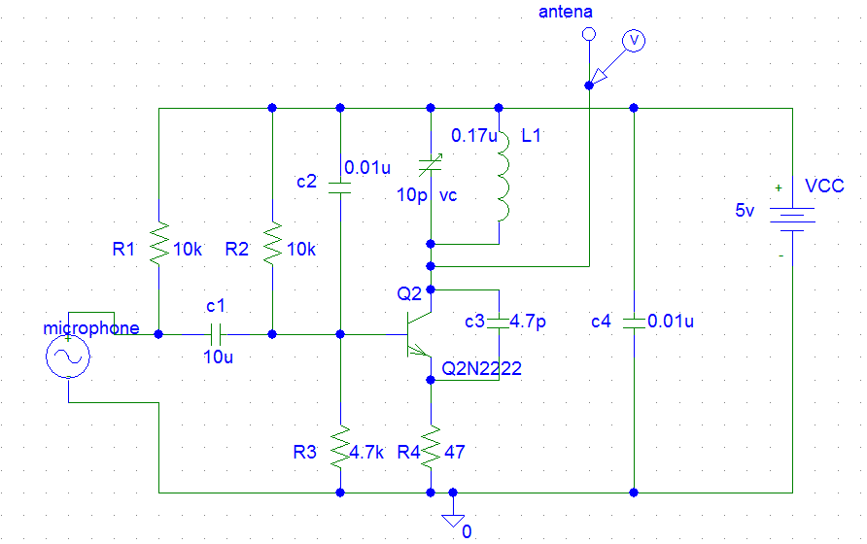

Transmitter Circuit

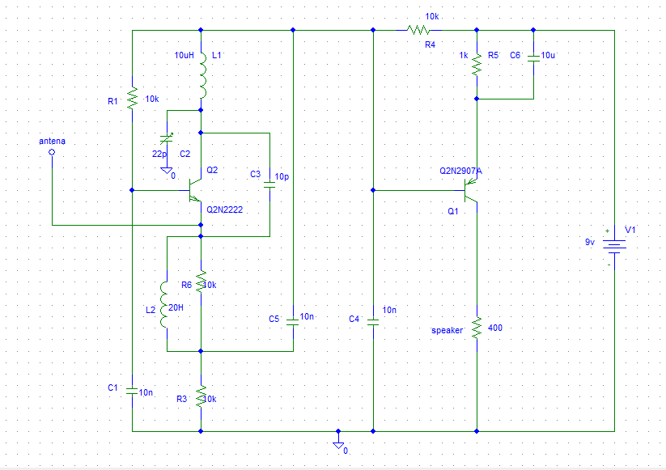

Receiver Circuit

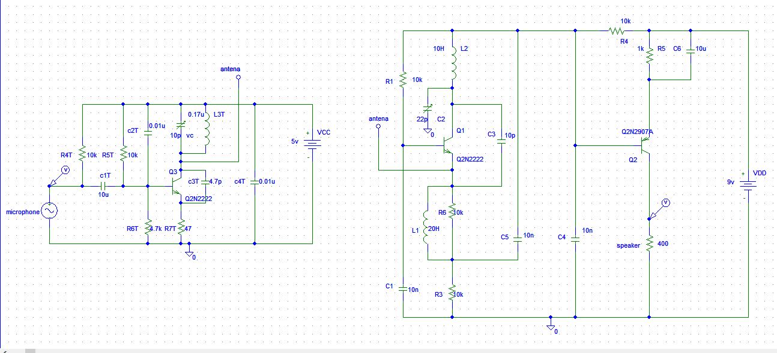

Transmitter with Receiver (connected together through antenna)

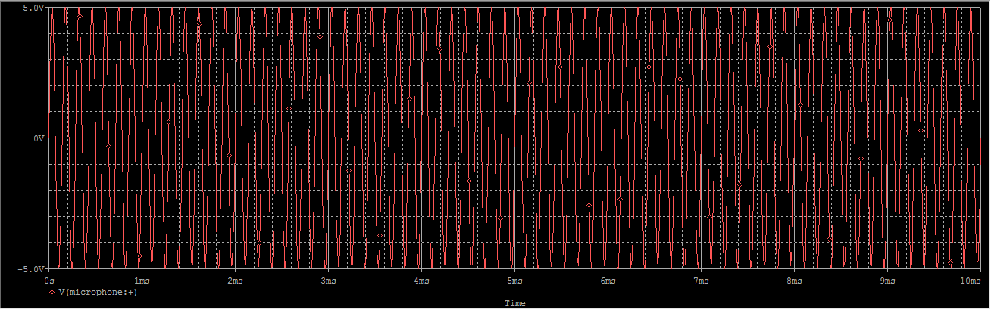

Message Signal m(t) (input from microphone)

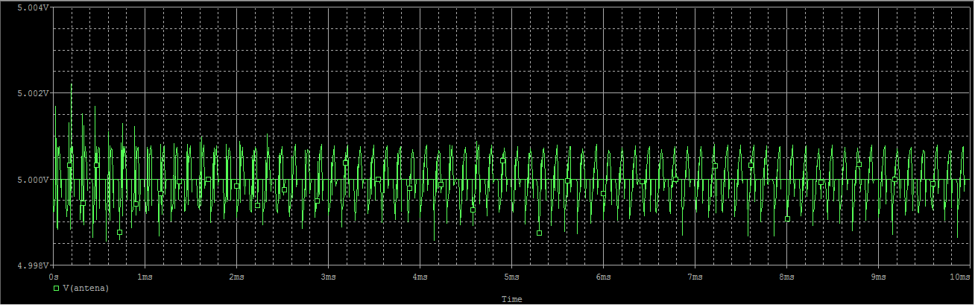

Modulated Signal s(t) (on Transmitter’s antenna)

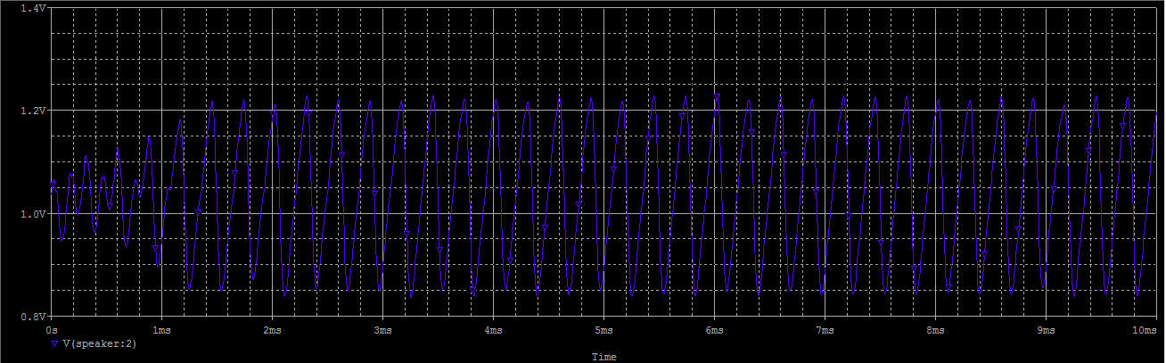

Received Signal (on Speaker of Receiver Circuit)

Note: the message received (which was took from receiver’s speaker) is similar to the one sent on the transmitter’s microphone, but with lower amplitude, and that was due to using other types of transistors in the receiver circuit than expected, which didn’t make the needed amplification, these transistors was replaced of course, because they weren’t available in the pspice program.

# Conclusion:

The concept of FM modulation has overcome the problems of AM modulation. The FM modulation has the advantage of reducing the effect of noise that is introduced by the transmission (communication channel) since it stores the information of the message signal in the crossings of the modulated signal. On the other hand, the AM modulation stores the information in the amplitude of the modulated signal, which is affected by the noise.

The super heterodyne receiver is simple in concept and operation, it is based on the Mixing operation, in which from it we can get the message signal from the modulated signal which was received from the communication channel.

In sum, we can say that, FM modulation and transmission is the most suitable way of broadcasting among other modulation techniques. It offers many advantages to use it, the main advantage is that it reduce the effect of noise that is introduced by the communication channel.

# References

[ 1 ]<https://en.wikipedia.org/wiki/FM_broadcasting>

[ 2 ] <http://www.radio-electronics.com/info/rf-technology-design/superheterodyne-radio-receiver/basics-tutorial.php>

[ 3 ]<http://www.hllye.com/news/fm-transmitter/DIy-a-wireless-fm-transmitter-test.html>

[ 4 ]<http://www.homemade-circuits.com/2013/10/make-this-simple-fm-radio-circuit-using.html>