

**Faculty of Engineering and Technology**

**Department of Electrical and Computer Engineering**

**ENEE339, COMMUNICATION SYSTEMS**

**Building Wireless FM Transmitter/Receiver System**

Report

Mohammad Sehweil 1131253

Mahmoud Abdelkareem 1130786

Hussein Dahir 1131138

Yazeed Obaid 1130036

**This project will consist of two parts, which are:**

1. **The transmitter side**

The transmission range of this circuit is approximately 10-20 meters.

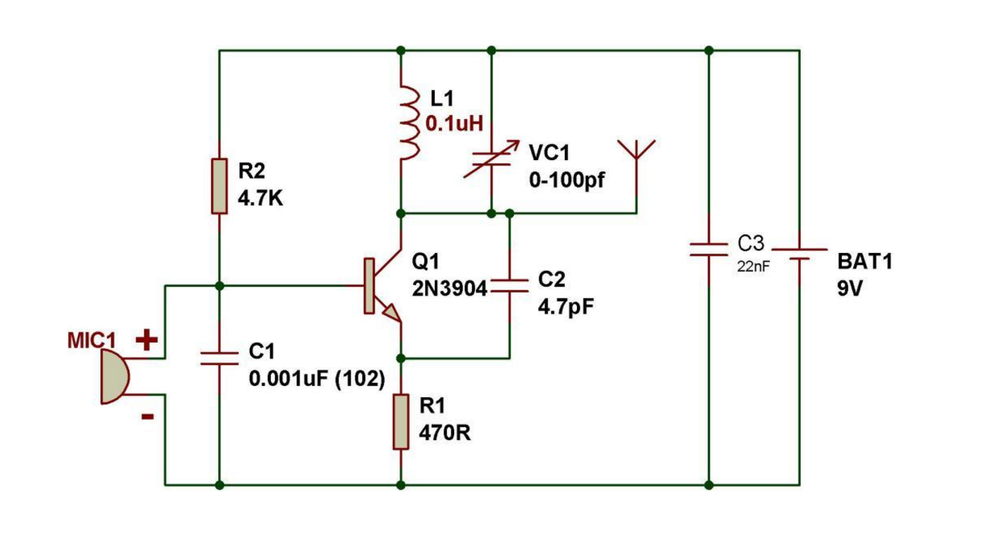

Parts used:

1- Transistor- 2N3904, 1-piece

2- Capacitors- 4.7pF, 0.001uF, 22nF. 1-piece each

3- Variable capacitor, 0-100pf. 1-piece

4- Resistors- 4.7 kilo Ohm, 470 Ohm, 1-piece each

5- Condenser/ Electret Microphone, 1-piece

6- Inductor- 0.1uH, 1-piece

7- Antenna, 1-piece

8- Battery, 9 volts, 1 piece

9- Breadboard

1. **The Receiver side**

A single transistor acts as a receiver, demodulator, and amplifier to constitute a wonderful tiny FM radio. It is based on a super regenerative audio receiver circuit where the use of minimal components becomes the main feature of the unit.

However fewer components also means a few compromises involved, here the receiver requires a large metal base for grounding the unwanted signals, and for keeping the noise factor to the lowest, and also this system would work only in places where the reception is rather strong and thus may not be suitable in areas where the signal strength is thinner.

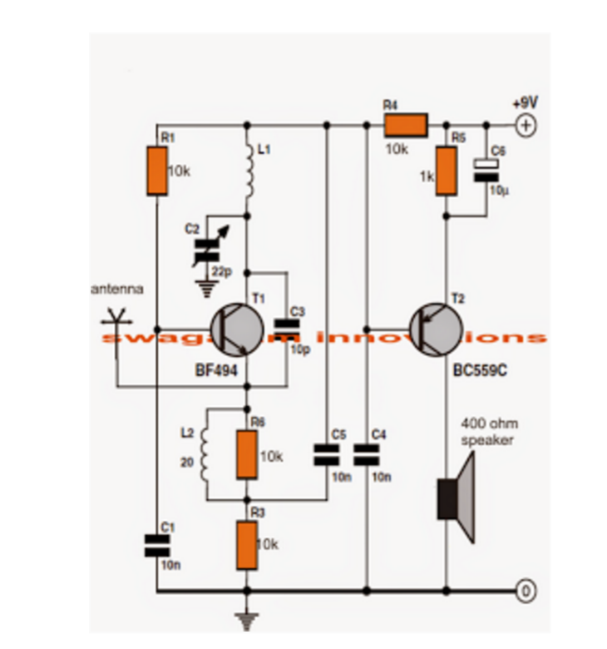

Parts used:

1- Transistor- BF494, 1 piece

2- Transistor- BC559C, 1 piece

3- Resistors- 10k (4 pieces) and 1k (1 pieces)

4- Capacitors- 10nF (3 pieces), 10pF (1 piece), 10uF (1 piece)

5- Variable Capacitor- 0-100pf, 1 piece

6- Battery, 9 volts, 1 piece

7- Inductor- one coil with 0.8mm in thickness, diameter of 8mm, with five turns, and another coil with 0.2mm super enameled copper wire with 20 turns

8- Antenna

9- Speaker 400 Ohm, 1 piece

# **References:**

* <http://www.homemade-circuits.com/2013/10/make-this-simple-fm-radio-circuit-using.html>
* <http://www.buildcircuit.com/simple-steps-for-making-fm-transmitter/>