

Faculty of Engineering and Technology

Electrical and Computer Engineering Department

Electromagnetics 1 (ENEE 3408)

**Assignment #2 Surface and Volume Integrals**

**Prepared by**

**Yazan Yousef – 1170249**

**Section No. 1**

Instructor

Dr. Ashraf Al-Rimawi

BIRZEITbTop of Form

April 2020

**Question**: The surfaces $r=0$, $r=2$, $φ=45°$, $φ=90°$, $θ=45°$ and $θ=90°$ define a closed surface.

Find:

1. The enclosed volume
2. The area of the closed surface *S*.
3. Write a MATLAB program to verify your answer.

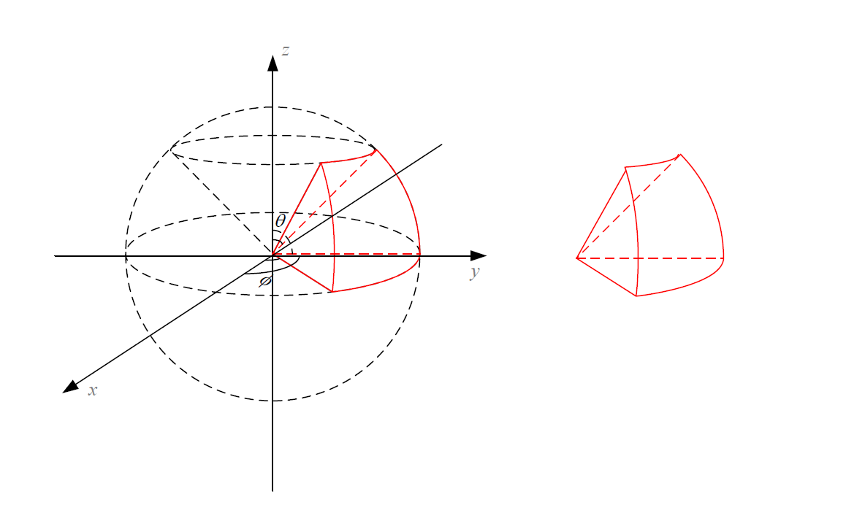

Figure 1: The surface of the question

________________________________________________________________________

1. To find the volume *v* of a closed surface we first find out *dv,* the volume element. In spherical coordinates, *dv* is given by $dv= r^{2}\sin{θ}dφdrdθ$**.** Once we get the expression of *dv*, we integrate *dv* over the entire volume.
$$dv=r^{2}\sin{θ}dθdrdφ$$

$$v=\iiint{dv}$$

$$v=\iiint{r^{2}\sin{θ}dθdrdφ }$$

$$v=\int_{\frac{π}{4}}^{\frac{π}{2}}{dφ}\int_{0}^{2}{r^{2}dr}\int_{\frac{π}{4}}^{\frac{π}{2}}{\sin{θ}dθ}$$

$$v={\left.( φ\right|}_{\frac{π}{4}}^{\frac{π}{2}}) (\frac{r^{3}}{3}|_{0}^{2})(-\cos{θ}|_{\frac{π}{4}}^{\frac{π}{2}})$$

$$v= \frac{\sqrt{2} π}{3}=1.48096 m^{3}$$

2. 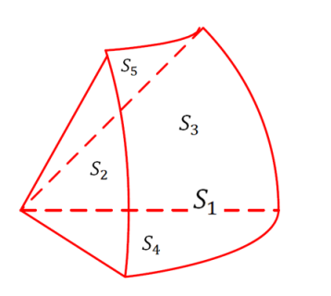The area of the closed surface is given by

$$S_{enclosed}=S_{1}+S_{2}+S_{3}+S_{4}+S_{5}$$

We need to find $dS_{1}$, $dS_{2}$, $dS_{3}$, $dS_{4}$, $dS_{5}$. Then we need to integrate them over their boundary. It is obvious that $S_{2}=S_{3}$.

Now we have,

$${dS}_{1}=r^{2}\sin{θ}dθdφ {\hat{a}}_{r}$$

$${dS}_{2}={dS}_{3}=rdθdr {\hat{a}}_{φ}$$

$${dS}_{4}={dS}_{5}=r\sin{θ}drdφ {\hat{a}}_{θ}$$

So,

$$\int{{dS}_{1}}=r^{2}\iint{\sin{θ}dθdφ }{\hat{a}}_{r}$$

$$\int{{dS}_{2}}=\int{{dS}_{3}}=\iint{rdθdr} {\hat{a}}_{φ}$$

$$\int{{dS}_{4}}=\sin{θ_{1}}\iint{rdrdφ }{\hat{a}}_{θ}$$

$$\int{{dS}_{5}}=\sin{θ_{2}}\iint{rdrdφ }{\hat{a}}_{θ}$$

Calculating the integrals will give

$S_{1}=2^{2}\int_{π/4}^{π/2}{\sin{θ}dθ}\int_{π/4}^{π/2}{dφ }$

$${ S}_{1}=2.2211 m^{2}$$

$S_{2}=S_{3}=\int_{0}^{2}{rdr}\int_{π/4}^{π/2}{dθ }$

$$S_{2}=S_{3}=\frac{π}{2} m^{2}=1.571 m^{2}$$

$S_{4}=\sin{90°}\int_{0}^{2}{rdr}\int_{π/4}^{π/2}{dφ }$

$$S_{4}=\frac{π}{2} m^{2}=1.571 m^{2}$$

$S_{5}=\sin{45°}\int_{0}^{2}{rdr}\int_{π/4}^{π/2}{dφ }$

$$S_{5}=\frac{\sqrt{2}π}{2} m^{2}=1.1107 m^{2}$$

$$S_{enclosed}=8.0451 m^{2}$$

1. The following MATLAB code verify the previous answers:

V = 0; %initialize volume of the closed surface to 0

S1 = 0; %initialize the area of S1 to 0

S2 = 0; %initialize the area of S2 to 0

S3 = 0; %initialize the area of S3 to 0

S4 = 0; %initialize the area of S4 to 0

S5 = 0; %initialize the area of S5 to 0

r = 0; %initialize r to the its lower boundary

theta = pi/4; %initialize theta to the its lower boundary

phi = pi/4; %initialize phi to the its lower boundary

Number_of_r_Steps = 1000; %initialize the r discretization

Number_of_theta_Steps = 1000; %initialize the theta discretization

Number_of_phi_Steps = 1000; %initialize the phi discretization

dr = (2-0)/Number_of_r_Steps; %The r increment

dtheta = (pi/2-pi/4)/Number_of_theta_Steps; %The theta increment

dphi = (pi/2-pi/4)/Number_of_phi_Steps; %The phi increment

%%the following routine calculates the volume of the enclosed surface

for k = 1: Number_of_phi_Steps

for j = 1: Number_of_theta_Steps

for i = 1: Number_of_r_Steps

V = V + r^2 * sin(theta) * dphi * dr * dtheta;

end

r = r + dr; %The first loop increment the r

end

r = 0;

theta = theta + dtheta; %The second loop increment theta

end

Volume = V %the volume of the shape

%%To calculate the circular area

r = 2 ; theta = pi/4;

for j = 1: Number_of_theta_Steps

for i = 1: Number_of_phi_Steps

S1 = S1 + r^2 * sin(theta) * dphi * dtheta;

end

theta = theta + dtheta;

end

%To calculate the left and right areas which have the same area

r = 0; %re-enter the initial values

for k = 1: Number_of_theta_Steps

for j = 1: Number_of_r_Steps

S2 = S2 + r* dtheta * dr;

end

r = r + dr;

end

if dphi ~= 0

S3 = S2;

end

%%To calculate the lower area on the xy plane

r = 0; theta = pi/2; % re-enter the the initial values

for k = 1: Number_of_r_Steps

for i = 1: Number_of_phi_Steps

S4 = S4 + r * sin(theta) * dphi * dr;

end

r = r + dr;

end

%%To calculate the upper area

r = 0; theta = pi/4; % re-enter the the initial values

for k = 1: Number_of_r_Steps

for i = 1: Number_of_phi_Steps

S5 = S5 + r * sin(theta) * dphi * dr;

end

r = r + dr;

end

Surface_area = S1+S4+S3+S4+S5 %the area of the enclosed surface

Answers:

Volume = 1.4785

Surface_area = 8.0384