

Faculty of Engineering and Technology

Electrical and Computer Engineering Department

Electromagnetics 1 (ENEE 3408)

**MATLAB Assignments**

**Prepared by**

**Yazan Yousef – 1170249**

**Section No. 1**

Instructor

Dr. Ashraf Al-Rimawi

BIRZEITbTop of Form

April 2020

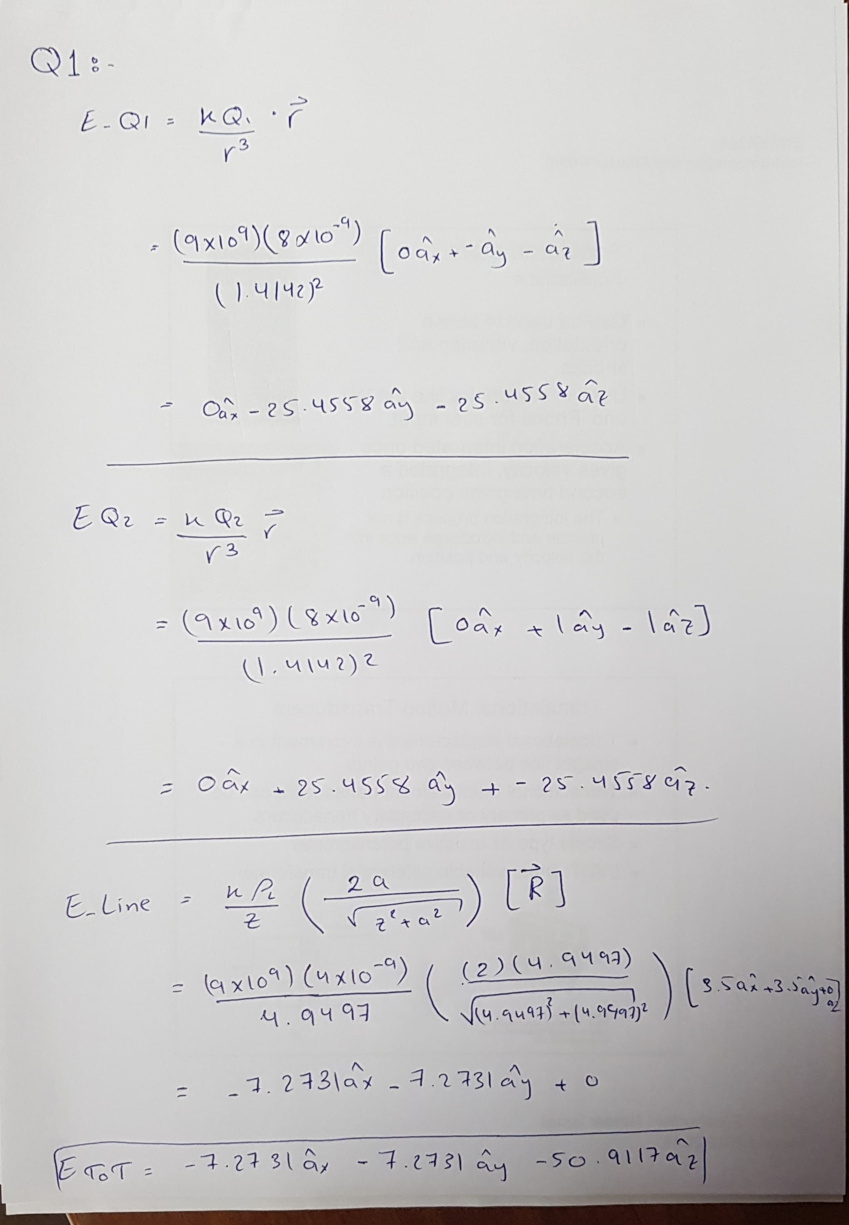

Code:

clear;

clc;

Q1 = 8e-9;

Q2 = 8e-9;

ro_L = 4e-9;

line_initial_point = [7 0 0];

line_final_point = [0 7 0];

Point_Q1 = [0 1 1];

Point_Q2 = [0 -1 1];

Point_EF = [0 0 0];

epsilon = (1e-9/(36*pi));

k = (1/(4*pi*epsilon));

R_Q1E = Point_EF - Point_Q1;

R_Q2E = Point_EF - Point_Q2;

R_LIP = (Point_EF - line_initial_point);

R_line = (line_final_point - line_initial_point);

Mag_R_Q1E = norm(R_Q1E);

Mag_R_Q2E = norm(R_Q2E);

Mag_R_line = norm(R_line);

Mag_LIP = norm(line_initial_point);

cos_theta = (dot(R_line , R_LIP)/(Mag_R_line*Mag_LIP));

sin_theta = sqrt(1-(cos_theta)^2);

z = Mag_LIP*sin_theta

a = Mag_LIP*cos_theta;

b = Mag_R_line - a;

Point_z = [3.5 3.5 0];

Mag_z_vector = norm(Point_z);

R_z = (Point_EF - Point_z)./(Mag_z_vector);

EQ1 = (k*Q1/(Mag_R_Q1E)^3).*R_Q1E;

EQ2 = (k*Q2/(Mag_R_Q2E)^3).*R_Q2E;

E_line = (k*ro_L/z)*((b/sqrt(z^2 + b^2))+(a/sqrt(z^2 + a^2)))*R_z

E_Tot = EQ1 + EQ2 + E_line

Result

= **-7.2731 -7.2731 -50.9117**

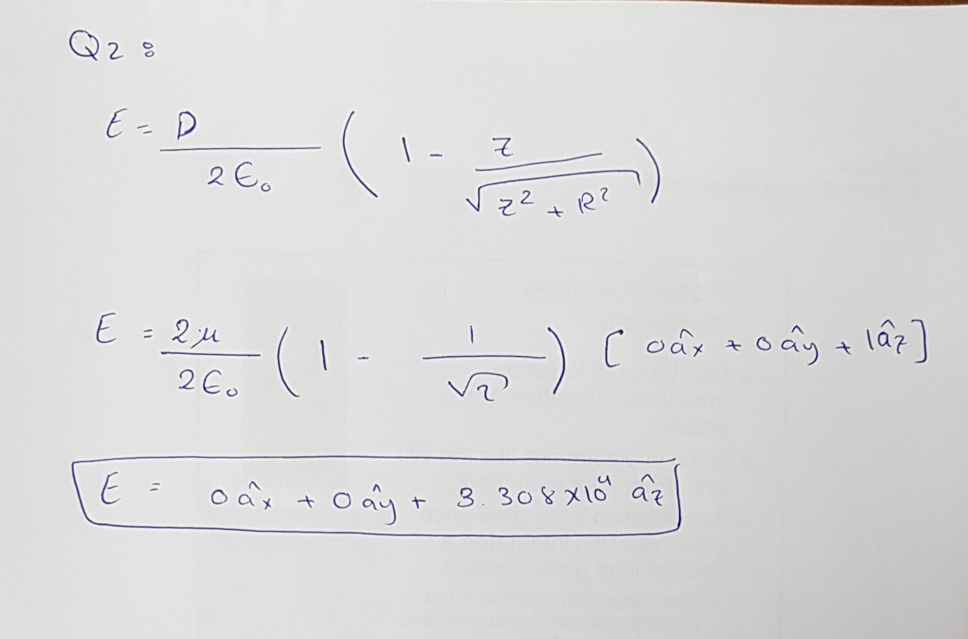

Code:

clc;

clear;

Epsilono=8.854e-12;

D=2e-6;

P=[0 1 0];

R = 1;

Z = 1;

E =(D/(2*Epsilono))*(1-(Z/(sqrt(Z^2+R^2))));

E_tot = E.*[0 0 1]

Result =

E_tot =

1.0e+04 *

0 0 3.3080

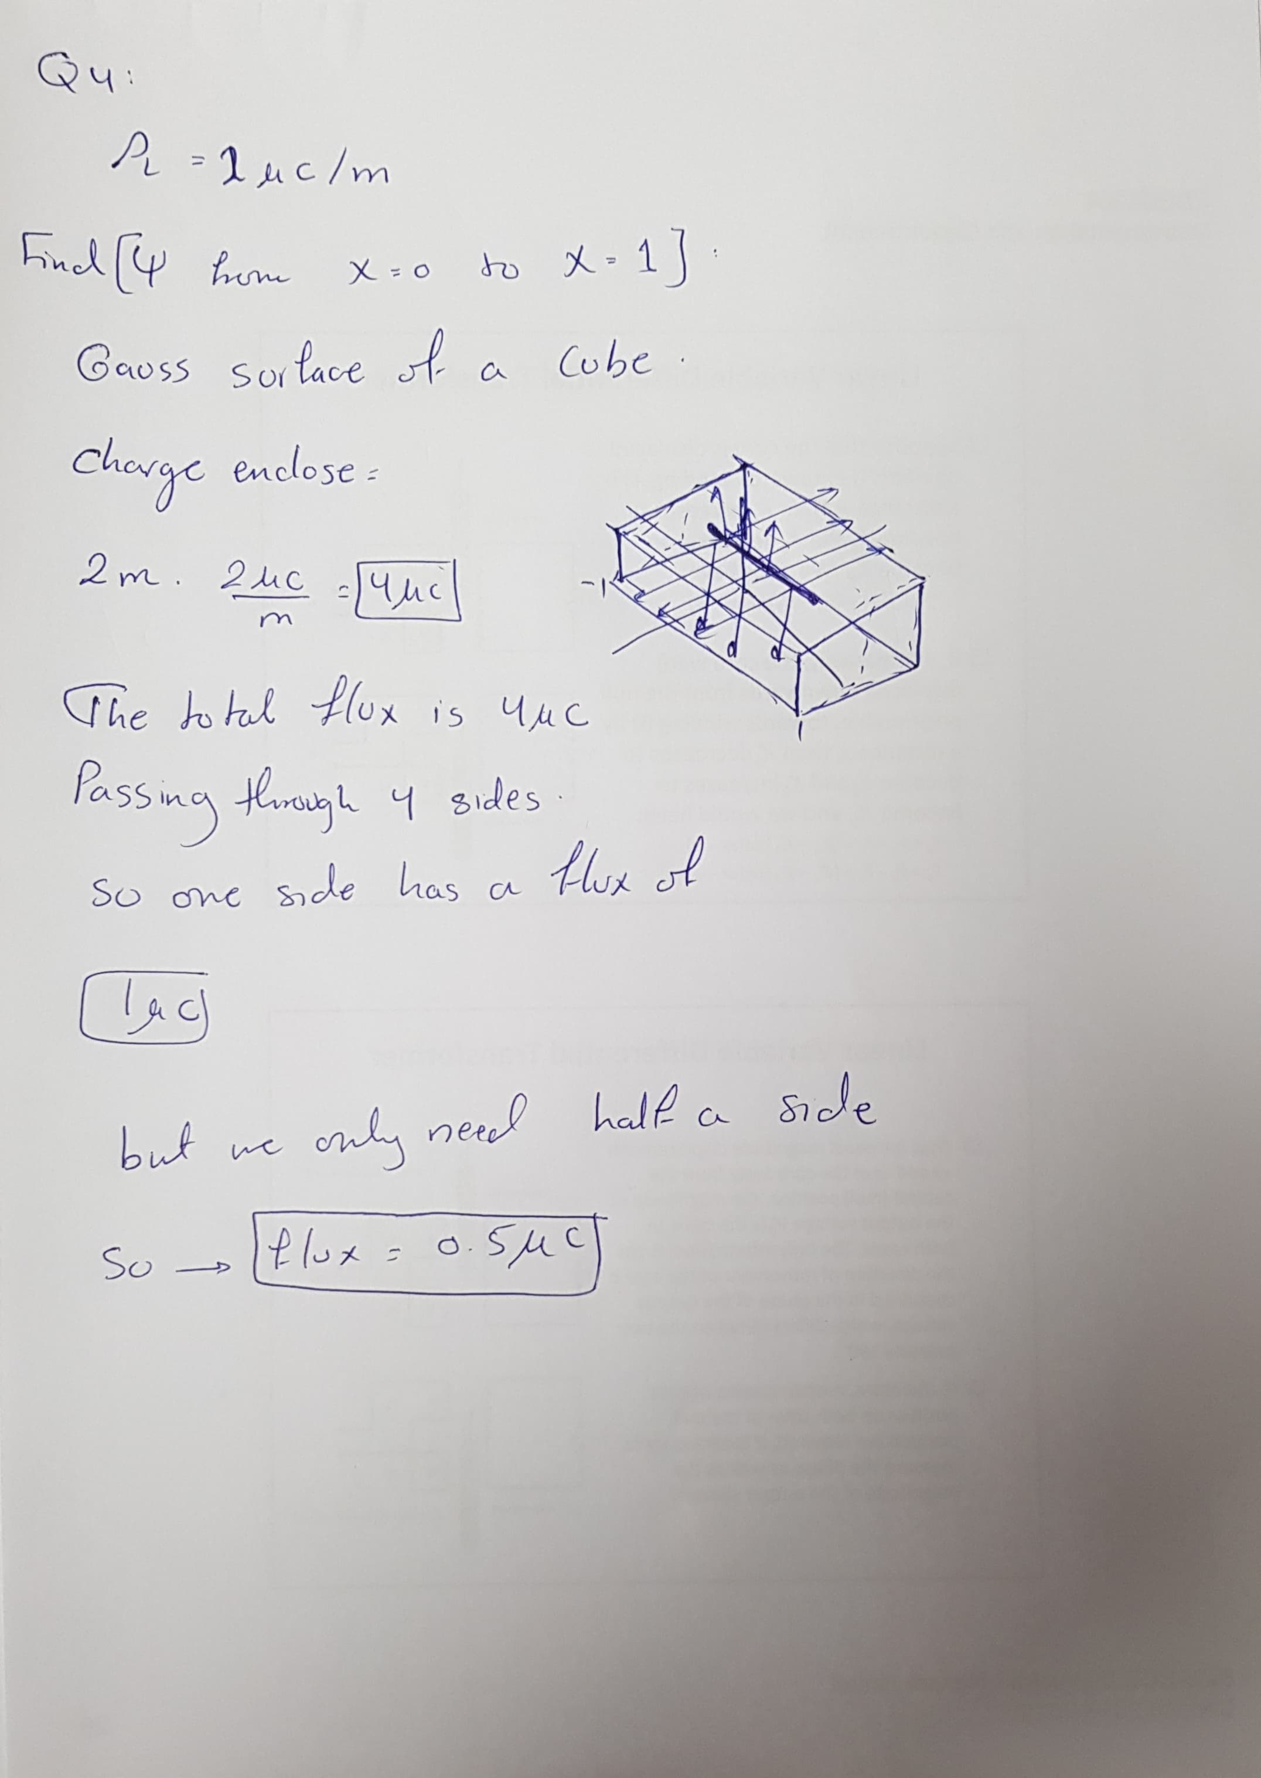

Code:

clc; %clear the command line

clear; %remove all previous variables

ro_L = 2e-6;

L_start = [0 -1 1];

L_end = [0 1 1];

Line = L_end - L_start;

Mag_Line = norm(Line);

Total_Charge_Q = ro_L*Mag_Line;

Line_Charges = 10000;

Q = Total_Charge_Q/Line_Charges;

az=[0 0 1]; % unit vector in the z direction

x_lower=0; %the lower boundary of x of the plane

x_upper=1; % the upper boundary of x of the plane

y_lower=-100; %the lower boundary of y of the plane

y_upper=100; %the upper boundary of y of the plane

Number_of_x_Steps=20; %step in the x direction

Number_of_y_Steps=1000; %step in the y direction

dx=(x_upper-x_lower)/Number_of_x_Steps; %the x increment

dy=(y_upper-y_lower)/Number_of_y_Steps; %the y increment

dP = Mag_Line/Line_Charges;

flux=0; %initialize the flux to 0

y1 = 4*pi;

ds = dx*dy;

for p = -1+dP : dP : 1-dP

for j=1:Number_of_y_Steps

for i=1:Number_of_x_Steps

x = x_lower+0.5*dx+(i-1)*dx; %x component of the center of a grid

y = y_lower+0.5*dy+(j-1)*dy; %y component of the center of a grid

P = [x y 0]; %the center of a grid

C = [0 p 1];

R = P-C; %vector R is the vector pointing from the point charge

RMag = norm(R); %magnitude of R

R_Hat = R/RMag; %unit vector in the direction of R

flux = flux + Q*ds*(-1*R_Hat(3))/(y1*RMag^2end

end

end

flux =

4.9995e-07

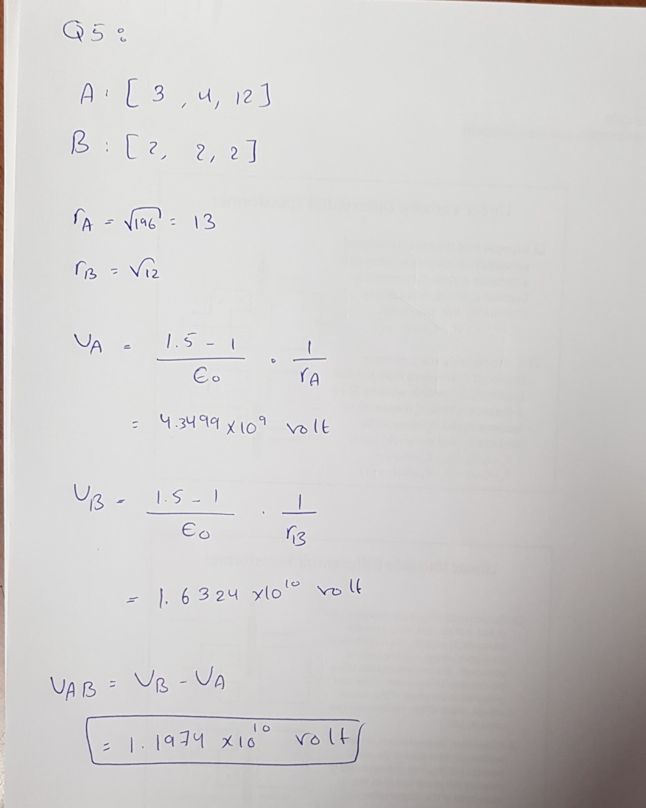

Code:

clear;

clc;

epsilon = (1e-9/(36*pi));

A = [3 4 12];

B = [2 2 2];

r_A = norm(A);

r_B = norm(B);

VA = (0.5/epsilon)*(1/r_A)

VB = (0.5/epsilon)*(1/r_B)

VAB = VB – VA

VAB =

1.1974e+10