**Electrical and Computer Systems Engineering Department**

**Simulation Lab   
  
(ENEE4104)***Assignment 1  
 DSB-Standard AM Modulation & Demodulation*

bIRZEIT UNIVERSITY

Name: Ali Sider  
  
Student Number: 1111829  
  
Dr.: Jamal Seyam   
   
Eng.: Al-Mutasem Bellah Omar  
  
Section: 2

28 FEB 2016

Part One: **AM Modulation**

For m(t) = 10 cos ($400πt$) and c(t) = 20 cos ($70000πt$)

Modulation Index = 0.5

MatLab Code:

Fm = 200;

Fc = 35000;

M = 0.5; %modulation index

fs=70000;%sampling frequency

n=0:7:7000;

m=10*cos(2*pi*Fm*n/fs); %Modulating Signal

c=20*cos(2*pi*Fc*n/fs);%Carrier Sinal

s =(1+M*cos(2*pi*200*n/fs)).*c ;%Am Signal

stem(s);grid;

title('Modulated Signal');

ylabel('Amplitude');

xlabel('n')

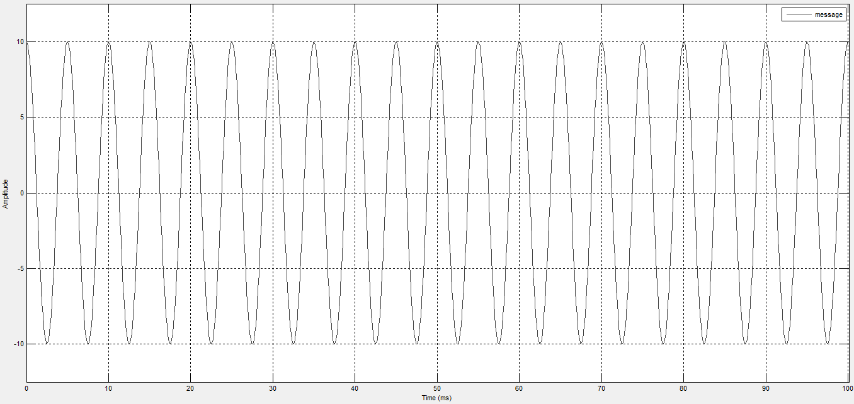  
*Figure -1-: Message Signal.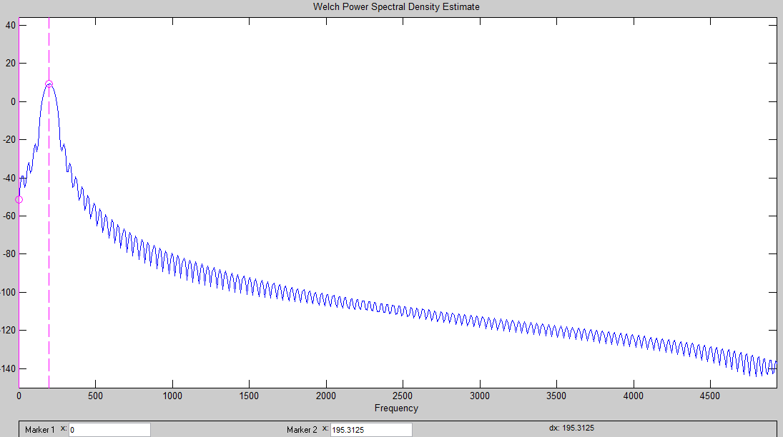 Figure -2-: Message Signal Spectrum.*

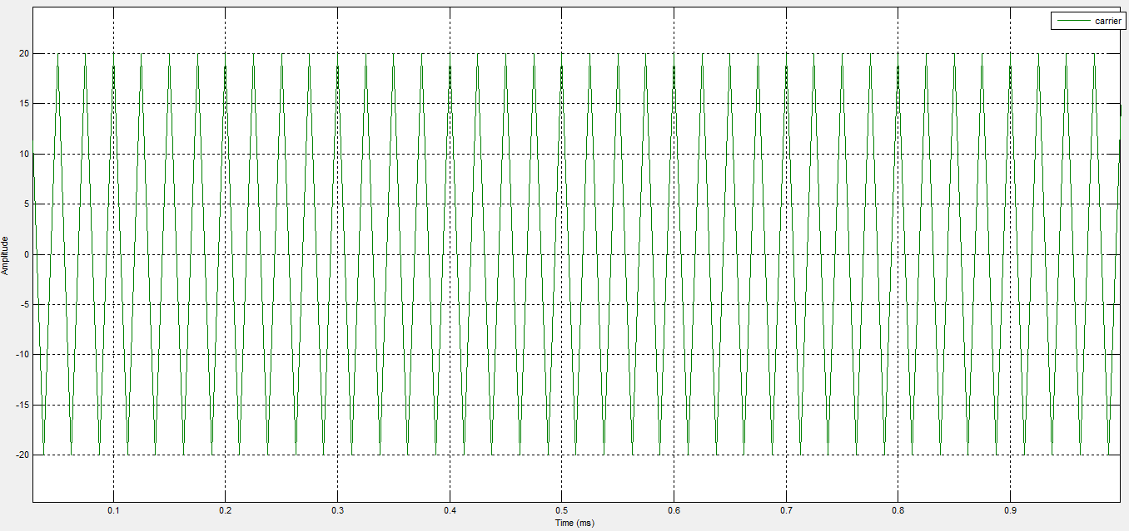  
*Figure -3-: Carrier Signal.*

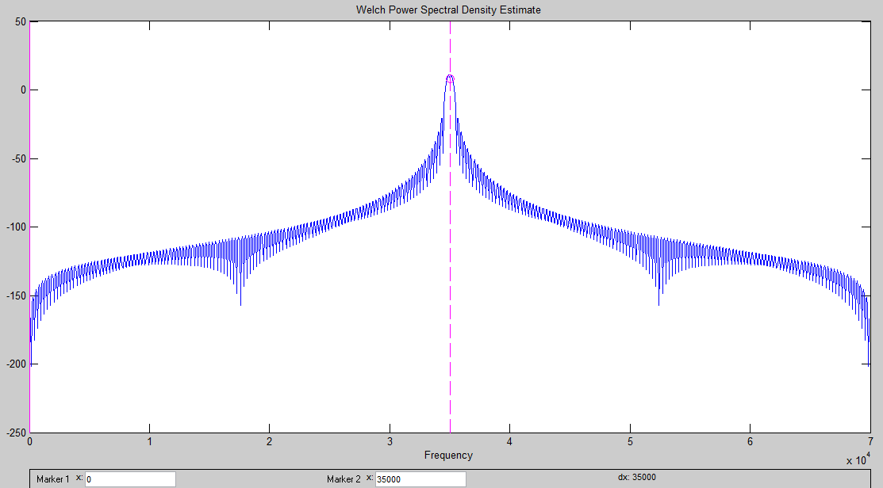 *Figure -4-: Carrier Signal Spectrum.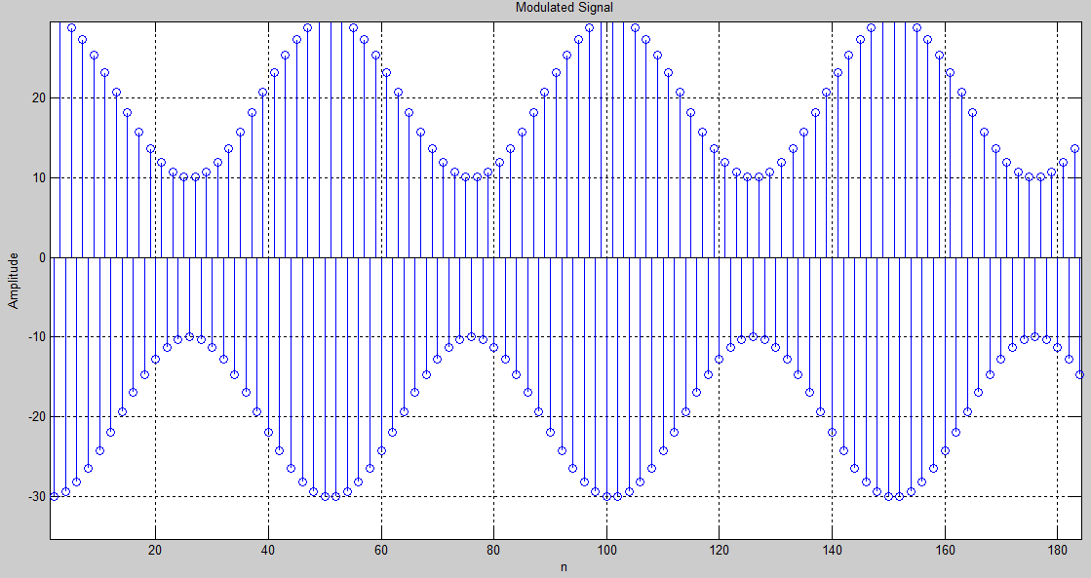 Figure -5-: Sampled Modulated Signal.*

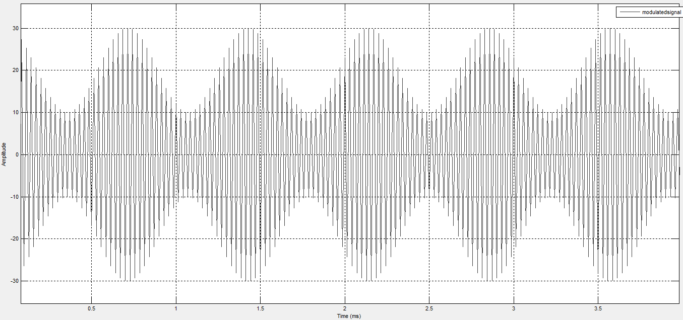 *Figure -6-: Modulated Signal in Time Domain.*

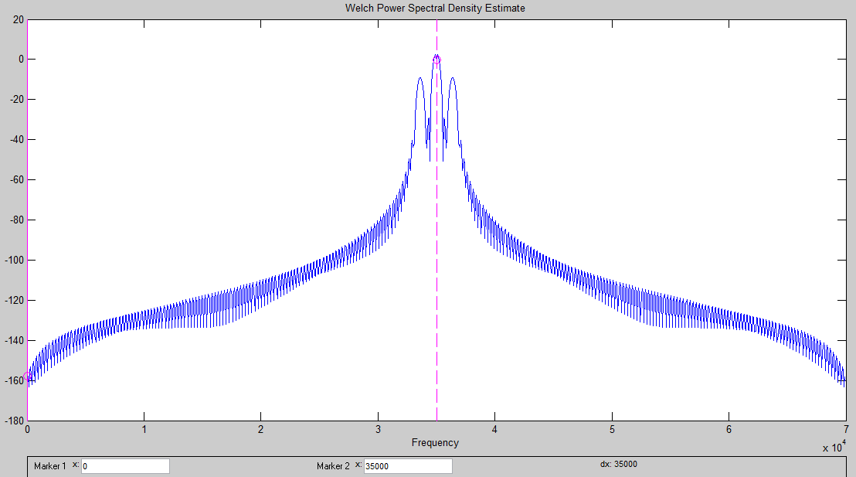  
*Figure -7-: Modulated Signal in Frequency Domain.*

Part Two: **AM Demodulation (Receiver)   
Using Envelop Detector Method**

env =abs(s) - 20; %to obtain the envelop of the modulated signal, -20 is to remove the DC component of the signal.  
  
**Using SPTool to Design a Low Pass Filter**

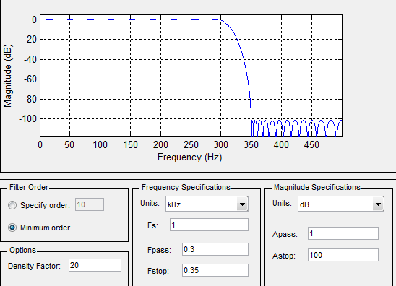

*Figure -8-: Magnitude Response and Filter Parameters.*

**After Filtration**

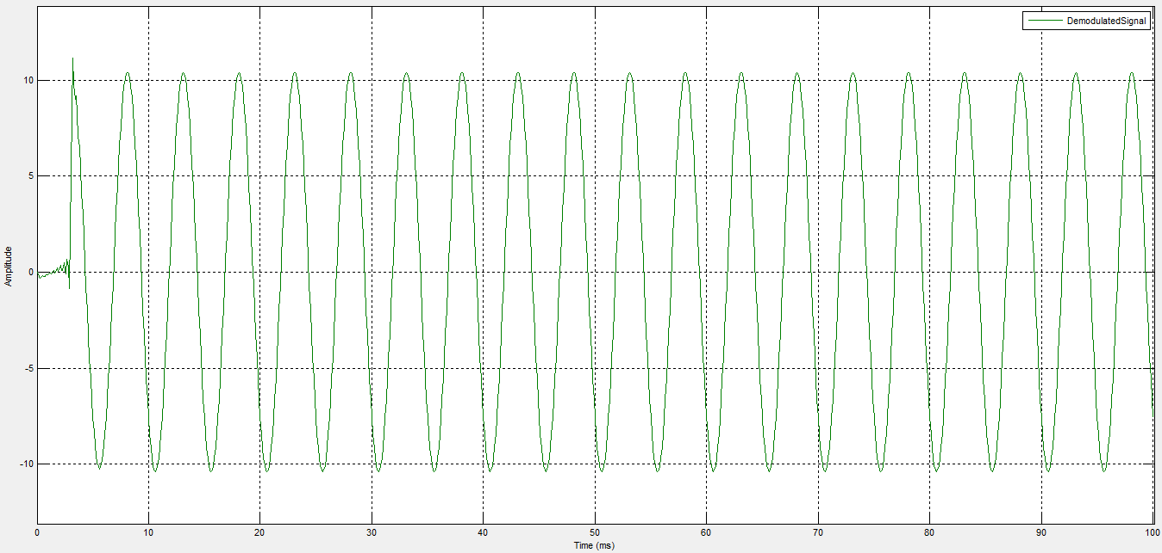

*Figure -9-: Demodulated Signal.*

**The Amplitude of Demodulated Signal =10.4 volt.  
The Frequency of Demodulated Signal =200 Hz.**

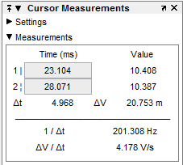

*Figure -10-: Curser Measurement.*