

**Electrical Engineering Department**

**Assignment**

**Modeling a DC Motor In Simulink**

Bara Al-Wawi 1101672

Section: 1

Instructor: Dr. Jamal Siam

Engineering : Issmat

Date handed : 19th of May , 2014

The Block Diagram was drawn as shown in the figure below and the code was written in the M-file with the given values in the box:

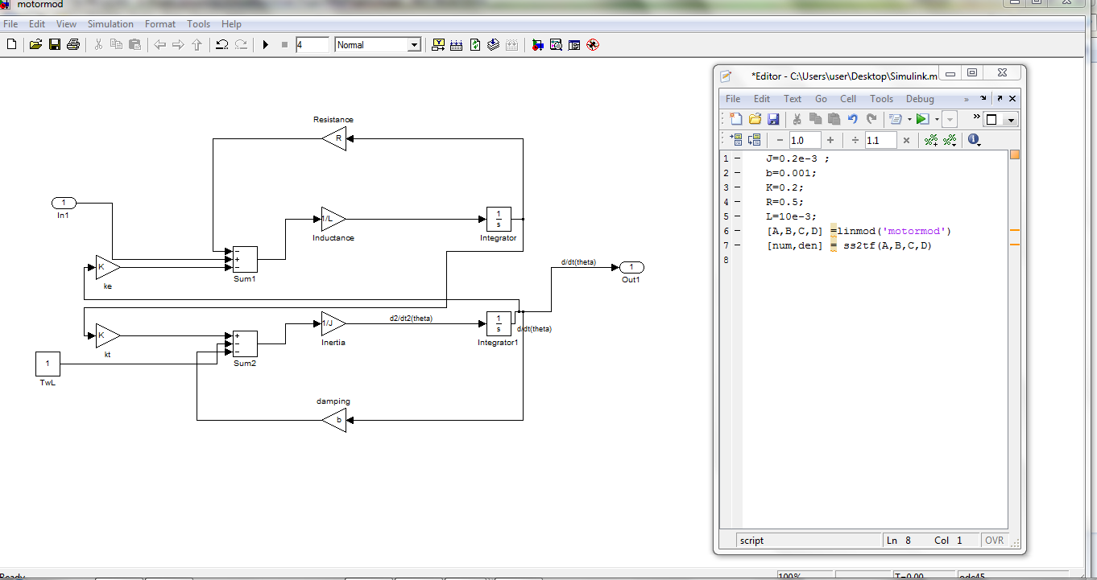

And the code was:

>> J=0.2e-3 ;

b=0.001;

K=0.2;

R=0.5;

L=10e-3;

[A,B,C,D] =linmod('motormod')

[num,den] = ss2tf(A,B,C,D)

To find the controller representation for the DC Motor, first the observer representation was found as the procedure in experiment 5 in the manual.

So the evaluation was as shown:

> In dlinmod at 172

In linmod at 60

A =

-5 1000

-20 -50

B =

0

100

C =

1 0

D =

0

num =

1.0e+005 *

0 0 1.0000

den =

1.0e+004 *

0.0001 0.0055 2.0250

the observere was:

>> A'

ans =

-5 -20

1000 -50