

**Electrical Engineering Department**

**Simulation Lap**

**Assignment #2**

**DC Motor**

**Instructor :Dr. Jamal Siam**

**Student Name:**

The Block Diagram Of The DC Motor and it was saved to MDL File

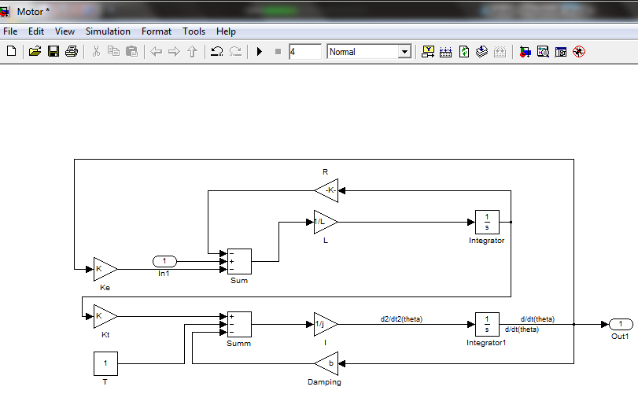

The Code on the Mfile :

**j=0.2e-3 ;**

**b=0.001;**

**K=0.4;**

**resistance=0.60;**

**L=20e-3;**

**[A,B,C,D] =linmod('MotorM')**

**[num,den] = ss2tf(A,B,C,D)**

After the evaluation is done:

**Warning: Using a default value of 0.08 for maximum step size. The simulation step size will be equal to or less**

**than this value. You can disable this diagnostic by setting 'Automatic solver parameter selection' diagnostic to**

**'none' in the Diagnostics page of the configuration parameters dialog**

**> In dlinmod at 172**

**In linmod at 60**

**A =**

**-5 2000**

**-20 -30**

**B =**

**0**

**50**

**C =**

**1 0**

**D =**

**0**

**num =**

**1.0e+005 \***

**0 0 1.0000**

**den =**

**1.0e+004 \***

**0.0001 0.0035 4.0150**

And Then To The Transfer Matrix Of A was submitted to find the Observer representation:

**>> A'**

**ans =**

**-5 -20**

**2000 -30**

**>>**